病人住院信息管理系统

系统分析

数据库设计

表分析

表结构

病人表

SQL语句
CREATE TABLE `NewTable` (
`id` bigint(20) NOT NULL AUTO_INCREMENT ,
`name` varchar(20) CHARACTER SET utf8 COLLATE utf8_general_ci NULL DEFAULT NULL ,
`sex` varchar(10) CHARACTER SET utf8 COLLATE utf8_general_ci NULL DEFAULT NULL ,
`age` int(10) NULL DEFAULT NULL ,
`phone` varchar(20) CHARACTER SET utf8 COLLATE utf8_general_ci NULL DEFAULT NULL ,
`address` varchar(100) CHARACTER SET utf8 COLLATE utf8_general_ci NULL DEFAULT NULL ,
`logtime` datetime NULL DEFAULT NULL ,
`sickbed_id` bigint(20) NULL DEFAULT NULL ,
PRIMARY KEY (`id`),
FOREIGN KEY (`sickbed_id`) REFERENCES `t_sickbed` (`id`) ON DELETE RESTRICT ON UPDATE RESTRICT,
INDEX `FK_patient_sickbed` (`sickbed_id`) USING BTREE
)
ENGINE=InnoDB
DEFAULT CHARACTER SET=utf8 COLLATE=utf8_general_ci
AUTO_INCREMENT=1
ROW_FORMAT=COMPACT
;

表视图
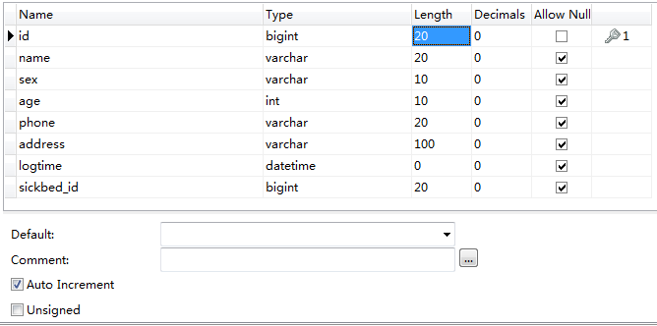

医生表

SQL语句
CREATE TABLE `NewTable` (
`id` bigint(20) NOT NULL AUTO_INCREMENT ,
`name` varchar(20) CHARACTER SET utf8 COLLATE utf8_general_ci NULL DEFAULT NULL ,
`sex` varchar(10) CHARACTER SET utf8 COLLATE utf8_general_ci NULL DEFAULT NULL ,
`username` varchar(20) CHARACTER SET utf8 COLLATE utf8_general_ci NULL DEFAULT NULL ,
`password` varchar(20) CHARACTER SET utf8 COLLATE utf8_general_ci NULL DEFAULT NULL ,
`age` int(10) NULL DEFAULT NULL ,
`phone` varchar(20) CHARACTER SET utf8 COLLATE utf8_general_ci NULL DEFAULT NULL ,
` title` varchar(20) CHARACTER SET utf8 COLLATE utf8_general_ci NULL DEFAULT NULL ,
`logtime` datetime NULL DEFAULT NULL ,
`department_id` bigint(20) NULL DEFAULT NULL ,
PRIMARY KEY (`id`),
FOREIGN KEY (`department_id`) REFERENCES `t_department` (`id`) ON DELETE RESTRICT ON UPDATE RESTRICT,
INDEX `FK_doctor_department` (`department_id`) USING BTREE
)
ENGINE=InnoDB
DEFAULT CHARACTER SET=utf8 COLLATE=utf8_general_ci
AUTO_INCREMENT=1
ROW_FORMAT=COMPACT;

表视图
注意：professional_title 改成了 title （医生职称）
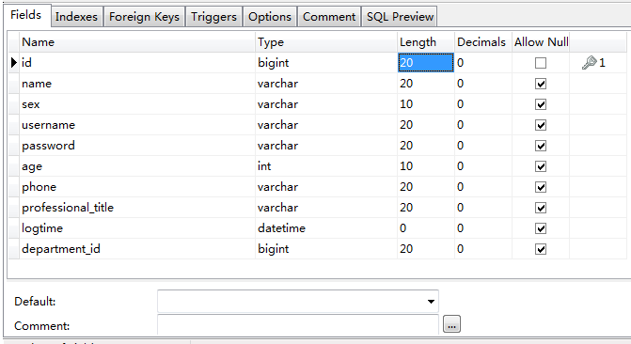

病床表

SQL语句
CREATE TABLE `NewTable` (
`id` bigint(20) NOT NULL AUTO_INCREMENT ,
`sickbedno` int(20) NULL DEFAULT NULL ,
`sickroom_id` bigint(20) NULL DEFAULT NULL ,
PRIMARY KEY (`id`),
FOREIGN KEY (`sickroom_id`) REFERENCES `t_sickroom` (`id`) ON DELETE RESTRICT ON UPDATE RESTRICT,
INDEX `FK_sickbed_sickroom` (`sickroom_id`) USING BTREE
)
ENGINE=InnoDB
DEFAULT CHARACTER SET=utf8 COLLATE=utf8_general_ci
AUTO_INCREMENT=1
ROW_FORMAT=COMPACT
;

表视图
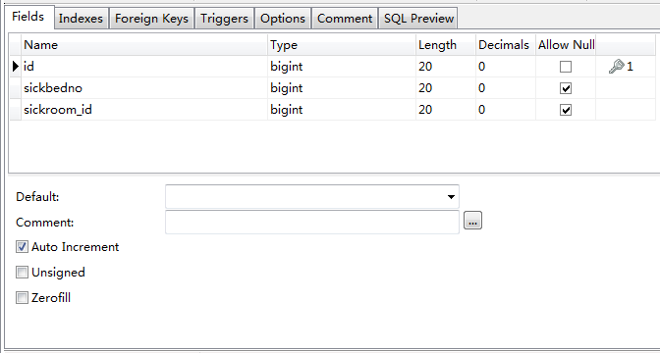

病房表

SQL语句
CREATE TABLE `NewTable` (
`id` bigint(20) NOT NULL AUTO_INCREMENT ,
`sickroomno` int(20) NULL DEFAULT NULL ,
`department_id` bigint(20) NULL DEFAULT NULL ,
PRIMARY KEY (`id`),
FOREIGN KEY (`department_id`) REFERENCES `t_department` (`id`) ON DELETE RESTRICT ON UPDATE RESTRICT,
INDEX `FK_sickroom_department` (`department_id`) USING BTREE
)
ENGINE=InnoDB
DEFAULT CHARACTER SET=utf8 COLLATE=utf8_general_ci
AUTO_INCREMENT=1
ROW_FORMAT=COMPACT
;

表视图
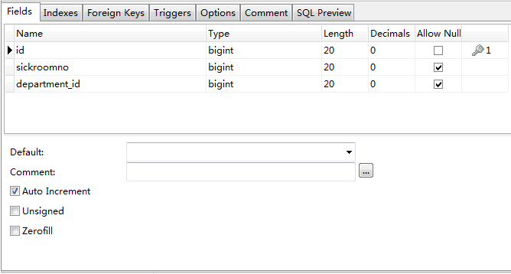

费用表

SQL语句
CREATE TABLE `NewTable` (
`id` bigint(20) NOT NULL AUTO_INCREMENT ,
`expensedec` varchar(50) CHARACTER SET utf8 COLLATE utf8_general_ci NULL DEFAULT NULL ,
`expensename` varchar(20) CHARACTER SET utf8 COLLATE utf8_general_ci NULL DEFAULT NULL ,
`unitprice` float(20,0) NULL DEFAULT NULL ,
`number` int(20) NULL DEFAULT NULL ,
`occurexpense` float(20,0) NULL DEFAULT NULL ,
`occurtime` datetime NULL DEFAULT NULL ,
`patient_id` bigint(20) NULL DEFAULT NULL ,
`doctor_id` bigint(20) NULL DEFAULT NULL ,
PRIMARY KEY (`id`),
FOREIGN KEY (`patient_id`) REFERENCES `t_patient` (`id`) ON DELETE RESTRICT ON UPDATE RESTRICT,
FOREIGN KEY (`doctor_id`) REFERENCES `t_doctor` (`id`) ON DELETE RESTRICT ON UPDATE RESTRICT,
INDEX `FK_expense_doctor` (`doctor_id`) USING BTREE ,
INDEX `FK_expense_patient` (`patient_id`) USING BTREE
)
ENGINE=InnoDB
DEFAULT CHARACTER SET=utf8 COLLATE=utf8_general_ci
AUTO_INCREMENT=1
ROW_FORMAT=COMPACT
;

表视图
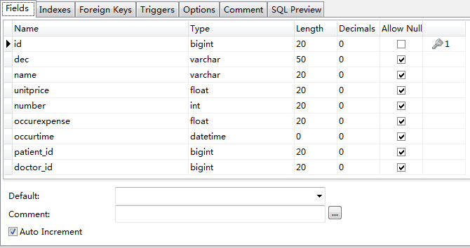

诊断表

SQL语句
CREATE TABLE `NewTable` (
`id` bigint(20) NOT NULL AUTO_INCREMENT ,
`illness` varchar(100) CHARACTER SET utf8 COLLATE utf8_general_ci NULL DEFAULT NULL ,
`treatment` varchar(500) CHARACTER SET utf8 COLLATE utf8_general_ci NULL DEFAULT NULL ,
`diagnosedate` datetime NULL DEFAULT NULL ,
`patient_id` bigint(20) NULL DEFAULT NULL ,
`doctor_id` bigint(20) NULL DEFAULT NULL ,
PRIMARY KEY (`id`),
FOREIGN KEY (`patient_id`) REFERENCES `t_patient` (`id`) ON DELETE RESTRICT ON UPDATE RESTRICT,
FOREIGN KEY (`doctor_id`) REFERENCES `t_doctor` (`id`) ON DELETE RESTRICT ON UPDATE RESTRICT,
INDEX `FK_diagnose_doctor` (`doctor_id`) USING BTREE ,
INDEX `FK_diagnose_patient` (`patient_id`) USING BTREE
)
ENGINE=InnoDB
DEFAULT CHARACTER SET=utf8 COLLATE=utf8_general_ci
AUTO_INCREMENT=1
ROW_FORMAT=COMPACT
;

表视图
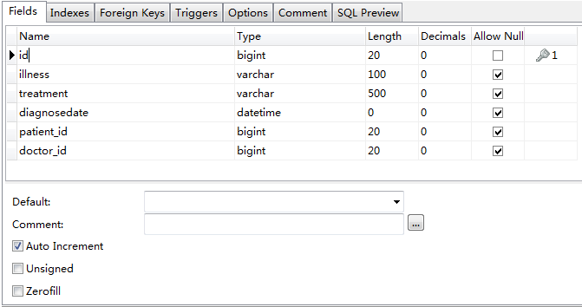

设计缺陷

varchar的大小都是10或者20等等，都是10的倍数，实际上的设计时最好是2的指数

表的结构不是很好，有些数据类型的选择不是很好，例如sex选用的是varchar类型

对于医生表的职称最好是能够有一个表来定义一下，保存所有的职称类型，这样在应用程序中就可以提供一个list便于选择

