INT 209 - Game Design Report

Name: Vaibhav Kumar
Registration number: 11811376
Roll Number: 08
Section: K18RD

Introduction:
The project was made using unity game editor software. Unity is simple and interactive software to make games. The game made for the CA isI a rolling ball game with force and gravity using C# in Unity with increasing score and Nature Starter Kit 2 contains trees and bushes compatible with the built-in tree generator, so you can easily create all kinds of new variations of your own to design the environment in the game.

Game Category or game theme:
The game is a 3d rolling ball game with force and gravity using C#. It is based on the theme of roller ball. The player is a roller ball and has to collect a specified number of points to win the game.
The player should also avoid to fall from the board of the ball on which boll is rolling because it can over the game if ball fall from the playing board. So player has to balance the ball and collect points to win the game

Game Play Description with snapshots:
In the game, we have to balance the ball by applying forces in opposite direction to the movement of rolling ball because ball is rolling with force and gravity using C# script. So, the player should also avoid to fall from the board of the ball on which boll is rolling.
If the rolling balls falls down from the beard the game will over and if we successfully collect the
Points (whose limit is defined in the script) the you will win the match.
Ball is also rotating in all direction so that it make the ball to roll more faster and we can also set any speed of rolling speed of ball in the script to in each increasing levels.
Main camera is scripted so that it will move according the movement of rolling ball.
Ball is rigid body with gravity (physics) and sphere collider and the board which name as ground is use as a mesh collider, therefore, ball will get attached with board.

First, you have to open the Unity project. Create terrain, trees, and water. Add skyboxes in your project.
Create a Plane:
In the Inspector, set its name to “ground”.
The Project Pane, Create a folder called “Materials”. In the Materials folder, create a Material called “ground”, and select it.
Drag this material from the Project pane onto the ground in the Scene.

Create sphere into your game:
Material will be displayed in the Assets panel. Change the material colour into blue. Drag and drop the material into sphere.

Use gravity in your game:
Click on the sphere
The rigid body will be added into the inspector panel. Tick on the "use gravity" checkbox to add Gravity in the sphere.
Go to Scripts. Create C# Scripts and write scripts to it.

Camera:
Position the Main Camera object
Create a C# Script called “CameraController” and attach it to the Main Camera object:

Displaying Text:
Create UI Text. Rename to winText. Reset the transform and change color to “PINK”. Select the Anchors icon. Hold shift and alt keys and select top left Change the rect transform to x 10 and y -10 In PlayerController, using Unity UI Public Text countText.
Similarly, Create UI Text. Rename to Count Text. Reset the transform and change color to “RED”. Select the Anchors icon. Hold shift and alt keys and select top left Change the rect transform to x 10 and y -10 In PlayerController, using Unity UI Public Text winText(GameOver)

Snapshots:
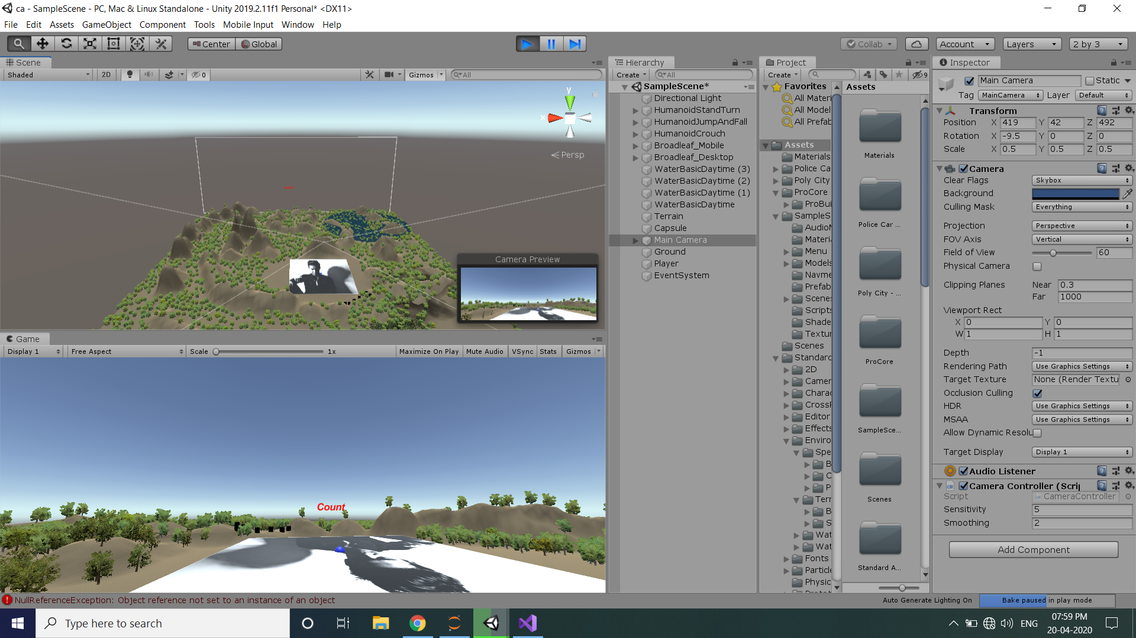

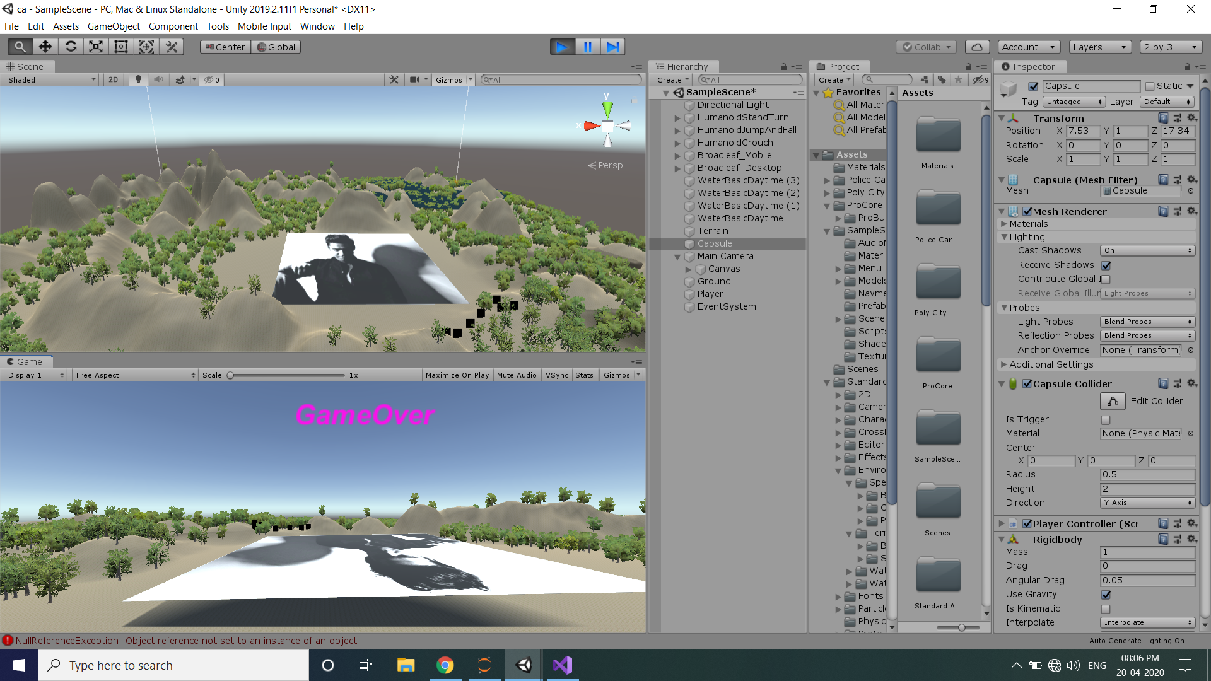

Implementation with Scripting:
- PlayerController Script:
using UnityEngine;
using UnityEngine.UI;
using System.Collections;

public class PlayerController : MonoBehaviour {

public float speed;
public Text countText;
public Text winText;

private Rigidbody rb;
private int count;

void Start ()
{
rb = GetComponent<Rigidbody>();
count = 0;
SetCountText ();
winText.text = "";
}

void FixedUpdate ()
{
float moveHorizontal = Input.GetAxis ("Horizontal");
float moveVertical = Input.GetAxis ("Vertical");

Vector3 movement = new Vector3 (moveHorizontal, 0.0f, moveVertical);

rb.AddForce (movement * speed);
}

void OnTriggerEnter(Collider other)
{
if (other.gameObject.CompareTag ( "Pick Up"))
{
other.gameObject.SetActive (false);
count = count + 1;
SetCountText ();
}
}

void SetCountText ()
{
countText.text = "Count: " + count.ToString ();
if (count >= 12)
{
winText.text = "You Win!";
}
}
}
- CameraController Script:
using System.Collections;
using System.Collections.Generic;
using UnityEngine;

public class CameraController : MonoBehaviour
{
private float minimumx = -60f;
private float maximumx = +60f;
private float minimumy = +360f;
private float maximumy = -360f;
[SerializeField]
public float sensitivity = 5.0f;
[SerializeField]
public float smoothing = 2.0f;
// the chacter is the capsule
private GameObject character;
// get the incremental value of mouse moving
private Vector2 mouseLook;
// smooth the mouse moving
private Vector2 smoothV;

// Use this for initialization
void Start()
{
character = this.transform.parent.gameObject;
}

// Update is called once per frame
void Update()
{
// md is mosue delta
var md = new Vector2(Input.GetAxisRaw("Mouse X"), Input.GetAxisRaw("Mouse Y"));
md = Vector2.Scale(md, new Vector2(sensitivity * smoothing, sensitivity * smoothing));
// the interpolated float result between the two float values
smoothV.x = Mathf.Lerp(smoothV.x, md.x, 1f / smoothing);
smoothV.y = Mathf.Lerp(smoothV.y, md.y, 1f / smoothing);
// incrementally add to the camera look
mouseLook += smoothV;

// vector3.right means the x-axis
transform.localRotation = Quaternion.AngleAxis(Mathf.Clamp(-mouseLook.y, minimumx, maximumx), Vector3.right);
character.transform.localRotation = Quaternion.AngleAxis((mouseLook.x), character.transform.up);
}

}

- CubeRotate Script:
using System.Collections;
using System.Collections.Generic;
using UnityEngine;

public class Cuberotate : MonoBehaviour
{
// Start is called before the first frame update
void Start()
{

}
float x;
float y;
float z;
// Update is called once per frame
void Update()
{
x+=Time.deltaTime*30;
y+=Time.deltaTime*30;
z+=Time.deltaTime*30;
transform.rotation=Quaternion.Euler(x,y,z);

}
}

