**DEMOCRATIZING**

**REAL ESTATE**

**INVESTING**

**AcreageWay**

**Executive summary**:

Real estate is an old, inefficient, high entry barrier, large red tape type of investment.  Democratizing real estate investing challenges the status quo of the traditional real estate investing.  It removes the barrier for entry, increase efficiency, cut down the red tape and increase liquidity.  This case study will look into the details of how democratizing works in real estate.  It’ll explain the blockchain technology that enabling the democratizing of real estate.  It’ll then go through the challenges that democratizing of real estate faces.  We’ll look at the potential solutions to those challenges.

**Introduction:**

Commercial real estate has a huge barrier for both developers and investors; Developers seek funding from a handful of institutional and ultra-high networth investors.  And only individual investors with a large amount of fund have access to these commercial real estate investments. AcreageWay is an up and coming Fintech company that vows to disrupt the commercial real estate investment in Canada.  The company was found in 2018 by two MBA classmates; Ms. Srivastava and Mr. Koparde, the company’s CEO and president, respectively. They want to remove the barriers to commercial real estate funding and investing.  By using blockchain technology commercial property can be tokenized into many small junk of investments.  This type of investment gives developers access to a bigger pool of finance. And average investors without deep pocket gain access to new source of return from commercial real estate which they wouldn’t be able to without a large capital.

Real Estate is one of the world’s largest asset and also the least advancement in term of utilizing technology in its investment process.  The chart below shows the global real estate valuation.  Globally, the total real estate asset is valued at US $228 trillion, of this total, US $32.3 trillion is commercial real estate.

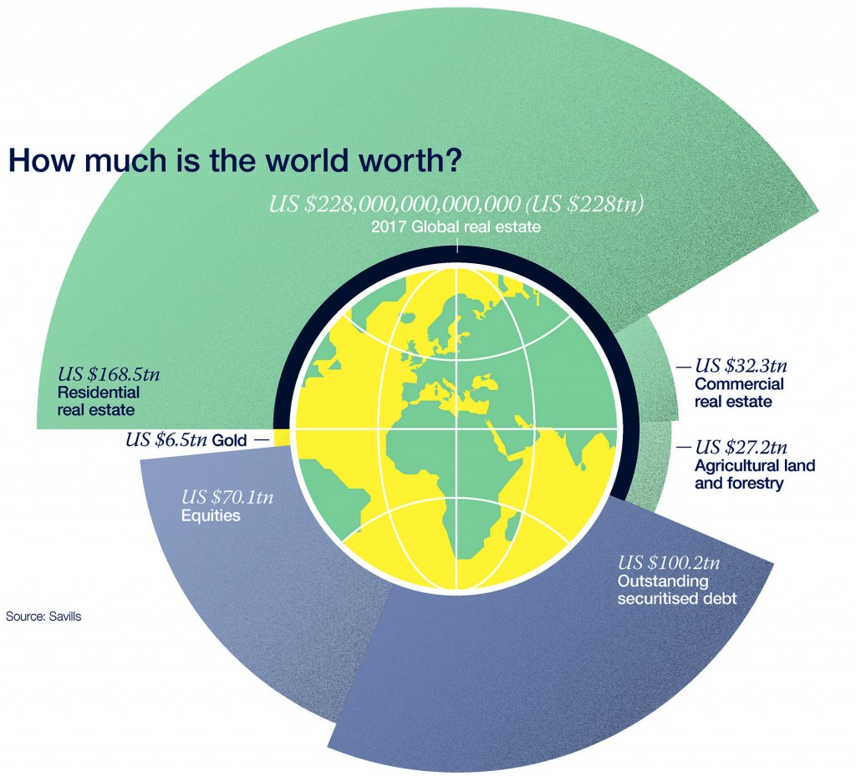

In Canada, commercial real estate is estimated to be ~CAN $50 billion.  However, less than 1% of the total commercial real estate financing has been raised through tokenization.  That gives FinTech companies like AcreageWay tremendous opportunity to gain market share in commercial real estate financing.

Blockchain technology reduces issuance cost and increases developer’s profitability. The traditional way of raising finance involves expensive legal fees, fees from middle men like banks or other financial companies.  In addition to the overhead cost, there is an opportunity cost from the time consuming of preparing the deals.  AcreageWay uses Ethereum BlockChain along with AI technology to create smart contracts that reduces the high financing cost and time associated with traditional deal issuing.

Tokenization of investments into small tokens gives the developers access to a bigger pool of investors.  At the same the investors now can also have access to private investments which they would’ve been able to with a small capital.  With smart contracts, investors now can tailor their investments to specific projects.  The ability to invest in specific projects tailor their risk/return profiles enable them to further diversify their investments, which in turn improves their portfolio diversification.

Real Estate Tokenization’s gain in popularity and advancement has been slow compared to other Fintech domains. The number of platforms that provide real estate tokenization is relatively small but growing. The table below demonstrates the process of real estate tokenization and the number of major platforms in this domain globally. Here in Canada there only two real estate tokenization; AcreageWay and TokenFunder.

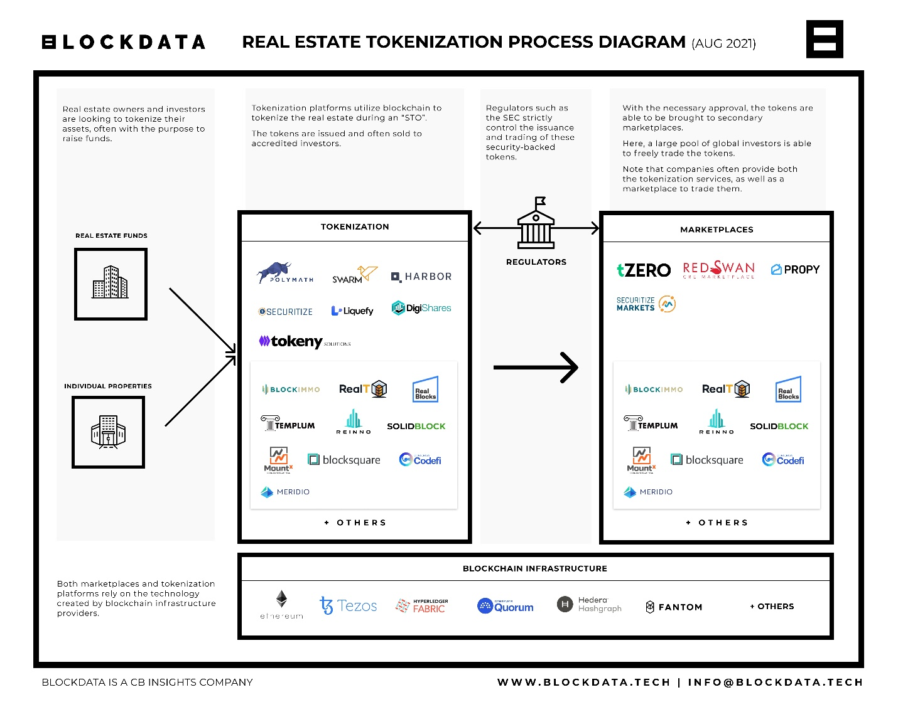

Real Estate Tokenization is under represented in the overall global real estate value but its market share is growing in the last 5 years. In addition, Deutsche Börse and Commerzbank announced in a joint venture to offer tokenized real estate and art. The number of tokenized real estate deals will more likely to increase with high profile financial institutions like Deutsche Börse and Commerzbank. Below is a list of tokenized real estate deals over in the last few years:

- A luxury villa in Paris valued at €6.5 million was tokenized on Ethereum blockchain

- Aspencoin tokenized $18M for fractional ownership in St. Regis Aspen Resort.

- Harbor tokenized $20 million student residence in South Carolina

- Propellr and Fluidity tokenized a Manhattan luxury condo for $30 million.

- RealT tokenized 75 properties since 2019 on Mt Pelerin platform.

- A largest deal was tokenized by Polymath estimated value $2.2 billion of commercial real estate for RedSwan.

AcreageWay launched their platform in Jun 2021.  Just under a year the company has already issued 7500 tokens.  The upside is tremendous for AcreageWay as there is only one direct competitor in this domain in Canada. Its competitor, TokenFunder is fairly new and also an up and coming company like AcreageWay. With limited data available it’s difficult to assess the relative performance between two companies. Regardless, the tokenization of real estate is so minuscule of the overall real estate valuation that there’s tremendous upside growth for both companies.

Tokenization of real estate by AcreageWay and in Canada as a whole still hasn’t solved the illiquidity issue with investment in real estate. There is a no secondary market place to trade your tokens. Your tokenized investments is cashed out when a property is sold. Outside of Canada tokenized real estate can be traded on a secondary market place. Lack of secondary market place is largely due to the regulation that’s imposed by the Canadian government for this type of fintech domain. AcreageWay and companies alike should invest in lobbying the government to grant the right to open a secondary market place for tokenized investments. The ability to trade a very illiquidity asset like real estate through tokenization is very appealing to investors.

Tokenized commercial real estate is hugely under-represented globally and in Canada locally.  Tokenizing real estate is a major disruption to the real estate industry.  The blockchain technology removes inefficiency and removes investment barriers; beneficial to both developers and investors.  The real estate industry is a status quo state to both developers and investors. But with further education of tokenization and blockchain technology, the growth in this domain will surely increase.

**References**:

Graeme Moore, head of tokenization at Polymat <https://www.blockdata.tech/blog/general/tokenized-real-estate-2021-update>

[Democratizing Real Estate Investing](https://www.blockdata.tech/blog/general/tokenized-real-estate-2021-update)

## [Yuval Wirzberger](https://medium.com/@yuval.wirzberger?source=follow_footer-----de7eeb807f72-----------------------------------)

<https://medium.com/solidblock/why-tokenized-securities-will-be-even-more-disruptive-than-cryptocurrencies-and-icos-de7eeb807f72>