Chapter #: CR Model for Argon I

#.# The Model
The collisional-radiative model for neutral argon (AR I) under evaluation originated in 1988 by J. Vlcek and was extended in 1998 by A. Bogaerts and R. Gijbels. The code implementing this model was received from E. Sciamma who in turn received it from A. Keesee.
The model consists of 65 effective levels. Each model level represents one or more physical levels. All included levels can be seen in Table #.# and Figure #.#. Some levels of similar energy and quantum numbers are grouped together to reduce the amount of atomic data needed and the number of equations needed to solve for the level populations.
The radiative processes included are spontaneous emissions, and recombination from the Ar II ground level. Photo-excitation is accounted for by an escape factor 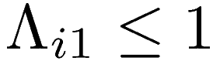 for spontaneous emissions to the ground level which reduces the rate of transitions, and 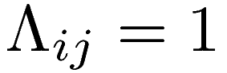 for 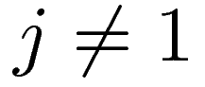.
The collisional processes included are electron impact excitation, de-excitation, ionization, two-body and three-body recombination from the Ar II ground state.

Table #.# List of Ar I Model levels [ref]
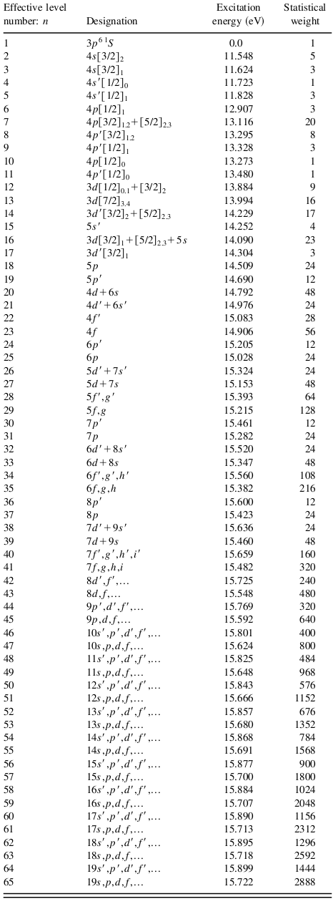

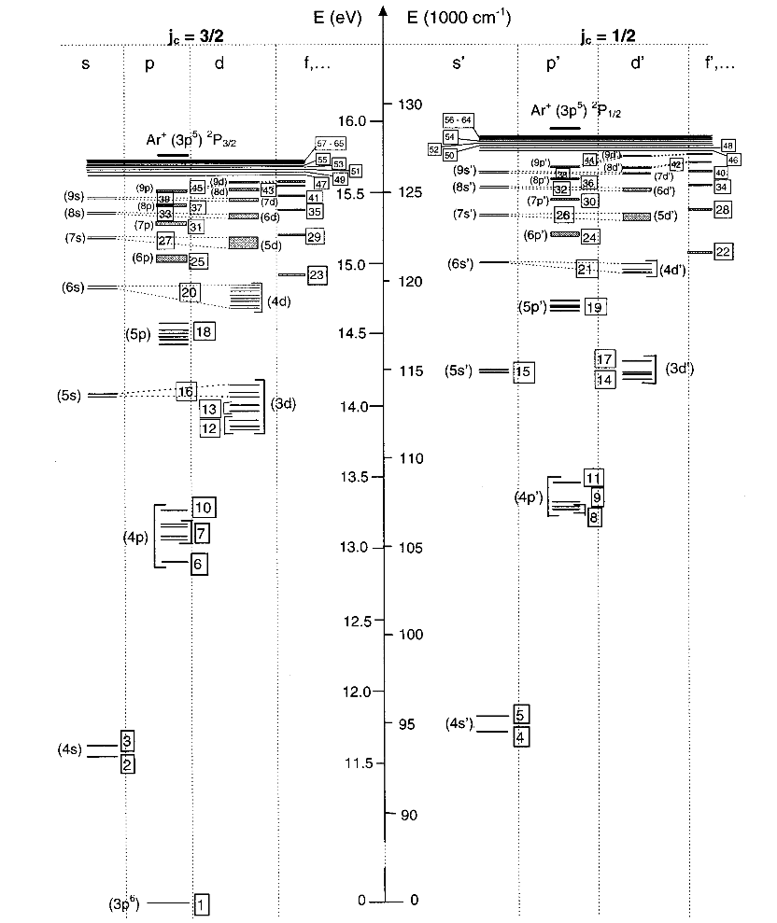
Figure #.#: Ar I model energy level diagram. [ref]

#.# Equilibrium
In the Texas Helimak, the neutral-neutral collision time for Argon is estimated to be 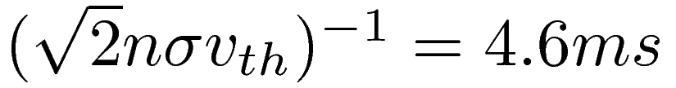, where 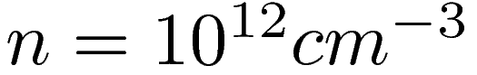, 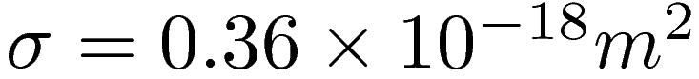 [ref], 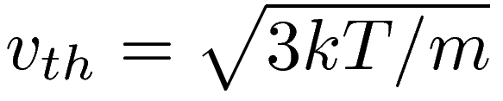, and 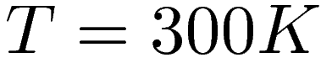.
The transit time is estimated to be 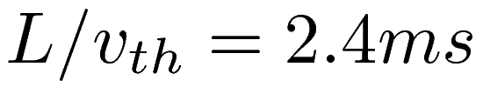 (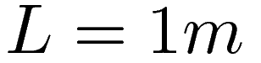). Therefore it is expected that the longest possible time-scale is limited by the transit time. The collisional-radiative model was used to estimate the typical life-time of levels of Argon I seen in figure #.#.

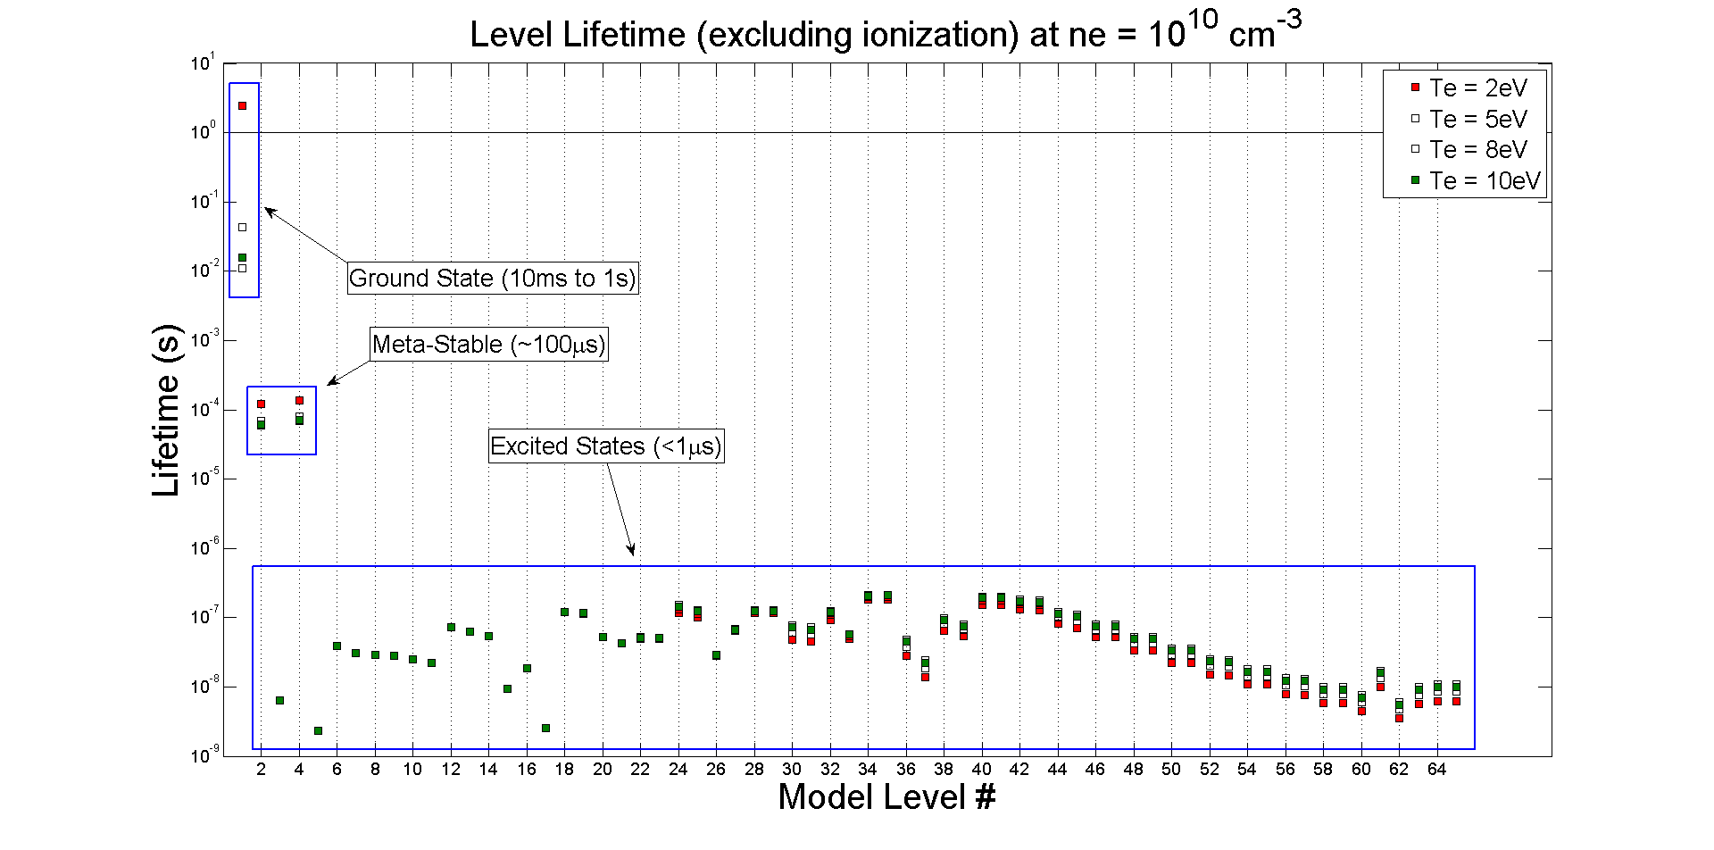
Figure #.#: AR I Level Lifetimes
As can be seen, the ground state has a lifetime much longer than the transit time, while all other levels have lifetimes much shorter than the transit time. Care will be taken to ensure that the model gives sensible results given a true equilibrium cannot be reached between all levels.
The dominate process for each model level (collisional versus radiative) can be determined from figure #.#. For example, given 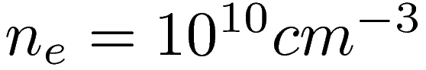, radiative processes dominate (>90%) the levels below approximately level 20 while collisional processes dominate levels above approximately level 46.

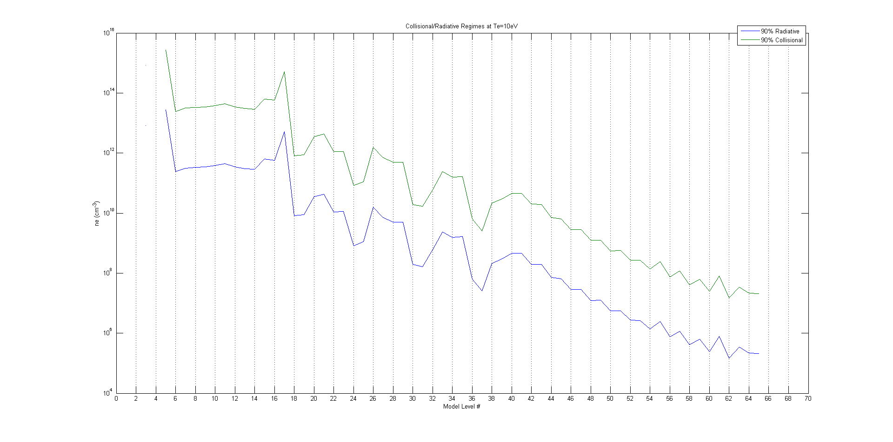
Figure #.#: Dominant Processes
This result indicates that levels above ~46 will not significantly impact this evaluation given that the transitions will be predominantly to the other levels nearby in energy. Whereas the lower lying levels, which have significant radiative transitions, may cause cascade to the levels being measured.

#.# Non-Local Effects
Given that Ar I does not come to a true equilibrium, the code was extended to estimate the magnitude of departure from local equilibrium. This was done by using a single speed 1D kinetic model described by distribution and source in eq. #.# and #.#, and the boundary condition that atoms coming from the walls are in the ground state in eq. #.# and #.#.
(#.#)
(#.#) (how do I show this is valid?)
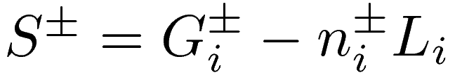
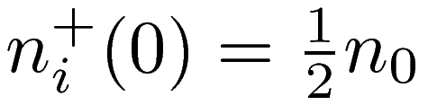 (#.#)
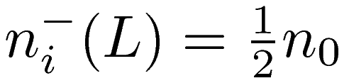 (#.#)
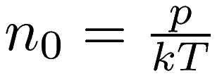
This set of distributions are used with the Boltzmann equation with sources eq. #.#, neglecting force and collision terms, and seeking equilibrium 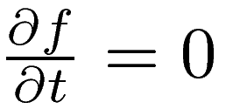. This allows the equation to be split into independent 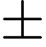 equations, which can be directly integrated to solve for the population's density and velocity as a function of position.
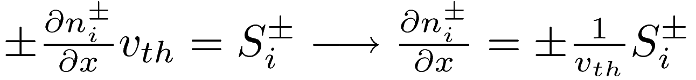 (#.#)
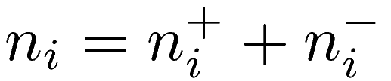 (#.#)
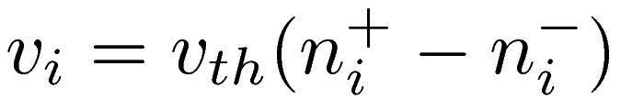 (#.#)
For the purpose of this analysis, a triangular profile was used for the electron density and temperature seen in Figures #.# and #.#.

#.# Comparison to ADAS Ar I Model

