Chapter #: Method of Measurements

#.# Spectrometer
The spectrometer used was produced by Ocean Optics, model USB-650. It has a wavelength range of 349nm to 999nm, with a resolution of 2nm (FWHM). It has 651 pixels and an adjustable integration time from 3ms to 65s.

#.# Optical Setup
The Helimak plasma was viewed through an optical port on the bottom of the machine as seen in figure #.#. The physical window was approximately 40cm wide, and gives a maximum effective viewing range of about 35cm for a 50mm lens. The lens was mounted on a ruled linear track which also served as a position measurement. The lens was connected to the spectrometer through an optical fiber of approximately 2m in length.
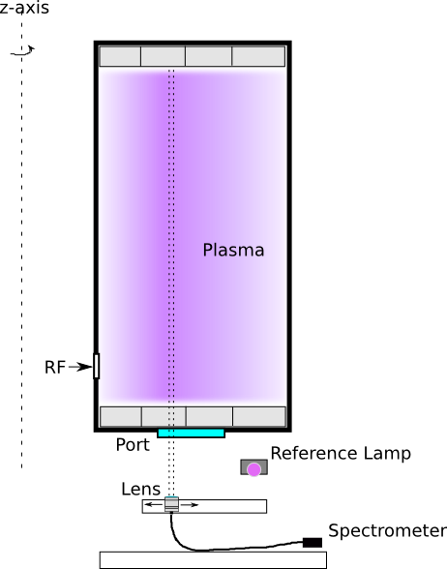
Figure #.#: Optical setup
The starting position of the track was measured from the inner radius of the Helimak chamber using a plumb line from the chamber to the track's position. The inner radius of the chamber was also measured to give the starting radius of the track. There were two track segments. The starting radius of the second track was also measured relative to the first track.

#.# Lens, Fiber, and Spectrometer Calibration
Calibration of the combination of the lens, fiber optic, and the spectrometer where done by taking the setup and measuring a known calibrated lamp, which has performed by William Rowan using a Lab-Sphere source at MIT. The known spectral radiance profile of the lamp , given in units of [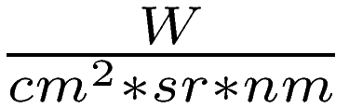], was used to calculate a calibration constant  for the system in terms of the measured number of counts per wavelength received on the spectrometer, as can be seen in figure #.#.
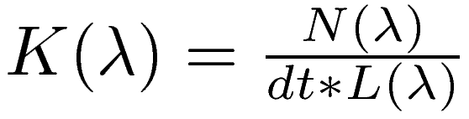 [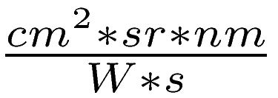] (#.#)
where  = integration time
This constant can then be used to calculate the radiance of a the plasma from the number of counts on the spectrometer.
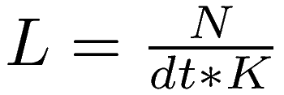 (#.#)

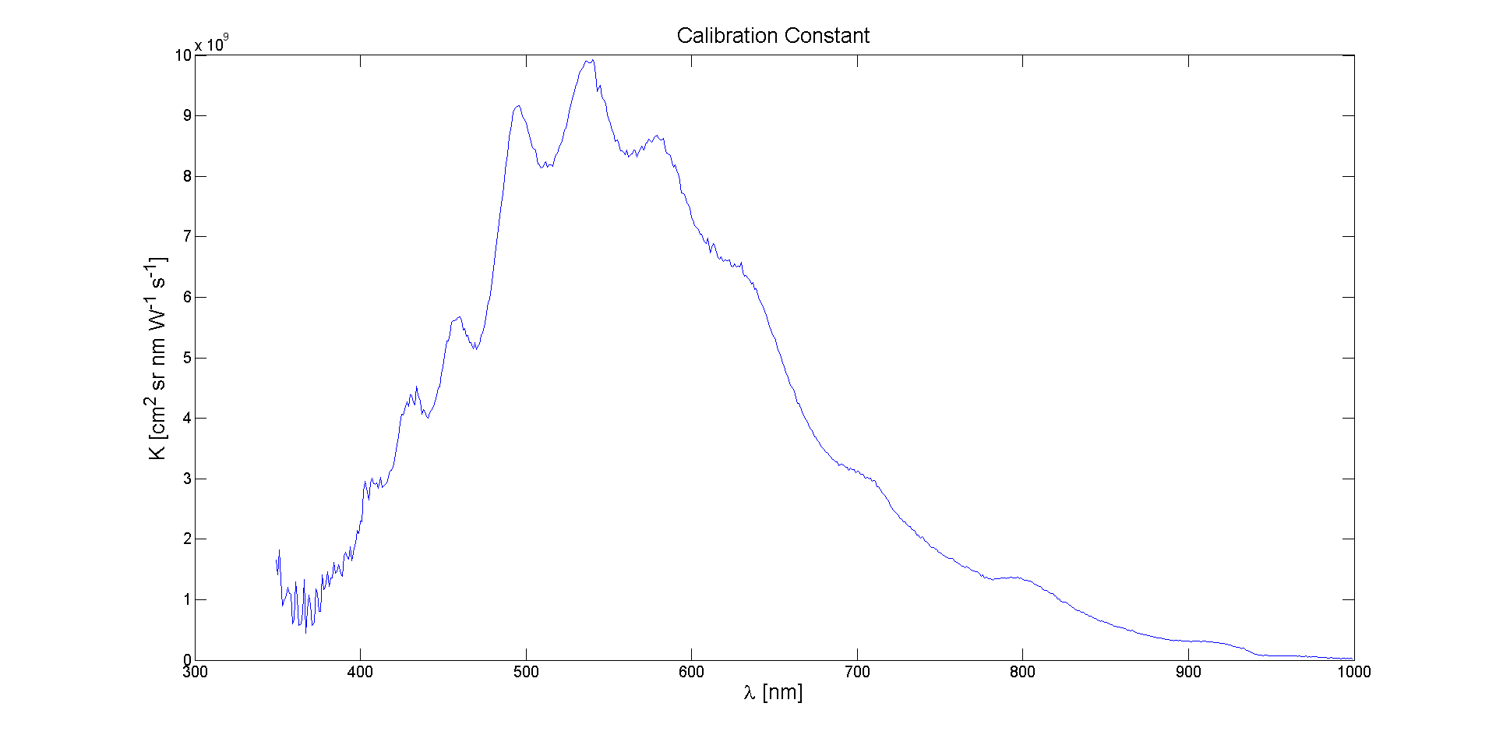
Figure #.#: Calibration versus wavelength

#.# Window Calibration
The optical transmission qualities of the port window where measured as a function of position along the width of the window to account for any variations. The window also has a copper mesh screen on top of it to prevent RF power from escaping through the port. Calibration was accomplished by removing the entire window and screen and mounting in on a linear track. A reference light source was positioned on one side and and the lens on the other, as seen in figure #.#.

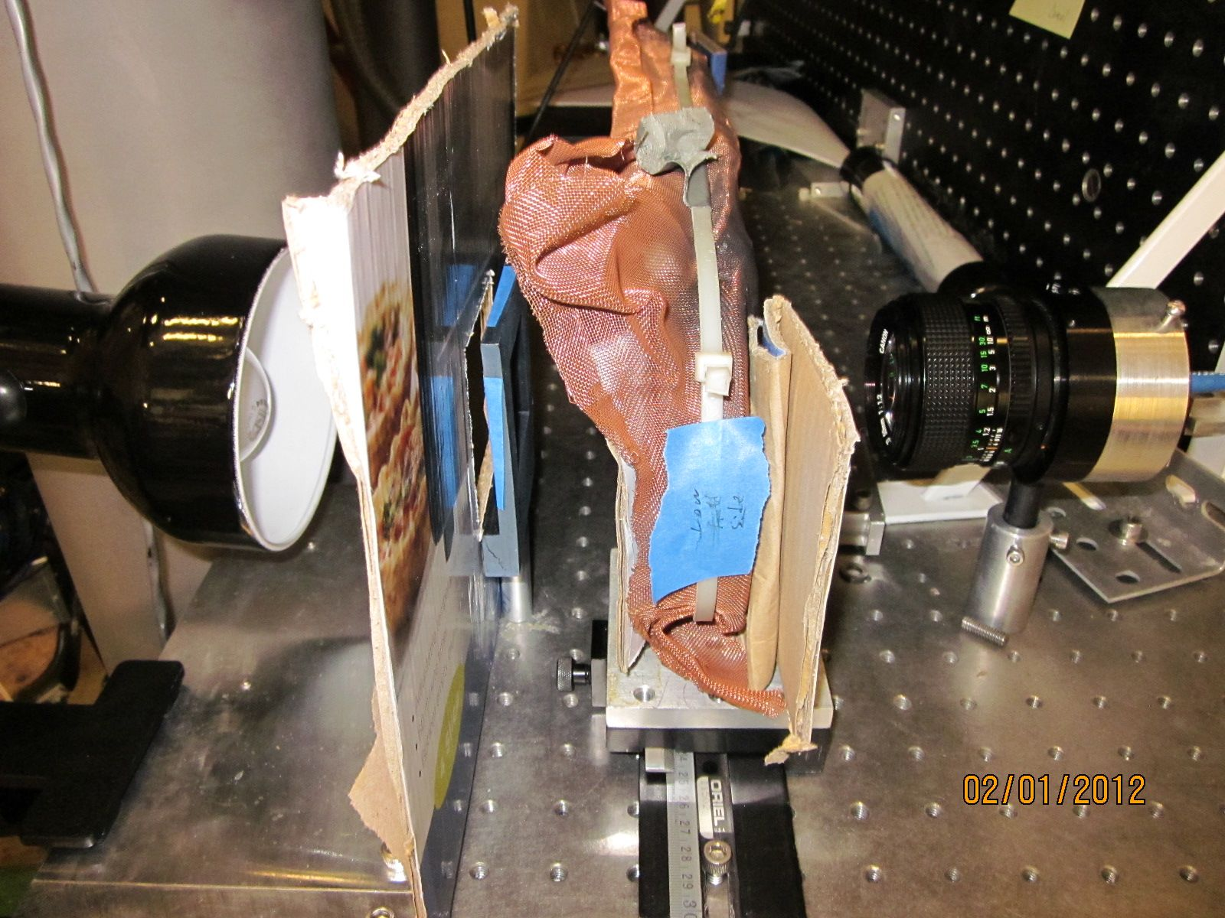
Figure #.#: Window Calibration Setup
The reference light source consisted of a standard light bulb and a diffusor made a piece of paper. A measurement of the light source was made without the window in place to serve as a reference, as well as a background reference. The cardboard served as a larger light block to prevent the light from reflecting off of other surfaces which might contribute to the measurements.
Measurements where made at 1cm increments along the length of the window. At each position, spectra was taken and averaged together. The transmission of the window versus wavelength is calculated by dividing the position measurements by the reference measurement. A sample of the transmission profile versus wavelength can be seen in figure #.# measured at position of 15cm from high field side. Figure #.# shows average transmission versus position.
This factor was included in the calibration constant for the lens/fiber/spectrometer by simply defining a total calibration constant where the window factor is .
 (#.#)
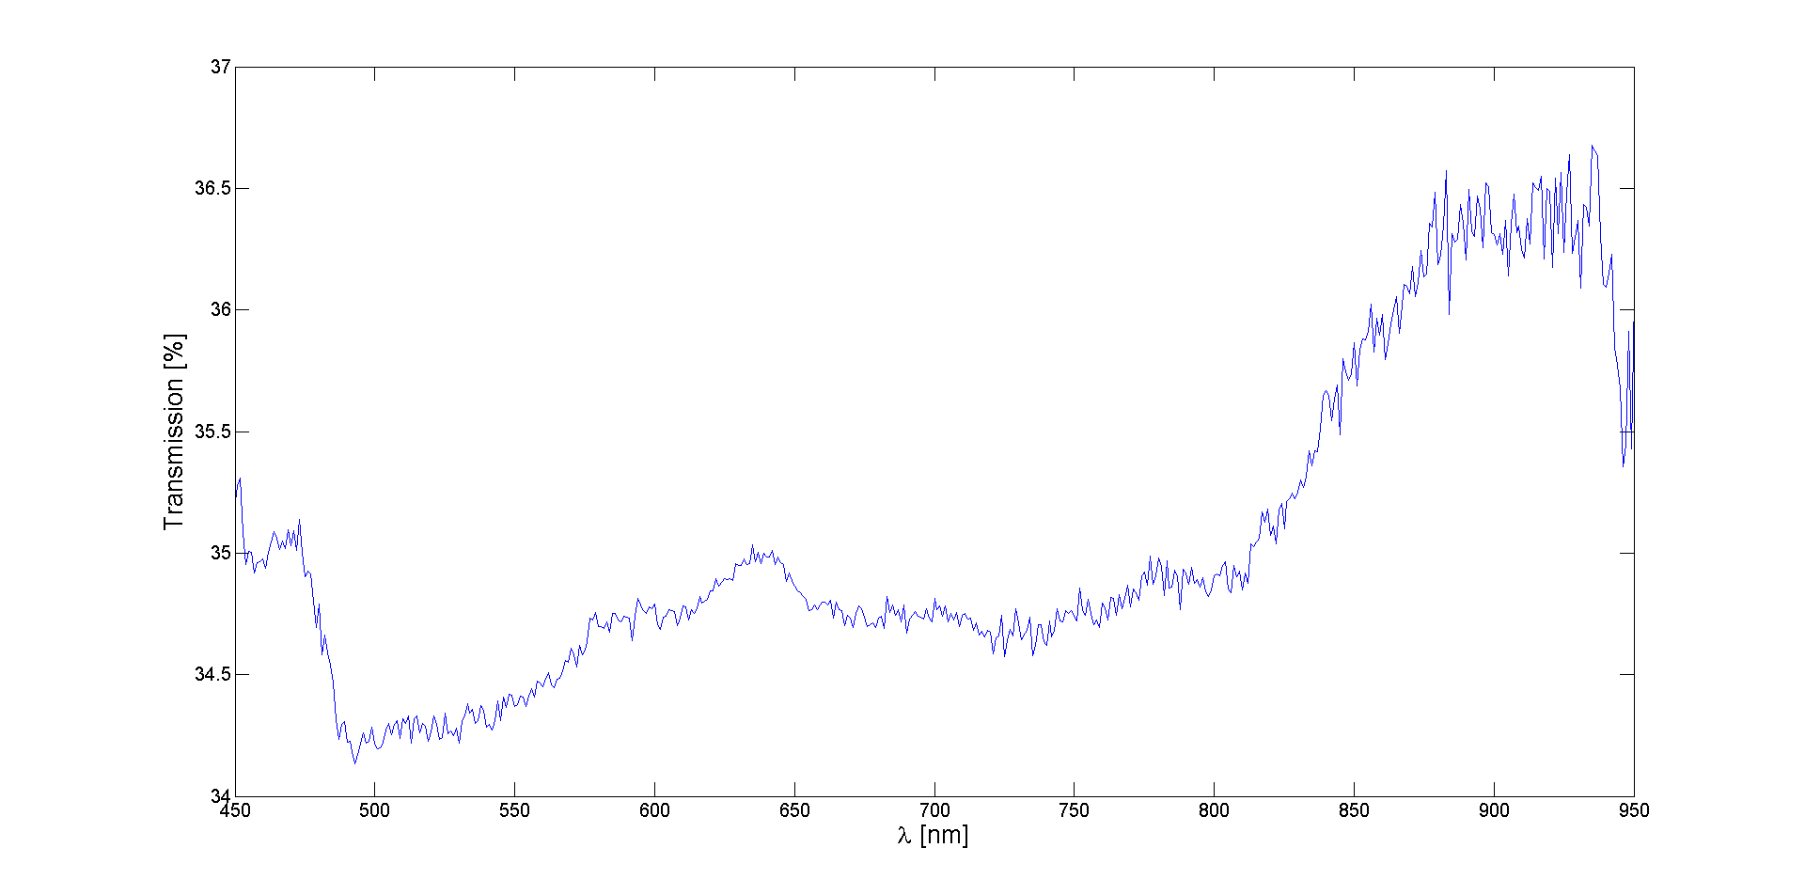
Figure #.#: Window transmission versus wavelength at x=15cm

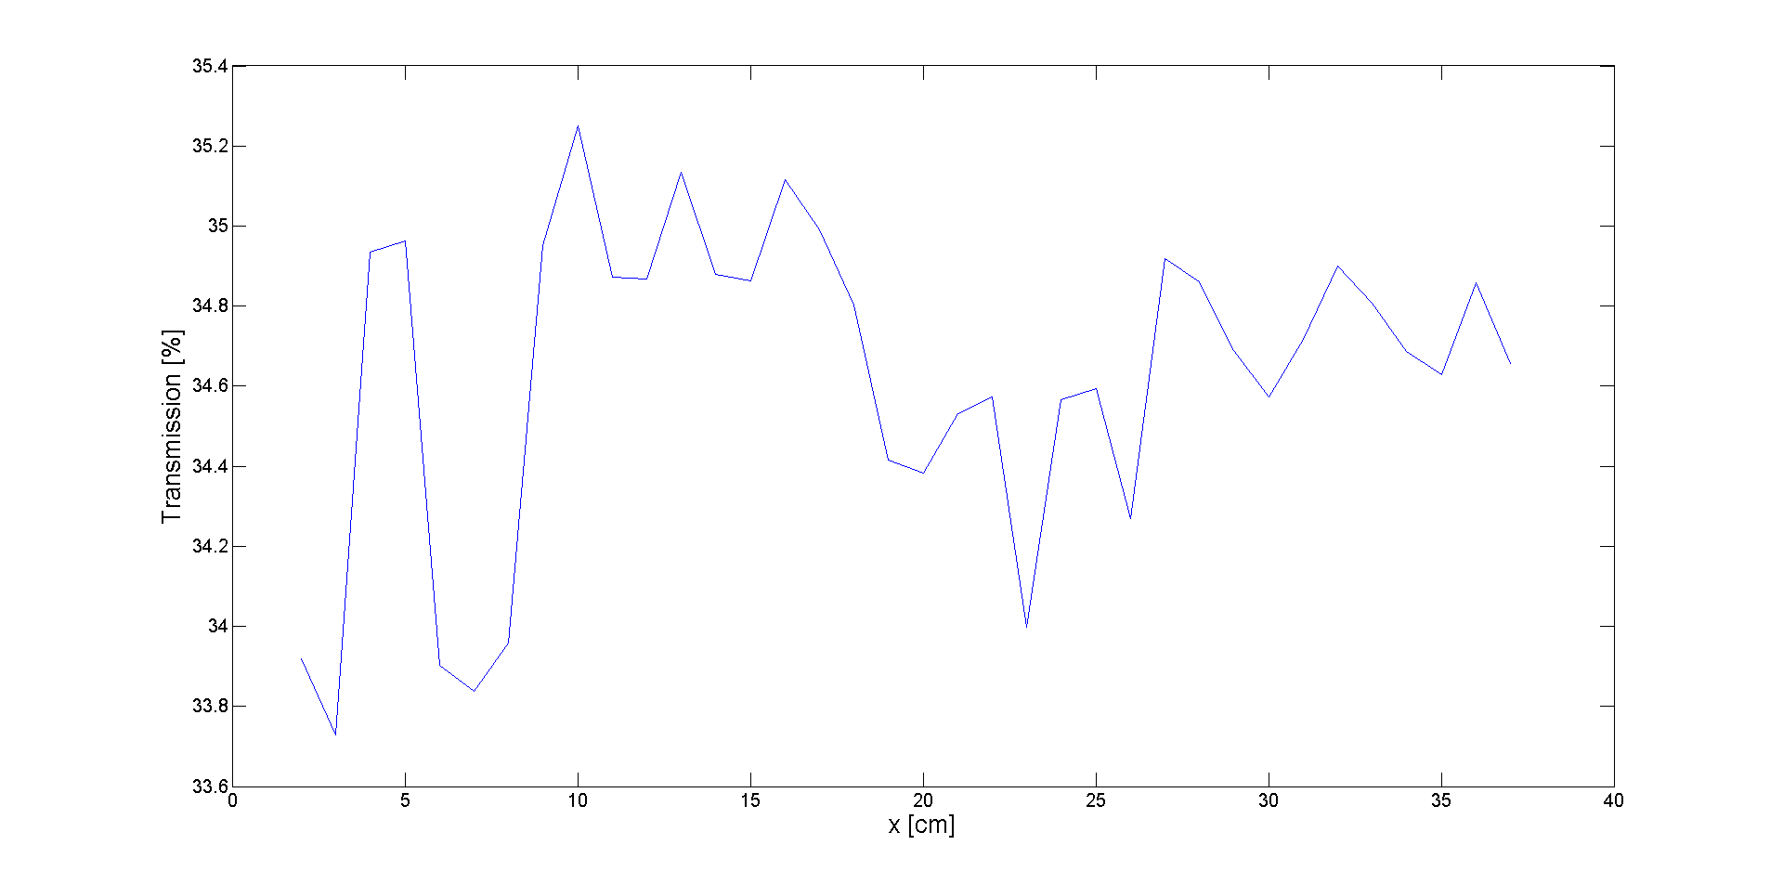
Figure #.#: Average window transmission versus position

#.# Neutral Gas Pressure
The neutral gas pressure was obtained from a hot filament ionization gauge which is located near the pumping system. The voltage output from the ionization gauge controller was acquired by a National Instruments USB-6008 multifunction DAQ. The pressure decade in units of Torr was given by the most significant voltage unit, and the linear scale was given by the lower significant units.
The raw voltage output was recorded, and the conversion to Torr was also performed at the time of measurement and recorded.

#.# Data Acquisition
A Labview vi was written to control and acquire data from the spectrometer, as well as acquire pressure readings from the ionization gauge of the Helimak. The USB-650 spectrometer was controlled through the Ocean Optics Labview interface. The vi also controlled the USB-6008 for pressure measurement.
The vi connected to the MDSPlus database of the Helimak, and used the mdsplus shot event to synchronize data acquisition with the shot. The even was received several seconds before the shot began, which allowed acquisition during the entire shot which lasts approximately 30s. Once it finished acquiring and storing the data, it would wait for user input to start waiting for the next shot.
The vi allowed the user to set multiple integration times for the spectrometer which would be alternated in sequential order during the shot. Delays between integration could also be set. The user could also input information about the location of the lens on the Helimak, as well as additional comments on the setup, which would be stored for each shot.
After each shot the vi would write the data to a data file which had a similar structure the data would have in MDSPlus. The first line of each data segment in the file contained the MDSPlus node name the data should be put into. The second line contained the data type; either numeric=0 or string=1. The third line contained the number of dimensions of the data: either 1D or 2D. If 1D then the fourth line gave the number of lines of data before the next data entry and the fourth line starts listing the data. If 2D then the third line gives the number of lines and the fourth line gives the number of columns.
The vi would also write to a status file which contained a number representing the status of data collection. A 0 in the file meant that collection is waiting for a shot. A -1 in the file means data collection has ended and is not waiting for any more shots. Otherwise the number in the file was equal to the shot number from which new data was collected. A script running in IDL would wait until the status file contained a new shot number, and would load the data from the corresponding data file into MDSPlus. The script would terminate when the status was set to -1.
MDSPlus does has a Labview interface which would have allowed the vi to load the data directly, but the interface was found to give unpredictable results. Also, the data file acted as a human readable backup of the data.
A sample screen-shot of the vi is shone in figure #.#. There are two plots shown on the right of the control panel to summarize the results at the end of each shot. The top plot shows the total number of counts from the spectrometer summed over all wavelengths versus time. The saw-tooth pattern is a result of sequentially longer and shorter integration times. Longer integration have more counts. The start and end of plasma formation can be seen from this plot.
The bottom plot gives the recorded pressure from the ionization gauge during the shot. Some variation of the pressure reading was observed during shots, but it is not known if this is a real pressure change or if the ionization gauge was affected by the Helimak's magnetic field.
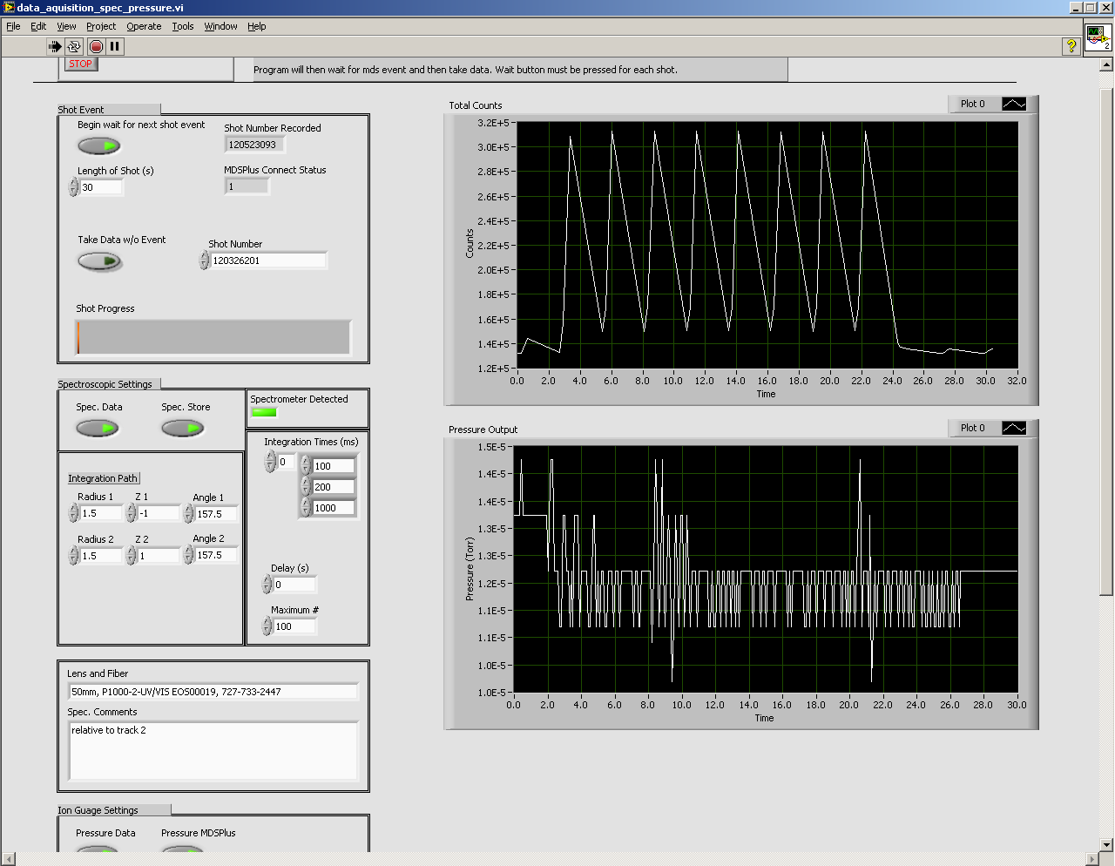
Figure #.#: Screen-shot of acquisition vi

