Chapter #: Electron Velocity Distribution
Electrons in the plasma are created through ionization of neutrals. The energy of the electrons initially comes from RF power heating some electrons which then collide with other electrons heating them up as well and transported through the plasma. The exact electron distribution would have to satisfy the full Boltzmann kinetic equation, which would be non-local and non-isotropic. The goal is to obtain a solution which deviates from Maxwellian due only to inelastic collisions between electrons and neutral atoms which reduce the energy of the incident electrons. These inelastic collisions are caused by excitation and ionization of the neutral atom's electrons, which may effect the rates of those very processes.

#.# Fokker-Planck Scattering
The starting point is the Fokker-Planck Equation, which can be used to describe the behavior of the electron distribution undergoing collisions between electrons which would drive the distribution toward a Maxwellian. The Landau-Boltzmann collision operator is taken from The Framework of Plasma Physics [ref. #] in the case of electron-electron collisions.

(#.#)
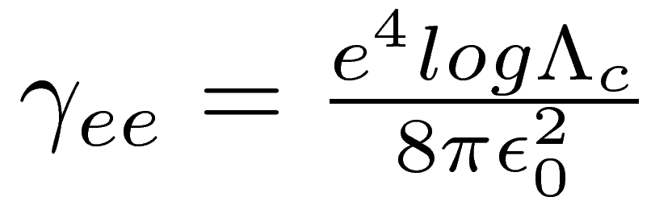
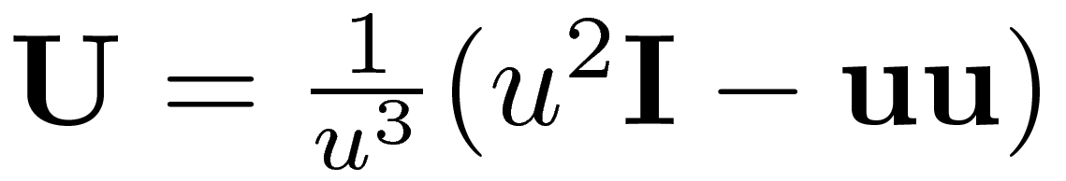
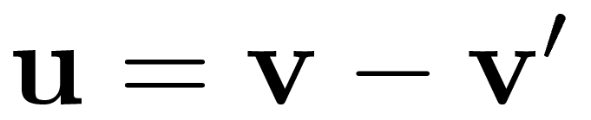
[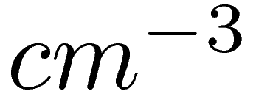],[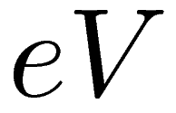] ref. [#]
An isotropic solution is desired which depends only on the magnitude of the velocity. This allows the operator to be written in spherical coordinates where 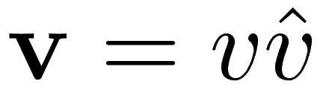, where the direction of importance is 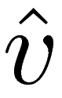.
(#.#)

Two new variables are introduced to simplify the formulae. The angle between the two normal vectors 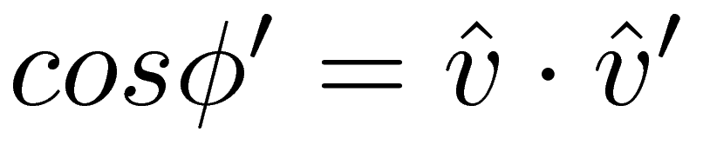, and the ratio of the two velocities 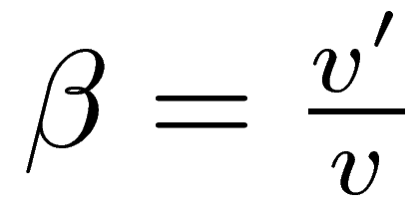. The angular integrals can also be computed now since the distribution does not depend on them.

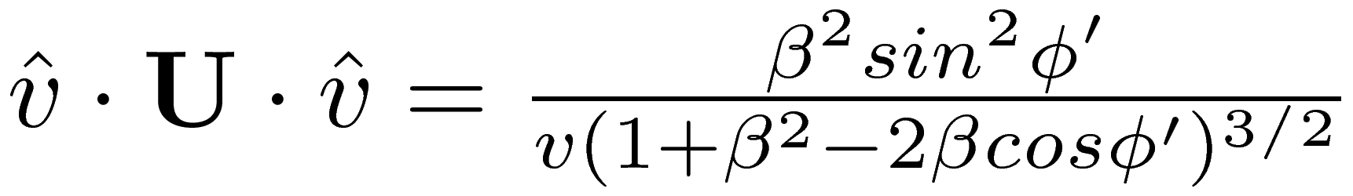 (#.#a)
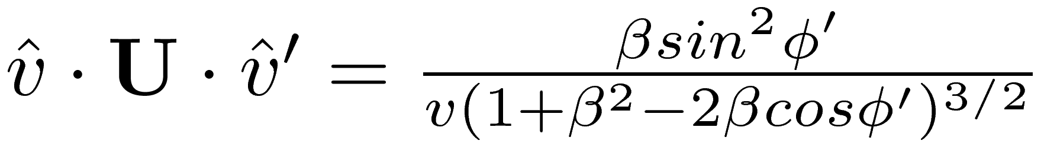 (#.#b)

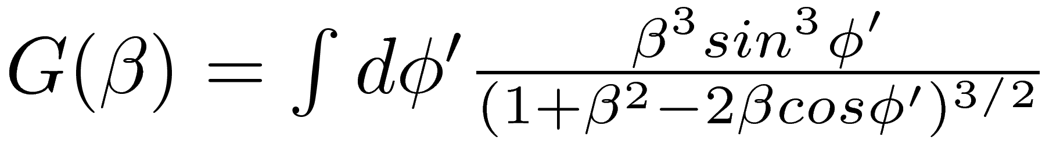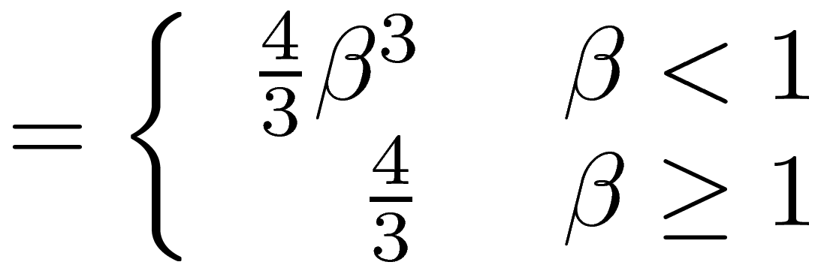 (#.#)

Using this result back in eq. (#.#) gives the electron-electron collision operator for an isotropic distribution.
(#.#)

#.# Inelastic Scattering
To account for inelastic scattering, an inelastic collision operator must be constructed. Two issues arise from this. One is that inelastic collisions do not conserve energy. The other is that if the operator is to include ionization, then the creation of electrons due to that ionization will not conserve particles. This means that with no other affects, there cannot be any equilibrium solution.
The solutions adopted was to add a fictitious velocity diffusion term and a particle loss term. The velocity diffusion term would cause the distribution to increase in average energy, and the magnitude chosen to exactly balance energy lost through inelastic collisions. The result is similar to having a population of electrons at high energy which heat the bulk distribution. The particle loss term was chosen to not depend on electron velocity, and the magnitude to exactly balance total gain from ionization. These added fictitious processes will necessarily undo some of the effects of the inelastic collisions to restore energy and particle balance, but the goal is to determine how the shape of the distribution is affected for a given equilibrium temperature and density.
The excitation collision operator is the simpler of the two, as the energy of the incident electron is reduced by a fixed amount due to an inelastic collision. It consists of a loss term that is proportional to the neutral density, velocity of the electrons, and the collisional cross section at that energy, and a gain term coming from the distribution at energy 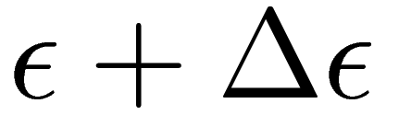. First writing this operator for the distribution in energy, and for a single excitation process that has an energy of 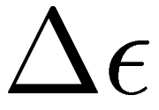, and neutral density 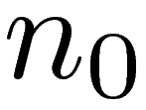.

Converting this operator to velocity space brings in a factor of 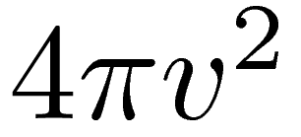 due to the angular integrals of velocity, and also a factor of 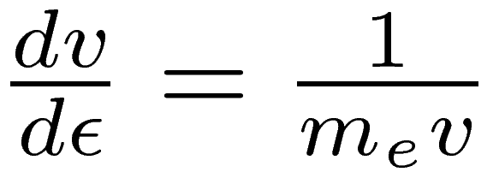 due to the conversion of the distribution to energy from velocity: 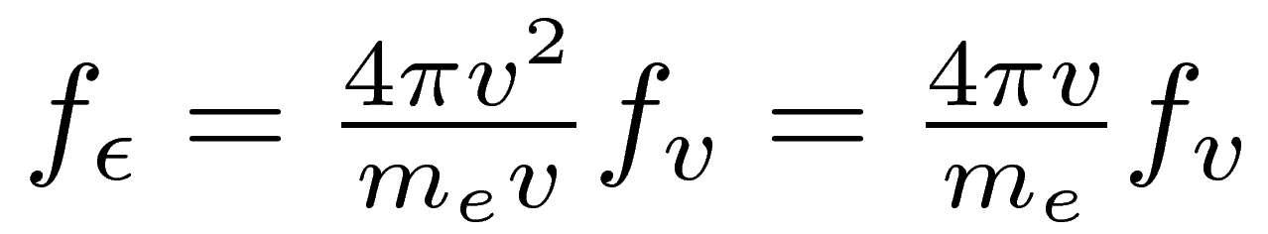.

The ionization operator is a bit trickier because in the absence of a differential cross-section, some assumption must be made about how the incident electron and the ejected electron share the total available kinetic energy: 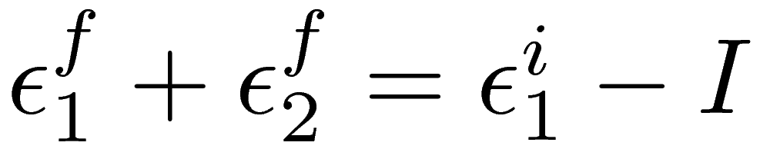, where 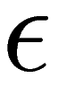 is the kinetic energy of each electron, and I is the ionization energy. Reference [#] discusses the effect of different distributions of energy between the two electrons. For ease of implementation, a symmetric sharing of energy was used, where the incident electron has an equal probability of ending with any energy in the range 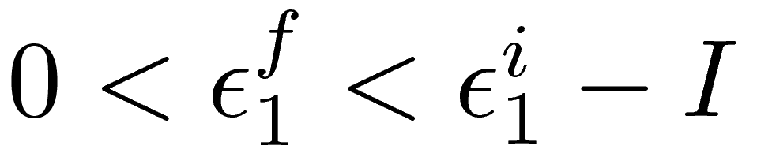, and the ejected electron has the remaining energy 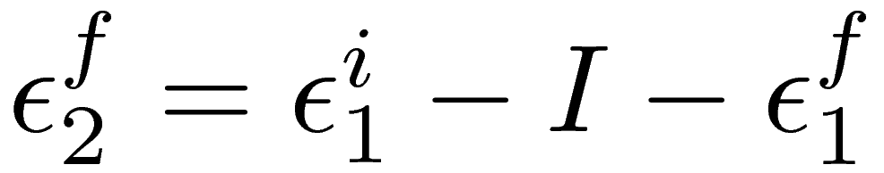.

The loss term is similar to that for excitations. The gain term must be integrated since the electrons from one part of the distribution are scattered into a range of lower energies. The minimum energy that can be scattered into a given energy comes from the above range for the final energy of the incident electron: 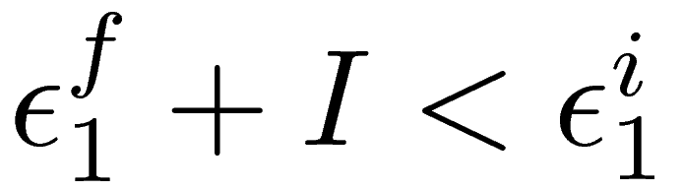. Since each ionization event results in two lower energy electrons, and both have the same distribution in energy, the gain factor is simply multiplied by a factor of two to account for the ejected electrons.

To restore particle balance, a loss term is added and solved such that total particle gain is zero. To restore energy energy balance from losses because of the inelastic collisions, the second moment of the operators is taken to find the average power loss density. The second moment is also taken of a diffusion operator with a variable magnitude. The magnitude is then solved such that the total power loss is zero.

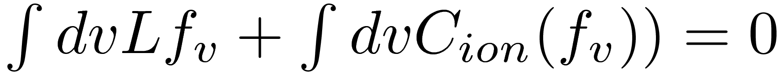 (particle balance)
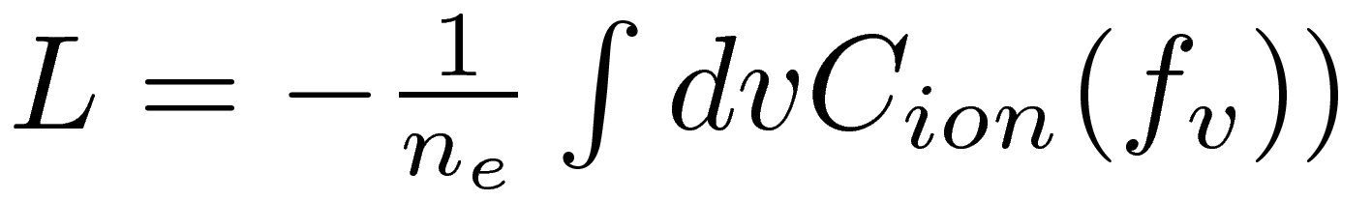 (#.#)

(power balance)
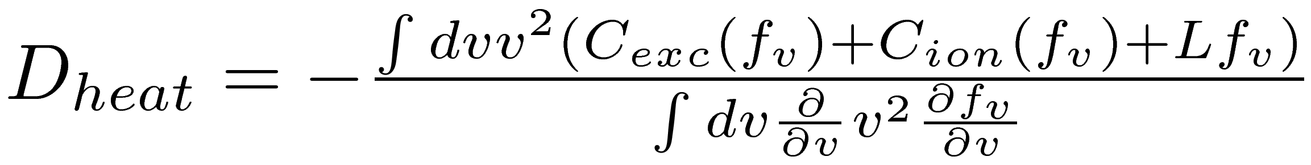 (#.#)

The total effective collision operator can then be written as the sum of the elastic and inelastic operators of the individual processes. An equilibrium is desired, so the effective collision operator should be solved equated to zero.

#.# Numerical Solution
The solution was computed numerically. Velocity was discretized up to a maximum velocity of 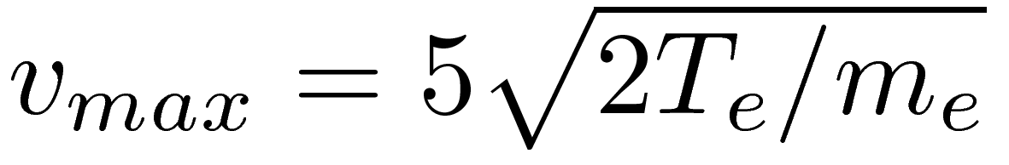, with a velocity resolution of 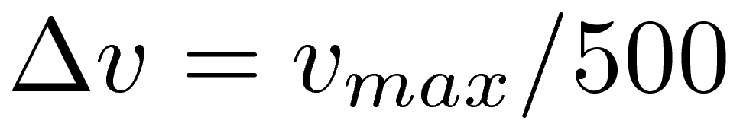. Excitation and ionization rates were pre-computed for Argon using the Bogaerts (ref. [#]) atomic cross-sections. A solution was found by starting with a Maxwellian velocity distribution at the desired temperature. The effective temperature of the distribution was defined from the second moment as 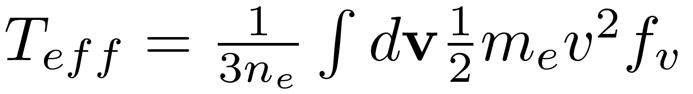 once the distribution began to be integrated.
The distribution was stepped in time in increments of 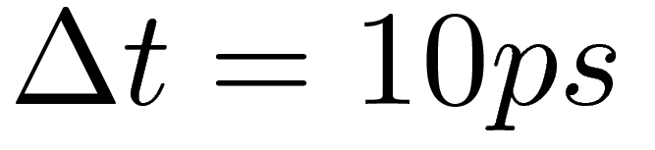 until the average rate of change lowered to a desired value. The average rate was defined as 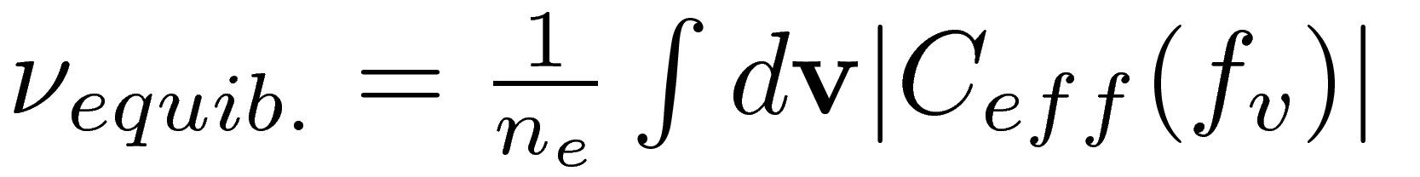, and the target rate of change was chosen to be 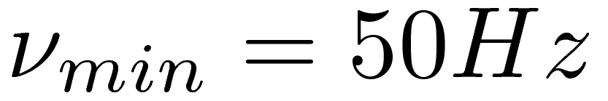, the goal being that the distribution is effectively in equilibrium on a ms time scale, approximately the confinement time of the Helimak.
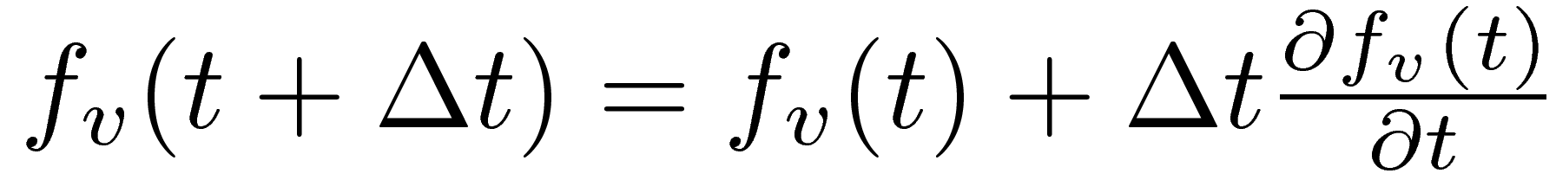
The integrals where computed using the 3-point Simpson's method. First derivatives were computed using a 4-point method, and second derivatives were computed using a 5-point method. The first and last points where handled by altering the discrete derivative.
Integral:
(if 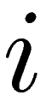 is even)
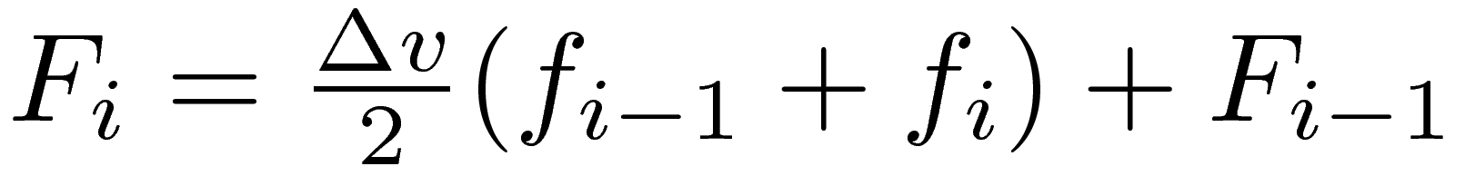 (if is odd)
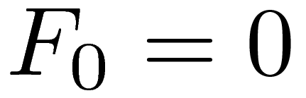
First Derivative:
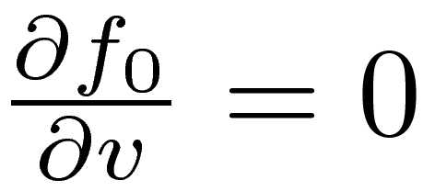
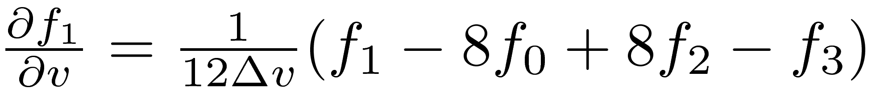
Second Derivative:
And example solution is plotted in Figures #.#-#.# at the Helimak's nominal electron temperature and density. The neutral density of the example is much higher than is encountered in the Helimak, but shows the extent of the expected non-maxwellian effect.
There are several features of the solution that are noted. There is an increase in distribution near v=0 of figure #.#, due to electrons losing energy and falling into this energy region, as well as electrons being produced through ionization with small initial energy. When plotted on a log scale in figure #.#, an increase in the the extreme tail of the distribution can be seen due to the artificial heating.
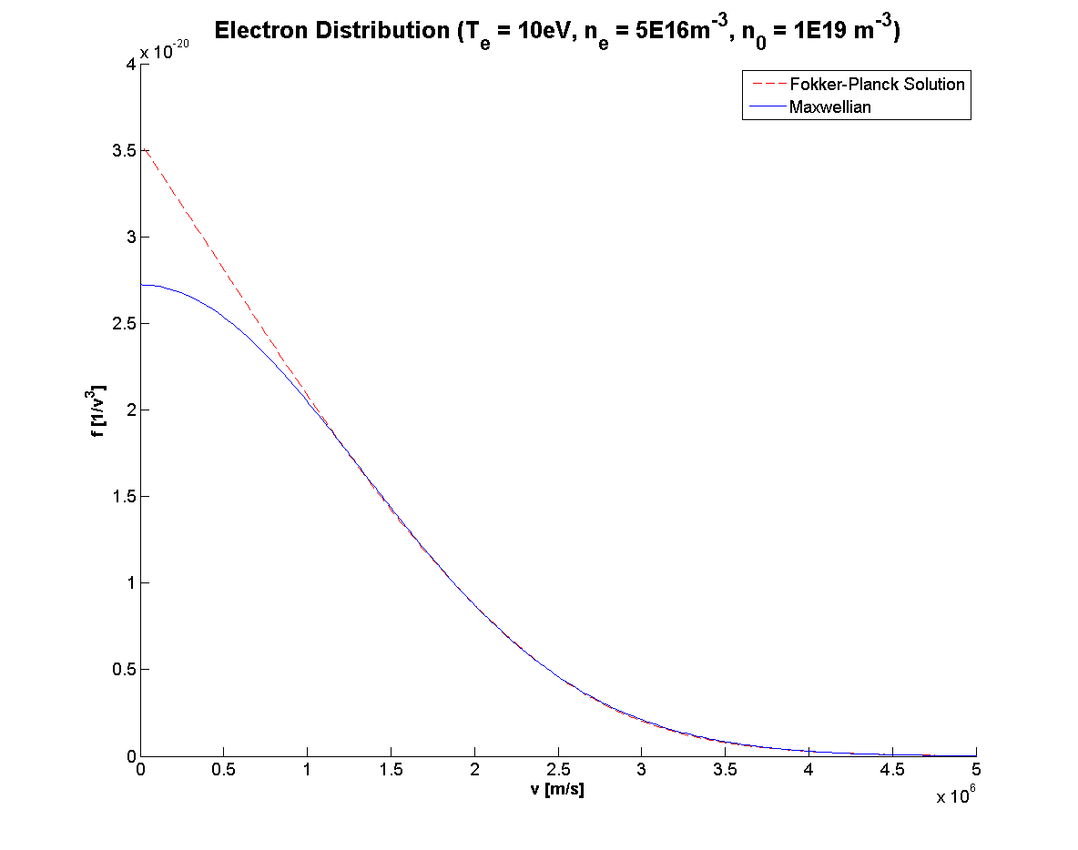
Fig. #.#
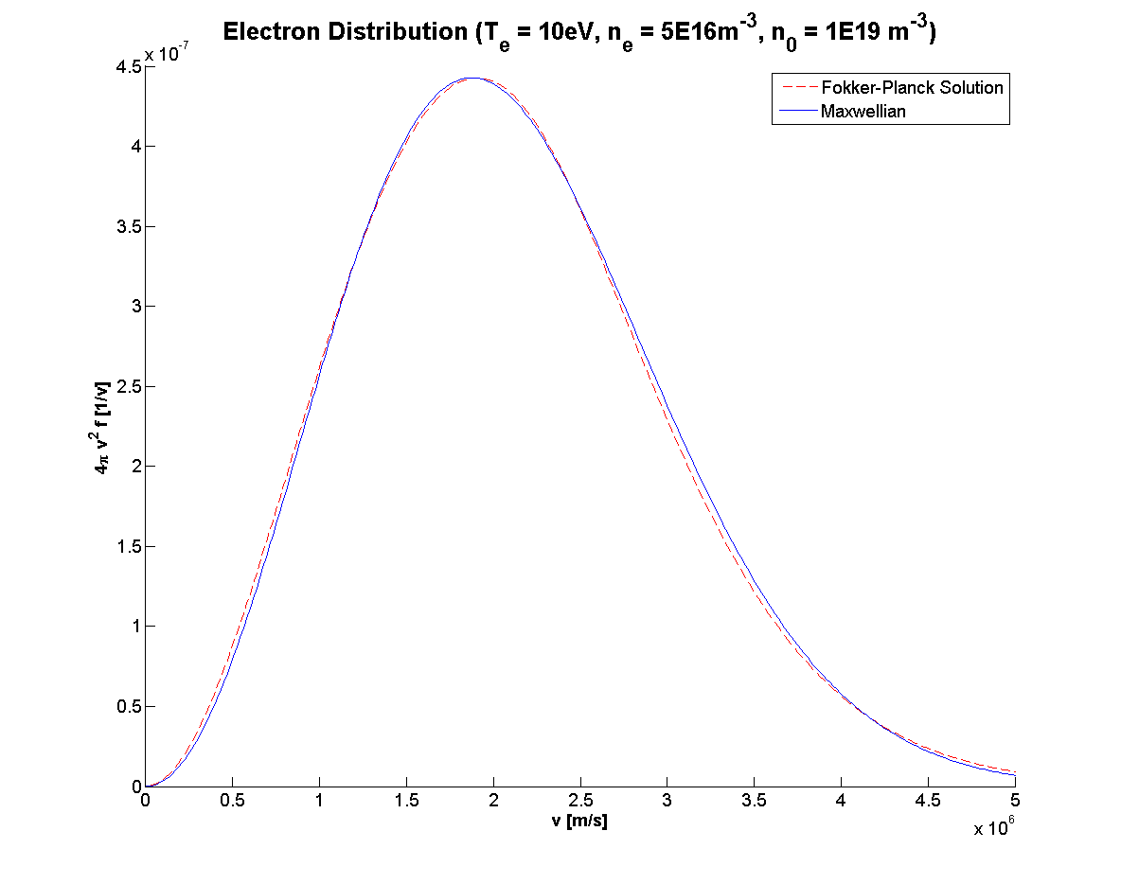
Fig. #.#
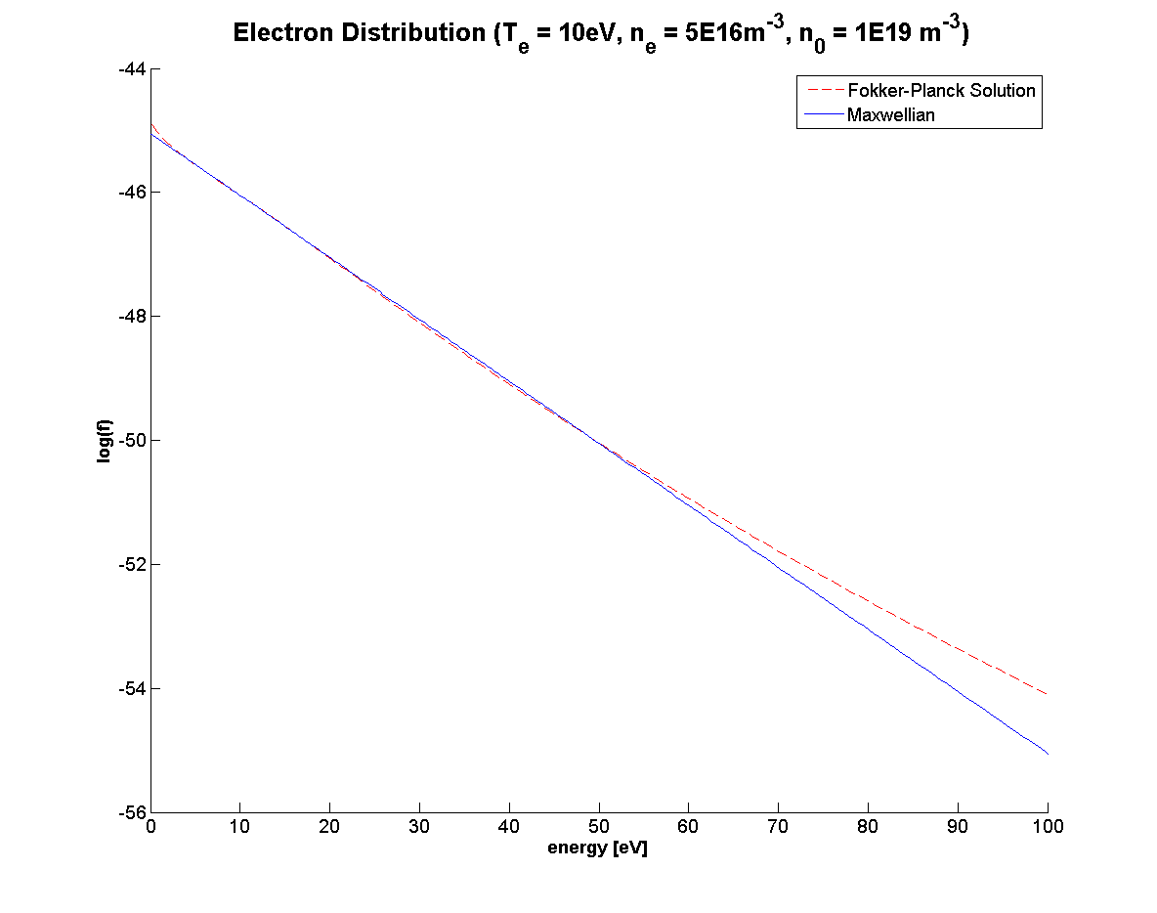

#.# Non-Maxwellian Correction
Existing atomic rate data are calculated using a Maxwellian distribution. It is desired to use the existing data without going back to the source and recalculating them for every distribution. The solution used was to define a correction factor in equation #.# by comparing the portion of the distribution above the threshold energy of the atomic transition to the same energy range of the non-maxwellian case. That is, if there are fewer total electrons above the threshold energy, then the rate would be proportionally lower than the Maxwellian case.
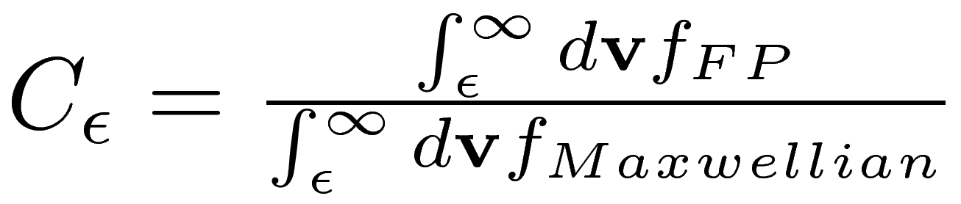 (#.#)
Correction factors were computed for three threshold energies corresponding to the excitation energy to the parent levels of observed lines of neutral and singly ionized Argon, as well as the ionization energy of neutral Argon: 11.5 eV, 19.2 eV, and 15.76 eV respectively.
It was found that for low electron temperatures < 5eV there was little deviation in the tail of the solution. It is believed this is due to the artificial heating mechanism which works to extend out the tail of the distribution, which seems to exactly counteract the effect of inelastic collisions which would only affect the tail of these low temperature distributions.

Table #.#: Argon I Excitation Rate Corrections (>11.5eV)
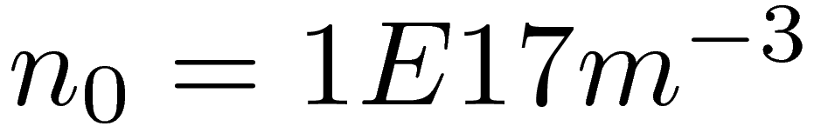
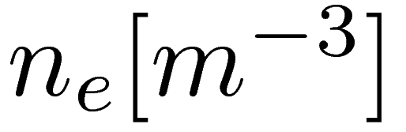  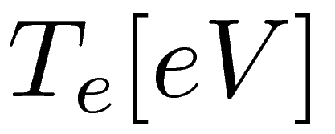 | 1E16 | 2E16 | 5E16 | 1E17 | 2E17 | 5E17 | 1E18 | 2E18
10 | 0.99 | 0.99 | 1 | 1 | 1 | 1 | 1 | 1
20 | 0.95 | 0.96 | 0.97 | 0.98 | 0.99 | 0.99 | 1 | 1
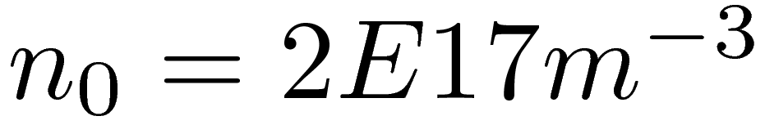
10 | 0.99 | 0.99 | 0.99 | 1 | 1 | 1 | 1 | 1
20 | 0.95 | 0.95 | 0.96 | 0.97 | 0.98 | 0.99 | 0.99 | 1
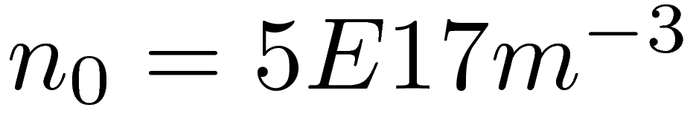
10 | 0.99 | 0.99 | 0.99 | 0.99 | 0.99 | 1 | 1 | 1
20 | 0.94 | 0.95 | 0.95 | 0.96 | 0.96 | 0.98 | 0.98 | 0.99
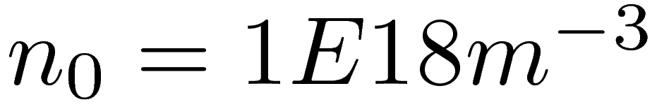
10 | 0.99 | 0.99 | 0.99 | 0.99 | 0.99 | 0.99 | 1 | 1
20 | 0.94 | 0.94 | 0.95 | 0.95 | 0.96 | 0.97 | 0.98 | 0.98

Table #.#: Argon II Excitation Rate Corrections (>19.2eV)
 | 1E16 | 2E16 | 5E16 | 1E17 | 2E17 | 5E17 | 1E18 | 2E18
5 | 0.96 | 0.98 | 0.99 | 1 | 1 | 1 | 1 | 1
10 | 0.99 | 0.99 | 0.99 | 1 | 1 | 1 | 1 | 1
20 | 0.93 | 0.94 | 0.95 | 0.96 | 0.98 | 0.99 | 0.99 | 1
5 | 0.93 | 0.96 | 0.98 | 0.99 | 0.99 | 1 | 1 | 1
10 | 0.98 | 0.99 | 0.99 | 0.99 | 1 | 1 | 1 | 1
20 | 0.92 | 0.93 | 0.94 | 0.95 | 0.96 | 0.98 | 0.99 | 0.99
5 | 0.86 | 0.91 | 0.95 | 0.97 | 0.99 | 0.99 | 1 | 1
10 | 0.98 | 0.98 | 0.98 | 0.99 | 0.99 | 1 | 1 | 1
20 | 0.92 | 0.92 | 0.93 | 0.93 | 0.95 | 0.96 | 0.98 | 0.99
5 | 0.8 | 0.86 | 0.92 | 0.95 | 0.97 | 0.99 | 0.99 | 1
10 | 0.98 | 0.98 | 0.98 | 0.98 | 0.99 | 0.99 | 1 | 1
20 | 0.92 | 0.92 | 0.92 | 0.93 | 0.93 | 0.95 | 0.96 | 0.97

Table #.#: Argon I Ionization Rate Corrections (>15.8eV)
 | 1E16 | 2E16 | 5E16 | 1E17 | 2E17 | 5E17 | 1E18 | 2E18
5 | 0.98 | 0.99 | 1 | 1 | 1 | 1 | 1 | 1
10 | 0.99 | 0.99 | 0.99 | 1 | 1 | 1 | 1 | 1
20 | 0.94 | 0.94 | 0.96 | 0.97 | 0.98 | 0.99 | 0.99 | 1
5 | 0.97 | 0.98 | 0.99 | 1 | 1 | 1 | 1 | 1
10 | 0.99 | 0.99 | 0.99 | 0.99 | 1 | 1 | 1 | 1
20 | 0.93 | 0.94 | 0.95 | 0.96 | 0.97 | 0.98 | 0.99 | 0.99
5 | 0.95 | 0.97 | 0.98 | 0.99 | 1 | 1 | 1 | 1
10 | 0.98 | 0.98 | 0.99 | 0.99 | 0.99 | 1 | 1 | 1
20 | 0.93 | 0.93 | 0.94 | 0.94 | 0.95 | 0.97 | 0.98 | 0.99
5 | 0.92 | 0.94 | 0.97 | 0.98 | 0.99 | 1 | 1 | 1
10 | 0.98 | 0.98 | 0.98 | 0.99 | 0.99 | 0.99 | 1 | 1
20 | 0.93 | 0.93 | 0.93 | 0.93 | 0.94 | 0.95 | 0.97 | 0.98

