Chapter #: Modeling Atomic Populations
Models are employed to relate spectral emission measurements to the properties of the plasma being observed. This chapter will give an overview of the types of models which could be used, which leads to the motivation for the model under evaluation.

#.# Atomic Processes
An atom in one state can transition to another state by interacting with something. These interactions are divided into two broad categories: collisional, and radiative. Radiative transitions are interactions with the electromagnetic field such that a photon is produced or absorbed to account for the change in energy between the two states. Collisional transitions account for the change in energy by other particles (electrons or atoms) gaining or losing energy.
An example of a radiative process is spontaneous emission. The rate of this transition is contained in the Einstein coefficient 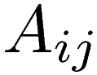 between states i and j, which has units of inverse time. There cannot be a spontaneous transition upward in energy since this would require emitting a photon of negative energy. For simplicity of notation here, upward transitions have 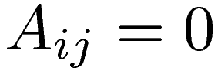, as well as 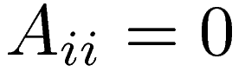.
An example of a collisional process is electron-impact excitation and de-excitation. The likelihood of an electron passing near the atom inducing a transition to another level is contained in a cross section 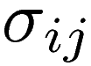, which has units of area, and depends on the relative velocity between the electron and atom. To calculate the total rate, the cross-section must be averaged over the distribution of relative velocities and multiplied by the electron density 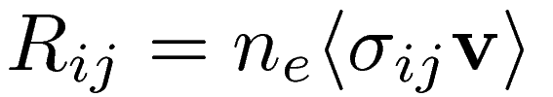. Also for convenience here 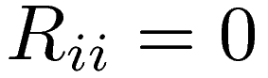.
If collisional transitions from the ground state to the ith state are now combined with spontaneous emissions, this gives a rate equation for the density of atoms in the ith state.
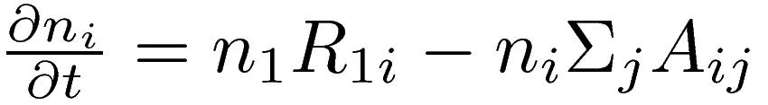 (#.#)
This is called coronal equilibrium. This is valid when radiative processes happen much faster than collisional ones for the level of interest, which occurs when the electron density is sufficiently low. As the electron density increases, collisional transitions between levels may not be neglected. This can be accounted for by simply including all the other levels.
(#.#)
This constitutes a collisional-radiative model. Other processes can also be included, such as ionization and recombination, but they all take a similar form with separate rate coefficients.
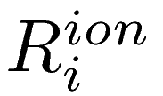 = ionization rate from level i
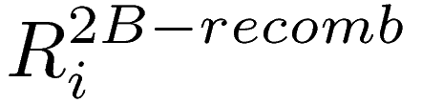 = 2-body recombination from ion (radiative recombination)
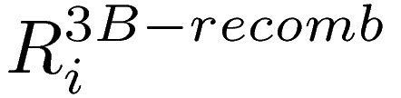 = 3-body recombination from ion
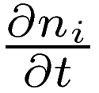 can be split into a “gain” term that depends on all other levels plus the environment and a “loss” term which depends only on the ith level plus environment.
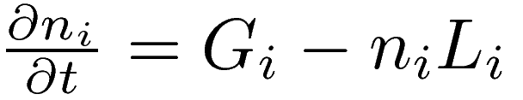
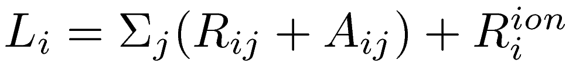

#.# Kinetic Theory
The previous discussion is fine for a system that does not depend on position, or depends on position only weakly. However, the effect of spatial variations will now be considered. The atoms being observed are typically part of a low density gas. If the atoms are ionized they will feel forces from macroscopic electric and magnetic fields as well as collision forces. For neutral atoms, only collisions affect their motion. At the most detailed level the evolution of a gas can be described by the Boltzmann equation.
(#.#)
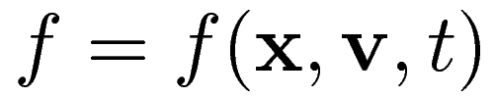, 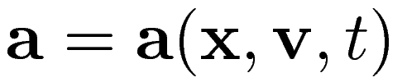
This requires information of not only the density of the gas at every location in space, but also its distribution in velocities. For a neutral gas, and neglecting the force of gravity, the acceleration term will go to zero.
This says nothing of the atomic processes which are of interest. The extension is to describe each atomic level as a gas with its own evolution. Transitions between levels, as well as ionization and recombination, are included into a source term 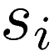. An index is also added to signify that each level has it's own evolution.
(#.#)
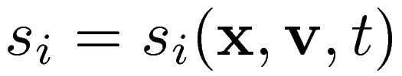
To see how relates to the atomic processes already discussed, the first moment of this equation will be taken.
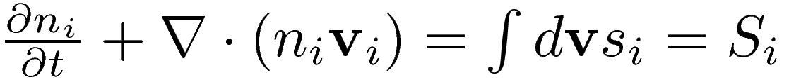 (#.#)
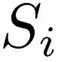, the first moment of , provides the link since 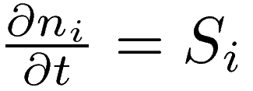 in the absence of spatial variations. The only detail is how to go backward to with rate terms 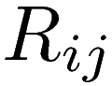, , etc.. . These rates are an integral over both atomic velocities and electron velocities. This gives rise to a velocity dependent electron-impact excitation rate as seen in eq. #.#.
(#.#)
where 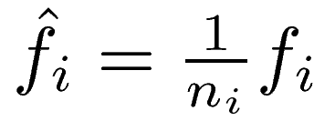
This means that 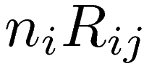 is the first moment of 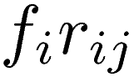. So, can be written vary similarly to by replacing all the 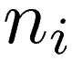 with 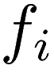, with 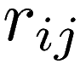, etc. with the understanding that they are functions in velocity space.
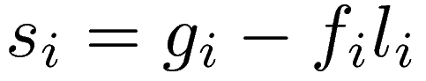
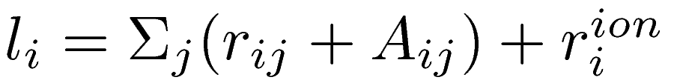

#.# Solution for Helimak
For the purpose of the Helimak, the atomic collision term will be neglected. The neutral collsion mean free path as defined by 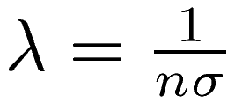, with 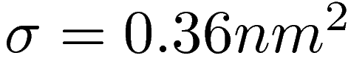 for Argon [ref. ??], is up to 10m, which is larger than the dimension of the Helimak chamber. Also, a solution of equilibrium is being sought, which reduces the equations to be solve to #.#
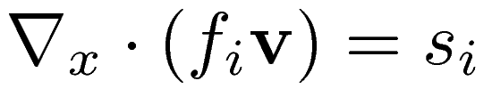 #.#
For a single direction and speed, eq. #.# can be re-arranged such that can be directly integrated from the boundary (x=0) along a chosen direction as in eq. #.#.
#.#
Once 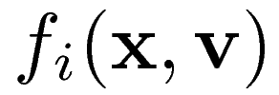 is calculated, the first two moments give the total population densities and velocities.
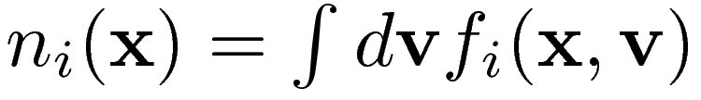
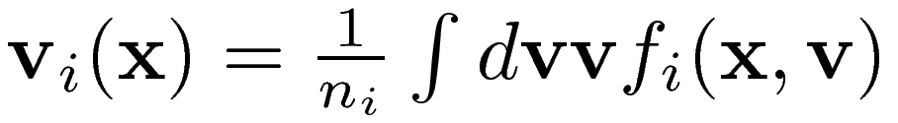
For the Helimak, the solution should possess axial symmetry, which reduces the spatial dimension of the problem by one, and a reflection symmetry in the vertical direction. The distribution in velocity space should also have reflection symmetry in the azimuthal direction. The velocity determines the path taken, and whether the path comes from the inner wall, outer wall, ceiling, or floor of the Helimak. The path is parameterized such that the distance to the Helimak axis is given by. 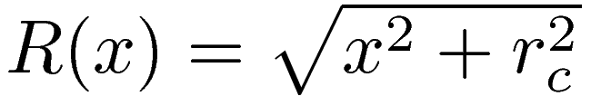. The cases of intersection to the outer and inner walls are illustrated in figures #.# and #.#.
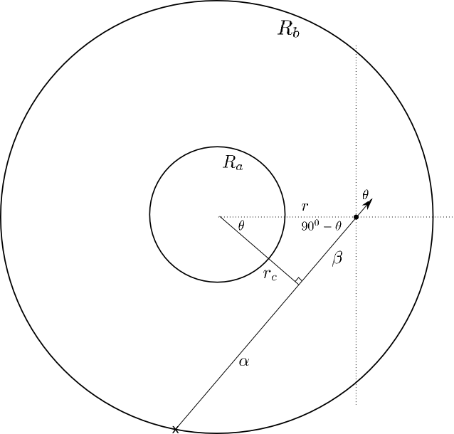 | 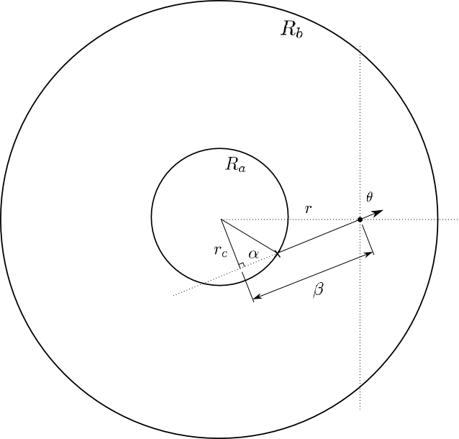

The distance of closest approach is 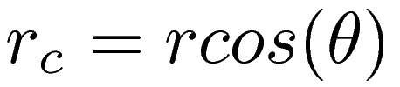, and the parameter 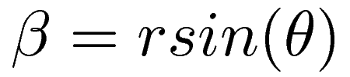. For intersection with the outer wall, the parameter 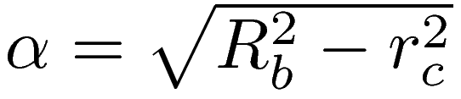, 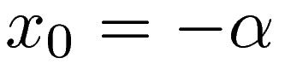, and the total distance is . 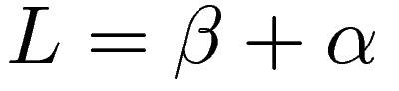. For intersection with the inner wall the parameter 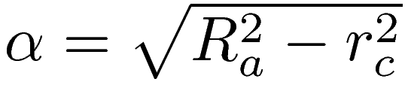, 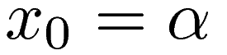, and the total distance to the wall is 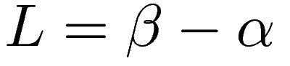. Intersection with the floor is determined by comparing 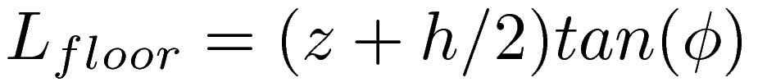 for 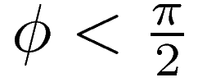, or 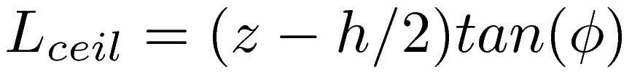 for 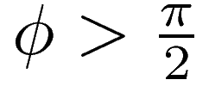, to L. If 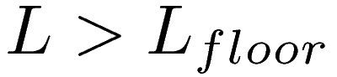, then the path intersects the floor and the new starting position is 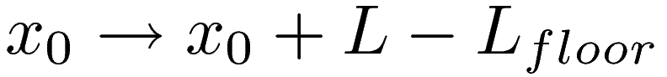.
The path integral from the wall is computed using an implicit stepping method. Since 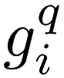, where q is the step and i is the level number, depends on all the other 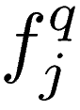, a self-consistent solution is found at each step by iteration. In the parameterized path, 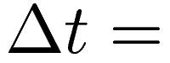.
The integral over velocity space is then approximated by a weighted sum of the discrete solutions, and where the weights are determined by the desired boundary conditions at the wall. An isotropic Maxwellian distribution with a temperature of 300K was used, and all walls had equal weight. Because there is significant ionization which is magnetically confined, the exact boundary conditions should in reality depend on the transport of the ions out to the walls where they recombine. Instead it assumes the ions behave the same as neutrals between the ionization and recombination events. Since this ignores any confinement of ions. it is thought that the boundary conditions used will produce an overestimate of the ground state population.
Using the atomic data from Bogaerts ArI CR model, the result is virtually the same values of 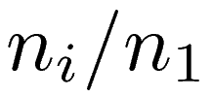. The only levels which differed were the two metastable levels of the model. However, those levels could not be measured directly, and their deviation from the static model did not appear to alter the other levels. This result is reasonable considering the level lifetimes as seen in figure #.#.
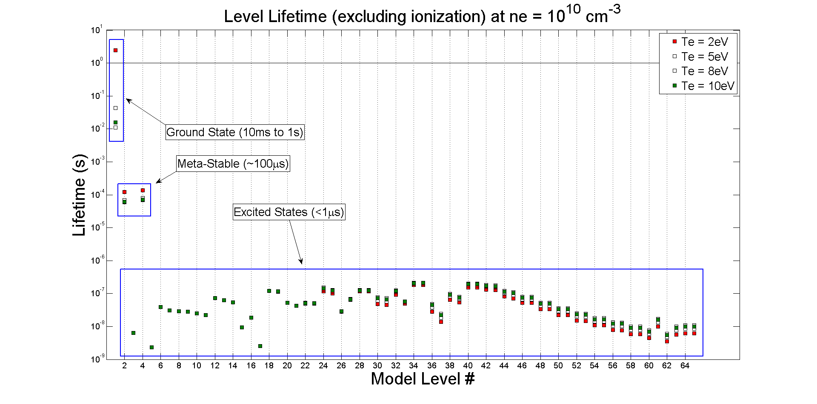
Because the non-metastable level lifetimes are short compared to the transit time of the atoms (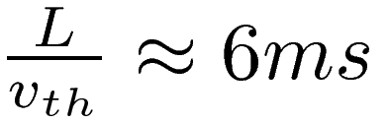), they should be in near equilibrium and should have the same as computed for a local equilibrium. The only extra information the non-local model gives for those levels comes from the velocity distribution. The average velocity of each level can be computed from the first order moment of the distribution.
For this experiment the important information from the non-local model is contained only in the density of the ground state 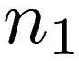. Variation of would be the result only of ionization. Reducing the model to ground state ionization simplifies the integration since the problem is takes the form 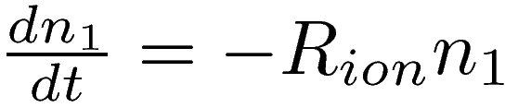, which can be solved as 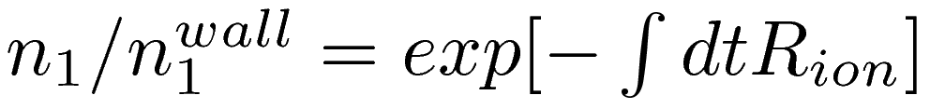 for each velocity path. 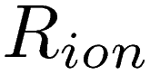 is a function of radius, but can be expressed as a function of time because position can be expressed as a function of time given the trajectory. The solution gave a nearly identical result for the ground state density as the full model.

