Chapter #: Neutral Density Profile

In order to better analyze the excited states of neutral Argon, the ground state density needs to be estimated. With no plasma it can be assumed that the neutral density would be uniform throughout the vacuum chamber. If it is not uniform, then any calculation depending on the neutral density could be affected.

#.1 Ionization
From Fig. #.#, the ionization rate for neutral Argon at 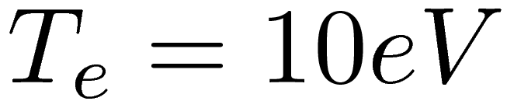 and 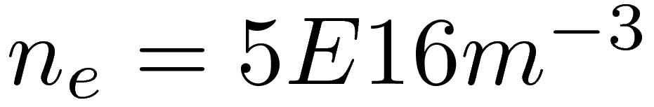 is about 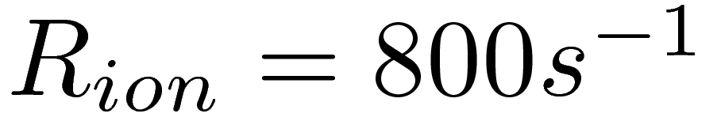. Using 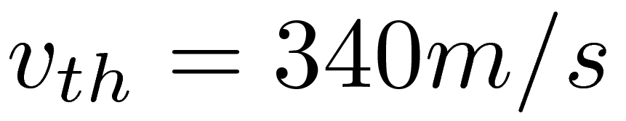 (T=300K), which gives a mean free path of an atom before being ionized of 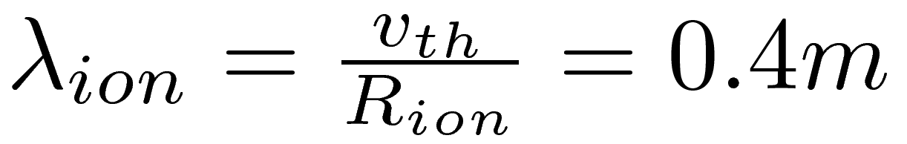. The Helimak's scale is of 1m, which implies that a significant fraction of the neutral atoms could be ionized while traversing the Helimak chamber.
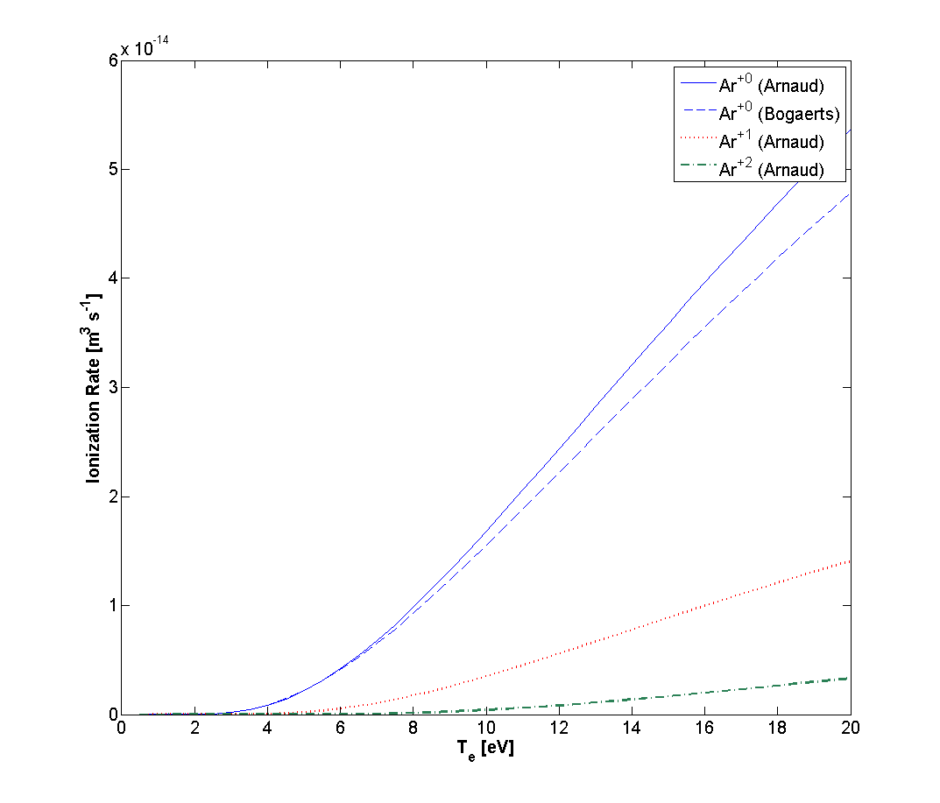
Figure #.#: Ionization Rate versus Te

The ionization rate would be a peaked profile since the electron density and temperature also have peaked profiles. Also, since the neutral atoms should be close to thermal distribution the mean free path would depend on exactly what velocity each atom is traveling. To find the actual profile of the neutral density, the non-local and thermal effects should be included.

#.2 Kinetic Model

A kinetic model is used to solve for the neutral density. Even though this approach is computationally intensive, it is straightforward. The evolution of the gas can be described by the Boltzmann equation, which models the distribution of particles in velocity and spatial dimensions. For three spatial dimensions, the distribution function has six dimensions plus time.
, (#.#)
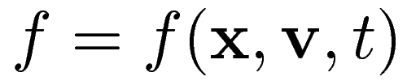, 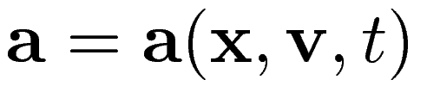, 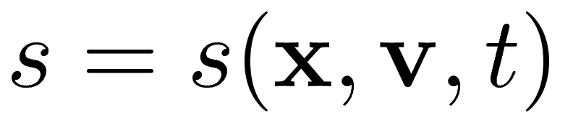
The first term on the left hand side is simply the time rate of change of the distribution at a particular velocity, position, and time. The second term the divergence of a flow of particles through space. The third term includes the acceleration due to external forces, and is in effect a divergence of a flow of particles through velocity. The first term on the right hand side is the collision term, including the effects of collisions between particles in the distribution as well as other species of particles. This term can be complex and would in reality be a functional of the distribution itself. The second term on the right is a source and sink term, which adds or removes particles from the distribution, such as through ionization.
A neutral gas does not produce nor interact with electromagnetic fields. The interaction with the gravitational force can also be neglected since the available gravitational potential energy of atoms is orders of magnitude lower than the average kinetic energy: 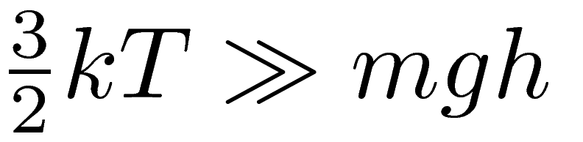. This allows the dropping of the external forces altogether. The neutral-neutral collisional mean free path as defined by 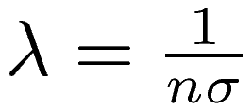, with 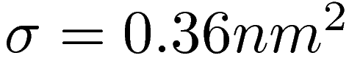 for Argon [ref. ??], is up to 10m, which is larger than the dimension of the Helimak chamber, which is used to justify neglecting the collision term.
For an equilibrium solution, this leaves only the spatial divergence term on the left and the source/sink term on the right.
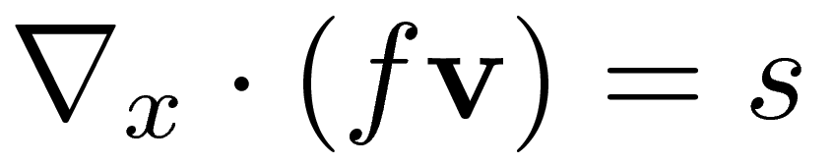, (#.#)
For a single direction and speed, eq. #.# can be arranged such that 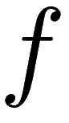 can be directly integrated from the boundary (x=0) along the chosen direction.
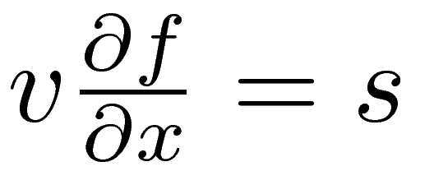
, (#.#)
The source term of interest will consist only of ionization: 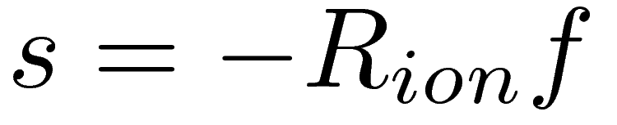. The Helimak has axially symmetric profiles for electron temperature and density, and so the ionization rate only depends on the radial position. Recombination is neglected along the path from the wall since the recombination rate is much slower than the ionization rate. This allows the above integral to be written in terms of the integral of the ionization rate only.
, (#.#)
The remaining problem is to determine the appropriate boundary conditions. Ignoring sources, the value of the distribution must be self consistent which means the distribution for velocities heading “out” are solutions to the above equation. The only values which are not directly part of the solution are the distribution at velocities heading back “in”. If particles are conserved, then the average velocity normal to the wall must be zero. One solution would be to reflect the distribution along the direction of the wall normal, which would be the result if the particles bounced off the wall as if it were a perfectly smooth surface.
Instead, the incoming particles were “re-thermalized” to a Maxwellian distribution set to T=300K. To ensure that the average normal velocity is zero, the incoming distribution had a magnitude determined by the average flow of particles into the wall in eq. #.#, where 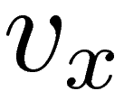 is the velocity normal to the wall, 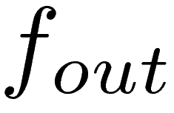 is the solution at the wall for outgoing velocities, and 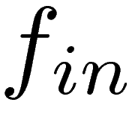 is a Maxwellian distribution for incoming velocities.
, (#.#)
The source of neutral particles is ultimately from recombination of ions at the wall, and the solution will depend on the magnitude and profile for recombination around the entire wall surface of the Helimak. The dominant ion loss is assumed to be parallel to the magnetic field lines, which terminate at the top and bottom of the chamber. The would imply that recombination would occur primarily at the top and bottom surfaces. Also, it is assumed that the electron temperature and density are peaked in the center of the chamber, which would imply that losses, and thus recombination, are also peaked in the center. The source term was set to zero on the outer and inner wall, while the top and bottom were set to a half-period sine shape (eq. #.#) to capture a peaked nature to the source with a Maxwellian distribution at T=300K.
, (#.#)
The full distribution can be solved in principle by performing the integral #.# at each velocity and position since set of six coordinates have straight trajectories. Once 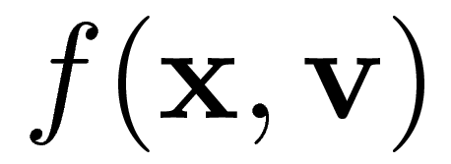 is calculated, the first two moments give the total population density and average flow.
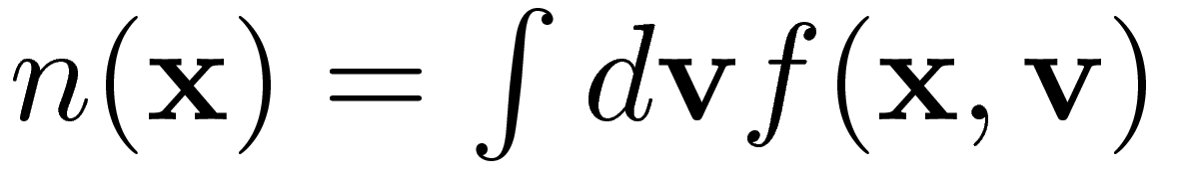, (#.#)
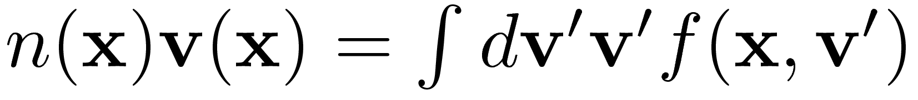, (#.#)
Since the Helimak is axially symmetric, the solution should also possess axial symmetry. This reduces the spatial dimension of the problem by one. The solution should also have reflection symmetry in the vertical direction for the same reason. The distribution in velocity space should also have reflection symmetry in the azimuthal direction since the Helimak also has reflection symmetry perpendicular to the axis and should have zero average azimuthal velocity.
Each combination of position and velocity of the distribution determines a path taken through the Helimak chamber. The paths begin at a boundary which can come from the inner wall, outer wall, ceiling, or floor of the Helimak. The path is parametrized such that the distance to the Helimak axis is given by 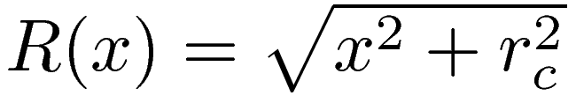. The cases of intersection to the outer and inner walls are illustrated in figures #.1a-b.
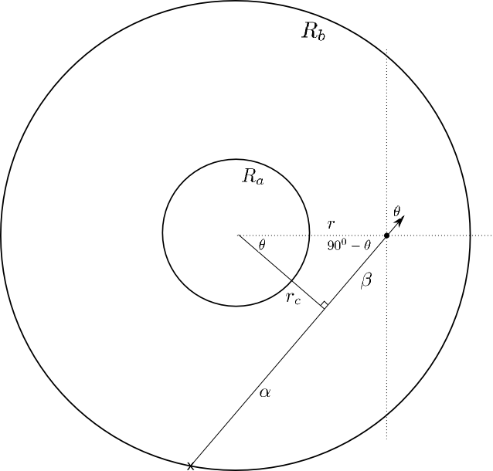  Figure #.1a: Intersect Outer Wall | 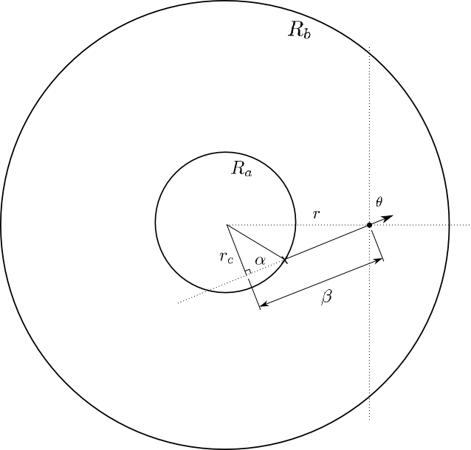  Figure #.1b: Intersect Inner Wall

The distance of closest approach to the axis is 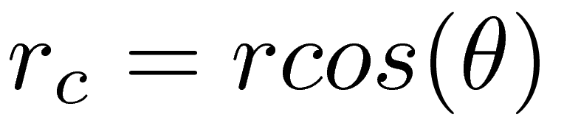, and the parameter 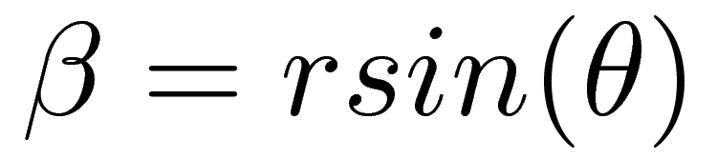 is the distance along the path from the point of closest approach to the position being calculated. The parameter 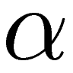 is the distance along the path from the point of closest approach to the wall. For intersection with the outer wall, the parameter 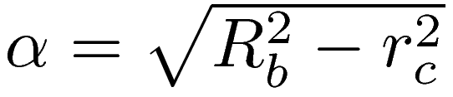, 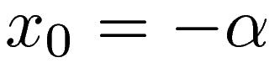, and the total distance is 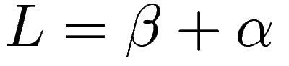. For intersection with the inner wall the parameter 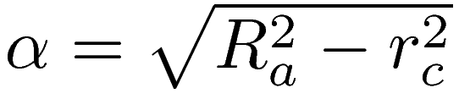, 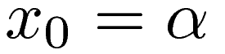, and the total distance to the wall is 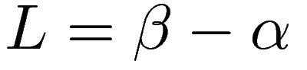. Intersection with the floor is determined by comparing 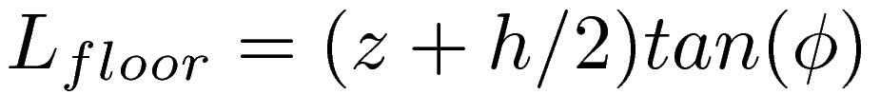 for 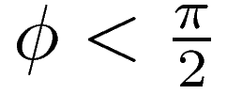, or 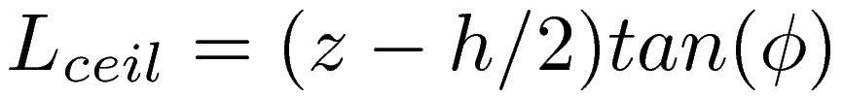 for 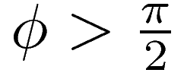, to L. If 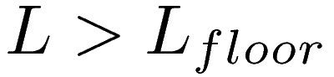, then the path intersects the floor and the new starting position is 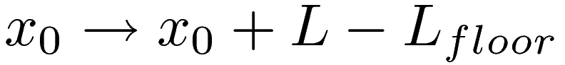.

#.2 Numerical Solution of Kinetic Model
The three velocity dimensions were discretized into 100 regular intervals out to a velocity of 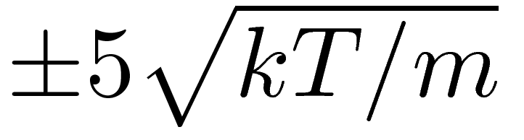 on each axis. The spatial dimensions where discretized in to 100 regular intervals in the radial direction and 90 in the z-direction, including on the wall. The integral over velocity space was approximated by the rectangle rule.
, (#.#)
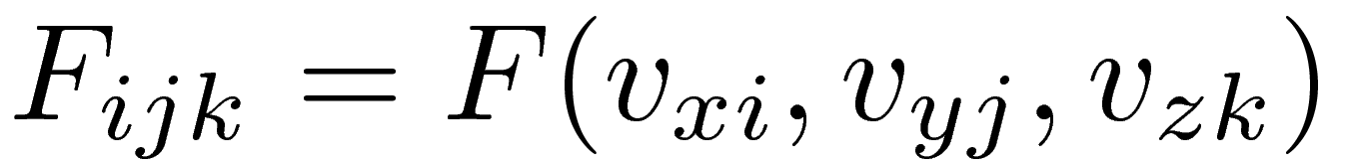
Each trajectory traced back to an intersection point on the wall. The value of the solution at the wall is also discrete, so linear interpolation was used for intersections between points.
The solution along the walls had to be calculated first since it has to be solved self-consistently. For N discrete points on the walls, an NxN matrix M was build where the ij element of the matrix held the contribution from jth point on the wall to the zeroth moment of the ith point on the wall. A similar NxN matrix P contained the contributions to the normal component of the first moment of the distribution (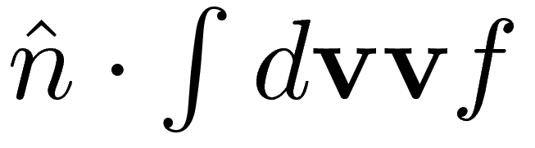) at ith each point from every other jth point.
The zeroth moment of the outgoing part of the distribution at each point is u=M(w+s), where w is the incoming part of the distribution at every other point on the wall, and s is the source on the wall. w is found to solve Pu + cw = 0 to satisfy the condition that the normal component of the average velocity at the wall is zero, where c is the multiplier for a Maxwellian incoming distribution. Conceptually this can be solved by solving (PM+cI)w=-PMs. This was implemented by solving for w by iteration from an initial guess for w.

