## Chapter 4: Using Argon Models to find ne and Te

Models can be employed to relate spectral emission measurements to the properties of the plasma being observed. A method of measuring the density of an excited state was shown in chapter two. In order to use that information, a model was needed that determined the excited state density in terms of the ground state density, the electron density, and temperature which would give a relation between all of those quantities.

### 4.1 Introducing Atomic Processes

Each electron bound within an atom has a unique set of quantum numbers that defines the state of that electron within the atom. The atom is considered in the ground state when all of the electrons bound to the atom fill the lowest possible energy states. For the models needed for this work, an excited atom is one that has one of the electrons in highest energy level of the ground state excited to a higher energy.

All of the atoms in the ground state define a particular population, where the density of those atoms is denoted here as $n_{1}$ [$m^{-3}$]. All of the atoms with their outer electron in the same excited state define another population denoted $n_{k}$, where $k=1,2,3…$ is the numeric label of the state of the outer electron. A part of the notation used here is defining the total density of atoms in any state as $n_{0}=\sum_{k}{n_{k}}$, but for practical purposes it is not much different than the ground state density $n_{1}≅n_{0}$, so they may be used interchangeably. The purpose of the models employed here were to determine the values of $n_{k}$ for some finite number of the excited states.

The transitions between states can be caused by either a collision from outside the atom, or by absorbing or emitting a photon of the appropriate energy.

A downward transition can happen spontaneously by the emission of a photon with a probability of $P=1-e^{-Δt A_{ji}}$, where $Δt$ is the time interval from when the electron is known to be in the state j, and $A_{ji}$ is the Einstein coefficient for the transition from state j to i which has units of $s^{-1}$. Therefore, on a time-scale of $τ=1/{A_{ji}}$, it becomes very likely that the spontaneous emission of a photon will happen, and the electron will go into a lower energy state.

The other dominant type of transition is induced by a collision from an external electron. The chance that an incident electron will cause a transition is determined by the collision cross section $σ_{ji}$. The cross section is a function of the velocity of the incident electron, so the total rate of transition causing collisions is only found by integrating the cross section over the whole velocity distribution of electrons: $n_{e}〈σ_{ji}v〉=\int{d\underline{v}'v'σ_{ji}\left(v^{'}\right)f_{e}(\underline{v}')}$, which also has units of $s^{-1}$. This, of course, would require knowledge of $f(\underline{v})$.

The usual assumption is that the electron distribution is nearly Maxwellian, where $f\left(\underline{v}\right)=n_{e}{\left(\frac{m_{e}}{2πkT_{e}}\right)}^{3/2}exp\left[{-\frac{1}{2}m_{e}v^{2}}/{kT_{e}}\right]$. Given the temperature of the plasma, this will determine the velocity integrated collision rate, assuming also that the cross section is known.

### 4.2 Coronal and LTE Models

A common starting point for discussing modeling of excited state populations is to consider two extremes in electron density. The two extremes are defined by comparing the rate of the spontaneous radiative transitions to the rate at which electron collisions induce transitions. Radiative transition rates are encoded in the Einstein coefficients $A_{ji}$, and depend on which level is being considered but not the plasma conditions. Collision rates with electrons depend on the velocity integrated collision rate for the transition, $n_{e}〈σ_{ji}v〉$, and so depend both on the level and the plasma conditions.

If the plasma is of sufficiently low density, then $A_{ji}≫n_{e}〈σ_{ji}v〉$ and the transitions are dominated by the radiative process. Excitations from other excited levels can usually be neglected for this reason, since they will typically spontaneously decay to a lower energy state before a collision can excite it to a higher level. The only non-radiative process that is needed is the excitation from the ground state. This leads to a very simple model if excitations from the ground state to a level is balanced by radiative transitions out of the level: $n_{1}n_{e}〈σ_{1k}v〉-A_{k}n_{k}=0$, where $A_{k}=\sum_{i}{A_{ki}}$ is the total rate of spontaneous emissions.

If the plasma is of sufficiently high density, on the other hand, then $A_{ji}≪n_{e}〈σ_{ji}v〉$ and the transitions are dominated by collisions with electrons. If it is then also assumed that the electrons are near thermal equilibrium, and the atomic levels are also in near thermal equilibrium with the electrons, then the populations are determined completely by statistical mechanics. This condition is called local thermal equilibrium, or LTE. The only atomic data needed is the excitation energies of the levels of interest to use the Boltzmann distribution for the levels: [1]. The other consequence of LTE is that each collisional process must be balanced by its inverse process, called detailed balance, which places a restriction on the collision cross sections used. When the system approaches LTE it must be true that $n_{k}〈σ_{ki}v〉=n_{i}〈σ_{ik}v〉$, or substituting in the above relation $\frac{〈σ_{ik}v〉}{〈σ_{ki}v〉}=\frac{g_{k}}{g_{i}}exp⁡[-{\left(E_{k}-E_{i}\right)}/{kT_{e}}]$.

Using the atomic data for neutral Argon used in the model by Bogaerts et. al. [4], the relative importance of radiative versus collisional transitions, $\frac{A_{k}}{A_{k}+n_{e}\sum_{i}{〈σ_{ki}v〉}}$, can be calculated for each level as in figure 4.1. For the collision terms, a range of values for $n_{e}$ and $T_{e}$ are used that are typical to the Helimak. Levels with this ratio close to 1 are determined mostly by radiative processes, such as those of lower level numbers. Those with the ratio toward 0 are determined mostly by collisions.

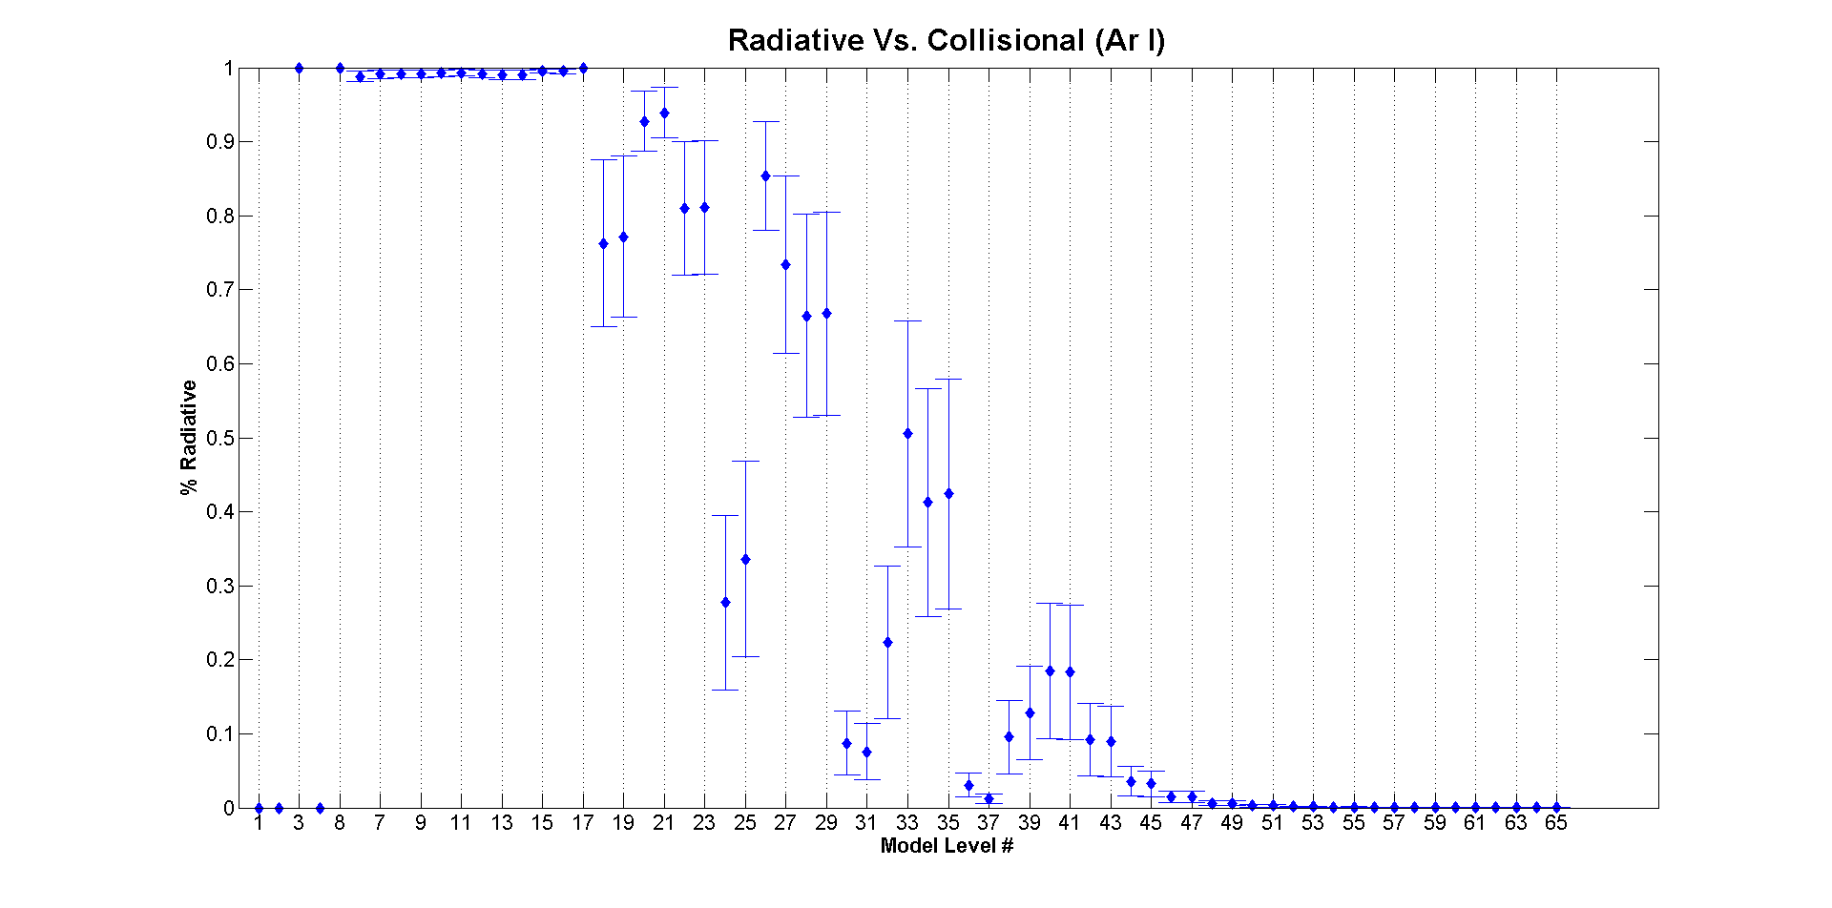

Figure 4.1: $\frac{A_{k}}{A_{k}+n_{e}\sum_{i}{〈σ_{ki}v〉}}$ calculated for each level in the Bogaerts model[4]. The values of $n_{e}$ and $T_{e}$ used are typical of the Helimak.

As can be seen, the ground state, k=1, as well as two other lower levels, k=2 & 4, have a ratio of identically 0. The levels 2 and 4 are called meta-stable levels because, similar to the ground state, they have no dipole allowed radiative transition. Otherwise, the lower levels are mostly determined by radiative transitions. The higher levels become more dominated by collisions until, at some point, they are completely collisional. The mix of dependence on both radiative and collisional processes is what motivates a more complex model.

### 4.3 Collisional-Radiative Model

The idea behind a collisional radiative model is to construct a rate equation for each population that would be valid in any density regime. Each could have any number of terms, each representing some atomic physics process, but can generally be grouped into gain and loss rates that are functions of the populations and the plasma conditions as in equation (4.1). Solving for a steady-state, $\frac{dn_{k}}{dt}=0$, then gives the values of $n_{k}$. This results in a number of coupled equations, one for each level, which must be solved simultaneously.

|  |  |  |
| --- | --- | --- |
|  | $$\frac{dn_{k}}{dt}=R_{k}^{gain}\left(n_{i≠k}, n_{e}, T_{e}, …\right)-R_{k}^{loss}\left(n_{i}, n_{e}, T_{e}, …\right)$$ |  |

If the plasma conditions are not uniform, then the population densities will necessarily not be uniform either. In principle the rate equations would be non-local to account for transport of the excited atoms. However, because transition rates are so high compared to the thermal velocities and characteristic length scale of the plasma, $\frac{R_{k}^{loss}}{n_{k}}≫\frac{v_{th}}{L}$, the streaming terms can usually be neglected. Figure 4.2 shows typical level lifetimes for argon levels. A transit time for an Argon atom would be $\frac{L}{v_{th}}≅3ms$, and so with the exception of the ground state, and possibly the meta-stable states, all other levels will not depend on non-local effects.

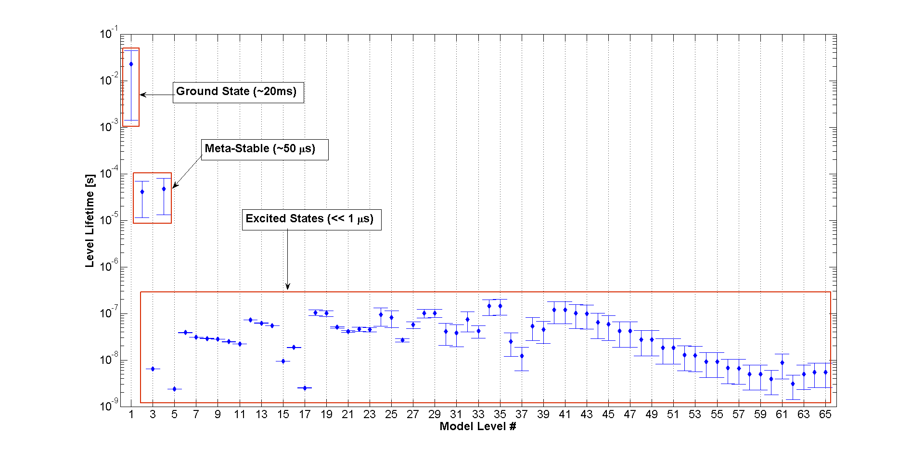

Figure 4.2: Level lifetimes calculated for each level in the Bogaerts model[4]. Values of $n_{e}$ and $T_{e}$ used are typical of the Helimak.

Determining the ground state density is the subject of chapter 5. The meta-stable levels could potentially cause problems because their rates could depend more on non-local streaming than the excited states, but the streaming time scale is still much longer than the level lifetime, and so their non-local effects was not dealt with.

### 4.4 Argon I CR Model

The collisional-radiative model for neutral Argon was taken from the work of Bogaerts et. al.[4], derived from Vlček’s original work[10][11]. It includes 65 effective levels including the ground state and 2 meta-stable levels. Each effective level is a grouping of two or more physical levels of similar energy, and are added together using the sub-level’s statistical weights, such that the sub-level densities are written in terms of the effective level density as $n_{j}=\frac{g_{j}}{g_{k}}n_{k}$, where $g_{k}=\sum_{j}{g_{j}}$. The energy levels of the effective levels are shown in figure 4.3.

The levels are divided into two groups, relating to whether the excited electron was in the spin up or spin down state, leaving the core electron configuration with either $j_{c}=3/2$ or $j_{c}=1/2$. This causes splitting of all the excited level energies into the two groups. All of the levels that give rise to measured lines in the visible spectrum are 4p to 4s transitions from both groups, coming from the effective levels 6 through 11.

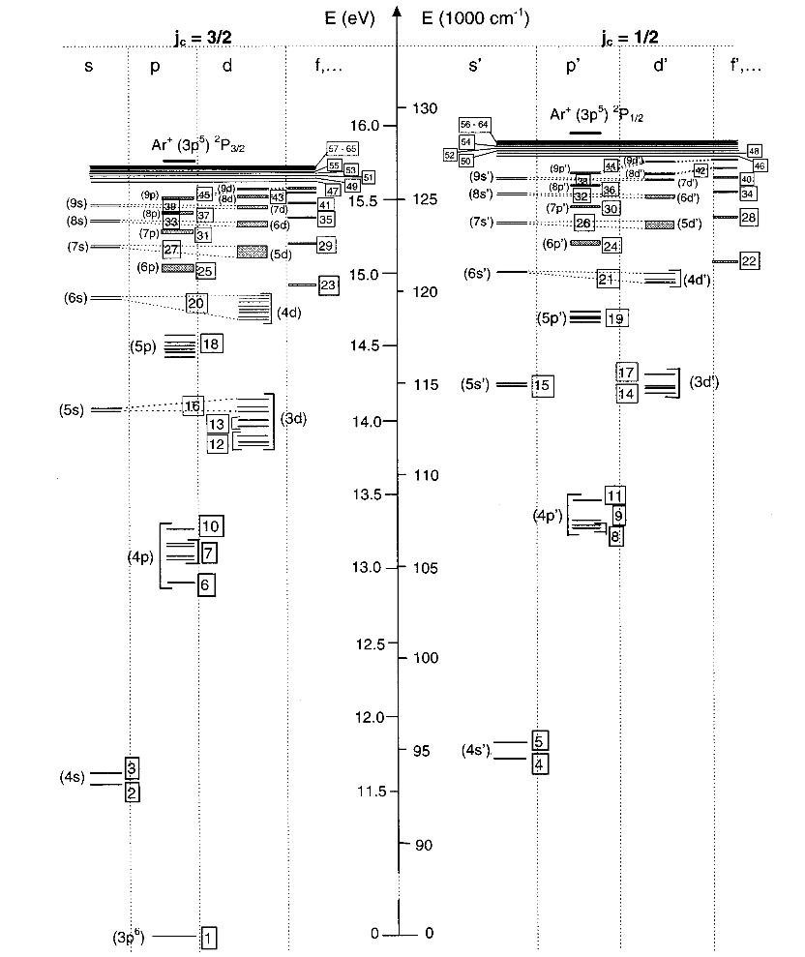

Figure 4.3: Energy level diagram of Ar I effective levels taken from Bogaerts[4].

The processes kept from the model are electron impact excitation, de-excitation, ionization, three-body and radiative recombination, and radiative decay. The neutral gas is of sufficiently low pressure that neutral collisions are infrequent and so the atom-atom terms from the model are not included. The gas is also optically thin and so the escape factor from the model is set to unity. The resulting rate equation is then equation 4.2.

Because the effective levels are not numbered in order of increasing excitation energy, $E_{k}^{exc}$, the notation unfortunately becomes somewhat unconventional. A convention is adopted that a rate coefficient is zero for un-allowed transitions. For example, the excitation coefficients $K_{ik}^{exc.}$ are zero by definition when $E_{k}<E_{i}$. This allows the indices to be summed over all levels. This makes it appear as though excitations, de-excitations, and radiative decay exists between all levels, but this is not really the case.

|  |  |  |
| --- | --- | --- |
|  | $$\frac{dn_{k}}{dt}=\sum_{i=1}^{N}{n_{i}\left[K_{ik}^{exc.}+K_{ik}^{de-exc.}+A_{ik}\right]}+n^{{Ar}^{+1}}\left(K_{k}^{RR}+K_{k}^{3BR}\right)-n_{k}\left[K_{k}^{ion}+\sum_{i=1}^{N}{\left[K_{ki}^{exc.}+K_{ki}^{de-exc.}+A_{ki}\right]}\right]=0$$ |  |

The ground state was not modeled as this will be determined later. These N-1 coupled equations are solved by iteration as coded in the Matlab routines from the work of E. Sciamma[5], with the initial solution having $n_{k>1}=0$.

To relate these solutions to the measured excited states of neutral Argon in chapter 3, the solutions to levels 6 through 9 are grouped together into a single compound excited state in the same way that was done with the spectroscopic measurements using eq. 3.5. The solutions $n_{k}/n_{1}$ were then tabulated for a range of electron temperatures and densities in table 4.1.

|  |  |  |  |  |  |  |  |  |
| --- | --- | --- | --- | --- | --- | --- | --- | --- |
|  | 1E16 | 2E16 | 5E16 | 1E17 | 2E17 | 5E17 | 1E18 | 2E18 |
| 0.5 | 4.742E-11 | 1.520E-10 | 7.450E-10 | 2.605E-09 | 9.516E-09 | 5.630E-08 | 2.287E-07 | 9.912E-07 |
| 1 | 4.455E-11 | 1.254E-10 | 5.365E-10 | 1.705E-09 | 5.605E-09 | 2.783E-08 | 9.504E-08 | 3.275E-07 |
| 2 | 1.396E-08 | 2.785E-08 | 6.890E-08 | 1.354E-07 | 2.614E-07 | 5.914E-07 | 1.022E-06 | 1.612E-06 |
| 5 | 8.228E-07 | 1.636E-06 | 4.013E-06 | 7.769E-06 | 1.460E-05 | 3.079E-05 | 4.849E-05 | 6.703E-05 |
| 10 | 2.916E-06 | 5.802E-06 | 1.423E-05 | 2.752E-05 | 5.154E-05 | 1.079E-04 | 1.687E-04 | 2.315E-04 |
| 20 | 4.956E-06 | 9.881E-06 | 2.432E-05 | 4.720E-05 | 8.890E-05 | 1.885E-04 | 2.993E-04 | 4.196E-04 |

Table 4.1: Solutions from Ar I effective levels 6 through 9 combined into compound-state density, divided by ground state density. Each row is electron temperature range in eV. Each column is the electron density range in $m^{-3}$. Values for compound state densities are found by multiplying by the Ar I ground state density.

### 4.5 Argon II CR Model

The model for Ar II comes from ADAS, the Atomic Data Analysis Structure. As described by Ella Sciamma[4] the model used was similar in structure to that of the Ar I model with the use of 35 effective levels. Tables for three of those levels were generated originally by Dr. W. L. Rowan, and are taken from Ella’s work. The changes are that the original tables were tabulated as a relative density such that the excited state density was found by multiplying by the ion density, as in the Ar I table 4.1.

Because there is very little double ionization, the ion density should be very close to the electron density $n_{ArII}≅n_{e}$. The table entries were multiplied by the corresponding electron density to give the absolute density of the excited states. Also, the three Ar II level tables were combined in the same way as table 4.1 using eq. 3.5, resulting in table 4.2.

|  |  |  |  |  |  |  |  |  |
| --- | --- | --- | --- | --- | --- | --- | --- | --- |
|  | 1E16 | 2E16 | 5E16 | 1E17 | 2E17 | 5E17 | 1E18 | 2E18 |
| 0.5 | 8.521E-07 | 3.815E-06 | 3.120E-05 | 1.692E-04 | 9.867E-04 | 1.054E-02 | 6.203E-02 | 3.555E-01 |
| 1 | 1.982E+02 | 8.404E+02 | 6.045E+03 | 2.892E+04 | 1.464E+05 | 1.324E+06 | 7.161E+06 | 3.899E+07 |
| 2 | 2.695E+06 | 1.109E+07 | 7.473E+07 | 3.288E+08 | 1.511E+09 | 1.192E+10 | 5.927E+10 | 3.042E+11 |
| 5 | 6.250E+08 | 2.540E+09 | 1.653E+10 | 6.956E+10 | 3.002E+11 | 2.163E+12 | 1.007E+13 | 4.934E+13 |
| 10 | 3.013E+09 | 1.216E+10 | 7.827E+10 | 3.258E+11 | 1.379E+12 | 9.647E+12 | 4.382E+13 | 2.107E+14 |
| 20 | 4.988E+09 | 2.014E+10 | 1.286E+11 | 5.319E+11 | 2.229E+12 | 1.537E+13 | 6.869E+13 | 3.256E+14 |

Table 4.2: Solutions from Ar II effective levels 13 through 15 combined into compound-state density, in units of $m^{-3}$. Each row is electron temperature range in eV. Each column is the electron density range in $m^{-3}$.

### 4.6 Determining $n_{e}$ and $T_{e}$

The two tables constructed from the collisional radiative models represent two functions of $n_{e}$ and $T_{e}$: $\frac{n_{ArI}^{*}}{n_{ArI}}=C(n_{e},T_{e})$, and $n_{ArII}^{*}=D\left(n_{e},T_{e}\right)$, where $n^{*}$ is the compound excited state density. If both values of $\frac{n_{ArI}^{*}}{n_{ArI}}$ and $n_{ArII}^{*}$ are measured as in chapter 3, then $n_{e}$ and $T_{e}$ are found by solving equations (4.3) and (4.4) simultaneously. For practical reasons the solution was found in log scale of the densities since it covers many orders of magnitude.

|  |  |  |
| --- | --- | --- |
|  |  |  |

|  |  |  |
| --- | --- | --- |
|  |  |  |

These functions are discrete because the tables were only calculated for certain values of $n_{e}$ and $T_{e}$. The functions were interpolated using the Matlab interp2 function, with the cubic interpolation method, for intermediate values. An example solution is plotted in figure 4.4 using the example measurement calculation from chapter 3: $n_{ArI}=3.1E17m^{-3}$, $n_{ArI}^{*}=2.6E12 m^{-3}$, and $n_{ArII}^{*}=4.7E10 m^{-3}$.

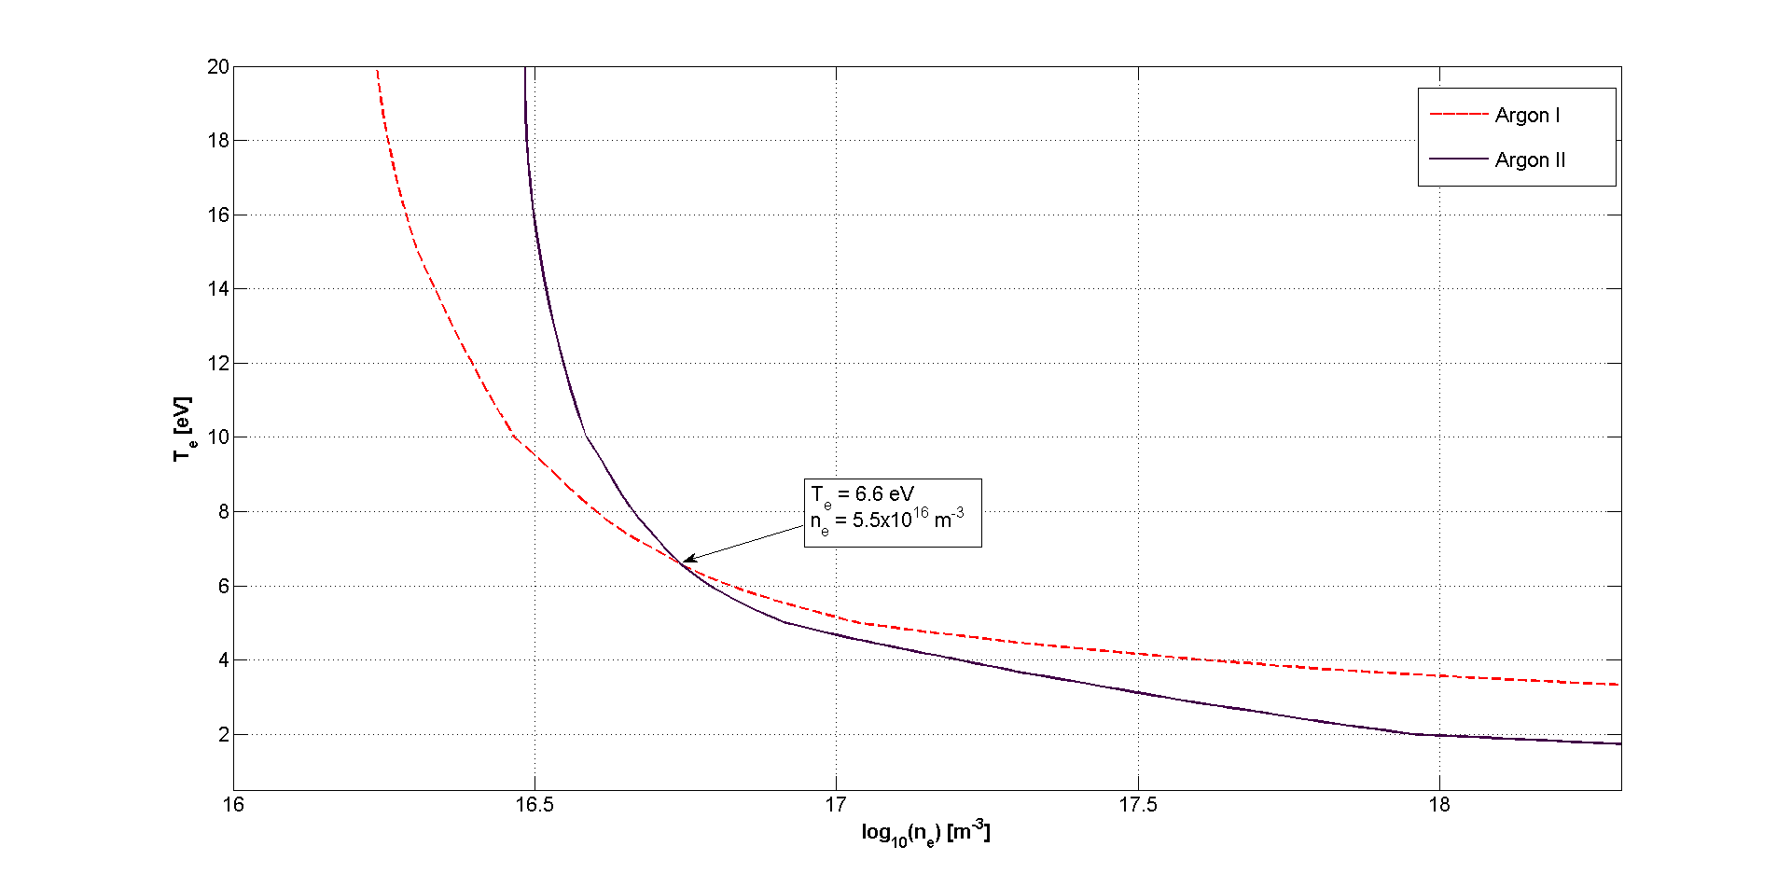

Figure 4.4: Solution of equations 4.3 and 4.4. The intersection of the two curves gives the value of $n_{e}$ and $T_{e}$.

Solving equations 4.3 and 4.4 produce two curves that are now only functions of one variable. The intersection of the two curves will give the unique values that are consistent with the spectroscopic measurements and the collisional-radiative models. In this example, the values determined graphically are $n_{e}=5.5E16{ m}^{-3}$ and $T_{e}=6.6 eV$.

Matlab code was written to solve for the intersection point programmatically. The interpolated functions are still discrete on a grid of higher resolution. The first step was to check each square of the grid to see if one of the functions had a zero in that square. Given the value of the function on the four grid points, $f_{00}, f_{01},{ f}_{10},{ f}_{11}$, if two point on the same side alternate from positive to negative, then the zero curve must pass between the two points. The intersection of the curve with that side of the square was found using linear interpolation between the two values. The other intersection point on the square was also found.

When a square is found that the first function has a zero inside, then the other function was checked to see if it had a zero in the same square. If both functions had zeros in the square then the code checked to see if the two zero curves intersected by linear interpolation given the two intersection points of each curve using eq. 4.5 and 4.6. Here the two curves are denoted by a and b.

|  |  |  |
| --- | --- | --- |
|  |  |  |

|  |  |  |
| --- | --- | --- |
|  |  |  |

### 4.7 First Correction for Neutral Density

The value for the neutral density used above is derived from the pressure reading from before the shot. If it is assumed that the total number of atoms within the vacuum chamber remains nearly constant throughout the shot, then when some fraction of them becomes ionized there are slightly less as neutrals. The total number can be expressed as the number density times the total volume of the vacuum chamber $N_{0}=n_{0}V_{vacuum}$, where $n_{0}$ is derived from the ion gauge pressure reading before the shot. The total number of ionized atoms would be $N_{ArII}=〈n_{ArII}〉V_{plasma}$, where $〈n_{ArII}〉$ is the average ion density of the plasma, and $V_{plasma}$ is the volume of just the plasma. The number of neutrals left should then be $N_{ArI}=〈n_{ArI}〉V_{vacuum}=N_{0}-N_{ArII}$. Solving for the average neutral density gives equation 4.7.

|  |  |  |
| --- | --- | --- |
|  | $$〈n_{ArI}〉=n_{0}-〈n_{ArII}〉\frac{V_{plasma}}{V_{vacuum}}$$ |  |

The average ion density was determined by taking a sample profile for $n_{e}$ from probe measurements and computing what the average density, weighted by the absolute radial distance, in terms of the maximum value of $n_{e}$. The value determined was $〈n_{e}〉=0.45×max\left(n_{e}\right)$. A value close to 0.5 was expected due to the peaked nature of the profile. The average ion density then can use the same value since the plasma should only be singly ionized. The maximum value of $n_{e}$ can already be determined by the above method.

The volume of the plasma is somewhat less than the vacuum chamber since the plasma does not extend all the way to the top or bottom. The termination plates extend approximately 28cm from the top and bottom, but the plasma does not end abruptly. With the chamber being 2m in height, an effective plasma height of 1.72m is used, giving a volume ratio of $\frac{V_{plasma}}{V_{vacuum}}=0.86$.

Using this above to correct for the neutral density changes the solution, including the value of maximum $n_{e}$. So the process must be iterative to converge to a self-consistent value. Continuing with the example calculations, this process changes the above solution values to $n_{e}=5E16{ m}^{-3}$ and $T_{e}=7.2 eV$, with the neutral density reduced to $〈n_{ArI}〉=0.935×n_{0}$.