Cecilia Reyes, Alice Rottersman, Lowell Schudel
This is our User Manual / ReadMe for Homework 5.
===

- Make sure you have jsoup-1.7.2 in your terminal’s build path.
- Compile all of the .java files in our project.
- Make sure you are connected to the internet, please…
- Run “MemeProgramMain” and be a little patient.
- A GUI will appear letting you know how many pages have loaded.
- The command line will print each time a pages has loaded.
- If any errors are encountered, a message prints and loading resumes.
- Once all ten pages have loaded, your quiz will begin!
- Just click “Like!” on either the left or right meme.
- You will be taken to the next page automatically, but can go back.
- You can continue doing this until the last page.
- Then you are told whether you picked more “popular” or “unpopular” memes.
- This is determined by scaling a memes native upvote count compared to the other memes on its site.

===
Sample Output:
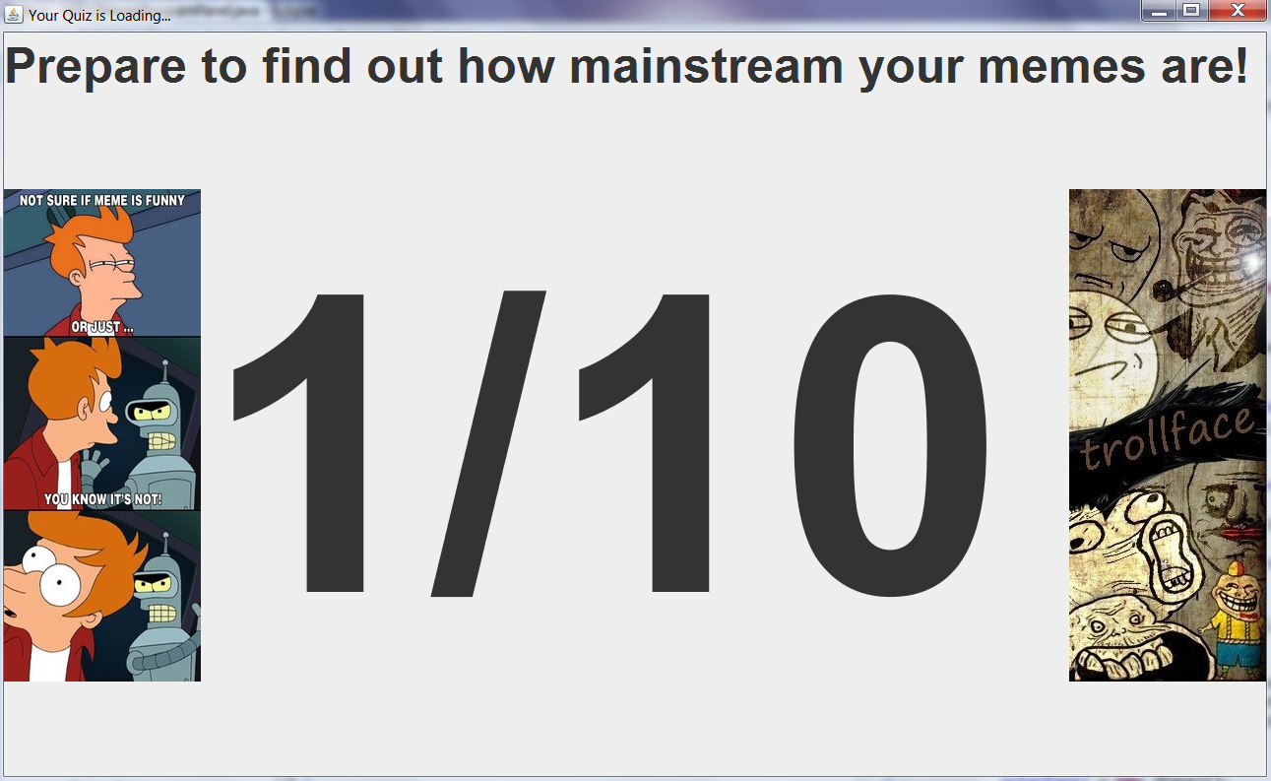
Your newest panel is ready to add to the GUI!
null
Your newest panel is ready to add to the GUI!
Your newest panel is ready to add to the GUI!
Your newest panel is ready to add to the GUI!
Your newest panel is ready to add to the GUI!
Your newest panel is ready to add to the GUI!
null
Your newest panel is ready to add to the GUI!
Your newest panel is ready to add to the GUI!
null
null
Your newest panel is ready to add to the GUI!
Your newest panel is ready to add to the GUI!
Adding a tab no. 1...
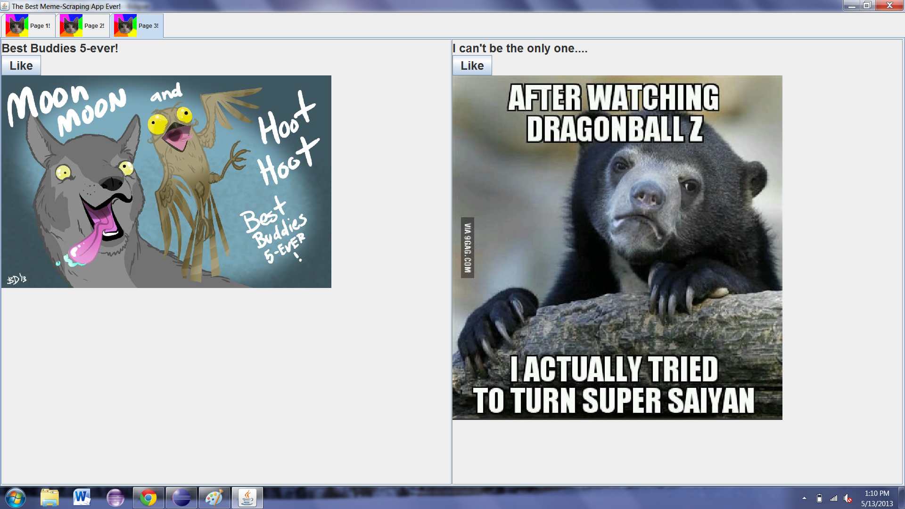
Adding a tab no. 2...
Adding a tab no. 3...
Adding a tab no. 4...
Adding a tab no. 5...
Adding a tab no. 6...
Adding a tab no. 7...
Adding a tab no. 8...
Adding a tab no. 9...
Adding a tab no. 10...
