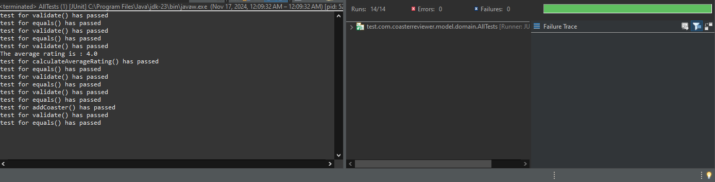

AllTests for Domain Classes

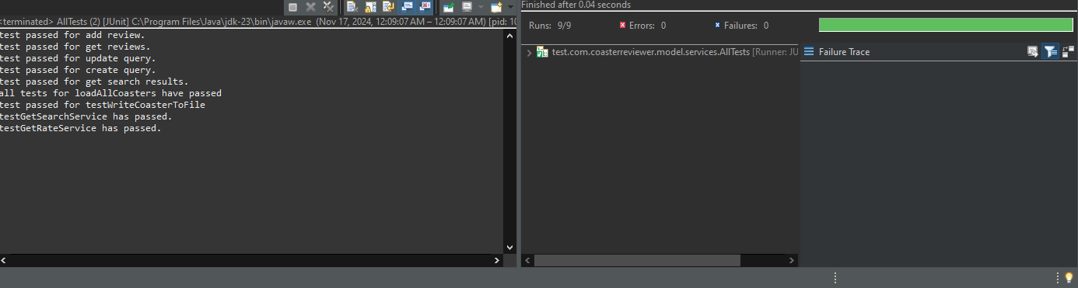

AllTests for Service Layer