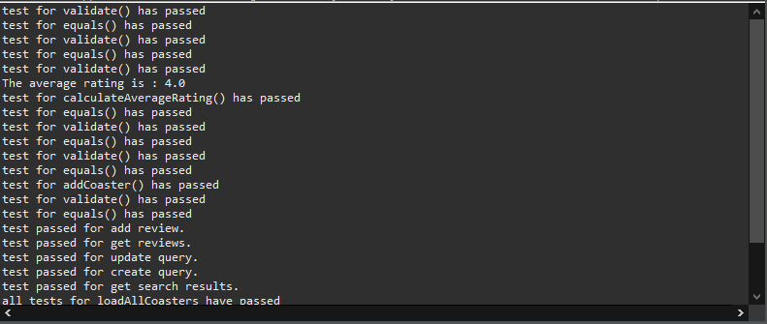

AllTests for entire application successfully passed.