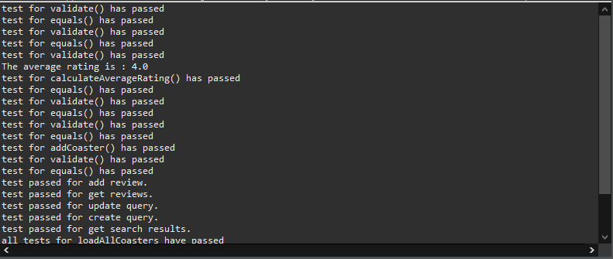

AllTests for entire application successfully passed. No new tests added for Week 7.