Kenya Data Collection

# Authors

Lucy, Carla

# Affiliations

# Corresponding author(s)

# Abstract

# Keywords

Renewable energy, Cost-optimization,Kenya , Energy policy, OSeMOSYS

# Specifications Table

|  |  |
| --- | --- |
|  |  |
| Subject | Engineering |
| Specific subject area | Energy Technology |
| Type of data | Table, Image, Chart, Graph, Figure, Description of main assumptions, tables and figures with model input data |
| How data were acquired | Literature survey (reports from international organizations, government agencies, and journal articles) |
| Data format | Raw  Analyzed  Filtered  Descriptive |
| Parameters for data collection |  |
| Description of data collection |  |
| Data source location | Not applicable |
| Data accessibility | With the article.   Repository name:   Data identification number:   Direct URL to data:  Data is available within this article |
| Related research article | Author’s name, Title, Journal, DOI/In Press |

# Value of the data

Why are these data useful?

Who can benefit from these data?

Who can benefit from these data?

What is the additional value of these data?

# Data in Brief

## Main modelling assumptions

### Electricity supply system

Table 1: Installed Power Plants Capacity in Kenya

|  |  |  |  |  |  |
| --- | --- | --- | --- | --- | --- |
|  |  |  |  |  |  |
| Power Generation Technology | 2015.0 | 2016.0 | 2017.0 | 2018.0 | Reference |
| Biomass Power Plant | 0.09 | 0.09 | 0.09 | 0.09 | PLEXOS |
| Biomass Power Plant with CCS | 0.0 | 0.0 | 0.0 | 0.0 | 0 |
| Coal Power Plant | 0.0 | 0.0 | 0.0 | 0.0 | 0 |
| Coal Power Plant with CCS | 0.0 | 0.0 | 0.0 | 0.0 | 0 |
| Geothermal Power Plant | 0.41900000000000004 | 0.41900000000000004 | 0.41900000000000004 | 0.41900000000000004 | PLEXOS |
| Light Fuel Oil Power Plant | 0.2875 | 0.2875 | 0.2875 | 0.2875 | PLEXOS |
| Oil Fired Gas Turbine (SCGT) | 0.44699999999999995 | 0.44699999999999995 | 0.44699999999999995 | 0.44699999999999995 | PLEXOS |
| Gas Power Plant (CCGT) | 0.0 | 0.0 | 0.0 | 0.0 | 0 |
| Gas Power Plant (SCGT) | 0.0 | 0.0 | 0.0 | 0.0 | 0 |
| Gas Power Plant with CCS | 0.0 | 0.0 | 0.0 | 0.0 | 0 |
| Solar PV (Utility) | 0.024 | 0.024 | 0.024 | 0.024 | PLEXOS |
| CSP without Storage | 0.0 | 0.0 | 0.0 | 0.0 | 0 |
| CSP with Storage | 0.0 | 0.0 | 0.0 | 0.0 | 0 |
| Large Hydropower Plant (Dam) (>100MW) | 0.499 | 0.499 | 0.499 | 0.499 | PLEXOS |
| Medium Hydropower Plant (10-100MW) | 0.3208 | 0.3208 | 0.3208 | 0.2488 | PLEXOS |
| Small Hydropower Plant (<10MW) | 0.0 | 0.0 | 0.0 | 0.0 | 0 |
| Onshore Wind | 0.336 | 0.336 | 0.336 | 0.31 | PLEXOS |
| Offshore Wind | 0.0 | 0.0 | 0.0 | 0.0 | 0 |
| Nuclear Power Plant | 0.0 | 0.0 | 0.0 | 0.0 | 0 |

### Fuel assumptions

Table 2: Fuel price projections until 2070

|  |  |  |  |  |  |  |  |  |  |
| --- | --- | --- | --- | --- | --- | --- | --- | --- | --- |
|  |  |  |  |  |  |  |  |  |  |
| Commodity | 2015.0 | 2020.0 | 2025.0 | 2030.0 | 2040.0 | 2050.0 | 2060.0 | 2070.0 | Reference |
| Crude Oil Imports | 13.145 | 12.199000000000002 | 12.76 | 14.267000000000001 | 16.896 | 19.525000000000002 | 22.154000000000003 | 24.783000000000005 | US EIA forecast extended to 2070. Price increased by 10% relative to MINOIL (assumption made for now) |
| Crude Oil Extraction | 11.95 | 11.09 | 11.6 | 12.97 | 15.36 | 17.75 | 20.14 | 22.53 | US EIA forecast extended to 2070 - See here https://docs.google.com/spreadsheets/d/1wevog_R7lY7P9j_tPpLbm2Y7LVQlcCywfeNKnDxuJMo/edit?usp=sharing . Based on the Reference Case from here https://www.eia.gov/outlooks/aeo/assumptions/pdf/international.pdf |
| Biomass Imports | 1.616 | 1.616 | 1.616 | 1.616 | 1.616 | 1.616 | 1.616 | 1.616 | TEMBA JRC Paper |
| Biomass Extraction | 1.6 | 1.6 | 1.6 | 1.6 | 1.6 | 1.6 | 1.6 | 1.6 | TEMBA JRC Paper |
| Coal Imports | 4.9 | 6.141165 | 5.709793 | 5.835283 | 5.898028 | 5.905418 | 5.912807 | 5.920196 | TEMBA |
| Coal Extraction | 3.3 | 4.09411 | 3.771924 | 3.819458 | 3.860528 | 3.865364 | 3.870201 | 3.875037 | TEMBA |
| Light Fuel Oil Imports | 15.8935 | 14.7497 | 15.428 | 17.250100000000003 | 20.4288 | 23.6075 | 26.7862 | 29.964900000000004 | MINOIL prices increased by 1/3 as done for TEMBA |
| Heavy Fuel Oil Imports | 9.56 | 8.872 | 9.28 | 10.376000000000001 | 12.288 | 14.200000000000001 | 16.112000000000002 | 18.024 | MINOIL prices decreased by 20% as done for TEMBA |
| Crude Oil Refinery Option 1 | 0.71775 | 0.71775 | 0.71775 | 0.71775 | 0.71775 | 0.71775 | 0.71775 | 0.71775 | TEMBA |
| Crude Oil Refinery Option 2 | 0.71775 | 0.71775 | 0.71775 | 0.71775 | 0.71775 | 0.71775 | 0.71775 | 0.71775 | TEMBA |
| Natural Gas Imports | 9.2 | 10.83392 | 13.2675 | 13.55592 | 14.13277 | 14.7955 | 15.45823 | 16.12096 | TEMBA |
| Natural Gas Extraction | 7.1 | 8.841474 | 10.53983 | 10.47503 | 10.92077 | 11.43288 | 11.94499 | 12.4571 | TEMBA |

### Emission assumptions

Table 3: Fuel specific CO2 emissions

|  |  |
| --- | --- |
|  |  |
| Crude Oil Imports | 73.3 |
| Crude Oil Extraction | 73.3 |
| Biomass Imports | 100 |
| Biomass Extraction | 100 |
| Coal Imports | 94.6 |
| Coal Extraction | 94.6 |
| Light Fuel Oil Imports | 69.3 |
| Heavy Fuel Oil Imports | 77.4 |
| Crude Oil Refinery Option 1 | 0 |
| Crude Oil Refinery Option 2 | 0 |
| Natural Gas Imports | 56.1 |
| Natural Gas Extraction | 56.1 |
| Reference: | IPCC Database |

### Transmission and Distribution

Table 4: Techno-economical parameters for transmission and distribution technologies

|  |  |  |  |  |  |
| --- | --- | --- | --- | --- | --- |
|  |  |  |  |  |  |
| Electricity Transmission | 365 | 0 | 0.0001 | 50 | 0.9523809523809523 |
| Electricity Distribution | 2502 | 0 | 0.0001 | 70 | 0.8645533141210372 |
| Reference | TEMBA | TEMBA JRC Paper | TEMBA | TEMBA | TEMBA JRC Paper - Kenya-specific |

### Refineries

Table 5: Techno-economic parameters for refineries technology

|  |  |  |  |  |  |  |
| --- | --- | --- | --- | --- | --- | --- |
|  |  |  |  |  |  |  |
| Crude Oil Refinery Option 1 | 24.1 | 0 | 0.71775 | 35 | 1 | 0.9 LFO : 0.1 HFO |
| Crude Oil Refinery Option 2 | 24.1 | 0 | 0.71775 | 35 | 1 | 0.8 LFO : 0.2 HFO |
| Reference | TEMBA | TEMBA | TEMBA | TEMBA JRC Paper | TEMBA | Default |

## Detailed power plant assumptions

Table 6: Fuel price projections until 2070

|  |  |  |  |  |  |  |  |  |
| --- | --- | --- | --- | --- | --- | --- | --- | --- |
|  |  |  |  |  |  |  |  |  |
| Technology | Input Fuel | Capital Cost ($/kW in 2020) | Capital Cost Source | Fixed Cost ($/kW/yr in 2020) | Fixed Cost Source | Variable Cost ($/GJ in 2020) | Variable Cost Source | Operational Life (years) |
| Biomass Power Plant | BIO | 2133.3333333333326 | TEMBA JRC paper | 75 | TEMBA JRC Paper | 0.0001 | TEMBA | 40 |
| Biomass Power Plant with CCS | BIO | 4125.333333333334 | TEMBA JRC paper | 91.28 | TEMBA JRC Paper | 6.7 | TEMBA | 40 |
| Coal Power Plant | COA | 1600 | TEMBA JRC paper | 65 | TEMBA JRC Paper | 0.0001 | TEMBA | 30 |
| Coal Power Plant with CCS | COA | 4366.666666666665 | TEMBA JRC paper | 156.6666666666667 | TEMBA JRC Paper | 0.0001 | TEMBA | 30 |
| Geothermal Power Plant | GEO | 3033.3333333333326 | TEMBA JRC paper | 60 | TEMBA JRC Paper | 0.0001 | TEMBA | 25 |
| Light Fuel Oil Power Plant | LFO | 1200 | TEMBA JRC paper | 35 | TEMBA JRC Paper | 0.0001 | TEMBA | 25 |
| Oil Fired Gas Turbine (SCGT) | HFO | 1467 | TEMBA JRC paper | 44 | TEMBA JRC Paper | 0.0001 | TEMBA | 25 |
| Gas Power Plant (CCGT) | NGS | 700 | TEMBA JRC paper | 25 | TEMBA JRC Paper | 0.0001 | TEMBA | 30 |
| Gas Power Plant (SCGT) | NGS | 400 | TEMBA JRC paper | 20 | TEMBA JRC Paper | 0.0001 | TEMBA | 25 |
| Gas Power Plant with CCS | NGS | 2366.6666666666674 | TEMBA JRC paper | 76.66666666666664 | TEMBA JRC Paper | 0.0001 | TEMBA | 30 |
| Solar PV (Utility) | SOL | 2066.6666666666674 | TEMBA JRC paper | 23.333333333333336 | TEMBA JRC Paper | 0.0001 | TEMBA | 25 |
| CSP without Storage | SOL | 4633.333333333335 | TEMBA JRC paper | 183.3333333333333 | TEMBA JRC Paper | 0.0001 | TEMBA | 25 |
| CSP with Storage | SOL | 6169 | TEMBA JRC paper | 211.3333333333333 | TEMBA JRC Paper | 0.0001 | TEMBA | 25 |
| Large Hydropower Plant (Dam) (>100MW) | HYD | 1987 | IRENA 2019 Costs | 55 | TEMBA JRC Paper | 0.0001 | TEMBA | 50 |
| Medium Hydropower Plant (10-100MW) | HYD | 1987 | IRENA 2019 Costs | 55 | TEMBA JRC Paper | 0.0001 | TEMBA | 50 |
| Small Hydropower Plant (<10MW) | HYD | 3170 | IRENA 2019 Costs | 65 | TEMBA JRC Paper | 0.0001 | TEMBA | 30 |
| Onshore Wind | WND | 1840 | TEMBA JRC paper | 46.66666666666667 | TEMBA JRC Paper | 0.0001 | TEMBA | 25 |
| Offshore Wind | WND | 4200 | TEMBA JRC paper | 151.6666666666667 | TEMBA JRC Paper | 0.0001 | TEMBA | 25 |
| Nuclear Power Plant | URN | 4000 | TEMBA JRC paper | 170 | TEMBA JRC Paper | 0.0001 | TEMBA | 60 |
| Electricity Imports | nan | 536 | TEMBA (but really this is the avg of all transmission projects involving Kenya in TEMBA, so needs updating) | 0 | Ed's data - to be checked and made a generic preset value? | 15.78 | TEMBA | 50 |
| Backstop Technology for ELC001 | nan | 999999999 | Default | 999999999 | Default | 999999999 | Default | 80 |
| Electricity Transmission | ELC001 | 365 | TEMBA | 0 | TEMBA JRC Paper | 0.0001 | TEMBA | 50 |
| Electricity Distribution | ELC002 | 2502 | TEMBA | 0 | TEMBA JRC Paper | 0.0001 | TEMBA | 70 |
| Light Fuel Oil Standalone Generator (1kW) | LFO | 752 | TEMBA JRC paper | 23 | TEMBA JRC Paper | 0.0001 | TEMBA | 10 |
| Solar PV (Rooftop) | SOL | 2440 | TEMBA JRC paper | 27.333333333333336 | TEMBA JRC Paper | 0.0001 | TEMBA | 20 |
| Solar PV (Distributed with Storage) | SOL | 3757.0000000000005 | TEMBA JRC paper | 47.333333333333336 | TEMBA JRC Paper | 0.0001 | TEMBA | 20 |

Table 7: Projections of costs of power plants until 2070

|  |  |  |  |  |  |  |  |  |  |
| --- | --- | --- | --- | --- | --- | --- | --- | --- | --- |
|  |  |  |  |  |  |  |  |  |  |
| Technology | 2015.0 | 2020.0 | 2025.0 | 2030.0 | 2040.0 | 2050.0 | 2060.0 | 2070.0 | Reference |
| Biomass Power Plant | 2150.0 | 2133.3333333333326 | 2116.666666666665 | 2100.0 | 2050.0 | 2000.0 | 1950.0 | 1900.0 | TEMBA JRC paper |
| Biomass Power Plant with CCS | 4256.0 | 4125.333333333334 | 3994.666666666668 | 3864.0 | 3612.000000000002 | 3360.0 | 3230.0 | 3100.0 | TEMBA JRC paper |
| Coal Power Plant | 1600.0 | 1600.0 | 1600.0 | 1600.0 | 1600.0 | 1600.0 | 1600.0 | 1600.0 | TEMBA JRC paper |
| Coal Power Plant with CCS | 4500.0 | 4366.666666666665 | 4233.33333333333 | 4100.0 | 3900.0 | 3700.0 | 3500.0 | 3300.0 | TEMBA JRC paper |
| Geothermal Power Plant | 3100.0 | 3033.3333333333326 | 2966.666666666665 | 2900.0 | 2800.0 | 2700.0 | 2600.0 | 2500.0 | TEMBA JRC paper |
| Light Fuel Oil Power Plant | 1200.0 | 1200.0 | 1200.0 | 1200.0 | 1200.0 | 1200.0 | 1200.0 | 1200.0 | TEMBA JRC paper |
| Oil Fired Gas Turbine (SCGT) | 1467.0 | 1467.0 | 1467.0 | 1467.0 | 1467.0 | 1467.0 | 1467.0 | 1467.0 | TEMBA JRC paper |
| Gas Power Plant (CCGT) | 700.0 | 700.0 | 700.0 | 700.0 | 700.0 | 700.0 | 700.0 | 700.0 | TEMBA JRC paper |
| Crude Oil Refinery Option 1 | 0.71775 | 0.71775 | 0.71775 | 0.71775 | 0.71775 | 0.71775 | 0.71775 | 0.71775 | TEMBA |
| Crude Oil Refinery Option 2 | 0.71775 | 0.71775 | 0.71775 | 0.71775 | 0.71775 | 0.71775 | 0.71775 | 0.71775 | TEMBA |
| Solar PV (Utility) | 2400.0 | 2066.6666666666674 | 1733.3333333333337 | 1400.0 | 1240.0 | 1080.0 | 920.0 | 760.0 | TEMBA JRC paper |
| CSP without Storage | 5050.0 | 4633.333333333335 | 4216.66666666667 | 3800.0 | 3350.0 | 2900.0 | 2450.0 | 2000.0 | TEMBA JRC paper |
| CSP with Storage | 6789.0 | 6169.0 | 5549.0 | 4929.0 | 4462.999999999996 | 3997.0 | 3531.000000000001 | 3065.0 | TEMBA JRC paper |
| Large Hydropower Plant (Dam) (>100MW) | 1987.0 | 1987.0 | 1987.0 | 1987.0 | 1987.0 | 1987.0 | 1987.0 | 1987.0 | IRENA 2019 Costs |
| Medium Hydropower Plant (10-100MW) | 1987.0 | 1987.0 | 1987.0 | 1987.0 | 1987.0 | 1987.0 | 1987.0 | 1987.0 | IRENA 2019 Costs |
| Small Hydropower Plant (<10MW) | 3170.0 | 3170.0 | 3170.0 | 3170.0 | 3170.0 | 3170.0 | 3170.0 | 3170.0 | IRENA 2019 Costs |
| Onshore Wind | 1880.0 | 1840.0 | 1800.0 | 1760.0 | 1720.0 | 1680.0 | 1640.0 | 1600.0 | TEMBA JRC paper |
| Offshore Wind | 4700.0 | 4200.0 | 3700.0 | 3200.0 | 2900.0 | 2600.0 | 2300.0 | 2000.0 | TEMBA JRC paper |
| Nuclear Power Plant | 4000.0 | 4000.0 | 4000.0 | 4000.0 | 4000.0 | 4000.0 | 4000.0 | 4000.0 | TEMBA JRC paper |
| Electricity Imports | 536.0 | 536.0 | 536.0 | 536.0 | 536.0 | 536.0 | 536.0 | 536.0 | TEMBA (but really this is the avg of all transmission projects involving Kenya in TEMBA, so needs updating) |
| Backstop Technology for ELC001 | 999999999.0 | 999999999.0 | 999999999.0 | 999999999.0 | 999999999.0 | 999999999.0 | 999999999.0 | 999999999.0 | Default |
| Electricity Transmission | 365.0 | 365.0 | 365.0 | 365.0 | 365.0 | 365.0 | 365.0 | 365.0 | TEMBA |
| Electricity Distribution | 2502.0 | 2502.0 | 2502.0 | 2502.0 | 2502.0 | 2502.0 | 2502.0 | 2502.0 | TEMBA |
| Light Fuel Oil Standalone Generator (1kW) | 752.0 | 752.0 | 752.0 | 752.0 | 752.0 | 752.0 | 752.0 | 752.0 | TEMBA JRC paper |
| Solar PV (Rooftop) | 2840.0 | 2440.0 | 2040.0 | 1640.0 | 1440.0 | 1240.0 | 1040.0 | 840.0 | TEMBA JRC paper |
| Solar PV (Distributed with Storage) | 4449.0 | 3757.0000000000005 | 3065.0 | 2373.0 | 2108.999999999999 | 1845.0 | 1604.5000000000005 | 1364.0 | TEMBA JRC paper |

## Detailed cooking stove assumptions

Table 8: Techno-economic parameters for cooking stoves

|  |  |  |  |  |  |  |
| --- | --- | --- | --- | --- | --- | --- |
|  |  |  |  |  |  |  |
| Residential Electric Stove | 76.2 | 0 | 0.0 | 10 | 0.9523809523809523 | Okolo & Teng (2017) Nigeria CLEWs study |
| Residential Oil Stove | 6.1 | 0 | 0.0 | 10 | 0.5500550055005501 | Okolo & Teng (2017) Nigeria CLEWs study |
| Residential Biomass Stove | 0.6 | 0 | 3.113 | 10 | 0.1801801801801802 | Okolo & Teng (2017) Nigeria CLEWs study |

## Demand Projection

### Electricity Demand Projection

Chart 1: Electricity Demand Projection by Sector (PJ)

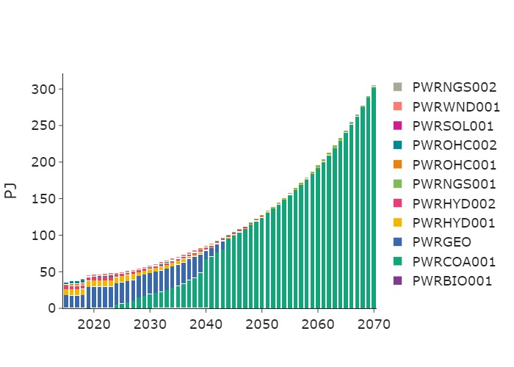

Chart 2: Annual Capacity by Technology (GW)

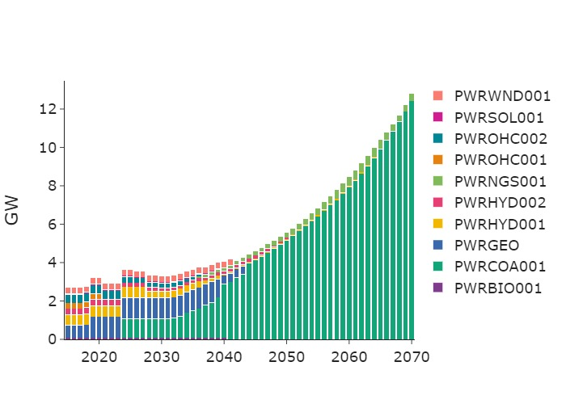

Chart 3: Cooking and Heat Demand by Technology (PJ)

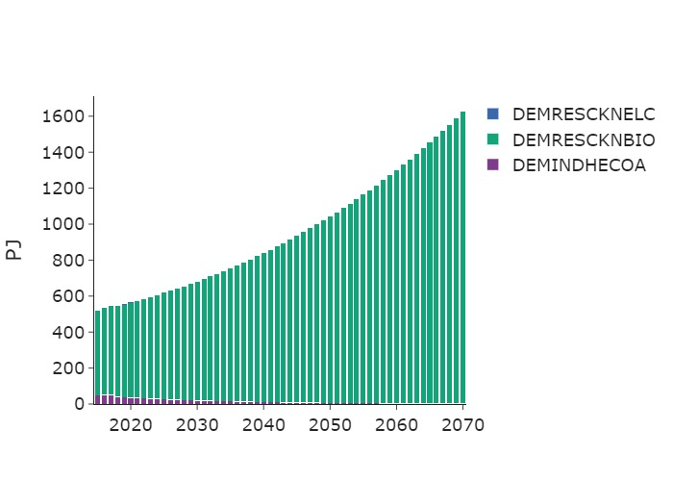

Chart 4: Transport Demand by Technology (PJ)

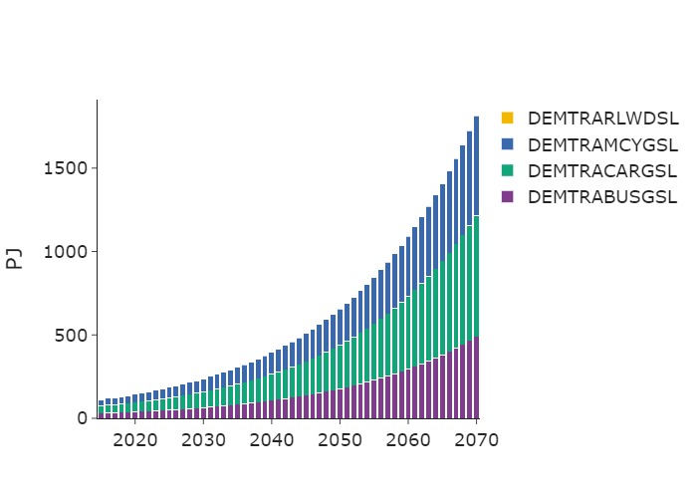

## Experimental Design, Materials, and Methods

## Appendix - Results

### Fossil Future

### NDC

### Net Zero