COMP2501 Assignment 3

Requirements
Submission deadline: April 30th, 2026 at 23:59.
Full mark of assignment 3: 50.
For the following questions, please:
- Replace all [Input here] places with your information or your answer.
- Complete the code block by adding your own code to fulfill the requirements in each question. Please use the existing code block and do not add your own code block. Noting that please use head() to show the corresponding results if there are too many rows in them.
Please make sure your Rmd file is a valid Markdown document and can be successfully knitted.
For assignment submission, please knit your final Rmd file into a Word document, and submit both your Rmd file and the knitted Microsoft Word document file to Moodle. You get 0 score if 1) the Rmd file you submitted cannot be knitted, and 2) you have not submitted a Word document. For each visualization question, please make sure that the generated plot is shown in-place with the question and after the code block.

Name and UID
Name: Kan Chi Fu
UID: 3035807902

Environmental setup
You need to have the dplyr and ggplot2 packages installed. If not yet, please run install.packages(c("dplyr", "ggplot2")) in your R environment.
# Load the package.
library(dplyr)
##
## Attaching package: 'dplyr'
## The following objects are masked from 'package:stats':
##
## filter, lag
## The following objects are masked from 'package:base':
##
## intersect, setdiff, setequal, union
library(ggplot2)

1. (2 points) Suppose that you roll a 6-sided die six times, compute the probability of not seeing a number bigger than 3.
# {1,2,3} in {1,2,3,4,5,6}
p_once <- 0.5
p_once^6
## [1] 0.015625

2. (3 points) The distribution of IQ scores is approximately normally distributed. The average is 100 and the standard deviation is 15. Suppose you want to know the distribution of the highest IQ among 10,000 people. Run a Monte Carlo simulation with B=100 generating 10,000 IQ scores and keeping the highest. Then plot the result with geom_histogram().
B <- 100
max_iq <- replicate(B,{
iq <- rnorm(10000, mean=100, sd=15)
max(iq)
})
df <- data.frame(max_iq)
df |> ggplot(aes(x=max_iq)) + geom_histogram()
## `stat_bin()` using `bins = 30`. Pick better value `binwidth`.
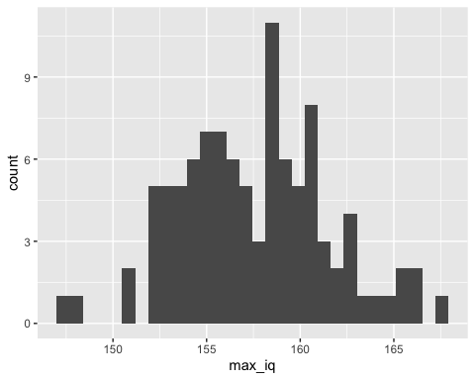

3. (3 points) Consider the classic statistical problem: Gambler’s ruin. (https://en.wikipedia.org/wiki/Gambler%27s_ruin). In simple terms, there is one person who plays a gambling game regarding the flip of a coin, and he can only place one dollar bet per round. If heads land, he wins one dollar, and he loses one dollar if the flip results in tails. He starts with one dollar, and he only ends the game under two conditions: if he reaches ten dollars or if he goes bankrupt. Use Monte Carlo simulations to simulate the probability of going bankrupt and expected winning per 10,000 games (multiplying the probability of winning by 10,000 is a simple solution).
game_bankrupt <- function(){
pocket <- 1
while (pocket > 0 && pocket < 10) {
flip <- sample(c("head", "tail"), size = 1)
if (flip == "head") pocket <- pocket + 1
else pocket <- pocket - 1
}
pocket == 0
}
set.seed(123)
p_bankrupt <- replicate(n = 10000, game_bankrupt()) |> mean()
paste("Prob of bankrupt =", round(p_bankrupt, 3)) |> print()
## [1] "Prob of bankrupt = 0.897"
paste("Expected winning per 10000 games =", round((1-p_bankrupt) * 10000, 3)) |> print()
## [1] "Expected winning per 10000 games = 1029"

4. (20 points) A trainer is trying to catch a rare Pokémon. Each Poké Ball throw catches the Pokémon with probability 0.07, independently of previous throws. Set the random seed as 2026. Answer the following sub-questions.

(a). (3 points) Use a Monte Carlo simulation with B <- 10000 to estimate the probability that the trainer catches the Pokémon within 30 throws.
set.seed(2026)
caught_in_30 <- function(){
throws <- sample(c("catched","not catched"),size=30,prob=c(0.07,1-0.07),replace=TRUE)
any(throws == "catched")
}
p_catched <- replicate(n = 10000, caught_in_30()) |> mean()
p_catched
## [1] 0.8834

(b). (2 points) Continuing from the previous question, use Monte Carlo simulation to estimate the expected number of throws required to catch the Pokémon.
set.seed(2026)
balls_to_caught <- function(){
n_throws <- 0
caught <- FALSE
while (!caught) {
n_throws <- n_throws + 1
caught <- sample(c(TRUE, FALSE), size = 1, prob = c(0.07, 1-0.07))
}
n_throws
}
e_throws <- replicate(n = 10000, balls_to_caught()) |> mean()
e_throws
## [1] 14.2162

(c). (3 points) Now let p_values <- seq(0.03, 0.15, by = 0.02). For each value of p, use Monte Carlo simulation to estimate the probability of catching the Pokémon within 30 throws. Then create a line plot with x-axis as catch probability p, and y-axis as the estimated probability of catching within 30 throws.
set.seed(2026)
p_values <- seq(0.03, 0.15, by=0.02)
caught_in_30 <- function(p){
throws <- sample(c("catched","not catched"),size=30,prob=c(p,1-p),replace=TRUE)
any(throws == "catched")
}
mc <- data.frame(
p = p_values,
prob_in_30s = sapply(p_values, function(p) {replicate(n = 10000, caught_in_30(p)) |> mean()})
)
mc |> ggplot() + geom_line(aes(x=p, y=prob_in_30s))
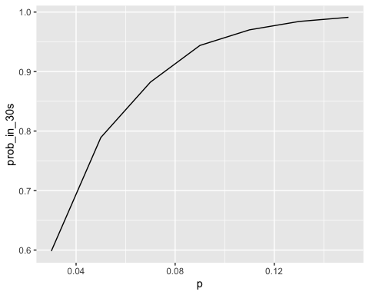

(d). (4 points) Now, suppose two trainers, Trainer Red and Trainer Blue, are playing a best-of-7 Pokémon battle series. The first trainer to win 4 battles wins the series. Suppose Trainer Red has probability 0.62 of winning each battle, independently of previous battles. Use a Monte Carlo simulation with B <- 10000 to estimate the probability that Trainer Red wins the series.
set.seed(2026)
red_win_4 <- function(){
games <- sample(c(T,F),size=7, prob=c(0.62,1-0.62), replace=T)
sum(games) >= 4
}
p_red_win <- replicate(n = 10000, red_win_4()) |> mean()
p_red_win
## [1] 0.7413

(e). (4 points) Now let p_values <- seq(0.50, 0.80, by = 0.05). For each value of p, use Monte Carlo simulation to estimate the probability that Trainer Red wins the best-of-7 series.Then create a line plot with x-axis as battle win probability p, and y-axis as the estimated probability of winning the series.
set.seed(2026)
p_values <- seq(0.5,0.8,by=0.05)
red_win_4 <- function(p){
games <- sample(c(T,F),size=7, prob=c(p,1-p), replace=T)
sum(games) >= 4
}
get_prob <- function(p){
replicate(n = 10000, red_win_4(p)) |> mean()
}
mc <- data.frame(
p = p_values,
prob_red_win = sapply(p_values, get_prob)
)
mc |> ggplot() + geom_line(aes(x=p, y=prob_red_win))
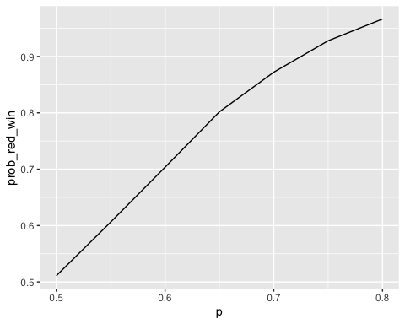

(f). (4 points) Now keep p <- 0.62, and let N <- seq(3, 15, by = 2). For each value of N, estimate the probability that Trainer Red wins a best-of-N series. Then create a line plot with x-axis as series length (best-of-N), and y-axis as the estimated probability of winning the series, and briefly describe the trend in sentence(s).
set.seed(2026)
p <- 0.62
Ns <- seq(3,15,by=2)
red_win_4 <- function(p,N){
games <- sample(c(T,F),size=N, prob=c(p,1-p), replace=T)
sum(games) >= (N+1)/2
}
get_prob <- function(N){
replicate(n = 10000, red_win_4(p,N)) |> mean()
}
mc <- data.frame(
N = Ns,
prob_red_win = sapply(Ns, get_prob)
)
mc |> ggplot() + geom_line(aes(x=N, y=prob_red_win))
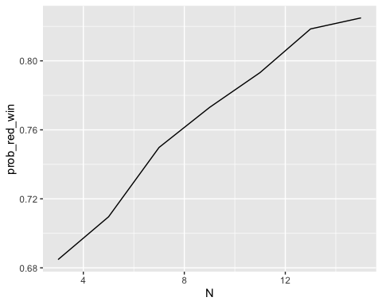

5. (12 points) Investigating the Regression-Correlation Relationship with Monte Carlo Simulation. In statistics, we often use both correlation and regression to understand relationships between variables. However, these two measures can behave differently under various conditions. In this problem, you’ll explore how sample size and outliers affect correlation coefficients and regression results using Monte Carlo simulation. Set the random seed as 2026. Answer the following sub-questions.

a. (4 points) Consider a simple linear relationship: Y = 2 + 0.8*X + ε, where X is normally distributed with mean = 10 and SD = 2, and ε (error term) is normally distributed with mean = 0 and SD = 1. Create the basic simulation with writing a function simulate_data(n) that: 1). Takes a sample size n as input; 2). Generates X from N(10, 2); 3). Generates Y using the relationship above; and 4). Returns a data frame with columns X and Y. Then, use this function with n = 50 to create one dataset, and: 1). Calculate the correlation between X and Y using cor(); 2). Fit a linear regression model using lm(Y ~ X); 3). Report both the correlation coefficient and the regression slope; and 4). Create a scatter plot with the regression line.
set.seed(2026)
sim_y <- function(x) {
2 + 0.8*x + rnorm(length(x))
}
simulate_data <- function(n) {
x <- rnorm(n,mean=10,sd=2)
y <- sim_y(x)
data.frame(X=x,Y=y)
}
df <- simulate_data(50)
cor_coef <- cor(df$X, df$Y)
slope <- coef(lm(Y~X, df))[2] |> as.numeric()
paste("Corr:", round(cor_coef, 3)) |> print()
## [1] "Corr: 0.874"
paste("Slope:", round(slope, 3)) |> print()
## [1] "Slope: 0.926"
df |> ggplot() +
geom_point(aes(x=X,y=Y)) +
geom_smooth(aes(x=X,y=Y),method='lm',se=F)
## `geom_smooth()` using formula = 'y ~ x'
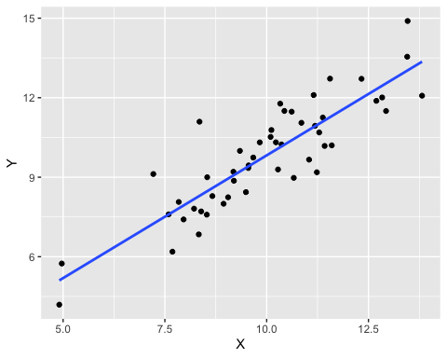

b. (4 points) Monte Carlo simulation for sampling distributions. Write a Monte Carlo simulation with B <- 1000 iterations to: 1). For each iteration, generate data with n <- 50 using your function from sub-question a above; 2). Calculate and store both the correlation coefficient and regression slope; 3). After all iterations, create two histograms side by side (use par(mfrow = c(1,2))): one for the distribution of correlation coefficients, and one for the distribution of regression slopes; and 4). Add vertical lines at the true values (correlation ≈ 0.85, slope = 0.8).
set.seed(2026)
cor_reg <- function() {
df <- simulate_data(50)
corr <- cor(df$X, df$Y)
slope <- coef(lm(Y~X, df))[2] |> as.numeric()
c(corr,slope)
}
df <- replicate(1000, cor_reg()) |> t() |> as.data.frame()
colnames(df) <- c('corr','slope')
par(mfrow = c(1, 2))
hist(df$corr, main = "Correlation", xlab = "corr", breaks=30)
abline(v = 0.85, col = "red", lwd = 2)
hist(df$slope, main = "Slope", xlab = "slope", breaks=30)
abline(v = 0.8, col = "red", lwd = 2)
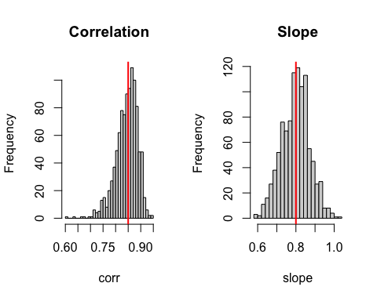

c. (4 points) Effect of outliers. Modify your simulation to investigate the effect of outliers: 1). Create a new function simulate_data_with_outliers(n, outlier_prob) that generates data as before and with probability outlier_prob, replaces Y with a value from N(30, 5); 2). Run a Monte Carlo simulation with B <- 1000, n <- 50, and outlier_prob <- 0.05; 3). Compare the distributions of correlation and slope with and without outliers; and 4). Create a table showing how outliers affect the mean and standard deviation of both statistics
set.seed(2026)
simulate_data_with_outliers <- function(n,outlier_prob) {
x <- rnorm(n,mean=10,sd=2)
is_outlier <- sample(c(T,F), n, prob=c(outlier_prob,1-outlier_prob), replace=T)
y <- ifelse(
is_outlier,
rnorm(n,mean=30,5),
sim_y(x)
)
data.frame(X=x,Y=y)
}
cor_reg_with_outliers <- function() {
df <- simulate_data_with_outliers(50,0.05)
corr <- cor(df$X, df$Y)
slope <- coef(lm(Y~X, df))[2] |> as.numeric()
c(corr,slope)
}
df <- replicate(1000, cor_reg()) |> t() |> as.data.frame()
colnames(df) <- c('corr','slope')
df_outliers <- replicate(1000, cor_reg_with_outliers()) |> t() |> as.data.frame()
colnames(df_outliers) <- c('corr','slope')
par(mfrow = c(2,2))
hist(df$corr, main = "Correlation", xlab = "corr", breaks=30)
hist(df$slope, main = "Slope", xlab = "slope", breaks=30)
hist(df_outliers$corr, main = "Correlation (with outliers)", xlab = "corr", breaks=30)
hist(df_outliers$slope, main = "Slope (with outliers)", xlab = "slope", breaks=30)
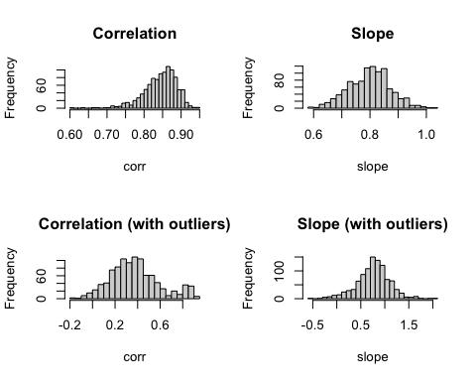
summarise_mean_sd <- function(d, label) {
data.frame(
variable = names(d),
dataset = label,
mean = sapply(d, mean),
sd = sapply(d, sd),
row.names = NULL
)
}
rbind(
summarise_mean_sd(df, "no_outliers"),
summarise_mean_sd(df_outliers, "with_outliers")
) |> arrange(variable)
## variable dataset mean sd
## 1 corr no_outliers 0.8443103 0.04348699
## 2 corr with_outliers 0.3768068 0.21738454
## 3 slope no_outliers 0.7986129 0.07291736
## 4 slope with_outliers 0.7583110 0.33756018

d. (4 points) Sample size effect. Investigate how sample size affects the stability of correlation and regression estimates: 1). Create a sequence of sample sizes: n_values <- c(10, 30, 50, 100, 200); 2). For each sample size, run a Monte Carlo simulation with B <- 500; 3). Calculate the standard deviation of both correlation coefficients and slopes for each sample size; and 4). Create a line plot showing how the variability of estimates decreases with sample size, with x-axis as Sample size (n) and y-axis as Standard deviation of estimates, and containing two lines: one for correlation variability, and one for slope variability.
n_values <- c(10, 30, 50, 100, 200)
set.seed(2026)
sim_y <- function(x) {
2 + 0.8 * x + rnorm(length(x))
}
simulate_data <- function(n) {
x <- rnorm(n, mean = 10, sd = 2)
y <- sim_y(x)
data.frame(X = x, Y = y)
}
cor_reg_n <- function(n) {
df <- simulate_data(n)
corr <- cor(df$X, df$Y)
slope <- as.numeric(coef(lm(Y ~ X, data = df))[2])
c(corr = corr, slope = slope)
}
sample_sd <- function(n, B = 500) {
sims <- replicate(B, cor_reg_n(n)) |> t() |> as.data.frame()
c(sd_corr = sd(sims$corr), sd_slope = sd(sims$slope))
}
mc <- sapply(n_values, sample_sd) |> t() |> as.data.frame()
mc$n <- n_values
library(tidyr)
mc |> pivot_longer(-n, names_to='stat', values_to='sd') |>
ggplot() +
geom_line(aes(x=n,y=sd,color=stat))
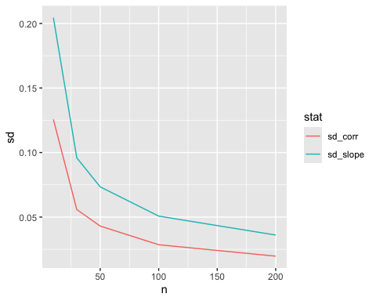

6. (10 points) Essay: (From Prof. RB Luo) In the mid-term exam, we tried something different. The use of RStudio was allowed. The use of Google and AI assistants like ChatGPT and Gemini was allowed. After all, as I mentioned in my lecture, if you can only take one thing away from this course, make it “knowing how to get started when given a data science problem”. But I am unsure how well the trial has worked out, especially from my students’ perspective. If you have attended the mid-term exam, how do you like the exam form? How would you like to improve the questions to help you to achieve the learning goals? If I ask you to be my TA and help me design the mid-term exam for next year’s class, what would you suggest? More generally, what improvements to the course would you suggest so I can do better the next year? Let me know your thoughts because when one teaches, two learn.
Exam form
In general, I like the exam being allowed for AI and RStudio. The questions are distributed evenly. Some are straight forward, basically can be answered by simply asking AIs. And some required more thinking and problem solving, but in fact also can be answered by AIs. So, the exam can be answered by AIs without much thinking. Students are more required to audit the output of AIs. This can be a good exercise of how to use AI properly.

