FINA4359 Assignment 1
Name:
Tsang Chun Kit (3036080288)
Tam Pai Lok (303592647)
Kan Chi Fu (3035807902)

Question 1: Asset Allocation
1.1 Based on Aswath Damodaran’s Historical Returns on Stocks, Bonds and Bills: 1928-2024
Correlation: Sharpe ratio and Annualized returns:
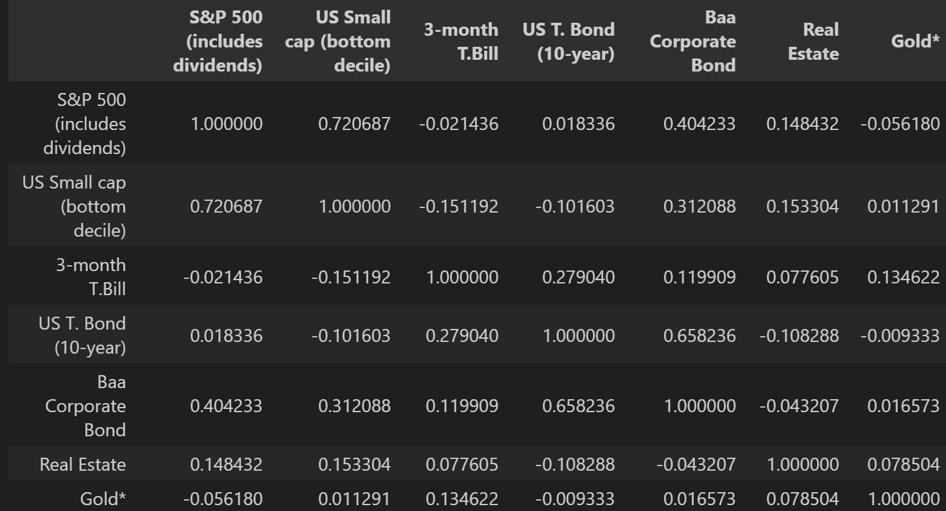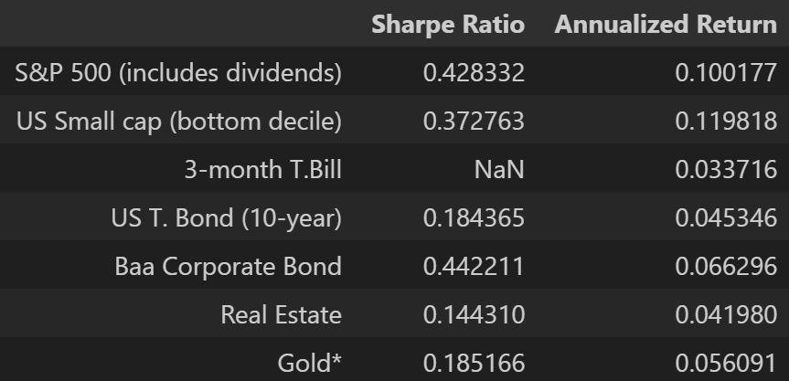

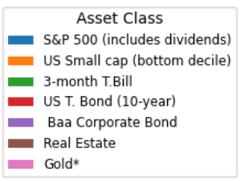
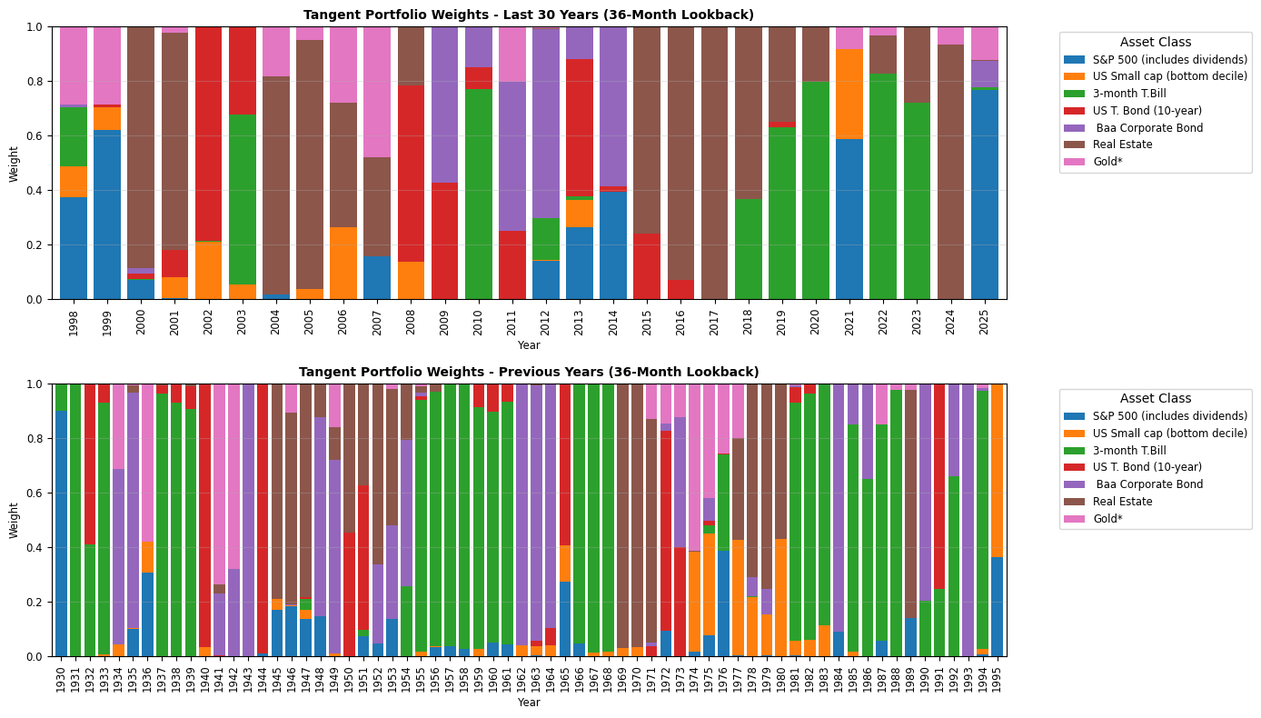
1.2 Assume optimal asset allocation by mean-variance, a 3-year lookback annual readjustment looks like the following (upper chart for last 30 years, lower chart for prior years)

It suggests optimal asset allocation with more real estate, with mean allocation of 34% over the 27 annual adjustments. In the prior period, T-Bill is more frequently and dominantly allocated, with a mean of 35%.
In the last 30 years, equities (both S&P500 and small cap) and gold stand out with cumulative returns of 1771%, 1419% and 1021% respectively.
According to JP Morgan, their 2026 CMA predicts the following 10-15 years return
 | US Large Cap | US Small Cap | US Cash | US 10-yr T-Bond | US Long Corporate Bond | U.S. Core Real Estate | Gold
Return | 6.7% | 6.9% | 3.1% | 4.6% | 5.4% | 8.2% | 5.5%
Y-o-Y change | 0 | 0 | 0 | +0.4% | +0.5% | +0.1% | +1.5%

BlackRock CMA provides 5, 10, 30 years returns with volatility prediction
Asset | 5yr ret | 10yr ret | 20yr ret | vol | gov bonds corr | equities corr
US Equities | 4.4% | 5.2% | 6.5% | 18.7% | -0.5% | 87.5%
US Real Estate | 5.7% | 5.8% | 6.0% | 10.8% | 25.1% | 62.5%
US Small Cap | 3.7% | 4.5% | 5.9% | 21.6% | -4.1% | 88.6%
T-Bill | 3.8% | 3.8% | 3.6% | 0 | 0 | 0
importance
- strategic compass by studying the past to guide the future, suggesting alternative investment beyond stock-bond to diversify and boost risk-adjusted return in the future
- disciplined framework for risk budgeting
- long term validation in balanced portfolio performance
fragility
- regime shift and unpredictability from economic nationalism, fiscal activism
- unstable and positive stock-bond correlation
- long term prediction can be adjusted greatly by years (see gold and bonds from JPM CMA)

1.4 Asset allocation - Equities (Stocks): 64%, Debt Securities (Bonds): 21%, Deposits & Cash: 15%
Geographical breakdown - HK: 59%, America: 13%, EU: 13%, Asia (ex-Japan,HK): 9%, Japan: 6%
Reasonableness: Not quite, 64% of equity is against usual 30-70, 40-60 (equity-bond) rules. 59% in HK is such a heavy weighting in one single market, moreover not the major US market but an Asia one. Such allocation lacks diversification, unable to diversify asset class risk and regional risk.
Rational reasons: 1. familiarity as HKers prefer assets they more understand and might invest better
2. avoid exchange rate risk by being heavy on HKD assets 3. accessibility and awareness for the MPFA educational campaign to promote the HK funds 4. HK strong rebound after 2008 Financial Crisis
Irrational reasons: 1. mental accounting: members separate their MPF form their other investment
2. Home bias: members feel more comfortable with known HK assets but over-concentrated

1.5 Typically it is advised to have a lower equity-bond ratio as age grows since the risk aversion level drops as people get older and capital accumulated, they won't hope to bear drawdown from volatility equities that will wipe out their years of accumulation and which may be their crucial wealth for living or retirement. Hence, there is a rule suggesting "100 - age" percent in equities.
Given a median age of 41 in 2009-10, a 64% equity allocation for the entire system is slightly aggressive but reasonable. Considering that MPF only takes up a very limited part of people's salary and total wealth, HK people at that time and age used to make deposits in banks which in turn lowers the equity-bond ratio as a total.
1.6 Assume Hong Kong equities fall to the GreaterChinaEquity category in the data and the global equity fund is the GlobalEquityLargeCap, then the overall total return of global beats the HK equities by 12% over the 2001-2024 period. To mimic the fact that people monthly contribute part of salary to MPF, by approximating an annual constant contribution (lack of monthly return), the IRR of global and Greater China equity are 6% and 2.78% respectively, further showing the superiority of global equity. An adjustment of 3% contribution growth per year gives IRR of 3.05% and -0.72%.

Question 2: Smart Beta ETFs

2.1 Beta for UMD factor is estimated to be 0.4314 by regressing SPMO’s daily return with respect to momentum factor downloaded from CRSP. This does not mean the portfolio is broken given the long-only nature of SPMO. UMD factor considers long-short portfolio, hence it makes sense that the long-only nature of SPMO entitles only a partial momentum premium.
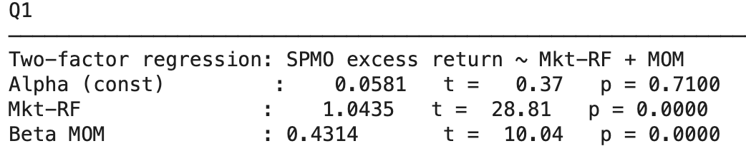

2.2 “The Invesco S&P 500® Momentum ETF (Fund) is based on the S&P 500 Momentum Index (Index). The Fund generally will invest at least 90% of its total assets in the securities that comprise the Index. The Index tracks the performance of stocks in the S&P 500® Index that have a high "momentum score". The Fund and Index are reconstituted and rebalanced twice a year on the third Fridays of March and September. Constituents are weighted by their market capitalization and their momentum score.”
The difference comes from the position difference and the underlying asset. UMD is long-short strategy while SPMO is long-only. Also SPMO focuses only on the companies in S&P500 index while there is no constraints in UMD’s universe. Rebalancing frequency of SPMO is also lower (twice a year) while UMD adjusts monthly.

2.3 Skipped

2.4
Betas:
SMB: -0.1465 (stat sig) - constitutes companies from S&P 500 only
HML: 0.0346 (stat insig) - portfolio construction irrelevant to companies’ book-to-market value
UMD: 0.3992 (stat sig) - weakens from 0.4314, introducing more factors reduces the explanatory power
Mkt-rf: 1.0655 (stat sig)
Correcting the long bias does not fix the beta to the market, instead it reduces the residual alpha from 0.0581 to 0.0127.
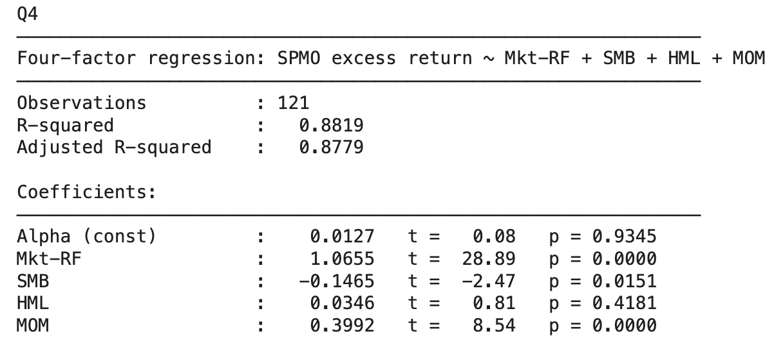

2.5

Two ETFs chosen are MTUM and JMOM.

JMOM selects U.S. small- and mid-cap stocks in Russell 1000 exhibiting strong momentum while enforcing sector diversification, resulting in a balanced, investable momentum tilt with less extreme factor exposures than narrower or more aggressive momentum ETFs.

JMOM’s Betas:
MOM: 0.2123 (stat sig) - effective capture of momentum premium
Mkt-rf: 1.0408 (stat sig)
SMB & HML: 0.0343 & -0.0308(both stat insig) - risk-adjusted nature of portfolio makes exposure balanced
CMA: -0.1038(stat sig) - small firm’s (RUSS1000) general practice in first-invest-then-expand style
RMW: -0.0012(stat insig) - unprofitability of small firms.
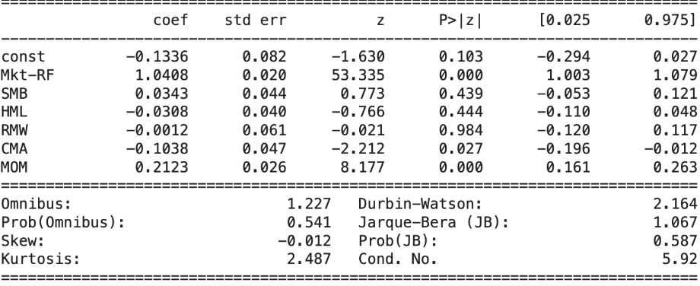

MTUM seeks to track the performance of the MSCI USA Momentum SR Variant Index. This index selects and weights U.S. large- and mid-capitalization stocks that exhibit relatively higher price momentum compared to the broader market.

MTUM’s Betas:
MOM: 0.4444(stat sig) - capture of momentum premium
Mkt-rf : 1.0868 (stat sig)
SMB & HML: -0.0344 & 0.0070(both stat insig) - risk-adjusted nature of portfolio makes exposure balanced
RMW & CMA: -0.0932 & 0.0232(both stat insig) - momentum strategies' typical aversion to deep value or high-investment stocks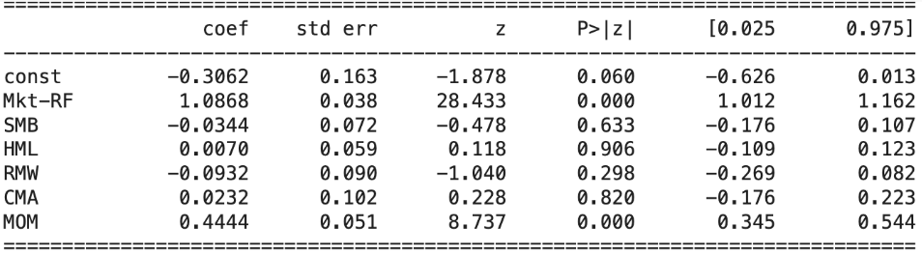

Question 3: Performance attribution
FF5 benchmarking
Conceptually, FF5 is not a good (comprehensive) benchmark for a global macro fund. Macro invests in all asset classes across regions, not just US equities, while FF5 only constructed the factors with US equities. While FF5 might still explain part of the returns, because (1) US equities is a subset in the macro universe, (2) FF5 factors may capture some latent factors (macro regimes, investor sentiments, etc.).

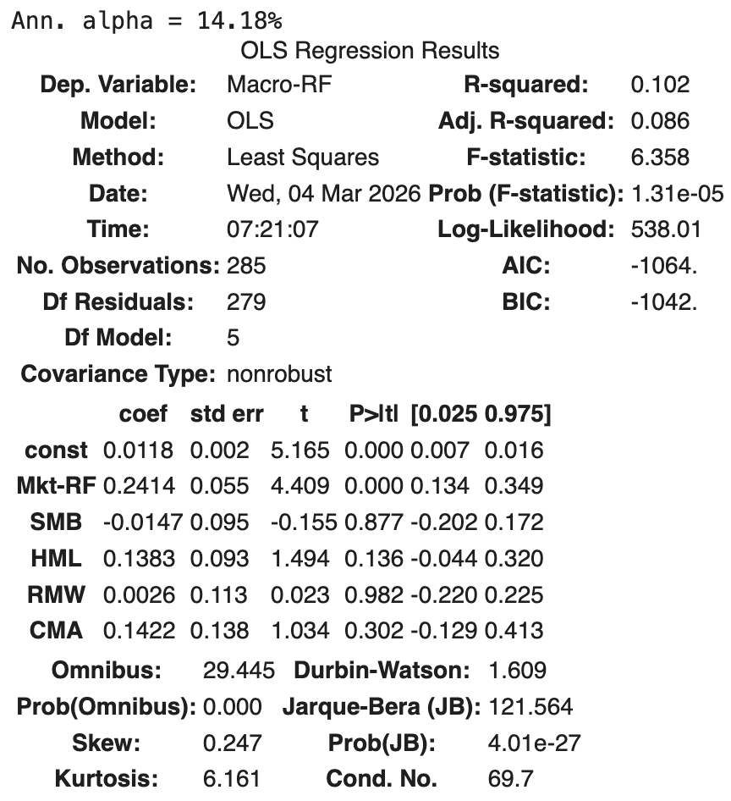
FF5 can be reasonable for investors whose core portfolio / business is already correlated to US market - alpha against FF5 adds uncorrelated returns to their portfolio. For example, US pensions that primarily invest in US equity, US big corp that are sensitive to US market cycles (high beta)
FF5 is inappropriate when investors have access to global assets. For example, benchmarking against peer macro funds, investors that allocate assets globally.

As expected, only 10% returns are explained, resulting in a significantly high alpha (14.18% ann.) relative to the US equity market. Only the market factor has a significant positive loading (0.24), part of the fund's return comes from long US market. Other than that, none of the loadings are significant. HML has a relatively less insignificant positive loading (0.14), indicating the fund may have some value play in US equities.

Custom benchmark
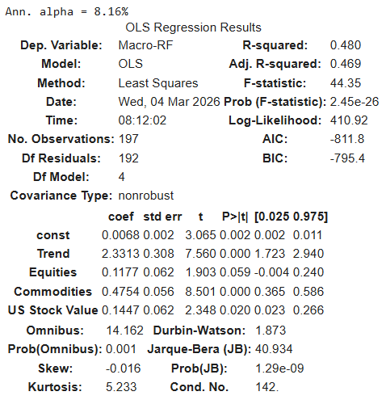
The custom benchmark uses 4 factors collected from Bloomberg (1) and AQR’s “How do factor premia vary over time? A century of evidence” (3):
- Trend - (BSLXAT Index) Bloomberg index applying trend following strategy on futures (time series momentum), allocating equal risks to equities / fixed incomes / currencies / commodities. A common factor captured by global macro funds such as CTAs. Behavioral interpretation is more convincing - underreaction (anchoring) and subsequent overreaction (herding) may lead to price move continuation. (Understanding Alternative Risk Premia, AQR)
- Equities - (Equity indices) AQR constructed a portfolio of 43 equity market indices to get the equity market factor. Risk premia interpretation - compensation for bearing non-diversifiable risks in global indices. (Equity Risk Premia Across Major International Markets, IM Gameiro)
- Commodities - AQR constructed a portfolio of 30 commodity futures (consists of spot and roll-down return) to get the commodity market factor. Risk premia interpretation - roll yields created by commodities producers hedging price fluctuations. (The Commodity Futures Risk Premium, Bhardwaj et al.)
- US Stock Value - AQR used book-to-market ratio following FF5 to construct long/short portfolio using US single stocks. Risk premia interpretation - compensation for higher distress and cash flow risks for value firms. (Size and Book-to-Market Factors in Earnings and Returns, Fama and French)
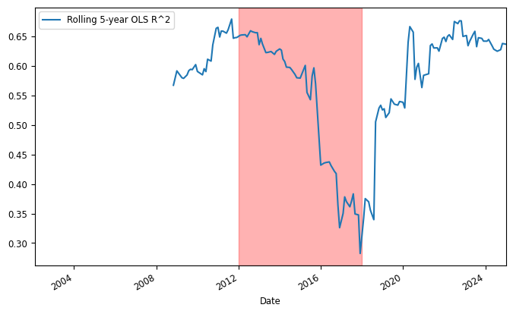
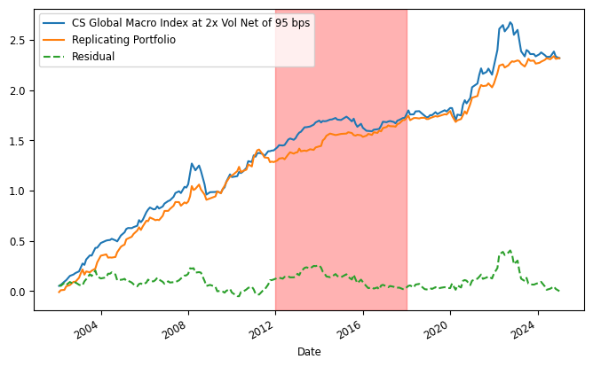
About half of the return is replicated with the custom benchmark. R^2 is 48% for the custom model, improved 38% relative to FF5. All loadings are significantly positive. The improvements mostly come from the loadings to trend and commodities, in addition to equity and value in FF5. Running a rolling 5-year regression, showing the factor explainability is worst in 2012-2018, dropped from 60% to 30%, implying the fund might have some non-factor premia trades during the period, producing alphas. Except the period, risk premia still contribute ⅔ of the returns.

