Voyant – Ember Sample App Ember 1.13.5

Create a simple single page javascript CRUD application using the Ember JS framework.

Ember JS –http://www.emberjs.com/

Ember Command Line Interface (CLI) - <http://www.ember-cli.com/>

(I’ve included an Ember quickstart at the end of this document)

The sample app consists of just two screens/views – a dashboard and a data entry view (in this case for employment items).

Dashboard – Contains links to edit pages for model items and a total for each type of model item entered. In this example app, only the Employment row will be implemented. Clicking “Employment” should navigate to the Employment data entry view. The value shown in the employment row should be the sum of all employment items entered.

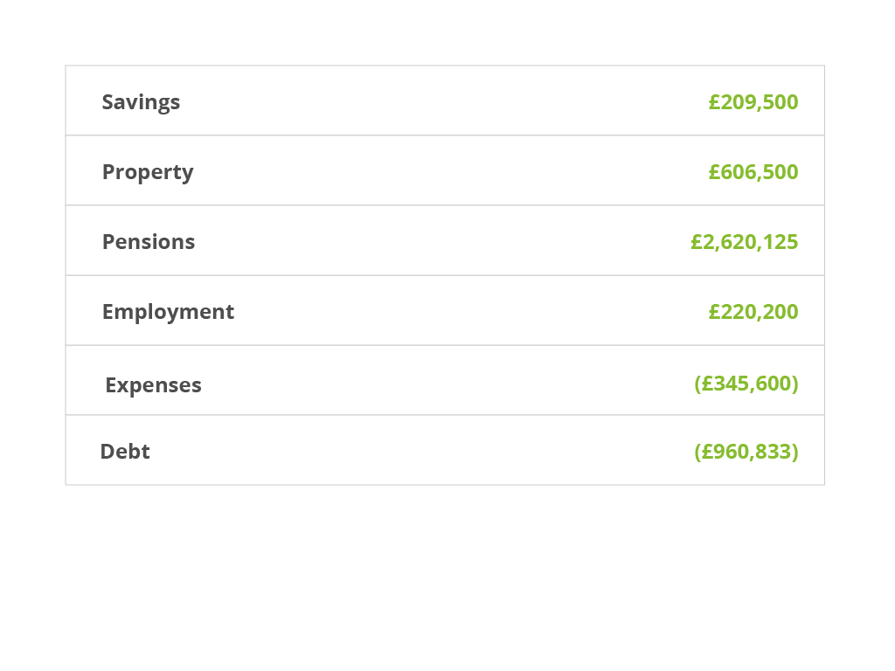

Employment View – Contains a list of all employment items entered and allows for adding, editing, and deleting items.

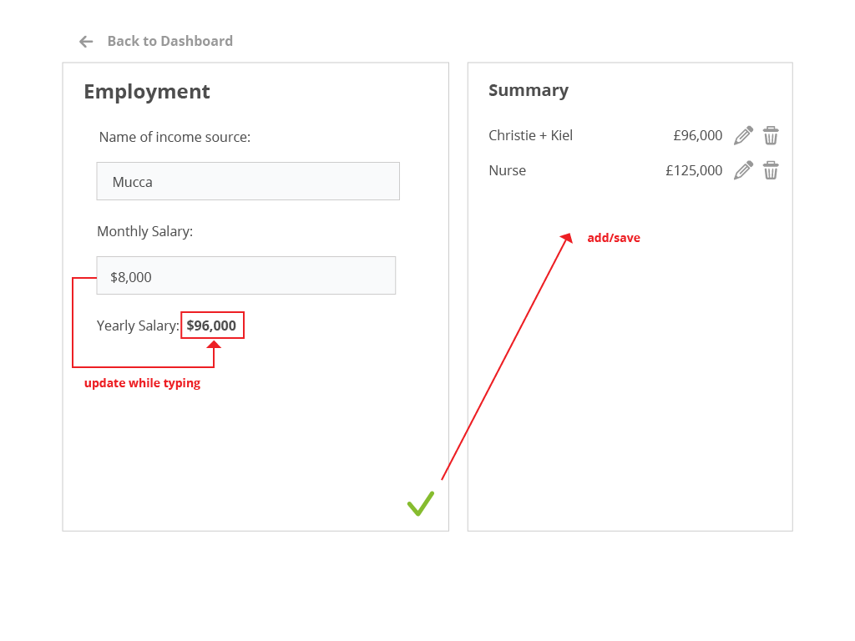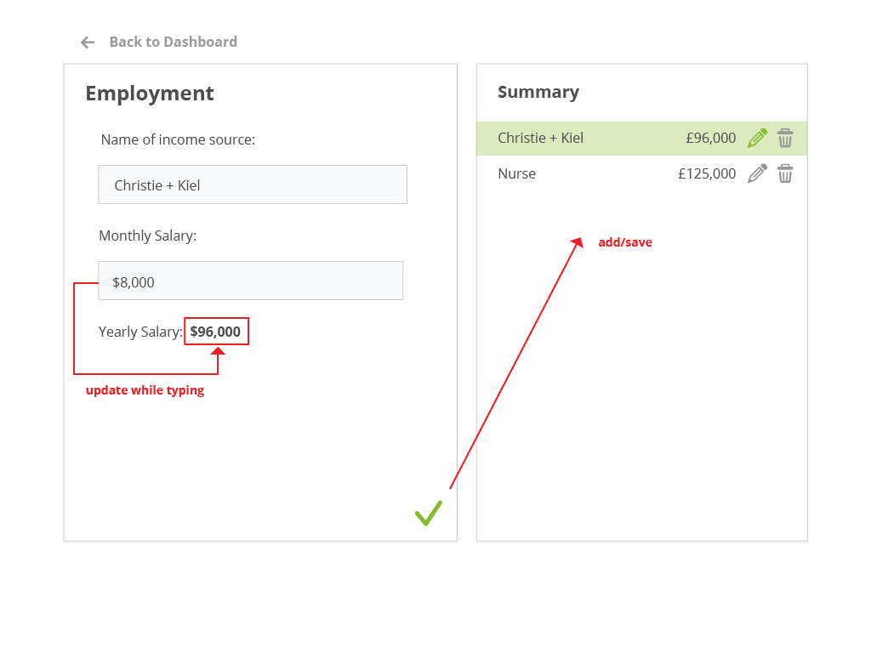

The exercise is fairly open and I’m not concerned at all with the styling. Below are the few requirements for your solution:

* Use Ember.js as the javascript framework to create a single-page application (i.e. navigation between the employment page and dashboard page should not cause a browser page refresh and should not lose data entered on the employment screen)
* Employment items should be stored locally using Ember Data and should be pre-initialized with a couple fixture items
* The employment page should be able to load directly to one of the pre-initialized Employment items
* On the employment page, use a component to facilitate the conversion of the inputted monthly amount to the displayed yearly value

Ember Command Line Interface Quickstart:

1. Install Node.js – <https://nodejs.org/download/>
2. Install Ember CLI using npm

*npm install -g ember-cli*

1. Create the boilerplate application structure

ember new voy-sample-app

1. Navigate to the top level app directory and create the two routes and the employment model

ember generate resource employment

ember generate route dashboard

1. Start the ember server. The application will then be available at <http://localhost:4200/>