AI ASSISTED CODING ASSIGNMENT-6
Name : K.Chaithra
RollNO: 2503A52711
Batch: 24

#q1
Task: Use an AI code completion tool to generate a loop-based
program.
Prompt: Generate Python code to print all even numbers between 1 and N
using a loop.
Code:
number = int(input("Enter N: "))
for value in range(2, number + 1, 2):
print(value)
output:
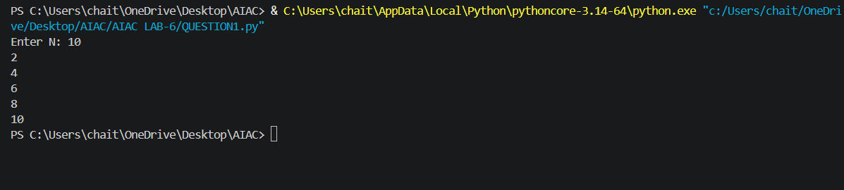

#q2
Task: Use an AI code completion tool to combine loops and
conditionals.
Prompt: Generate Python code to count how many numbers in a list are even and odd.
Code:
numbers = list(map(int, input("Enter numbers separated by spaces: ").split()))
even_count = 0
odd_count = 0
for number in numbers:
if number % 2 == 0:
even_count += 1
else:
odd_count += 1
print("Even numbers:", even_count)
print("Odd numbers:", odd_count)
output:
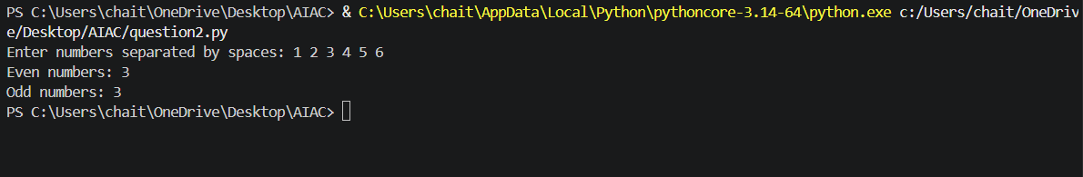

#q3
Task: Use an AI tool to complete a Python class that validates user
input.
Prompt: Generate a Python class User that validates age and email using
conditional statements.
Code:
class User:

def __init__(self, name, age, email):
if age < 18:
raise ValueError("Age must be at least 18.")
if "@" not in email or "." not in email.split("@")[-1]:
raise ValueError("Email must be in a valid format.")
self.name = name
self.age = age
self.email = email
def __str__(self):
return f"User(name={self.name}, age={self.age}, email={self.email})"
def verify_user(name, age, email):
"""Create a user and display whether validation succeeded."""
try:
user = User(name, age, email)
print(f"Valid: {user}")
except ValueError as error:
print(f"Invalid: {error}")
verify_user("Alice", 25, "alice@example.com")
verify_user("Bob", 16, "bob@example.com")
verify_user("Charlie", 30, "charlie.example.com")
verify_user("Diana", 22, "diana@example")
output:
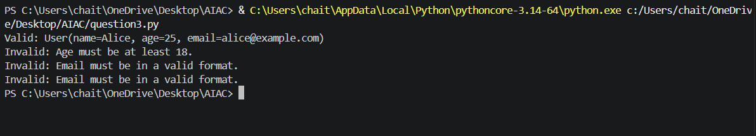

#q4
Task: Use an AI code completion tool to generate a Python class for
managing student details.
Prompt: Generate a Python class Student with attributes (name, roll number, marks) and methods to calculate total and average marks.
Code:
class Student:
def __init__(self, name: str, roll_number: int, marks: list[float]):
self.name = name
self.roll_number = roll_number
self.marks = list(marks)
def total_marks(self) -> float:
"""Return the sum of all marks."""
return sum(self.marks)
def average_marks(self) -> float:
"""Return the average mark, or 0.0 when no marks are present."""
if not self.marks:
return 0.0
return self.total_marks() / len(self.marks)
if __name__ == "__main__":
student = Student("Aisha", 101, [85, 90, 88])
print(f"Total marks: {student.total_marks()}")
print(f"Average marks: {student.average_marks():.2f}")
output:
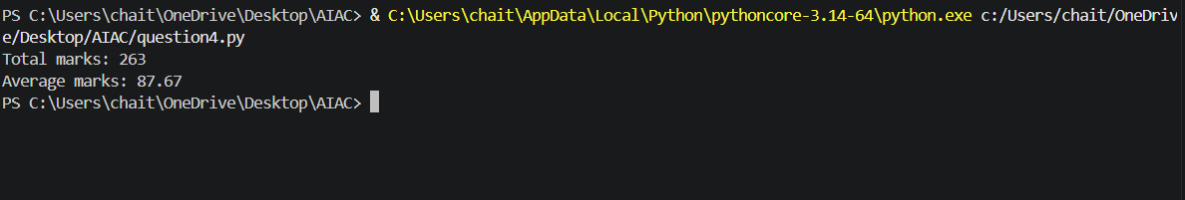

#q5
Task: Use an AI tool to generate a complete Python program using
classes, loops, and conditionals together.
Prompt:
Generate a Python program for a simple bank account system using
class, loops, and conditional statements.
Code:
class BankAccount:
def __init__(self, account_holder: str, balance: float = 0.0):
self.account_holder = account_holder
self.balance = balance
def deposit(self, amount: float) -> None:
if amount > 0:
self.balance += amount
print(f"Deposited: ${amount:.2f}")
else:
print("Deposit amount must be greater than zero.")
def withdraw(self, amount: float) -> None:
if amount <= 0:
print("Withdrawal amount must be greater than zero.")
elif amount > self.balance:
print("Insufficient balance.")
else:
self.balance -= amount
print(f"Withdrawn: ${amount:.2f}")
def show_balance(self) -> None:
print(f"Current balance: ${self.balance:.2f}")
def main() -> None:
account_holder = input("Enter account holder name: ")
account = BankAccount(account_holder)
while True:
print("\n1. Deposit")
print("2. Withdraw")
print("3. Check balance")
print("4. Exit")
choice = input("Choose an option: ")
if choice == "1":
account.deposit(float(input("Enter deposit amount: $")))
elif choice == "2":
account.withdraw(float(input("Enter withdrawal amount: $")))
elif choice == "3":
account.show_balance()
elif choice == "4":
print(f"Goodbye, {account.account_holder}!")
break
else:
print("Invalid option. Please choose 1, 2, 3, or 4.")
if __name__ == "__main__":
main()
output:
