AI ASSISTED CODING ASSIGNMENT-7.1
Name: K.Chaithra
Roll No: 2503A52711
Batch:24
#Q1
Task: Provide a Python snippet with a missing parenthesis in a print
statement (e.g., print &quot;Hello&quot;). Use AI to detect and fix the syntax
error.
# Bug: Missing parentheses in print statement
def greet():
print &quot;Hello, AI Debugging Lab!&quot;
greet()
Week4 -
Monday
Requirements:
• Run the given code to observe the error.
• Apply AI suggestions to correct the syntax.
• Use at least 3 assert test cases to confirm the corrected code
works.
Prompt: Provide a Python snippet with a missing parenthesis in a print
statement (e.g., print &quot;Hello&quot;). Use AI to detect and fix the syntax
error.
Code:
def greet():
message = "Hello, AI Debugging Lab!"
print(message)
return message
result = greet()
assert isinstance(result, str)
assert result == "Hello, AI Debugging Lab!"
assert "AI Debugging" in result
output:
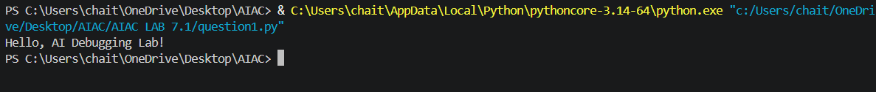
#q2
Task: Supply a function where an if-condition mistakenly uses =
instead of ==. Let AI identify and fix the issue.
# Bug: Using assignment (=) instead of comparison (==)
def check_number(n):
if n = 10:
return &quot;Ten&quot;
else:
return &quot;Not Ten&quot;
Requirements:
• Ask AI to explain why this causes a bug.
• Correct the code and verify with 3 assert test cases.
Prompt: Supply a function where an if-condition mistakenly uses =
instead of ==. Let AI identify and fix the issue.
Code:
def check_number(n):
if n == 10:
return "Ten"
else:
return "Not Ten"
assert check_number(10) == "Ten"
assert check_number(5) == "Not Ten"
assert check_number(-10) == "Not Ten"
print("All 3 tests passed.")
output:
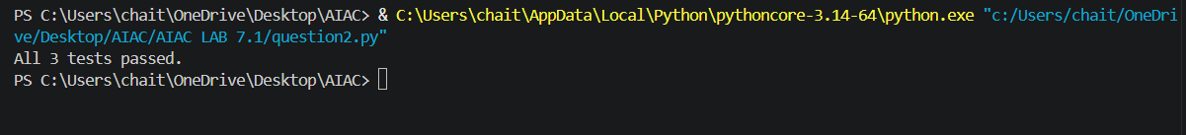
#q3
Task: Provide code that attempts to open a non-existent file and
crashes. Use AI to apply safe error handling.
# Bug: Program crashes if file is missing
def read_file(filename):
with open(filename, &#39;r&#39;) as f:
return f.read()
print(read_file(&quot;nonexistent.txt&quot;))
Requirements:
• Implement a try-except block suggested by AI.
• Add a user-friendly error message.
• Test with at least 3 scenarios: file exists, file missing, invalid
path.
Prompt: Provide code that attempts to open a non-existent file and
crashes. Use AI to apply safe error handling.
Code:
from pathlib import Path
from tempfile import TemporaryDirectory
def read_file(filename):
try:
with open(filename, "r", encoding="utf-8") as file:
return file.read()
except FileNotFoundError:
print(f"Error: The file '{filename}' was not found.")
except IsADirectoryError:
print(f"Error: '{filename}' is a directory, not a file.")
except ValueError:
print("Error: The file path cannot be empty or invalid.")
except OSError as error:
print(f"Error: Could not read '{filename}': {error}")
return None
if __name__ == "__main__":
with TemporaryDirectory() as temp_dir:
existing_file = Path(temp_dir) / "example.txt"
existing_file.write_text("This file exists.", encoding="utf-8")
print("Scenario 1 - existing file:")
print(read_file(existing_file))

print("\nScenario 2 - missing file:")
print(read_file(Path(temp_dir) / "nonexistent.txt"))
print("\nScenario 3 - invalid path:")
print(read_file(""))
output:
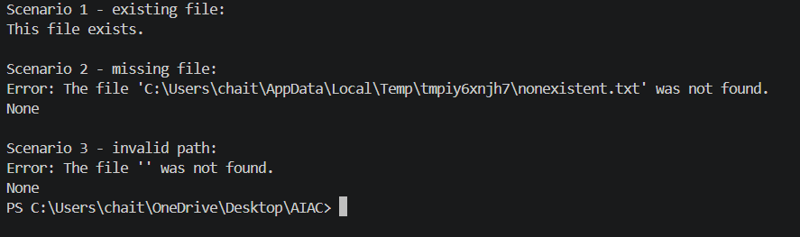
#q4
Task: Give a class where a non-existent method is called (e.g.,
obj.undefined_method()). Use AI to debug and fix.
# Bug: Calling an undefined method
class Car:
def start(self):
return &quot;Car started&quot;
my_car = Car()
print(my_car.drive()) # drive() is not defined
Requirements:
• Students must analyze whether to define the missing method
or correct the method call.
• Use 3 assert tests to confirm the corrected class works.
Prompt: Give a class where a non-existent method is called (e.g.,
obj.undefined_method()). Use AI to debug and fix.
Code:
class Car:
def start(self):
return "Car started"
my_car = Car()
print(my_car.start())
assert isinstance(my_car, Car)
assert callable(my_car.start)
assert my_car.start() == "Car started"
output:
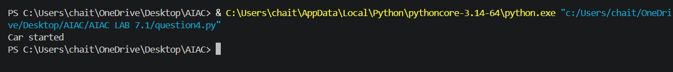

#q5
Task: Provide code that adds an integer and string (&quot;5&quot; + 2) causing
a TypeError. Use AI to resolve the bug.
# Bug: TypeError due to mixing string and integer
def add_five(value):
return value + 5
print(add_five(&quot;10&quot;))
Requirements:
• Ask AI for two solutions: type casting and string
Prompt: Provide code that adds an integer and string (&quot;5&quot; + 2) causing a TypeError. Use AI to resolve the bug.

Code:
def add_five_as_number(value: str) -> int:
"""Convert the input to an integer before adding five."""
return int(value) + 5
def add_five_as_string(value: str) -> str:
"""Convert five to a string before concatenating it with the input."""
return value + str(5)
value = "10"
print("Type casting solution:", add_five_as_number(value))
print("String solution:", add_five_as_string(value))
output:
