AI ASSISTED CODING (ASSIGNMENT-2.1)

Name: K. Chaithra
Roll No: 2503A52711
Batch:24

Task1:
Scenario:
You are a data analyst intern working with survey responses stored as numerical lists.

Task:
Use Google Gemini in Colab to generate a Python function that reads a list of numbers and calculates the mean, minimum, and maximum values.
Prompt: generate a Python code that reads a list of numbers and calculates the mean, minimum, and maximum values.
Code:
numbers = list(map(float, input("Enter numbers separated by spaces: ").split()))
if numbers:
print("Mean:", sum(numbers) / len(numbers))
print("Minimum:", min(numbers))
print("Maximum:", max(numbers))
else:
print("No numbers entered.")
Output:
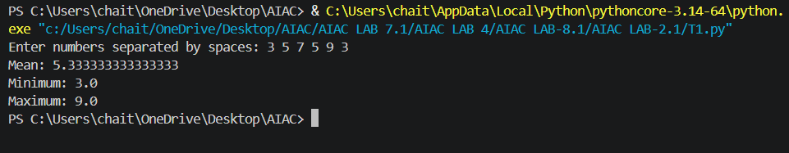

Task2:
Scenario:
You are evaluating AI tools for numeric validation logic.
Task:
Generate an Armstrong number checker using Gemini and GitHub Copilot.
Compare their outputs, logic style, and clarity.
Prompt: Generate a python code to check whether a given number is an Armstrong number.
Code:
def is_armstrong(number):
if number < 0:
return False
digits = str(number)
power = len(digits)
total = sum(int(digit) ** power for digit in digits)
return total == number
number = int(input("Enter a number: "))
if is_armstrong(number):
print(f"{number} is an Armstrong number.")
else:
print(f"{number} is not an Armstrong number.")
output:
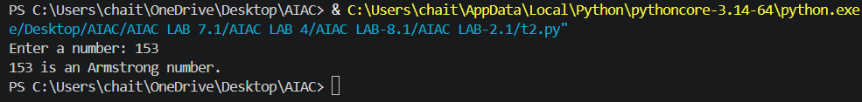
Task3:
Leap Year Validation Using Cursor AI
- Scenario:
You are validating a calendar module for a backend system.
- Task:
Use Cursor AI to generate a Python program that checks whether a given year is a leap year.
Use at least two different prompts and observe changes in code.
Prompt1: Write a Python program to check whether a given year is a leap year or not.
Prompt2: Create a simple Python program that takes a year from the user and prints whether it is a leap year.
Code1:
def is_leap_year(year):
return year % 400 == 0 or (year % 4 == 0 and year % 100 != 0)
year = int(input("Enter a year: "))
if is_leap_year(year):
print(f"{year} is a leap year.")
else:
print(f"{year} is not a leap year.")
output1:
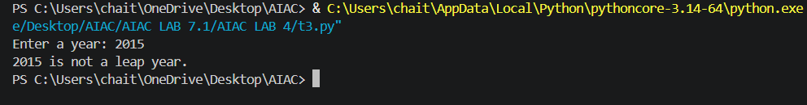
Code2:
import calendar

year = int(input("Enter a year: "))
result = calendar.isleap(year)
print(f"{year} is a leap year." if result else f"{year} is not a leap year.")
output:
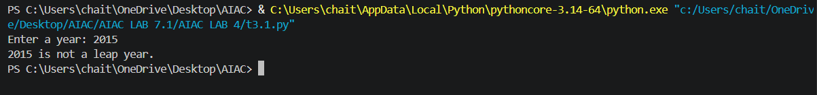
Task4:
Student Logic + AI Refactoring (Odd/Even Sum)
Scenario:
Company policy requires developers to write logic before using AI.
Task:
Write a Python program that calculates the sum of odd and even numbers in a tuple, then refactor it using any AI tool.
Prompt: generate a Python program that calculates the sum of odd and even numbers in a tuple, then refactor it using any AI tool.
Code:
numbers = (1, 2, 3, 4, 5, 6, 7, 8, 9, 10)
odd_sum = 0
even_sum = 0
for number in numbers:
if number % 2 == 0:
even_sum += number
else:
odd_sum += number
print("Sum of odd numbers:", odd_sum)
print("Sum of even numbers:", even_sum)
odd_sum = sum(number for number in numbers if number % 2 != 0)
even_sum = sum(number for number in numbers if number % 2 == 0)
print("Refactored result:")
print("Sum of odd numbers:", odd_sum)
print("Sum of even numbers:", even_sum)
output:
