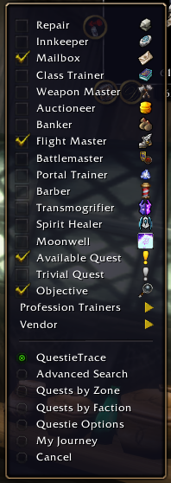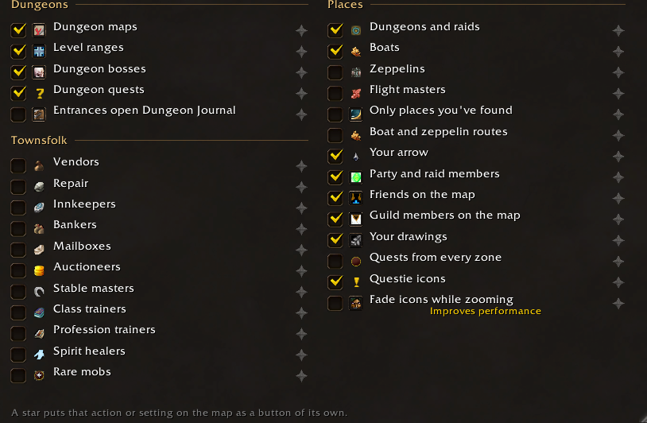
This is the list of map items for questie and open map. These are the items that should show up in the in game drop down menu with no duplicates. I want it in the style and layout of the questie one on the list. It currently resembles openmaps with the unneeded category headers. Dungeons is the only think I want under its own section within the dropdown. Something to keep in mid for icons. Questie and open maps both ship icons. Don’t overlap them. We will deal with advance search, quest by zone and faction, my journey and opytions further down. They should not show in the dropdown though.
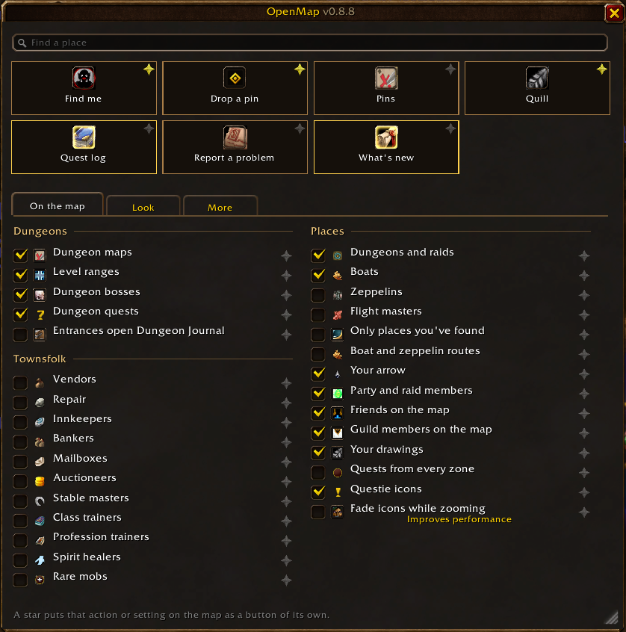
Im a big fan of this settings page and would like it to serve as the core for all settings. (openmaps settings panel.
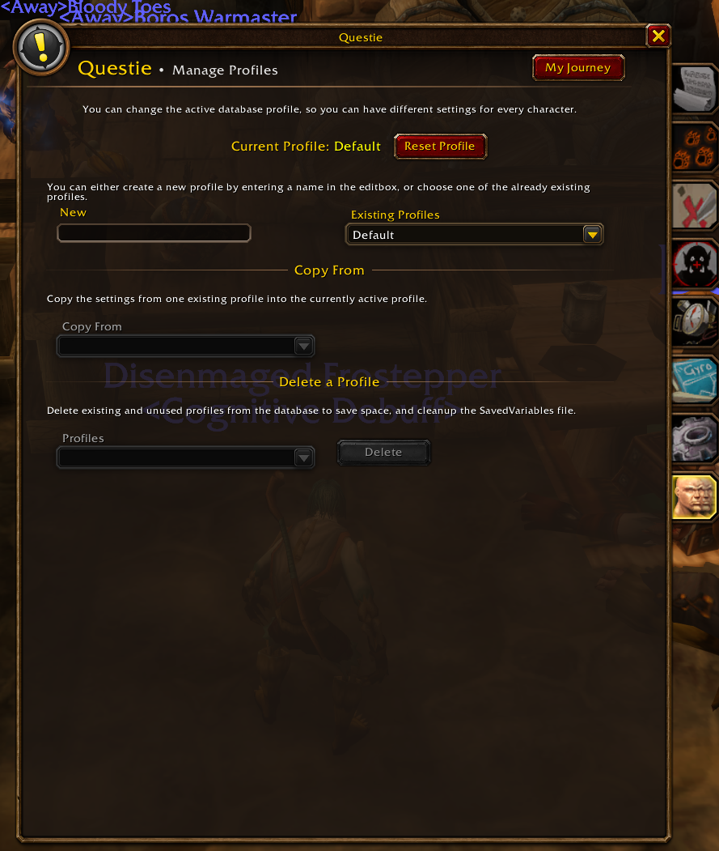
For example do you see those tabs on the right hand side of questies settings? We could add those to the open maps settings pane. One tab for openmaps settings, 1 tab for quest settings, 1 tab for book settings, 1 tab that has questis journey, quest window features. Pictured below
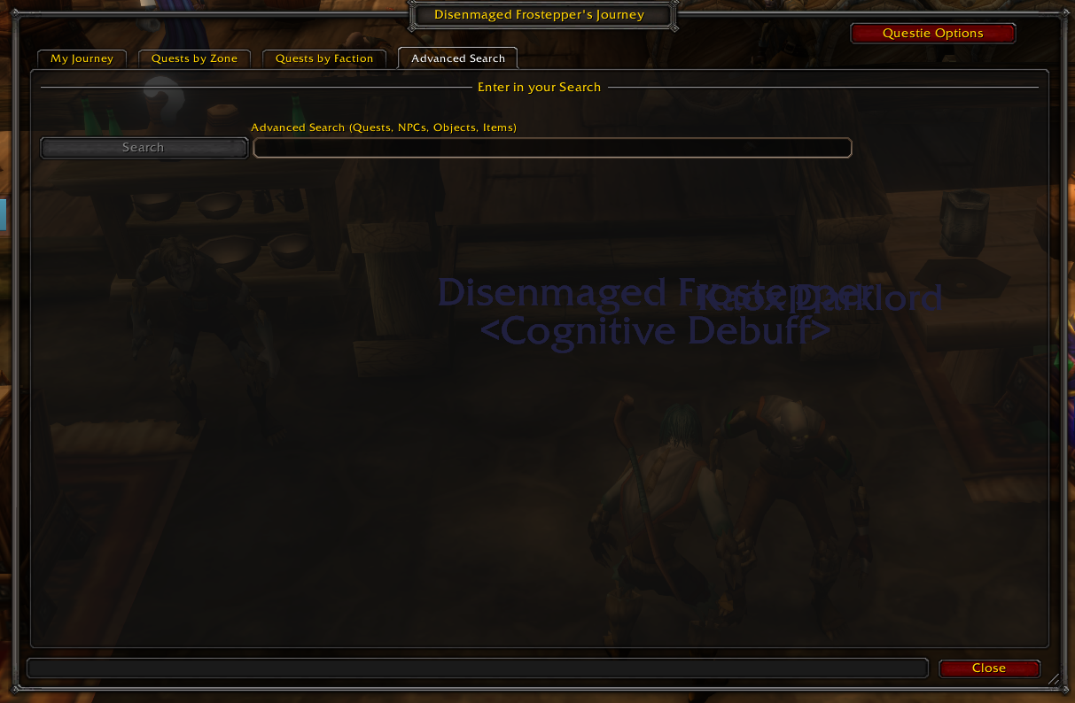
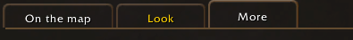
Then those separate tabs from questie and books could be put under tabs like this.



