**Issue 01.**

**Title**: When user enter numbers in left side tile then system display incorrect output

**Steps to reproduce:**

1. Navigate google translate page
2. Click on text tab
3. Select detect language as “English”
4. Select translate language as “sinhala”
5. Enter any number in left hand side tile

**Actual result**: System provide incorrect Output 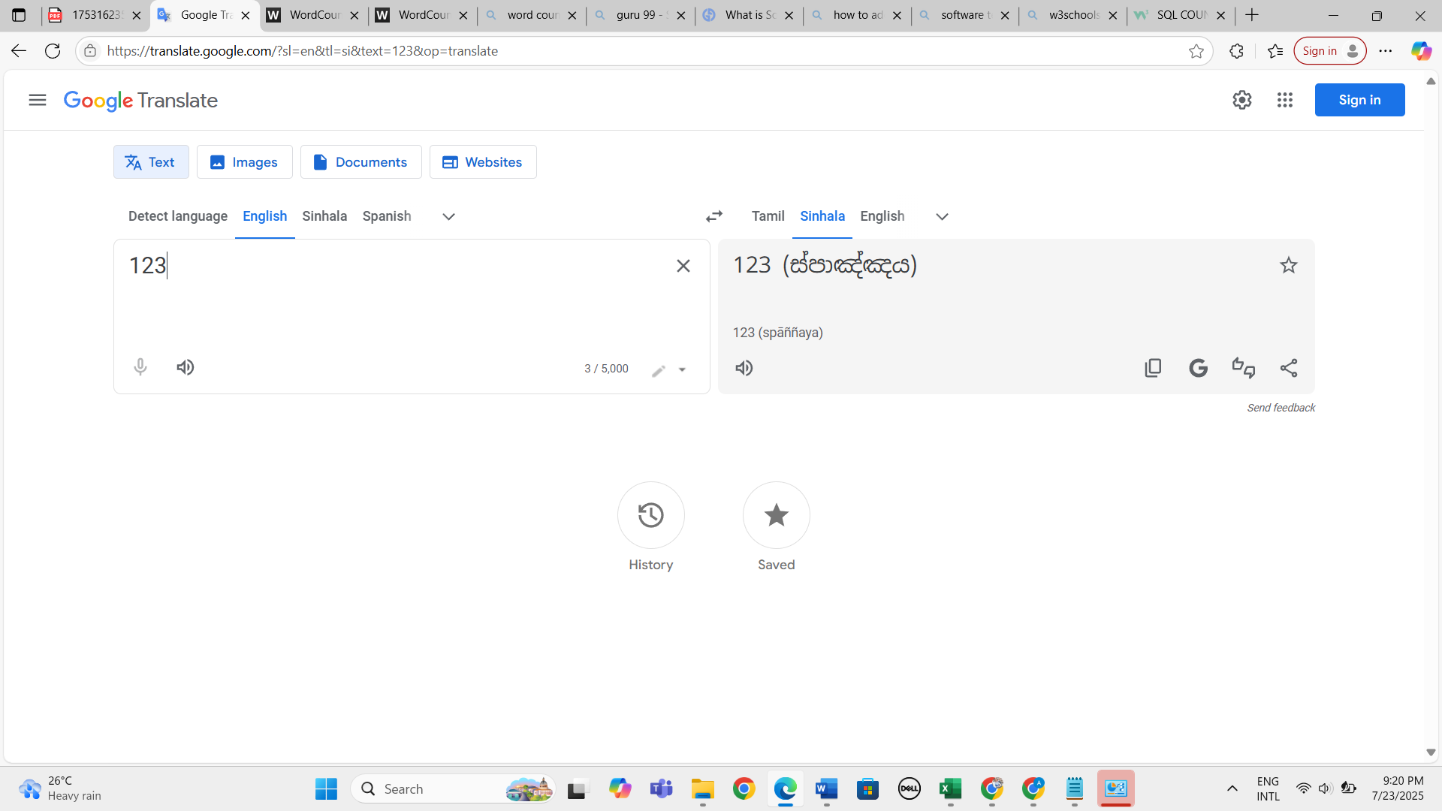

Expected result: 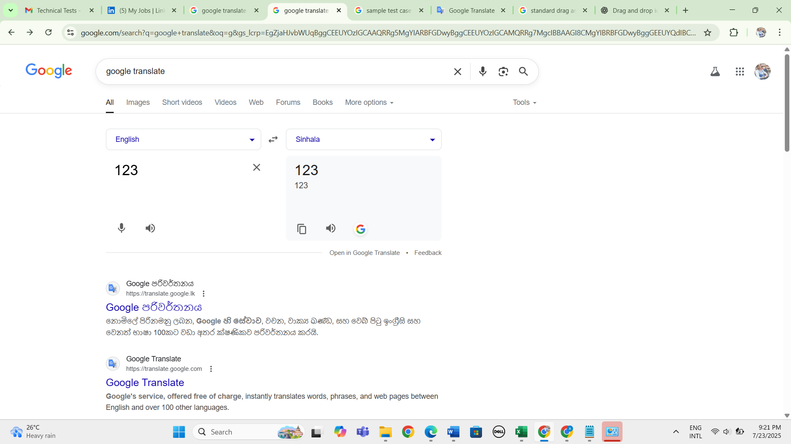

**Issue 02**

**Title**: Swap functionality is not working properly

**Steps to reproduce**

1. Navigate google translate page
2. Click on text tab
3. Select detect language as “English”
4. Select translate language as “sinhala”
5. Enter any number in left hand side tile
6. Click on swap icon

**Actual result:**

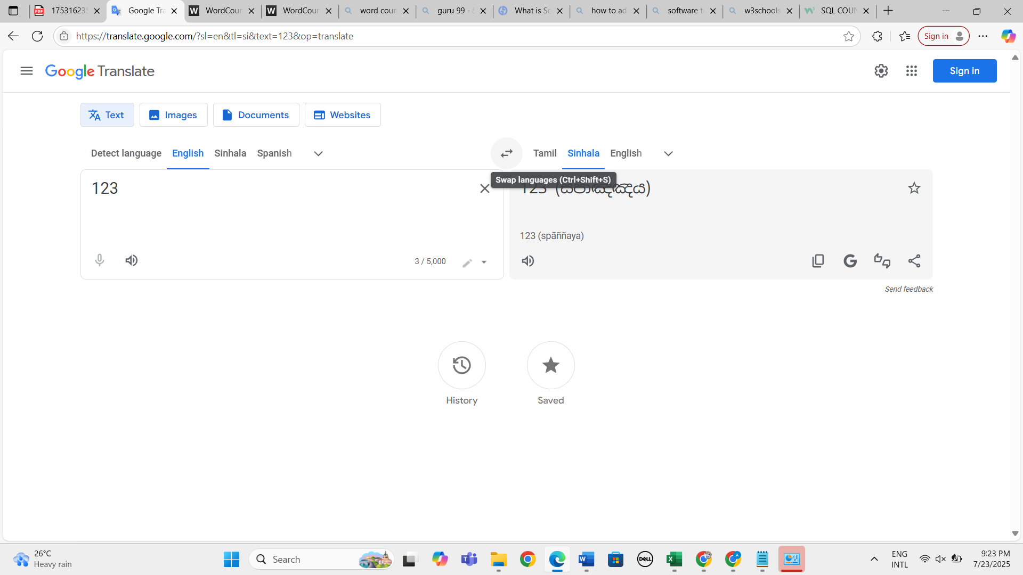 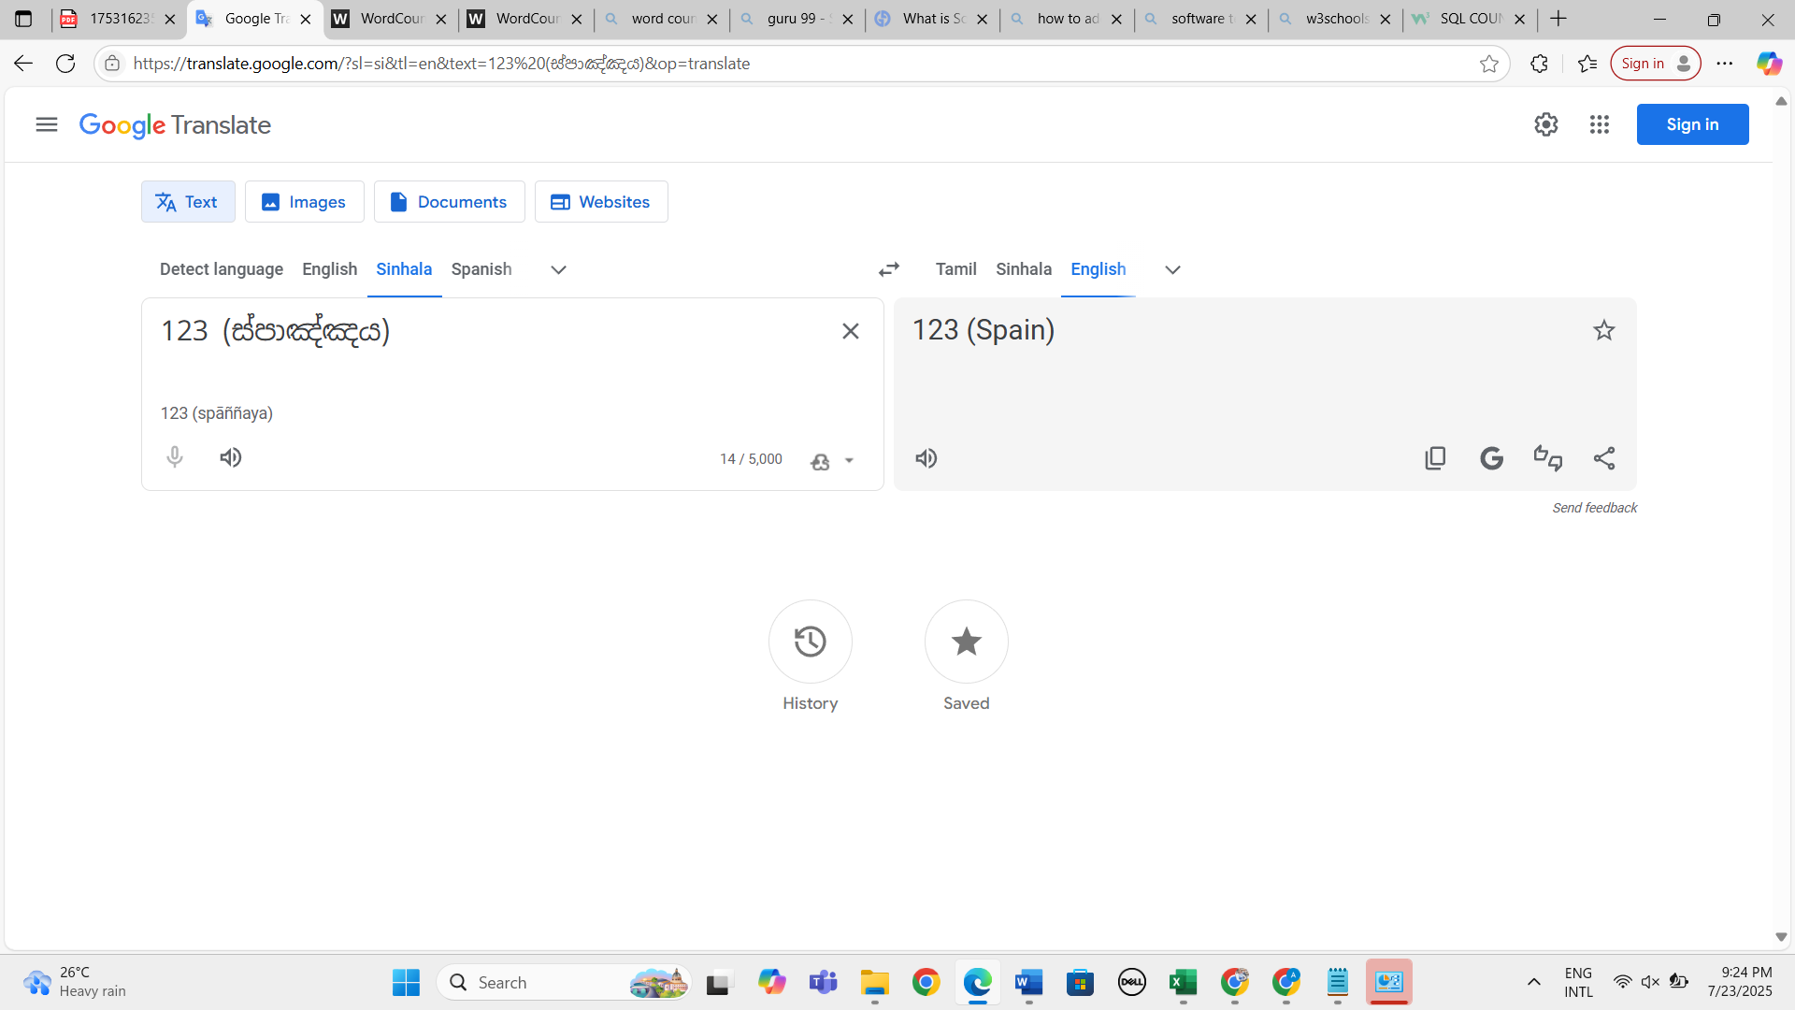

Expected result: 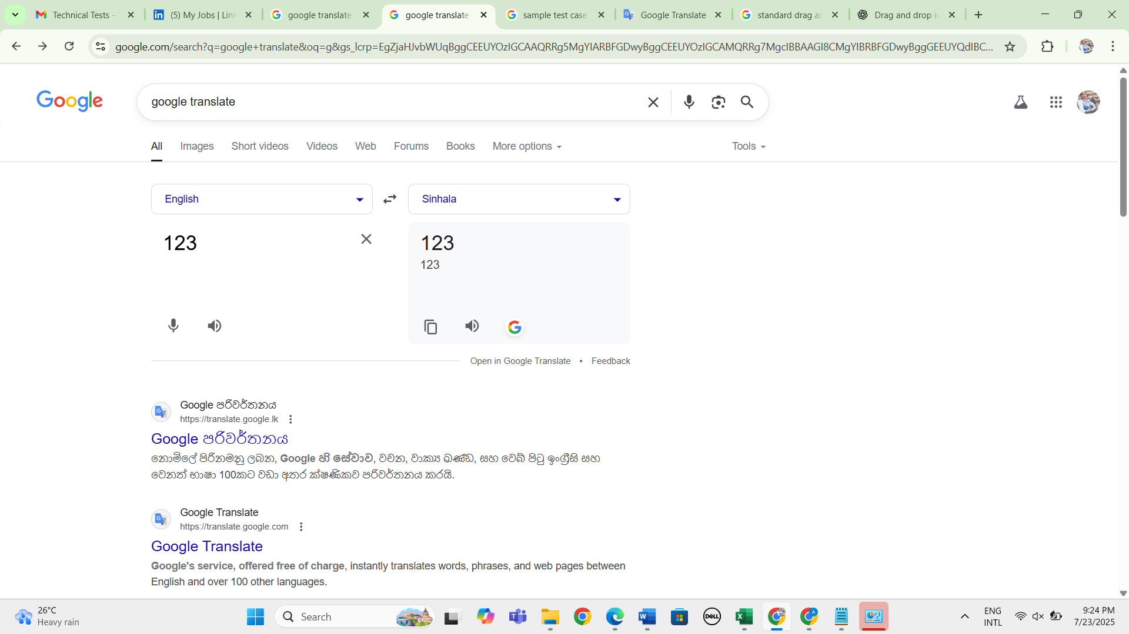 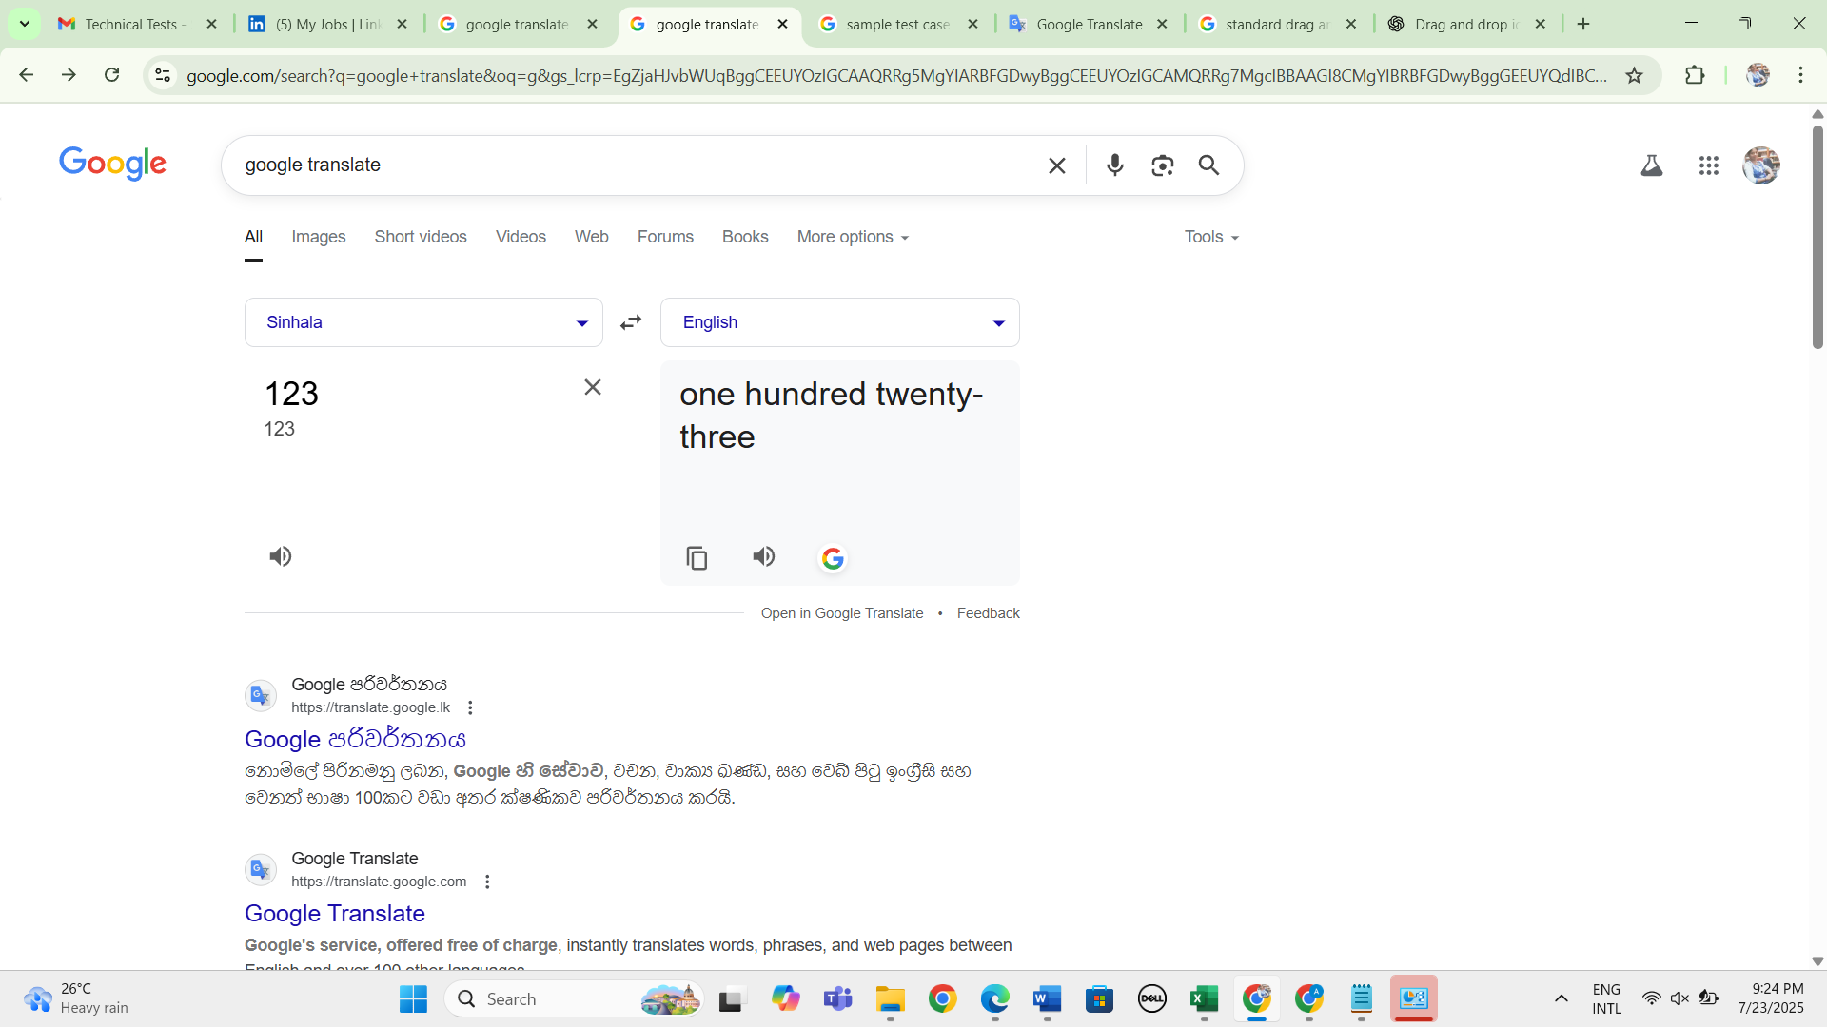

**UI issue 03**: drag and drop image display as clickable and input methods are available under output section

**Steps to reproduce:**

1. Navigate google translate page
2. Click on images tab

Actual result: 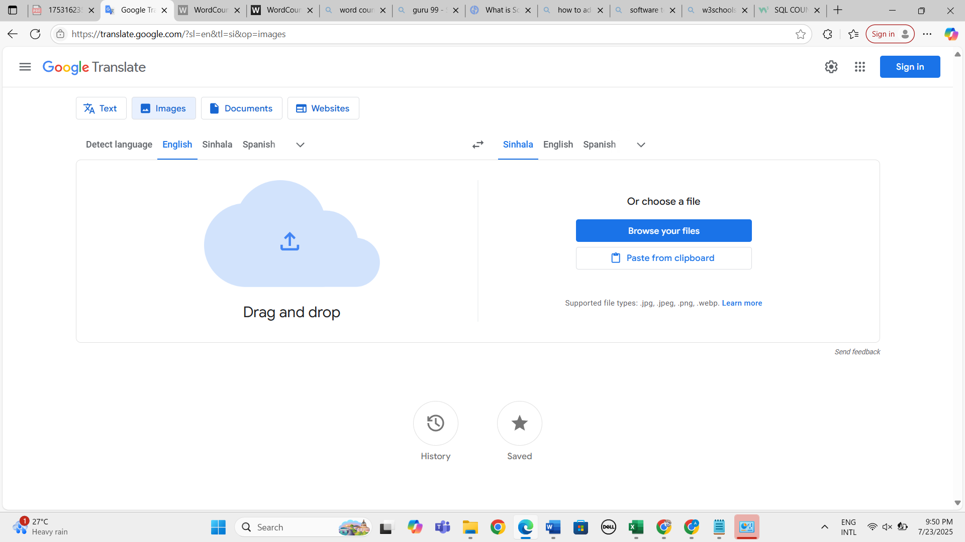

**Expected result:** change the dra and drop icon and list all the input methods are in one side

**Issue 04:**

**Title**: "paste from clipboard" button functionality not working properly for PNG format

**Steps to reproduce:**

1. Navigate google translate page
2. Click on images tab
3. Copy an image from somewhere
4. Click on “paste from clipbroard button

**Actual result:** 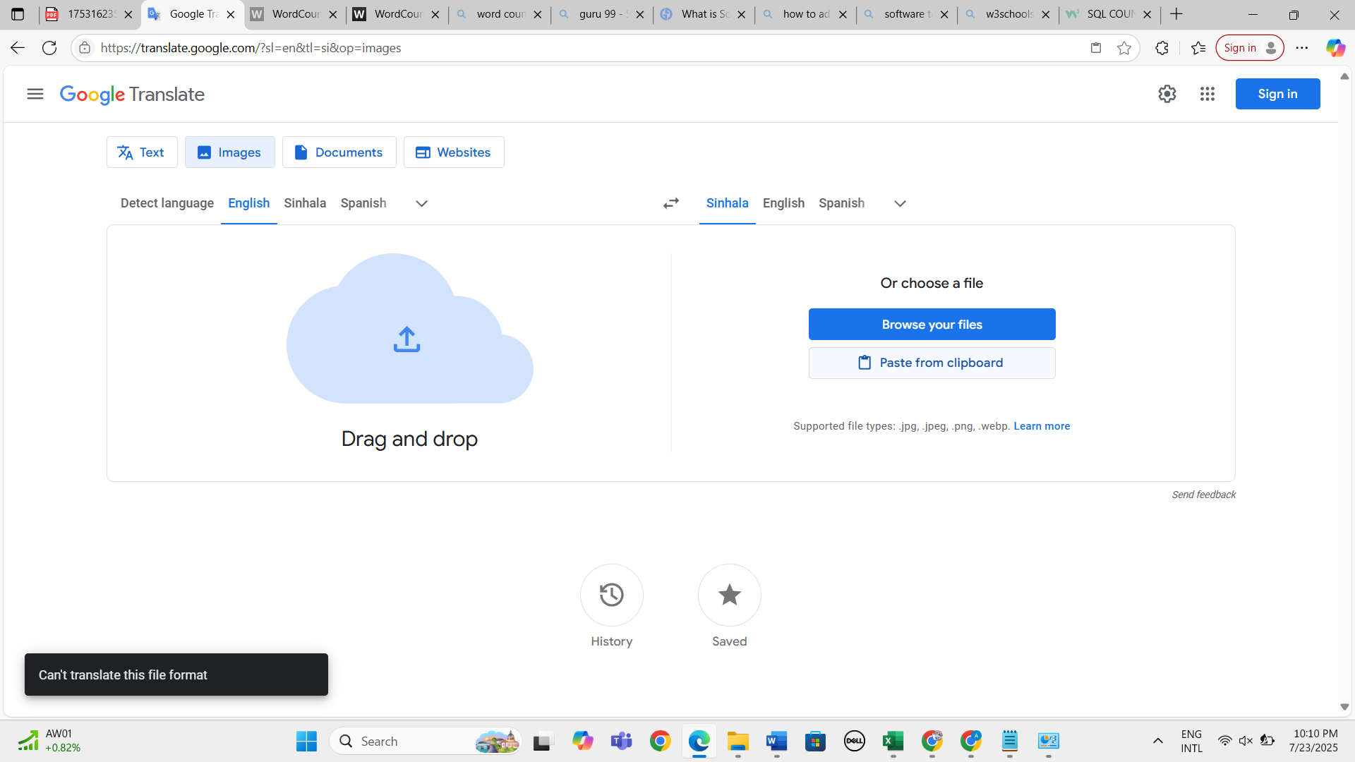

**Expected result:** user should be able upload images in PNG format 

Issue 04

Title: getting 401 status code error continusely 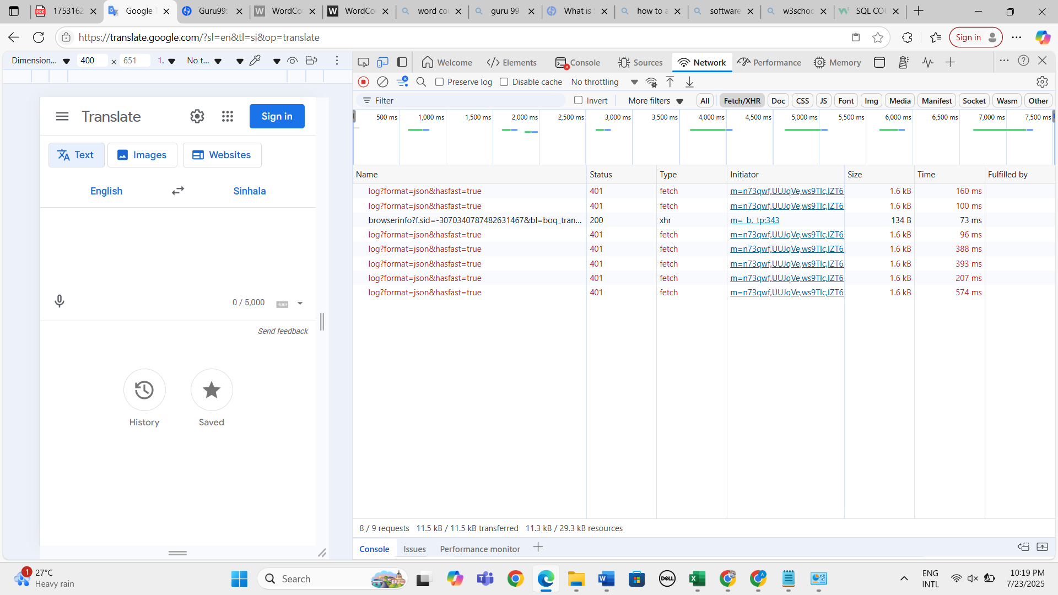

**Steps to reproduce**

1. Navigate google translate page
2. Click on text tab
3. Select detect language as “English”
4. Select translate language as “sinhala”
5. Right click
6. Inspect the page
7. Navigate network tab

**Actual result:** 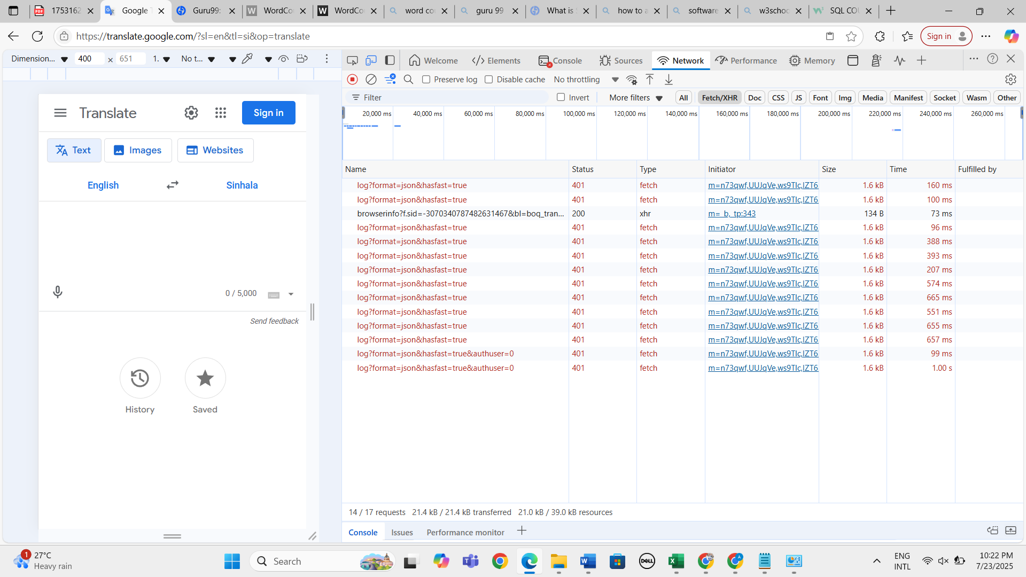

Expected result: user should not be able to get 200