1. **1. Create a customer table which comprises of these columns – ‘customer_id’, ‘first_name’, ‘last_name’, ‘email’, ‘address’, ‘city’,’state’,’zip’.**
2. **Insert 5 new records into the table-**

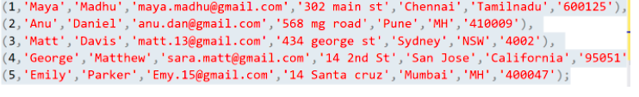

1. **Select only the ‘first_name’ & ‘last_name’ columns from the customer table.**
2. **Create an ‘Orders’ table which comprises of these columns – ‘order_id’, ‘order_date’, ‘amount’ 'customer_id’.**
3. **Insert 5 new records into the table-**

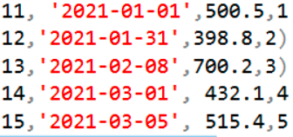

1. **Update the ‘Orders’ table, set the amount to be 100 where ‘customer_id’ is 3.**
2. **Use the inbuilt functions and find the minimum, maximum and average amount from the orders  table.**
3. **Arrange the ‘Orders’ data in decreasing order of amount.**
4. **Create a table with name ‘Employee_details1’ and comprising of these columns – ‘Emp_id’ ‘Emp_name’, ‘Emp_salary’. Create another table with name ‘Employee_details2’, which** **comprises of same columns as first table.**
5. **Insert 5 new records into the table-**

