**Music Mixer Website Inspiration & Ideas**

**Final outcome:**

* <https://www.youtube.com/watch?v=GjSJ9IXvgFg>

**Animal and sound effects free download websites:**

* <http://soundbible.com/tags-animal.html>
* <https://www.mysoundeffect.com/animals/>

**Inspiration:**

[**https://www.incredibox.com**](https://www.incredibox.com)

[**https://www.animaljam.com/welcome**](https://www.animaljam.com/welcome)

[**https://academy.allaboutbirds.org/features/beastbox/**](https://academy.allaboutbirds.org/features/beastbox/)

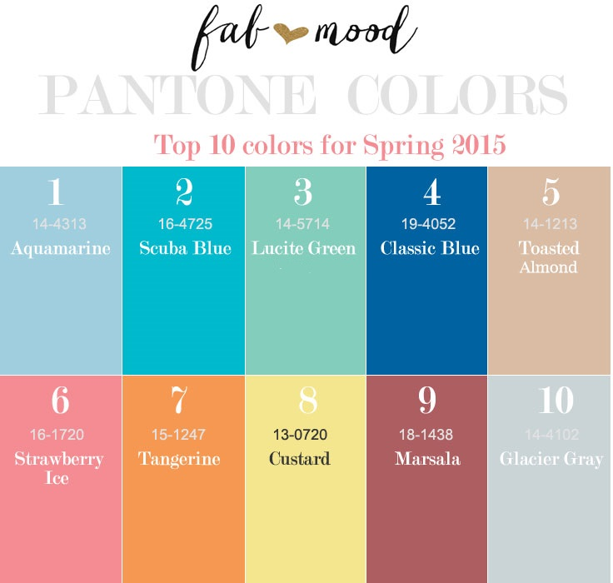

**Layout and icon sketches:**

