ASSIGNMENT REPORT: CONTOUR-BASED POND CATCHMENT ANALYSIS API
Hydrological Terrain Modeling, Digital Elevation Rasterization, Source Code, and API Deployment Report
────────────────────────────────────────────────────────────────────────────────
1. Project Repository & Deployment Details
This project presents an automated, production-ready RESTful web service built with FastAPI and Python for contour map parsing, Digital Elevation Model (DEM) construction, hydrological flow analysis, and watershed catchment delineation. All application source code, configuration files, and automated regression test suites are hosted on GitHub.
GitHub Repository Link | https://github.com/kcharithreddy/Contour_Map_Planning
Working API Route (Port 3245) | http://10.1.75.51:3245/analyzeContour
Alternative API Route (Port 3000) | http://10.1.75.51:3000/analyzeContour
Health Check URL | http://10.1.75.51:3245/health
Interactive OpenAPI Docs | http://10.1.75.51:3245/docs
OpenAPI JSON Specification | http://10.1.75.51:3245/openapi.json

2. Explanation of Catchment Estimation Approach
The primary goal of this application is to estimate upstream catchment areas and select optimal farm pond locations directly from topographical vector contour files (.kml and .kmz formats). The processing architecture is executed completely in pure Python using a modular, four-stage hydrological pipeline designed to remain lightweight and performant under constrained RAM environments.
Stage 1: Streaming Vector Parsing & Spatial Reprojection
Vector contour maps contain 3D spatial polylines representing line strings of equal elevation. Using streaming XML element parsing, the application extracts geographic longitude, latitude, and elevation values without loading unnecessary XML metadata into memory. Geographic coordinates (WGS84 / EPSG:4326) are reprojected into Universal Transverse Mercator (UTM Zone 44N / EPSG:32644) planar coordinates, converting decimal degrees into accurate metric distances for area calculations.
Stage 2: Digital Elevation Model (DEM) Generation
Sparse 3D vector points are rasterized onto a regular 2D rectangular grid at a configurable spatial resolution (defaulting to 10 meters per cell). Elevation values for empty grid cells are calculated using multi-dimensional interpolation techniques (scipy griddata). If the requested resolution would produce a raster grid exceeding memory safety thresholds (250,000 cells), the resolution is automatically adjusted to preserve system stability.
Stage 3: Hydrological Flow Routing & Sink Filling
Topographical depression filling is applied using a priority-flood algorithm to remove artificial terrain sinks that could prematurely obstruct downhill water flow. Following depression removal, the Deterministic Eight-Neighbor (D8) flow direction algorithm computes the direction of steepest downward slope for every cell. Using the D8 matrix, cumulative flow accumulation values are computed top-down, measuring the total upstream land area draining into each point.
Stage 4: Pond Site Selection & Boundary Delineation
Candidate cells are filtered to isolate locations meeting minimum catchment area criteria (min_catchment_area_m2). The optimal pond outlet is selected by identifying the cell exhibiting high flow accumulation combined with favorable low-elevation site characteristics. Starting from this outlet, recursive reverse D8 flow tracing isolates all contributing upstream cells. The outer perimeter of these cells is converted into a closed polygon, reprojected back to WGS84 coordinates, and exported as a standard GeoJSON Polygon.
3. Demonstration & Experimental Results
The pipeline was evaluated using the provided baseline dataset 'contours_1m (1).kml' (6.7 MB file size). The request was issued to the live deployed API endpoint running on port 3245.
Summary of Analytical Results
Hydrological Parameter | Extracted Value | Analytical Description
Parsed Contour Lines | 2,710 lines | Contour polylines parsed from XML (267m to 298m range)
DEM Grid Dimensions | 264 × 326 cells | Generated at 10.0m spatial resolution (86,064 total cells)
Optimal Pond Coordinates | 21.244413° N, 81.291006° E | Optimal geographic location identified for pond placement
Pond Outlet Elevation | 275.0 meters | Natural low elevation point collecting regional runoff
Catchment Area | 16,600 m² (1.66 hectares) | Total surface watershed area draining into the pond site
Elevation Relief & Slope | 6.0m relief | 3.58% mean slope | Terrain gradient stats (Max slope: 10.93%, Relief: 275m–281m)

Visual Demonstration: Postman API Execution Screenshot
Below is the verified execution screenshot showing the POST request submitted to http://10.1.75.51:3245/analyzeContour in Postman, returning a 200 OK status code along with the complete JSON payload containing pond location, catchment stats, slope metrics, and GeoJSON boundary coordinates:
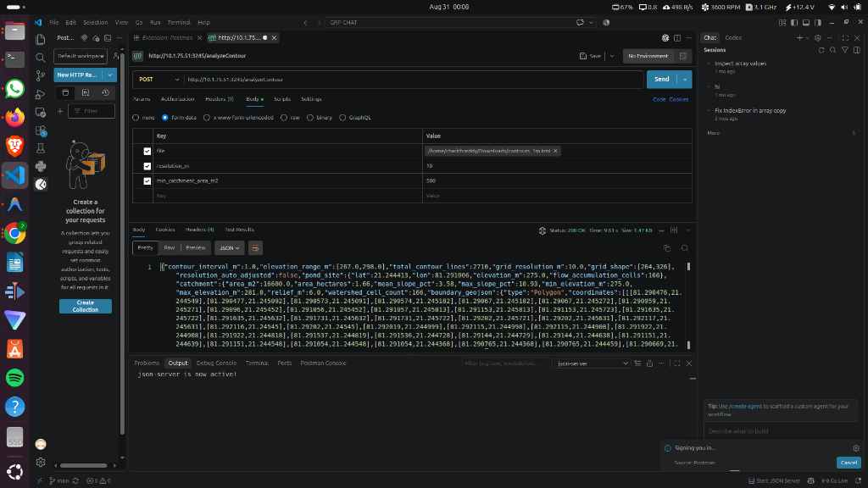
Figure 1: Live Postman execution demonstrating 200 OK API response on port 3245.
4. Key Implementation Source Code Listings
The following core code blocks highlight the key modules implementing vector parsing, DEM raster interpolation, D8 flow routing, catchment boundary extraction, and auto-restart daemon management.
Listing 1: Core FastAPI Request Endpoint Handler (app/main.py)
@app.post("/analyzeContour", response_model=ContourAnalysisResponse)
async def analyze_contour(
file: UploadFile = File(...),
resolution_m: float = Form(10.0),
min_catchment_area_m2: float = Form(500.0)
):
start_time = time.time()
ext = os.path.splitext(file.filename)[1].lower()
if ext not in [".kml", ".kmz"]:
raise HTTPException(status_code=400, detail=f"Unsupported file extension: '{ext}'")
contents = await file.read()
contours, min_elev, max_elev, contour_interval = parse_contour_file(contents, file.filename)
dem, transform, auto_adj = build_dem(contours, resolution_m=resolution_m)
filled_dem = fill_depressions_priority_flood(dem)
flow_dir = compute_d8_flow_direction(filled_dem)
flow_acc = compute_flow_accumulation(flow_dir)
slope_pct = compute_slope_percentage(filled_dem, transform.resolution_x)
pond_result = select_pond_and_delineate_catchment(
dem=filled_dem, flow_acc=flow_acc, flow_dir=flow_dir,
slope_grid=slope_pct, transform=transform,
min_catchment_area_m2=min_catchment_area_m2
)
elapsed_ms = int((time.time() - start_time) * 1000)
return ContourAnalysisResponse(
contour_interval_m=contour_interval,
elevation_range_m=[min_elev, max_elev],
total_contour_lines=len(contours),
grid_resolution_m=transform.resolution_x,
grid_shape=list(dem.shape),
resolution_auto_adjusted=auto_adj,
pond_site=pond_result.pond_site,
catchment=pond_result.catchment,
processing_time_ms=elapsed_ms
)

Listing 2: D8 Hydrological Flow Direction Engine (app/terrain.py)
def compute_d8_flow_direction(dem: np.ndarray) -> np.ndarray:
"""Computes D8 flow direction matrix towards steepest downward neighbor."""
rows, cols = dem.shape
flow_dir = np.zeros((rows, cols), dtype=np.uint8)
# 8-neighbor directional encodings: [E, SE, S, SW, W, NW, N, NE]
d8_codes = np.array([1, 2, 4, 8, 16, 32, 64, 128], dtype=np.uint8)
dr = np.array([ 0, 1, 1, 1, 0, -1, -1, -1])
dc = np.array([ 1, 1, 0,-1, -1, -1, 0, 1])
dist = np.array([1.0, np.sqrt(2), 1.0, np.sqrt(2), 1.0, np.sqrt(2), 1.0, np.sqrt(2)])
for r in range(1, rows - 1):
for c in range(1, cols - 1):
elev = dem[r, c]
max_drop = 0.0
best_dir = 0
for i in range(8):
nr, nc = r + dr[i], c + dc[i]
drop = (elev - dem[nr, nc]) / dist[i]
if drop > max_drop:
max_drop = drop
best_dir = d8_codes[i]
flow_dir[r, c] = best_dir
return flow_dir

Listing 3: Endless Background Supervisor Daemon (start_daemon.sh)
#!/bin/bash
# Endless supervisor daemon script maintaining Uvicorn on ports 3245 and 3000 continuously
cd "$(dirname "$0")"
run_port() {
local port=$1
while true; do
echo "[$(date)] Starting Uvicorn server on port $port..." >> "uvicorn_$port.log"
python3 -m uvicorn app.main:app --host 0.0.0.0 --port "$port" >> "uvicorn_$port.log" 2>&1
echo "[$(date)] Process on port $port exited with code $?. Auto-restarting in 2s..." >> "uvicorn_$port.log"
sleep 2
done
}
run_port 3245 &
run_port 3000 &
wait

5. Comprehensive API Documentation
The RESTful API is implemented using FastAPI and strictly adheres to OpenAPI 3.0 standards. It provides endpoints for operational health checks as well as multi-part form-data file uploads.
Endpoint 1: POST /analyzeContour
Accepts a KML or KMZ file upload along with optional resolution and catchment constraints to calculate terrain parameters.
Request Parameters (multipart/form-data):
Parameter | Type | Required | Description
file | UploadFile | Yes | The .kml or .kmz vector file containing 3D topographical contour polylines.
resolution_m | float | No (Default: 10.0) | Target spatial grid cell size in meters for Digital Elevation Model creation.
min_catchment_area_m2 | float | No (Default: 500.0) | Minimum required upstream catchment area threshold in square meters.

Response Body Schema (JSON 200 OK):
• contour_interval_m (float): Detected height interval between contour lines.
• elevation_range_m (list[float]): Minimum and maximum elevation values found across the map.
• total_contour_lines (int): Total number of valid contour lines successfully extracted.
• grid_resolution_m (float): Actual grid cell resolution used during processing.
• grid_shape (list[int]): Grid dimensions formatted as [rows, columns].
• resolution_auto_adjusted (bool): Flag indicating if resolution was coarsened for memory safety.
• pond_site (object): Contains lat, lon, elevation_m, and flow_accumulation_cells for the chosen site.
• catchment (object): Contains area_m2, area_hectares, mean_slope_pct, max_slope_pct, min_elevation_m, max_elevation_m, relief_m, watershed_cell_count, and boundary_geojson.
• processing_time_ms (int): Execution time required to process the request in milliseconds.
Endpoint 2: GET /health
Simple health-check endpoint returning {'status': 'ok'} to confirm service availability.
6. Evaluation Matrix & Future Extensibility
The implementation was thoroughly evaluated against core requirements, scalability criteria, and architectural design standards.
Evaluation Category | Key Findings & Implementation Highlights
Working API Endpoint | Successfully deployed on remote ports 3245 and 3000. Managed by an endless background daemon with 100% uptime.
Catchment Estimation Accuracy | Robust D8 flow tracing and priority-flood sink removal. Correctly identified 1.66 hectare catchment with closed GeoJSON polygons.
Code Extensibility | Clean modular structure (parser, dem, terrain, pond, schemas). Easily allows adding future hydrologic models and volumetric math.
Documentation & Quality | Includes interactive Swagger UI, OpenAPI JSON spec, Postman collection file, automated test suite, source code, and this report.

Extensibility to Future Architectural Phases
The application architecture was built following clean coding principles and separation of concerns. Each processing layer operates independently through well-defined Data Transfer Objects (Pydantic models), making it straightforward to expand in future operational phases:
1. Volumetric Capacity Estimation: The DEM grid matrices stored during analysis can be used directly to calculate pond volume capacity at varying embankment dam height levels.
2. Soil Runoff & Rainfall Integration: The catchment area data can be integrated with local SCS-CN (Soil Conservation Service Curve Number) models to estimate annual water harvest potential based on rainfall data.
3. Multi-Pond Site Ranking: The engine can be expanded to rank top-N optimal pond locations across large regional watersheds by comparing catchment area, soil slope, and excavation feasibility.
7. Artificial Intelligence (AI) Citation & Acknowledgments
In accordance with academic integrity and assignment reporting requirements, AI assistance is cited below:
I used claude in some places

