
Faculty of Science

Course: CSCI 2020u – Software System Development & Integration
Component: Assignment
Weight: 10%
Deadline: March 5, 2020 (due by 11:59pm)

Collaboration Policy
You are permitted to work on this assignment in a team, and submit the results as a team. For this sort of assignment, with an open-ended component, the collaboration between multiple team members can be beneficial. Between groups, however, please limit the discussion to the level of general strategy (not code). Groups of size 2 are recommended. Larger groups will be considered with the proviso that the marker will mark your assignment with higher expectations. In any case, be sure that all members of the team fully understand all code, otherwise they will miss intended learning objectives, which may be a considerable disadvantage at exam time.

How to Submit
You will maintain a git repository for this assignment, which is a public repository. To submit the assignment, create a single file ‘README.txt’ that contains instructions on how to download, compile, and run your codes for each question. A .zip, .7z, or .rar file will not be acceptable. Also submit this word file (once you complete) into related drop box on Blackboard before deadline.

Note: Comments are mandatory. Failure to properly document your program will result in a deduction on the marks you receive for this (and any other) assignment.

Remember:
You need to complete this file and submit it in related drop box on Blackboard, in addition to uploading your codes in your git repository, before deadline.

Question 1: Displaying Three Cards

Problem Description:
Display a frame that contains three labels. Each label displays a card, as shown in the figure below. The card image files are named 1.png, 2.png, ..., 54.png and stored in the image/card directory. All three cards are distinct and selected randomly.

The image icons can be found in the attached card folder.

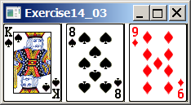

Your Task:
- Create three ImageView and set their icons using the images.
- Display three images from 54 image cards randomly.

Your Code:
Copy-paste your code here:
/* Assignment
Question One
Displaying Three Cards
Software System Development and Integration
CSCI 2020U
March 05, 2020
Keshopan Arunthavachelvan */
import javafx.application.Application;
import javafx.geometry.Insets;
import javafx.scene.Scene;
import javafx.scene.image.Image;
import javafx.scene.image.ImageView;
import javafx.scene.layout.HBox;
import javafx.scene.layout.Pane;
import javafx.stage.Stage;
import java.util.ArrayList;
import java.util.List;
import java.util.Random;
public class QuestionOne extends Application {
// Allows executions of program in the command line
public static void main(String[] args) { launch(args); }
@Override
public void start(Stage primaryStage) {
// Variable Declaration
Random rand = new Random();
List<Integer> cards = new ArrayList<Integer>();
// Randomly choose three numbers between 1 and 54 (inclusive)
while (cards.size() < 3) {
int randomNum = rand.nextInt(54) + 1;
// If the randomly generated number does not already exist in the cards list, append the random number to
// the cards array
if (!cards.contains(randomNum)) {
cards.add(randomNum);
}
}
// Instantiates Pane with padding and spacing
Pane pane = new HBox(10);
pane.setPadding(new Insets(5,5,5,5));
// Creates an image view using the first randomly generated number to select a card from the cards directory
Image image1 = new Image("image/card/" + cards.get(0) + ".png");
ImageView imageView1 = new ImageView(image1);
pane.getChildren().add(imageView1);
// Creates an image view using the second randomly generated number to select a card from the cards directory
Image image2 = new Image("image/card/" + cards.get(1) + ".png");
ImageView imageView2 = new ImageView(image2);
pane.getChildren().add(imageView2);
// Creates an image view using the third randomly generated number to select a card from the cards directory
Image image3 = new Image("image/card/" + cards.get(2) + ".png");
ImageView imageView3 = new ImageView(image3);
pane.getChildren().add(imageView3);
// Displays the three cards on the main Pane window
Scene scene = new Scene(pane);
primaryStage.setScene(scene);
primaryStage.setTitle("Question One: Display Three Cards");
primaryStage.show();
}
}

Screen shots:
Include two screen shots here:

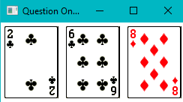

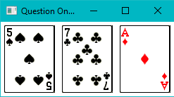

Question 2: Investment-Value calculator

Problem Description:
Write a program that calculates the future value of an investment at a given interest rate for a specified number of years. The formula for the calculation is as follows:

futureValue = investmentAmount * (1 + monthlyInterestRate)years*12

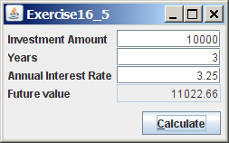

Your Task:
Use text fields for interest rate, investment amount, and years. Display the future amount in a text field when the user clicks the Calculate button, as shown in the figure.

Your Code:
Copy-paste your code here.

/* Assignment
Question Two
Investment Value Calculator
Software System Development and Integration
CSCI 2020U
March 05, 2020
Keshopan Arunthavachelvan */
import javafx.application.Application;
import javafx.geometry.HPos;
import javafx.geometry.Insets;
import javafx.geometry.Pos;
import javafx.scene.Scene;
import javafx.scene.control.Button;
import javafx.scene.control.Label;
import javafx.scene.control.TextField;
import javafx.scene.layout.GridPane;
import javafx.stage.Stage;
import java.text.DecimalFormat;
public class QuestionTwo extends Application {
// Allows execution of program in the command line
public static void main(String[] args) { launch(args); }
@Override
public void start(Stage primaryStage) {
// Instantiates Grid with padding and spacing
GridPane pane = new GridPane();
pane.setAlignment(Pos.CENTER);
pane.setPadding(new Insets(10,10,10,10));
pane.setVgap(5);
pane.setHgap(5);
// Instantiates the TextFields used in the form
TextField investmentAmount = new TextField();
investmentAmount.setAlignment(Pos.CENTER_RIGHT);
TextField years = new TextField();
years.setAlignment(Pos.CENTER_RIGHT);
TextField annualInterestRate = new TextField();
annualInterestRate.setAlignment(Pos.CENTER_RIGHT);
TextField futureValue = new TextField();
futureValue.setAlignment(Pos.CENTER_RIGHT);
// Turns Future Value Text Field into a non editable field
futureValue.setEditable(false);
futureValue.setStyle("-fx-background-color: lightgrey");
// Button used to calculate the Future Value using the provided values in the form text fields
Button calculate = new Button("Calculate");
calculate.setOnAction(e -> {
// Calculates the future value only if all the required fields have a value
if (!annualInterestRate.getText().isEmpty() &&
!investmentAmount.getText().isEmpty() &&
!years.getText().isEmpty()) {
// Assign formatting for Decimal Value
DecimalFormat df = new DecimalFormat("###.##");
// Calculates the compounded interest using the provided values in the form text fields
Double compoundedInterest = Math.pow(1 + (Double.parseDouble(annualInterestRate.getText()) / 100 / 12),
(Double.parseDouble(years.getText()) * 12));
// The compounded interest is used to calculate the future value which is then assigned the the Future
// Value TextField. Future Value is rounded to two decimal places.
futureValue.setText((df.format(Double.parseDouble(investmentAmount.getText()) *
compoundedInterest)));
}
// Notifies the user to fill in all required fields
else {
System.out.println("Please fill in all required fields.");
}
});
// Appends the TextField Form values and the button the the Grid pane
pane.add(new Label("Investment Amount *"),0,0);
pane.add(investmentAmount, 1,0);
pane.add(new Label("Years *"),0,1);
pane.add(years, 1,1);
pane.add(new Label("Annual Interest Rate *"), 0,2);
pane.add(annualInterestRate, 1,2);
pane.add(new Label("Future Value"), 0 , 3);
pane.add(futureValue, 1 ,3);
pane.add(calculate, 1,4);
GridPane.setHalignment(calculate, HPos.RIGHT);
// Displays the Investment Calculator GridPane on the main window
Scene scene = new Scene(pane);
primaryStage.setScene(scene);
primaryStage.setTitle("Question Two: Investment-Value Calculator");
primaryStage.show();
}
}

Screen shots:
Include two screen shots here:

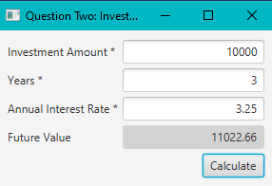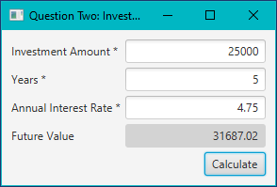

Question 3: Dragging Points on a Circle

Problem Description:
Draw a circle with three random points on the circle. Connect the points to form a triangle. Display the angles in the triangle. Use the mouse to drag a point along the perimeter of the circle. As you drag it, the triangle and angles are redisplayed dynamically.

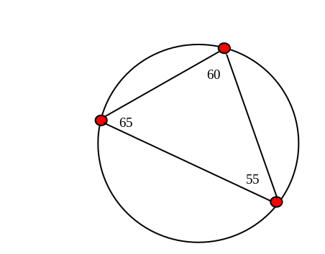

Here is the formula to compute angles:

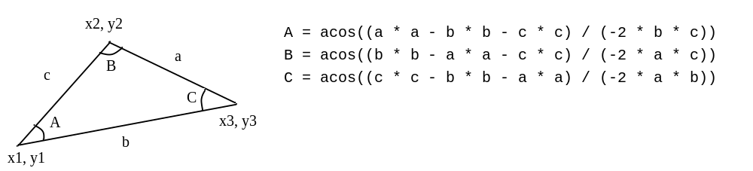

Your Code:
Copy-paste your code here:

/* Assignment
Question Three
Dragging Points on a Circle
Software System Development and Integration
CSCI 2020U
March 05, 2020
Keshopan Arunthavachelvan */
import javafx.application.Application;
import javafx.scene.Scene;
import javafx.scene.layout.Pane;
import javafx.scene.transform.Rotate;
import javafx.stage.Stage;
import javafx.scene.shape.Circle;
import javafx.scene.text.Text;
import javafx.scene.shape.Line;
import javafx.geometry.Point2D;
import java.util.ArrayList;
import java.util.List;
import java.util.Random;
public class QuestionThree extends Application {
// Global Variables
Random randInt = new Random();
// Global Variables for Shapes
List<Circle> vertex = new ArrayList<>();
List<Text> degree = new ArrayList<>();
List<Line> line = new ArrayList<>();
List<Double> angle = new ArrayList<>();
// Allows executions of program in the command line
public static void main(String[] args) {
launch(args);
}
@Override
public void start(Stage primaryStage) {
// Instantiates the Global Variables
for (int i = 0; i < 3; i++) {
degree.add(new Text());
line.add(new Line());
angle.add(0.0);
// Positions new vertex on a random point on the perimeter of the main circle
Circle newPoint = new Circle(225, 125, 5);
Integer randDegree = randInt.nextInt(360);
Rotate rotate = new Rotate(randDegree, 125, 125);
newPoint.getTransforms().add(rotate);
Double x = newPoint.localToParent(newPoint.getCenterX(), newPoint.getCenterY()).getX();
Double y = newPoint.localToParent(newPoint.getCenterX(), newPoint.getCenterY()).getY();
newPoint.setCenterX(x);
newPoint.setCenterY(y);
newPoint.getTransforms().clear();
vertex.add(newPoint);
}
// Instantiates Pane
Pane pane = new Pane();
// Sets size for main central circle
Circle mainCircle = new Circle(125, 125, 100);
mainCircle.setStyle("-fx-stroke: black; -fx-fill: white");
// Appends main circle and initial points to the window pane
pane.getChildren().add(mainCircle);
for (int i = 0; i < 3; i++) {
pane.getChildren().addAll(vertex.get(i), degree.get(i), line.get(i));
}
// Dynamically computes the angles between each three vertices in the triangle
measureDegree();
// Assign coordinates of each vertex as it is moved
for (int i = 0; i < 3; i++) {
int temp = i;
vertex.get(temp).setOnMouseDragged(e -> {
if (vertex.get(temp).contains(e.getX(), e.getY())) {
// Adjusts position of vertex to move along the circumference of the circle
// This is done when the mouse pointer intersects a point on the circumference of the circle
double xLen = e.getX() - 125;
double yLen = e.getY() - 125;
double radiusLen = Math.sqrt(Math.pow(xLen, 2) + Math.pow(yLen, 2));
vertex.get(temp).setCenterX(125 + (xLen * 100 / radiusLen));
vertex.get(temp).setCenterY(125 + (yLen * 100 / radiusLen));
// Adjusts the degree as the vertex is moved
measureDegree();
}
});
}
// Displays the vertices and main circle on the main pane window
Scene scene = new Scene(pane, 250, 250);
primaryStage.setTitle("Question Three: Dragging Points on a Circle");
primaryStage.setScene(scene);
primaryStage.show();
}
public int calculateDirection() {
if (randInt.nextInt(2) == 1) { return 1; }
else { return -1; }
}
public void drawLine() {
// Draws the lines between each vertex
line.get(0).setStartX(vertex.get(0).getCenterX());
line.get(0).setEndX(vertex.get(1).getCenterX());
line.get(0).setStartY(vertex.get(0).getCenterY());
line.get(0).setEndY(vertex.get(1).getCenterY());
line.get(1).setStartX(vertex.get(0).getCenterX());
line.get(1).setEndX(vertex.get(2).getCenterX());
line.get(1).setStartY(vertex.get(0).getCenterY());
line.get(1).setEndY(vertex.get(2).getCenterY());
line.get(2).setStartX(vertex.get(1).getCenterX());
line.get(2).setEndX(vertex.get(2).getCenterX());
line.get(2).setStartY(vertex.get(1).getCenterY());
line.get(2).setEndY(vertex.get(2).getCenterY());
}
private void measureDegree() {
// Computes lengths between three vertices
double a = new Point2D(
vertex.get(2).getCenterX(),
vertex.get(2).getCenterY()).distance(
vertex.get(1).getCenterX(),
vertex.get(1).getCenterY()
);
double b = new Point2D(
vertex.get(2).getCenterX(),
vertex.get(2).getCenterY()).distance(
vertex.get(0).getCenterX(),
vertex.get(0).getCenterY());
double c = new Point2D(
vertex.get(1).getCenterX(),
vertex.get(1).getCenterY()).distance(
vertex.get(0).getCenterX(),
vertex.get(0).getCenterY());
// Calculates the degrees between the three vertices using cosine law
angle.set(0, Math.acos((a * a - b * b - c * c) / (-2 * b * c)));
angle.set(1, Math.acos((b * b - a * a - c * c) / (-2 * a * c)));
angle.set(2, Math.acos((c * c - b * b - a * a) / (-2 * a * b)));
// Displays the degree beside it's respective vertex
for (int i = 0; i < 3; i++) {
degree.get(i).setX(vertex.get(i).getCenterX() + 8);
degree.get(i).setY(vertex.get(i).getCenterY());
degree.get(i).setText(Double.toString((int)(Math.toDegrees(angle.get(i)))));
}
// Updates the lines as the vertices move
drawLine();
}
}

Screen shots:
Include two screen shots here:
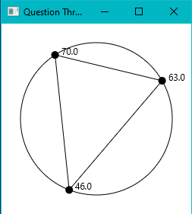
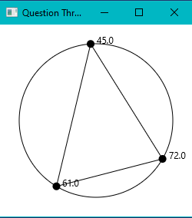

Question 4: Histogram

Problem Description:
Develop a program that displays a histogram to show the occurrences of each letter in a text area. The histogram should show the occurrences of each letter in a text file, as shown in the following figure. Assume that the letters are not case sensitive.

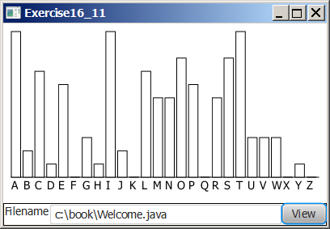

Your Task:
- Place a pane that will display the histogram in the center of the frame.
- Place a label and a text field in a panel, and put the panel in the south side of the frame. The text file will be entered from this text field.
- Pressing the Enter key on the text field causes the program to count the occurrences of each letter and display the count in a histogram.

Your Code:
Copy-paste your code here:

/* Assignment
Question Four
Histogram
Software System Development and Integration
CSCI 2020U
March 05, 2020
Keshopan Arunthavachelvan */
import javafx.application.Application;
import javafx.scene.Scene;
import javafx.scene.chart.BarChart;
import javafx.scene.chart.CategoryAxis;
import javafx.scene.chart.NumberAxis;
import javafx.scene.chart.XYChart;
import javafx.scene.control.Button;
import javafx.scene.control.Label;
import javafx.scene.control.TextField;
import javafx.scene.input.KeyCode;
import javafx.scene.layout.HBox;
import javafx.scene.layout.VBox;
import javafx.scene.text.TextAlignment;
import javafx.stage.Stage;
import java.io.File;
import java.io.FileNotFoundException;
import java.util.*;
public class QuestionFour extends Application {
// Global Variable Declaration
CategoryAxis xAxis = new CategoryAxis();
NumberAxis yAxis = new NumberAxis();
BarChart <String,Number> histogram = new BarChart<>(xAxis, yAxis);
Button viewButton = new Button("View");
// Example filename formats include
// "src/resources/text/Test.txt"
// "src/resources/text/Test2.txt"
Label labelFilename = new Label("Filename");
TextField filename = new TextField();
Map<Character, Integer> occurrences = new HashMap<>();
VBox box = new VBox();
HBox footer = new HBox(labelFilename, filename, viewButton);
// Allows executions of program in the command line
public static void main(String[] args) {
Application.launch(args);
}
@Override
public void start(Stage primaryStage) throws Exception {
// Sets styling for histogram
histogram.setBarGap(0);
histogram.setMinWidth(720);
histogram.setAnimated(false);
histogram.setLegendVisible(false);
labelFilename.setStyle("-fx-min-width: 60px");
labelFilename.setTextAlignment(TextAlignment.CENTER);
filename.setMinWidth(650);
// Creates an HBox with the histogram on the top-most layer, and a footer on the bottom-most layer
box.getChildren().addAll(histogram, footer);
// Event handler to generate histogram using view button and enter key in TextField
viewButton.setOnAction(e -> search());
filename.setOnKeyPressed(e -> {
if (e.getCode() == KeyCode.ENTER) {
search();
}
});
// Displays the histogram on the main Pane window
Scene scene = new Scene(box);
primaryStage.setScene(scene);
primaryStage.show();
}
public void search() {
// Resets number of occurrences from the previous file
occurrences.clear();
// Calculates the number of occurrences of each letter in the user's file and generates a new histogram
// with the updated result
calculateOccurrences();
generateHistogram();
box.getChildren().clear();
box.getChildren().addAll(histogram, footer);
}
public void calculateOccurrences() {
// Opens file with user's filename for reading
File file = new File(filename.getText());
try {
// Iterates through each character in the file and calculates the number of occurrences for each
// alphabetical letter into a hashmap
Scanner scanner = new Scanner(file);
scanner.useDelimiter("");
while (scanner.hasNext()) {
Character curr = scanner.next().charAt(0);
if (Character.isLetter(curr)) {
// Characters are changed to uppercase to ignore case sensitivity
if (occurrences.containsKey(Character.toUpperCase(curr))) {
// If the current letter already exists in the hashmap, increase it's counter by one
occurrences.replace(
Character.toUpperCase(curr),
occurrences.get(Character.toUpperCase(curr)) + 1
);
}
// If the current character does not exist in the current hashmap, add it to the hashmap with a
// value of 1
else {
occurrences.put(Character.toUpperCase(curr), 1);
}
}
}
}
// If the input file does not exist, print a statement to the user indicating that the file does not exist
catch (FileNotFoundException e) {
System.out.println("File does not exist.");
}
}
public void generateHistogram() {
// Variable Declaration
ArrayList<Character> alphabet = new ArrayList<>(Arrays.asList(
'A', 'B', 'C', 'D', 'E', 'F', 'G', 'H', 'I', 'J', 'K', 'L', 'M', 'N', 'O',
'P', 'Q', 'R', 'S', 'T', 'U', 'V', 'W', 'X', 'Y', 'Z'));
XYChart.Series histogramData = new XYChart.Series();
// iterate through each element in the alphabet and create a column with the number of occurrences that the
// current character occurs in the selected file
for (Character key : alphabet) {
if (occurrences.containsKey(key)) {
histogramData.getData().add(new XYChart.Data(key.toString(), occurrences.get(key)));
}
else {
// If current character doesn't exist in the hashmap, initialize it with a value of 0
histogramData.getData().add(new XYChart.Data(key.toString(), 0));
}
}
// update the histogram with the updated number of occurrences for each letter
histogram.getData().clear();
histogram.getData().addAll(histogramData);
}
}
Screen shots:
Include two screen shots here:
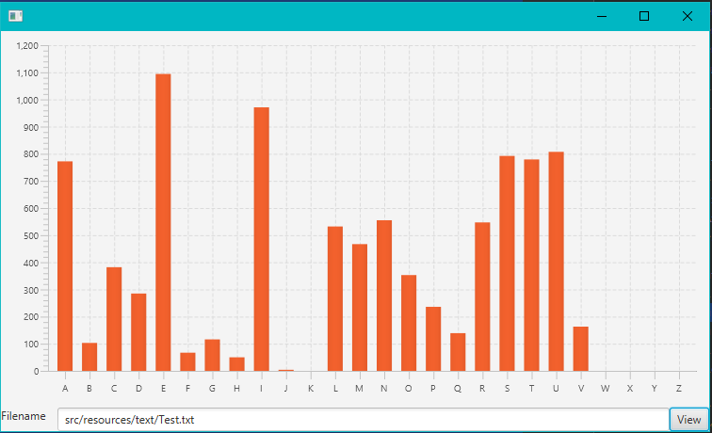
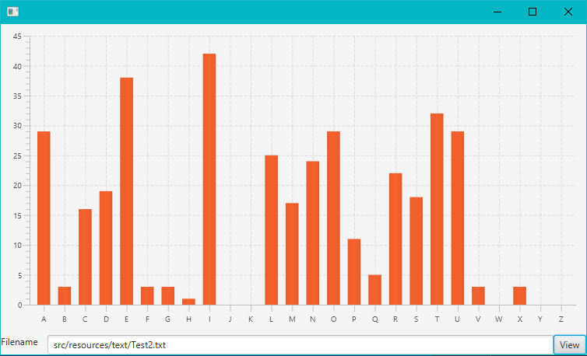
Remember:

You need to complete this file and submit it in related drop box on Blackboard, in addition to uploading your codes in your git repository, before deadline.

