# StatPro (http://developer.statpro.com/Revolution/WebApi/Intro)

## Resource structure

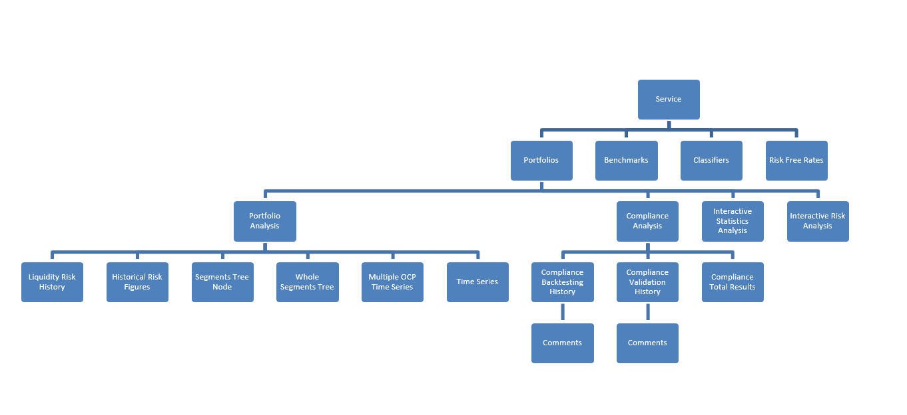

We started to connect to the API from getting back the Service resource on the top of the tree. The returned JSON data will have resource URIs for the second layer of the tree, i.e. Portfolios, Benchmarks, Classifiers and Risk Free Rates. The securities level daily data can only be retrieved through the Custom Time Period Portfolio Analysis resource, which comes through the Portfolio Analysis Controller. Once the Custom Time Period Portfolio is returned, we query for the Whole Segments Tree data which returns the data in securities level. Note that you cannot query directly Whole Segments Tree data through Portfolio Analysis as the returned data are in aggregated segment level not you cannot make a custom date. It must come through the Custom Time Period Portfolio Analysis.

## Detail for Custom Time Period Portfolio Analysis

(<http://developer.statpro.com/Revolution/WebApi/Resource/CustomTimePeriodPortfolioAnalysis>

For example, TimeSeries and Multiple OCP Time Series resources can only be used to extract results at total and segment level and the Interactive Statistics Analysis only supports the extraction of total level results. This is why we have the concept of a **Custom Time Period Portfolio Analysis** [resource](http://developer.statpro.com/Revolution/WebApi/Resource/CustomTimePeriodPortfolioAnalysis) which support the calculation of results all the way down to security level for a number of ad-hoc time periods.)

## The hierarchy of getting to the custom time period portfolio analysis

service -> portfolios (portfoliosQuery) -> default-portfolio-analysis (defaultAnalysis)

-> portfolioAnalysis (has ocp, seg-tree, whole-seg, time-series in results)

-> portfolio-analysis-controller-query (portfolioAnalysisControllerQuery)

-> custom-time-period-portfolio-analysis (customTimePeriodPortfolioAnalysis) (get seg-tree, whole-seg, time-series, ocp)

# Portfolio Analysis URI

## AED Top-Bottom

https://revapi.statpro.com/v1/portfolios/7c0220b4-a948-4d75-a1ce-bec760144fde/analysis/default?lastSuccessful=false

## Arbitrage Fund by Region

https://revapi.statpro.com/v1/portfolios/48e40143-a82f-416c-8a90-8b39fd3c477a/analysis/default?lastSuccessful=false

## CAM - by Asset Class

https://revapi.statpro.com/v1/portfolios/85179d51-a941-4115-9243-b39d04195822/analysis/default?lastSuccessful=false

## Columbia AP Multi Manager Alternative Strategy – W

https://revapi.statpro.com/v1/portfolios/337c73e1-40ca-49fc-a2f5-530164f47818/analysis/default?lastSuccessful=false

## Litman Gregory Master Alternative Strategy - Water

https://revapi.statpro.com/v1/portfolios/e181c371-daca-4b19-96c4-5e1b2fafddb0/analysis/default?lastSuccessful=false

## Long/Short by Strategy

https://revapi.statpro.com/v1/portfolios/3f4f77c8-e72b-43d5-89bc-6023c77f49ef/analysis/default?lastSuccessful=false

## TACO - Top/Bottom

https://revapi.statpro.com/v1/portfolios/0dc691fa-95ab-4591-b52e-51e2fd67cdcf/analysis/default?lastSuccessful=false

## The Arbitrage Credit Opportunities Fund

https://revapi.statpro.com/v1/portfolios/e11630f0-cd9a-44fc-af59-f0ed8410461c/analysis/default?lastSuccessful=false

## The Arbitrage Event-Driven Fund

https://revapi.statpro.com/v1/portfolios/800d2ea3-e180-4d3b-b1a8-b19aa6d25e28/analysis/default?lastSuccessful=false

## The Arbitrage Fund

https://revapi.statpro.com/v1/portfolios/a4b3fc9b-6716-450d-92a9-b2aae17fbf96/analysis/default?lastSuccessful=false

## The Arbitrage Tactical Equity Fund

https://revapi.statpro.com/v1/portfolios/cc5b9049-f869-42c5-adc1-87d63726ae83/analysis/default?lastSuccessful=false

## Transamerica Arbitrage Strategy

https://revapi.statpro.com/v1/portfolios/bfa0ec94-2d08-4858-937d-4ee1ce1a9e87/analysis/default?lastSuccessful=false

## Water Island Credit Portfolio

<https://revapi.statpro.com/v1/portfolios/33f80791-c53d-469e-bd7c-6ca6477efbb3/analysis/default?lastSuccessful=false>

# Measures

All the segment attributes (what StatPro called Measures) can be picked from below link. Jon said he needs only return, contribution, weight mean and classification 3 name at the moment. The corresponding identifiers for these fields are Rp, Ctp, Wp and Classification3Name in the below link.

<https://revapi.statpro.com/v1/apidocs/measures/segmentsTreeNode>

# Request limit

There is request limit in StatPro that only allows 100 days daily data retrieval per request and 10 such requests per hour. This should let you download one portfolio in a few hours for all the historical data since we do no have a long history. I have downloaded **The Arbitrage Fund** and **Columbia AP Multi Manager Alternative Strategy – W**.

Below is an image of how an excess limit request error is shown. To learn more about request limit, visit

[http://developer.statpro.com/Revolution/WebApi/FairUsagePolicy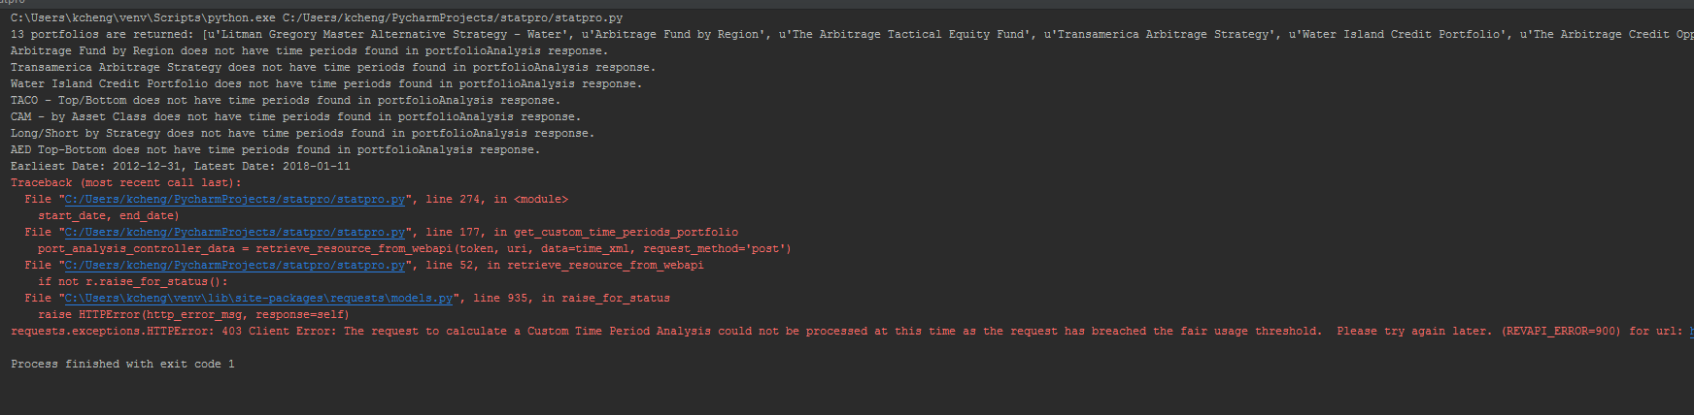](http://developer.statpro.com/Revolution/WebApi/FairUsagePolicy#)

## Holiday data

The holiday dates avoidance function is disabled as it is not impacting the result. StatPro is sending back no data for the holiday dates.

# Post-cleaning

As the data is downloaded quarterly, I later on combine the four quarter files into one year file.