SONARQUBE MANUALLY:

1.DOWNLOAD ZIP from <https://www.sonarqube.org/downloads/> and unzip.

2.set path in environment variables.

3.open sonarqube and start as Startsonar.bat by command prompt ,once it is up.

4.open browser as localhost:9000 you will see sonarqube dashboard.

5 you need to configure sonar plugin in pom.xml as

<build>

    <pluginManagement>

        <plugins>

            <plugin>

                <groupId>org.sonarsource.scanner.maven</groupId>

                <artifactId>sonar-maven-plugin</artifactId>

                <version>3.4.0.905</version>

            </plugin>

        </plugins>

    </pluginManagement>

</build>

Jacoco plugin:

|  |
| --- |
| <plugin> |
|  | <groupId>org.jacoco</groupId> |
|  | <artifactId>jacoco-maven-plugin</artifactId> |
|  | <version>0.7.8</version> |
|  | <executions> |
|  | <execution> |
|  | <id>pre-unit-test</id> |
|  | <goals> |
|  | <goal>prepare-agent</goal> |
|  | </goals> |
|  | </execution> |
|  | <execution> |
|  | <id>post-unit-test</id> |
|  | <phase>test</phase> |
|  | <goals> |
|  | <goal>report</goal> |
|  | </goals> |
|  | </execution> |
|  | </executions> |
|  | </plugin> |

6.need to configure settings.xml file in maven config.

<settings>

<pluginGroups>

<pluginGroup>org.sonarsource.scanner.maven</pluginGroup>

</pluginGroups>

<profiles>

<profile>

<id>sonar</id>

<activation>

<activeByDefault>true</activeByDefault>

</activation>

<properties>

<!-- Optional URL to server. Default value is http://localhost:9000 -->

<sonar.host.url>

http://myserver:9000

</sonar.host.url>

</properties>

</profile>

</profiles>

</settings>

7.open job and from there by command prompt run as mvnsonar:sonar.

8.you can see the project is analyzed in sonarqube.

SONARQUBE AUTOMATION:

1.Need to download SonarScanner FROM <https://docs.sonarqube.org/latest/analysis/scan/sonarscanner/>& unzip it.

2.Need To Configure SonarQube From manage Jenkins--->Configure Systems as

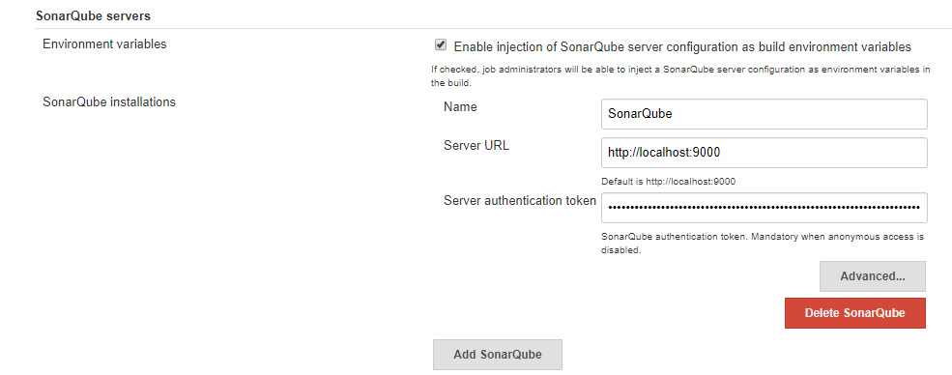

Server Authentication token can be generated from Sonarqube.

3.need to configure sonar-scanner in manage Jenkins--->Global Tool Configuration as

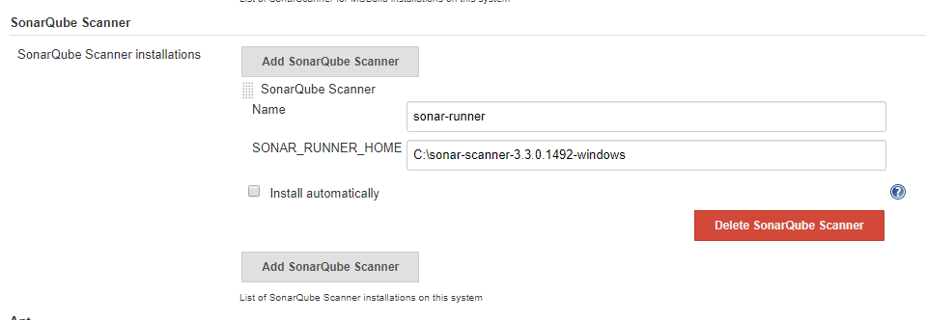

4.we can create sonar.propertyfile in github or you can paste the sonarqube properties in Jenkins job as

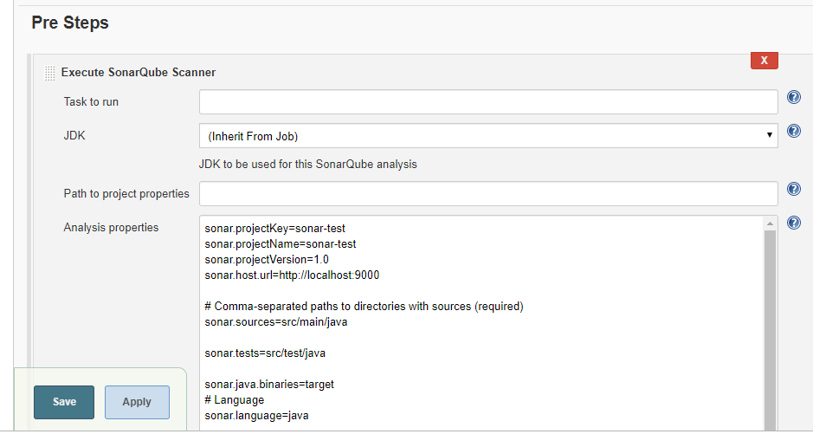

If you created sonar Properties provide the path in path to project properties.Otherwise place the properties in job pre steps select Execute SonarQube Scanner in analysis properties.