0 Docker compose

what is Docker compose
compose is a tool for defining and running multi-container Docker applications.with compose use a yaml file to configure your application services.with a singe command you create and start all the services from configuration Run "docker-compose up" and compose starts "docker-compose down" stop.

installing docker compose?

run the command current stable release of docker compose

curl -L "https://github.com/docker/compose/releases/download/1.10.0-rc2/dockercompose-$(uname -s) -$(uname -m)" -o /home/docker-compose

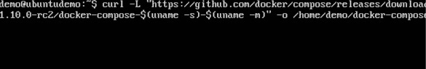
chmod +x /home/docker-compose
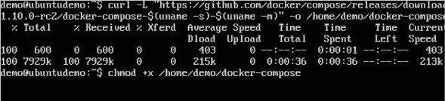

$ docker-compose --version
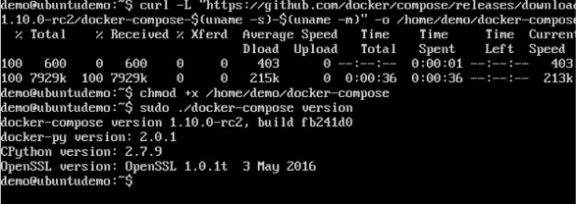

Compose use a YAML or yml scripts it looks like this

version: "3.7"
services:
webapp:
build: ./dir

docker-compose config

it will check validity of the command

docker-compose up -d

it will run in deatch mode

docker-compose down

it will down the application

*For creating a simple app using compose file
Create a directory
mkdir Dockercompose
cd Dockercompose
ls (list the files or directories)

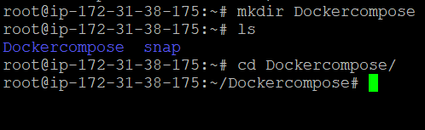
touch docker-compose.yml
ls
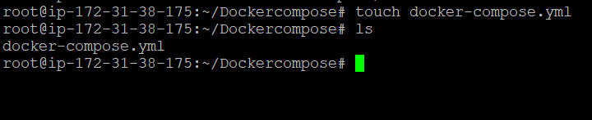
docker-compose.yml

version: "2"
services:
webapp:
image: nginx
ports:
- 8080:80
database:
image: redis



docker-compose config
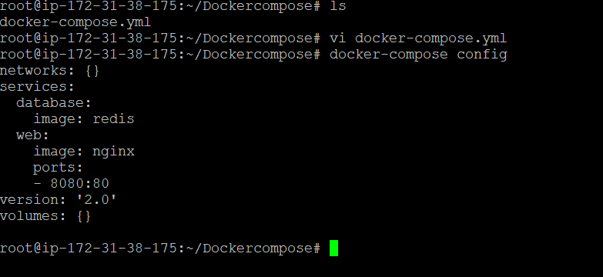
it will check the syntax

docker-compose up
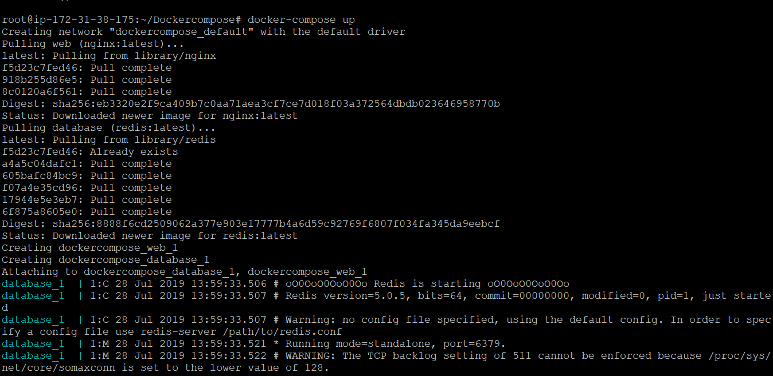

it will pull the images from docker hub
and start the applications

see


docker-compose down

it will stop the applications

if you want scale the servicesdocker-compose up scale web=4
They did introduce the scale option for version 2.2 and 2.3 of docker-compose but removed it for version 3.0. Also, to use version 2.2 or 2.3 you would need to download an older version of the docker-compose tool. The current version does not support 2.2 or 2.3 (it does support 2.0 or 2.1 however). There is also a new deploy section with replicas: 5 but it's only for swarm mode.
Write a docker-compose.yml file
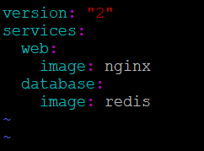
$ docker-compose up -d --scale web=4

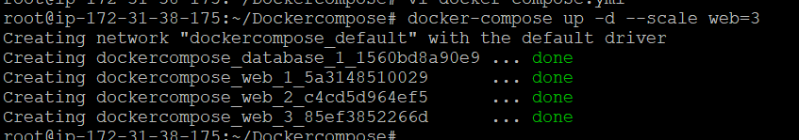

$ docker-compose up scale web=4
to check the services
docker ps
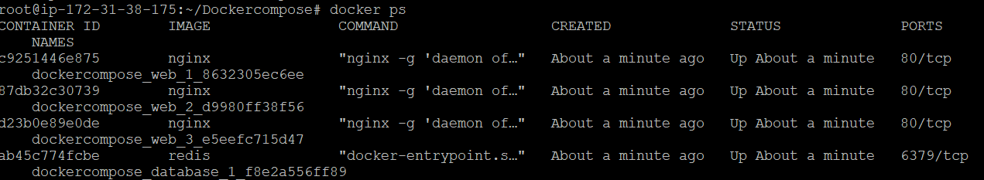
s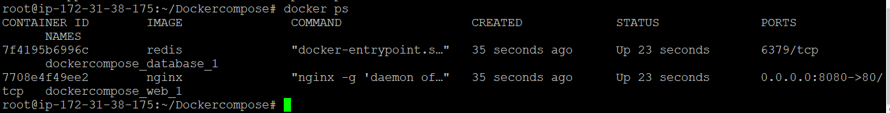
to a sample app

i am creating a flask project "app.py"
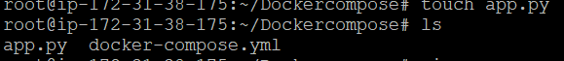
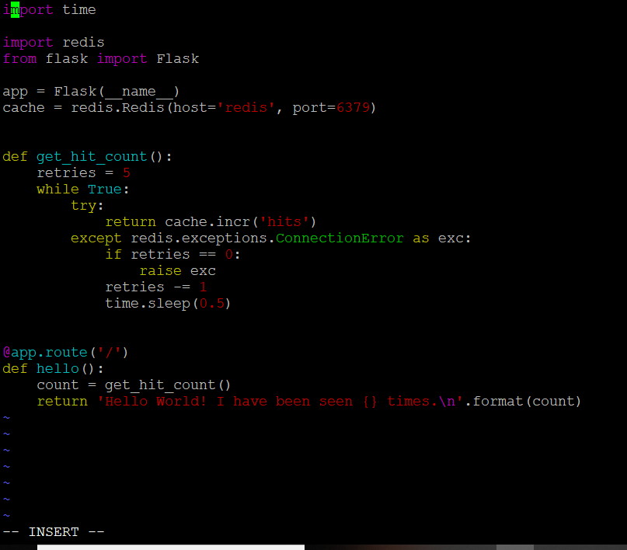

import time
import redis
from flask import Flask

app = Flask(__name__)
cache = redis.Redis(host='redis', port=6379)

def get_hit_count():
retries = 5
while True:
try:
return cache.incr('hits')
except redis.exceptions.ConnectionError as exc:
if retries == 0:
raise exc
retries -= 1
time.sleep(0.5)

@app.route('/')
def hello():
count = get_hit_count()
return 'Hello World! I have been seen {} time\n'.format(count)

create requirements.txt file
flask
redis

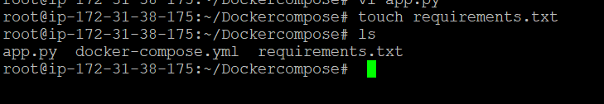

create a Docker file

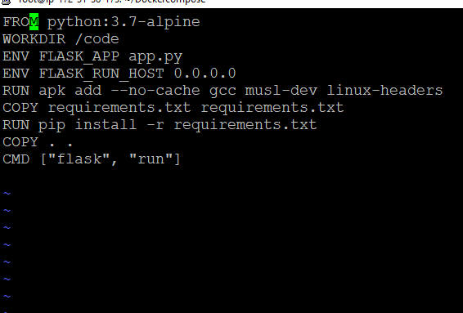

FROM python:3.7-alpine
WORKDIR /code
ENV FLASK_APP app.py
ENV FLASK_RUN_HOST 0.0.0.0
RUN apk add --no-cache gcc musl-dev linux-headers
COPY requirements.txt requirements.txt
RUN pip install -r requirements.txt
COPY . .
CMD ["flask", "run"]

create a docker-compose.yml

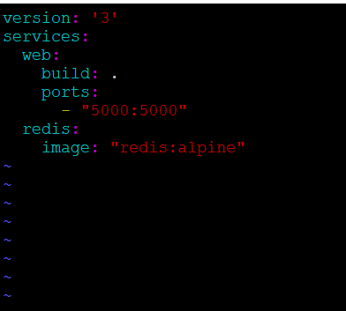
version: '3'
services:
web:
build: .
ports:
- "5000:5000"
redis:
image: "redis:alpine"

to build up a application

run
docker-compose up
