**Case1:** Maill from User- Where we can see details clearly in SPLUNK.

**

Used below query in SPLUNK

Query: index="ei_prod_mule_apps" "0807563904" "metadata.source"="Oracle TMS" "metadata.target"=SAP

**Got below results from query:**

**Event 1:**

{"eventDatetime": "2025-02-09T15:01:39.104Z","eventType": "INFO","metadata": {"step": 3,"comments": "sa10018-bts-sapbe-v2-prod","uniqueId": "3d40a214-b8df-4093-9f9b-af2b42c4b3b4","interfaceId": "SA10018","correlationId": "c3277120-e6f6-11ef-bdb2-0affe4b39e75","source": "Oracle TMS","target": "SAP","originalClientId": "b64921d31e5748f6a1254b968762ab33","originalClientName": "prod-pa10132-gp-shipments-v1","businessObject": "Planned Shipments","appName": "sa10018-bts-sapbe-v2-prod","environment": "prod","customMetadata": [{"name": "Start Time and End Time in (UTC)","value": "2025-02-09T15:01:38.394Z and 2025-02-09T15:01:39.103Z"},{"name": "Processing Time","value": "0.709 Seconds"},{"name": "shipmentId","value": "4868650"},{"name": "SAP Delivery Numbers","value": "0807563904"}]}}

**Event 2 :**

{"eventDatetime": "2025-01-24T16:55:56.24Z","eventType": "INFO","metadata": {"step": 3,"comments": "sa10018-bts-sapbe-v2-prod","uniqueId": "cedc0e89-df0e-432a-934b-195435ed477c","interfaceId": "SA10018","correlationId": "14068d90-da74-11ef-8e08-0edb69cb6b65","source": "Oracle TMS","target": "SAP","originalClientId": "b64921d31e5748f6a1254b968762ab33","originalClientName": "prod-pa10132-gp-shipments-v1","businessObject": "Planned Shipments","appName": "sa10018-bts-sapbe-v2-prod","environment": "prod","customMetadata": [{"name": "Start Time and End Time in (UTC)","value": "2025-01-24T16:55:55.978Z and 2025-01-24T16:55:56.239Z"},{"name": "Processing Time","value": "0.261 Seconds"},{"name": "shipmentId","value": "4868650"},{"name": "SAP Delivery Numbers","value": "0807563904"}]}}

**Event 3:**

{"eventDatetime": "2025-01-24T16:39:49.288Z","eventType": "INFO","metadata": {"step": 3,"comments": "sa10018-bts-sapbe-v2-prod","uniqueId": "946b5581-7f37-4211-a6ad-6c52f85f0fd4","interfaceId": "SA10018","correlationId": "cc518970-da71-11ef-865a-12bbce70d0f9","source": "Oracle TMS","target": "SAP","originalClientId": "b64921d31e5748f6a1254b968762ab33","originalClientName": "prod-pa10132-gp-shipments-v1","businessObject": "Planned Shipments","appName": "sa10018-bts-sapbe-v2-prod","environment": "prod","customMetadata": [{"name": "Start Time and End Time in (UTC)","value": "2025-01-24T16:39:36.696Z and 2025-01-24T16:39:49.285Z"},{"name": "Processing Time","value": "12.59 Seconds"},{"name": "shipmentId","value": "4868650"},{"name": "SAP Delivery Numbers","value": "0807563904"}]}}

**Responded Below email to User :**

**Case 2:** Maill from User- I can see partially details in SPLUNK

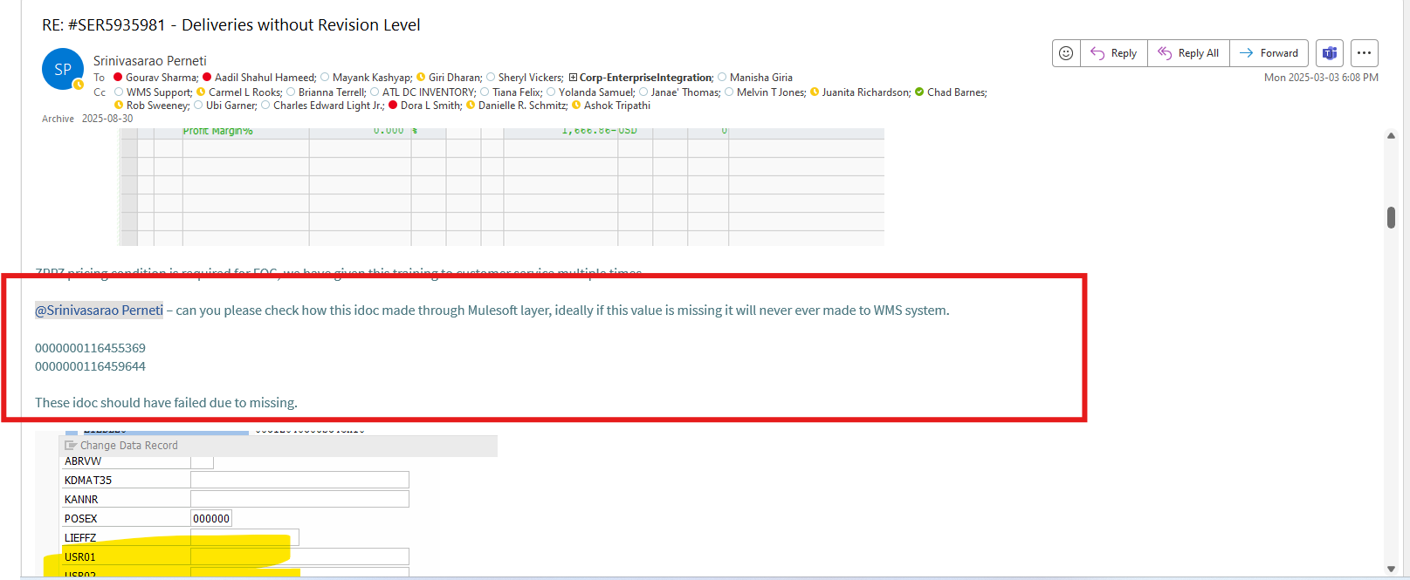

Used below query in SPLUNK

**Query 1:**

index="ei_prod_mule_apps" "0000000116455369" "metadata.target"=WMSBTS

Response for Query 1

{"eventDatetime": "2025-02-14T16:50:51.499Z","eventType": "INFO","metadata": {"step": 6,"comments": "I10163 Integration API Delivery Order Business Object","uniqueId": "e612ba5a-3941-4ef6-b6df-172ffc4a0d29","interfaceId": "I10163","correlationId": "d8b81570-eaf3-11ef-a205-0ed703fffb79","source": "SAPS4HANA","target": "WMSBTS","originalClientId": "client_id","originalClientName": "prod-us-i10163-gp-saps4hana-wmsbts-v1","businessObject": "Delivery Order","appName": "i10163-gp-saps4hana-wmsbts-v1-prod","environment": "prod","customMetadata": [{"name": "IDOC Number","value": "0000000116455369"},{"name": "Delivery Number","value": "0831204858"},{"name": "Message Type","value": "DESADV"}]},"anypointmq": {"destination": "i10163.q.s4hana.deliveryorder.wmsbts.sub-prod"}}

**Query 2 :**

index="ei_prod_mule_apps" "d8b81570-eaf3-11ef-a205-0ed703fffb79"

index="ei_prod_mule_apps" "d8b81570-eaf3-11ef-a205-0ed703fffb79" "metadata.target"=WMSBTS "metadata.appName"="sa10109-bts-wmsbts-v1-prod"

**Responded Below email to User :**

Responses for Query2

{"eventDatetime": "2025-02-14T16:50:51.453Z","eventType": "INFO","metadata": {"step": 5,"comments": "SA10109 System API Shipment Requests POST","uniqueId": "077a2912-3ca2-4fd8-96b3-3ab4b902d3ad","interfaceId": "SA10109","correlationId": "d8b81570-eaf3-11ef-a205-0ed703fffb79","source": "SAPS4HANA","target": "WMSBTS","originalClientId": "e0785588d58443b787facdbb8834bbe3","originalClientName": "prod-i10163-gp-saps4hana-wmsbts-v1","businessObject": "Delivery Order","appName": "sa10109-bts-wmsbts-v1-prod","environment": "prod","customMetadata": [{"name": "File Name","value": "SHIPORD_INB_IFD_116455369_2025021416505081800.xml"},{"name": "Order Number","value": "0831204858"}]}}

{"eventDatetime": "2025-02-14T16:50:50.824Z","eventType": "INFO","metadata": {"step": 3,"comments": "SA10109 System API Shipment Requests POST","uniqueId": "e3f03656-cd4b-423a-b780-bff9c3e793b8","interfaceId": "SA10109","correlationId": "d8b81570-eaf3-11ef-a205-0ed703fffb79","source": "SAPS4HANA","target": "WMSBTS","originalClientId": "e0785588d58443b787facdbb8834bbe3","originalClientName": "prod-i10163-gp-saps4hana-wmsbts-v1","businessObject": "Delivery Order","appName": "sa10109-bts-wmsbts-v1-prod","environment": "prod","customMetadata": [{"name": "File Name","value": "SHIPORD_INB_IFD_116455369_2025021416505081800.xml"},{"name": "Order Number","value": "0831204858"}]}}

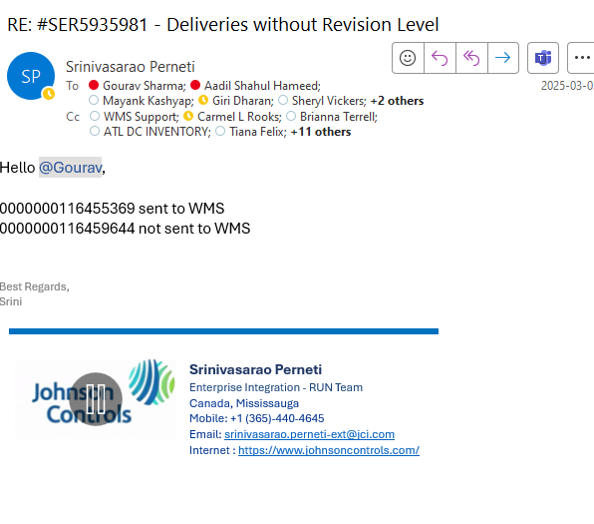

Case 3: **:** Maill from User for multiple unique IDs

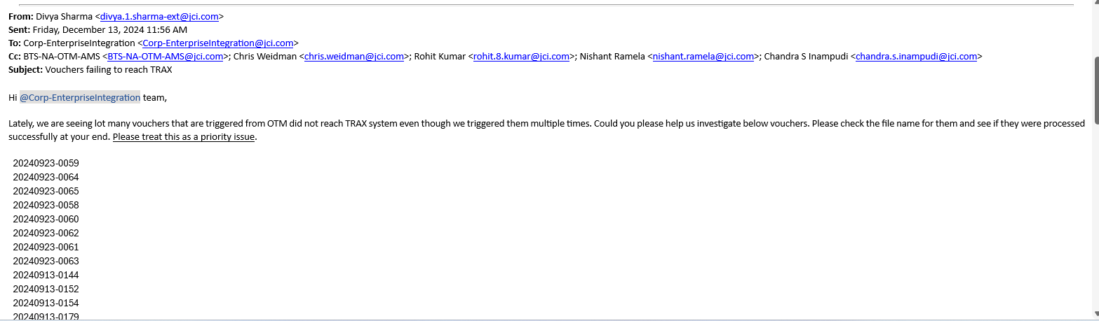

Used below query with or condition and pulled for all records

index="ei_prod_mule_apps" "20240923-0059" OR "20240923-0064" "metadata.source"="Oracle TMS" "metadata.target"="IntelligentAudit, Trax"

Responded below email to suer with downloaded attachment from SPLUNK

