*Usage of concept of inheritance:*

Usage of subclass extends the functionality of parent class. We don’t need to rewrite methods, redeclare variables by using the concept of inheritance. It overall helps in keeping the code concise, easy to track and minimal. It also supports the concept of DRY(Don’t Repeat Yourself) which is an important programming concept. Class Audio inherits the properties from the class Advert in this assignment.

Overriding of superclass is done in one instant to use the methods of superclass with the variables used for particular instances of the subclass.

*Usage of Polymorphic method calls and polymorphic variables:*

Polymorphism refers to the practice of utilizing variables and methods of one parent class to many other classes in java. Polymorphism is an important concept in Object-Oriented programming that can substantially slash down the need to rewrite and redeclare methods and variables over a program.

The method GetCost() is being called in child classes and the polymorphic parameters associated with it too have been redrawn.

*Usage of git:*

Git is used to track progress and follow an incremental development approach.

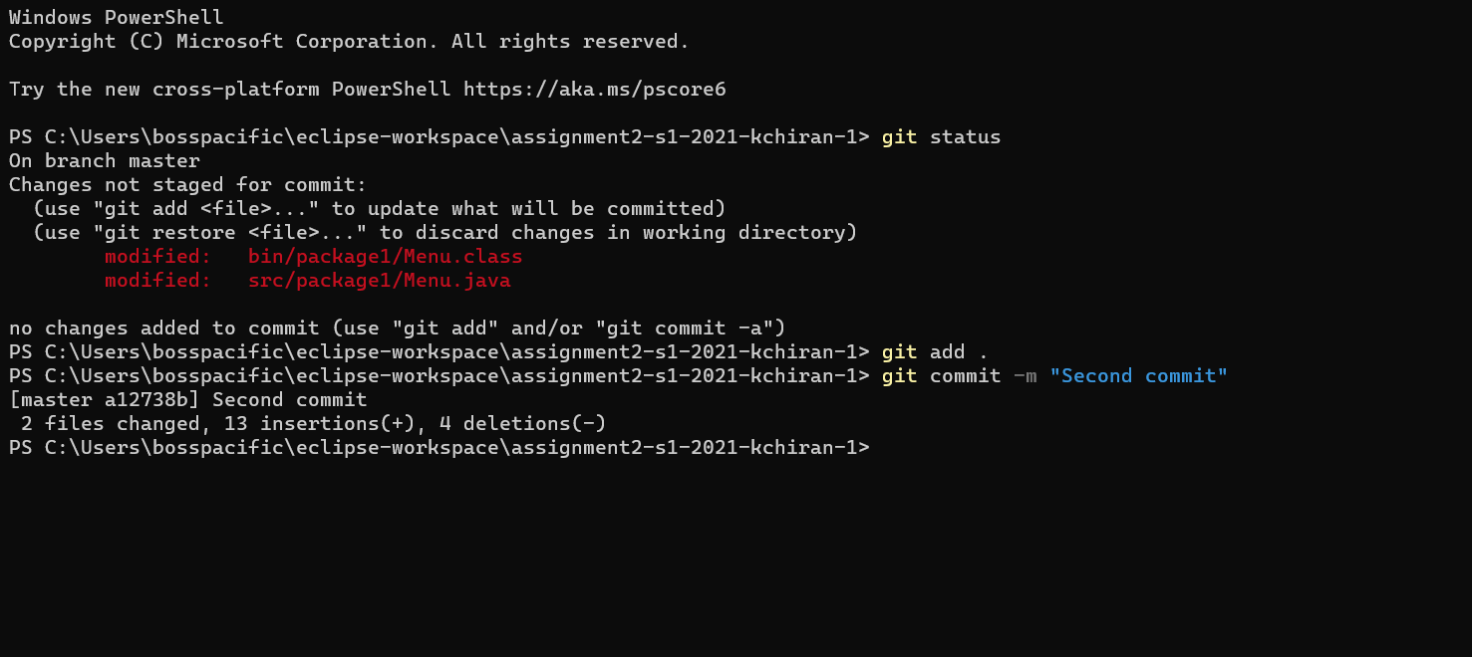

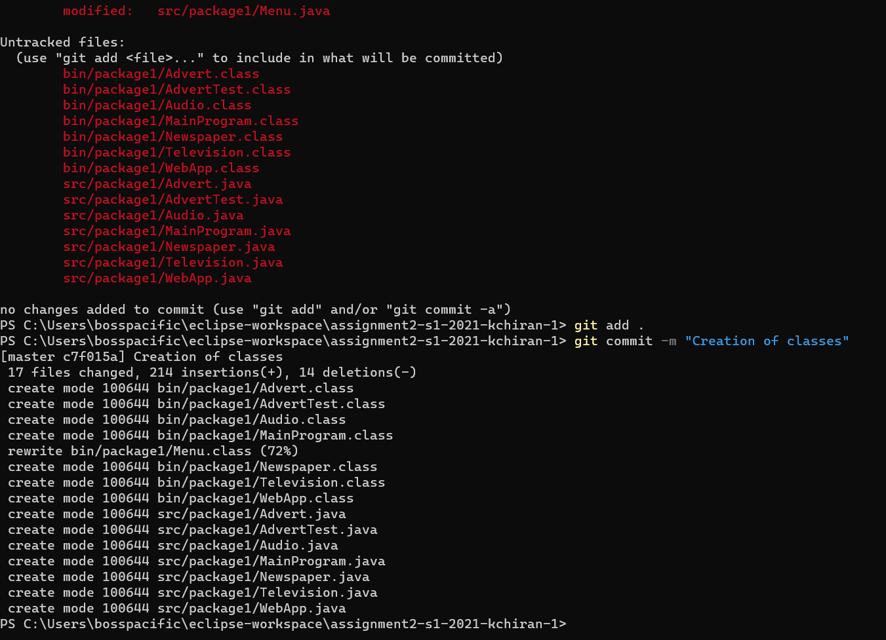

*JUnit Test Cases:*

Junit Test cases have been implemented to follow the principle of Test-Driven-Development(TDD). The approach tests the viability and procedure of the program and tests it for severa unit test cases.