# VARpedia – user manual

By Group 48  
GitHub Repository: <https://github.com/kcho9906/SOFTENG206_a04>

Table of Contents

VARpedia – user manual 1

First Time Launch 2

Main Menu 3

Create a Creation 4

Adding Audio Files 5

Using Audio Files 6

Adding Background Music 6

Selecting Images for Creation 7

Viewing a Creation 9

Playing Creations 10

Quiz 11

# First Time Launch

Thank you for choosing VARpedia as your choice of language learning tool. Before you launch, please be aware that this is only compatible with Unix/Linux operating systems and also requires the flickr4java API to function correctly.

Furthermore, you will need to have the bash commands, espeak, ffmpeg, ffplay, ffprobe, mp3info, and lame to run this application correctly.

# Main Menu

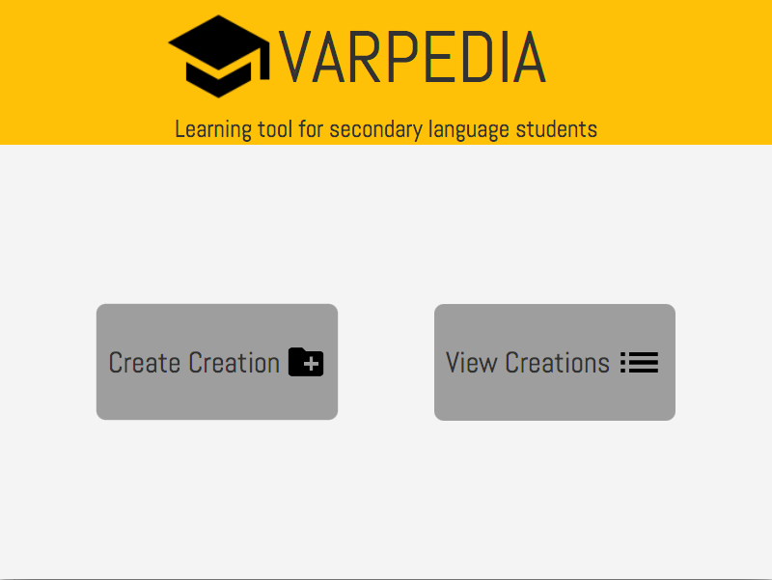

Figure 1 : Main Menu Scene

On opening of the application (VARpedia), you will see the Main Menu. From the Main Menu you can either create a creation or view existing creations by clicking on the respective buttons.

|  |  |
| --- | --- |
| To create a creation | To view a creation |
| Figure 1.1: Create a creation button | Figure 1.2: View creations button |

# Create a Creation

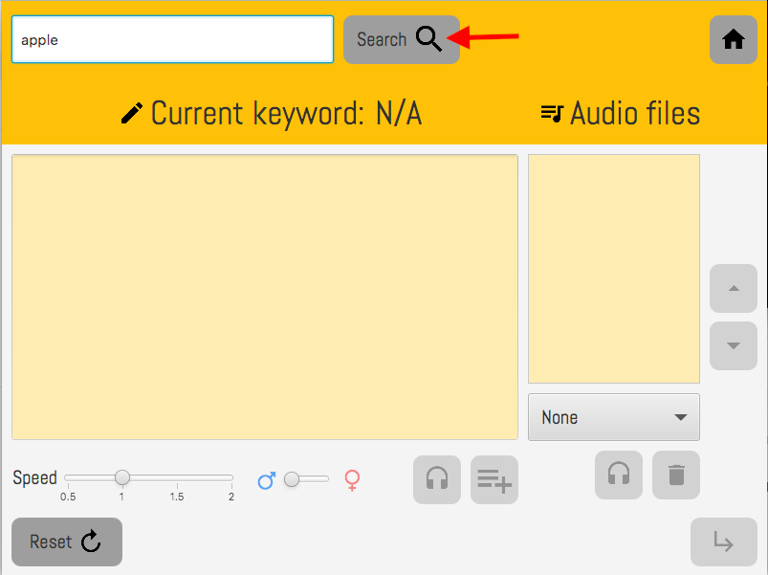

Figure 2: Create a creation scene

Changing to the create a creation scene, the user can enter in an English word into the search bar at the top. Once they have the term they want, they can push the search button. The search button will find information of the topic and show the result in the text area below.

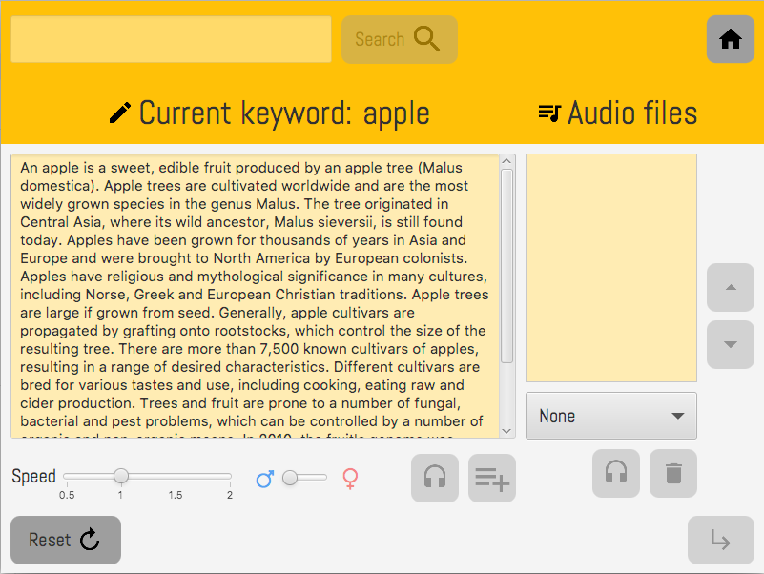

Figure 2.1: Text output

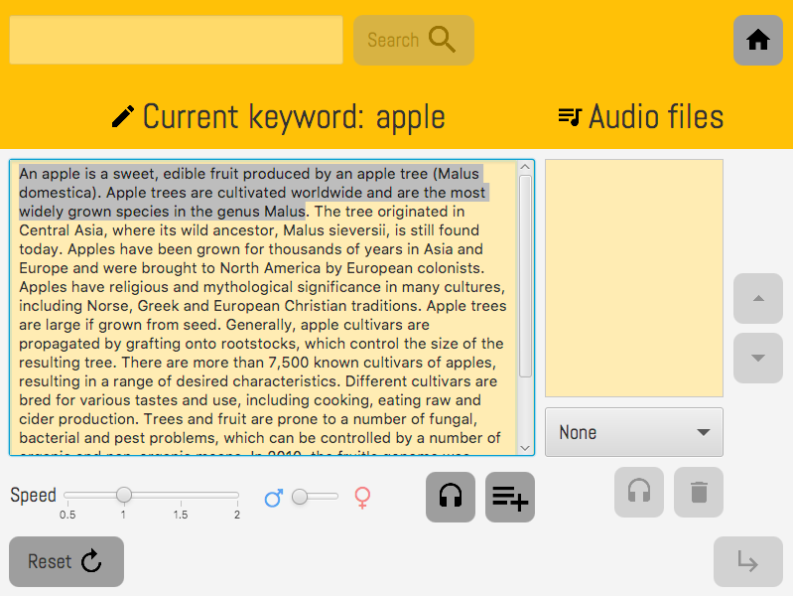

Figure 2.2: Highlighted text

## Adding Audio Files

After selecting a chunk of text (below 30 words), the user can adjust the speed and change the type of speaker between male and female. Once settings have been changed, the user can choose to preview the text, or save the audio file. If the user saves the audio file, it appears in the audio file list (Figure 2.6)

|  |  |
| --- | --- |
| Figure 2.3: eSpeak speech modifiers (speed and gender) | |
| Figure 2.4 Preview Audio Button | Figure 2.5: Add Audio to List Button |

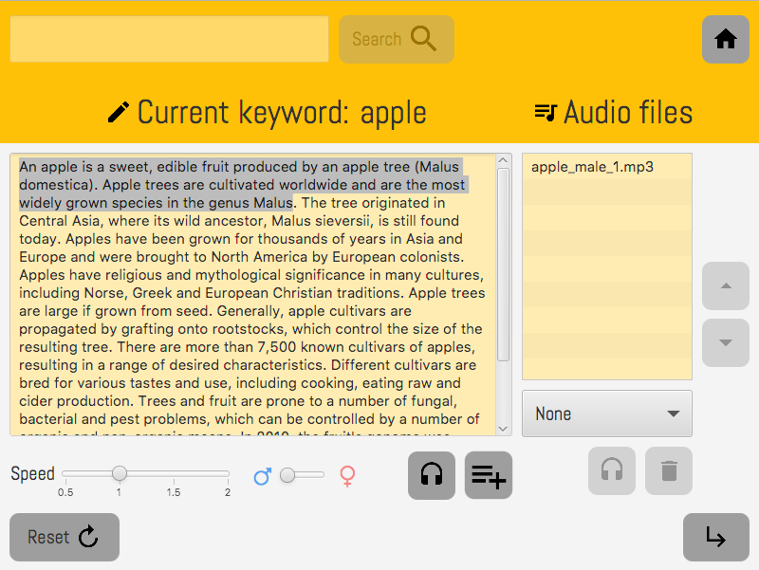

Figure 2.6: Audio file list

## Using Audio Files

The user can choose to play or remove an existing audio file. To do this, the user must select an audio file and has the option to:

|  |  |  |  |
| --- | --- | --- | --- |
| Figure 2.7: Play existing audio | Figure 2.8: Move audio up | Figure 2.9: Move audio down | Figure 2.10: Delete existing audio |

## Adding Background Music

The user can then add background music to the creation by clicking on the drop-down bar below the audio files list. The user has an option between upbeat and on_fire. This will add the music to the creation.

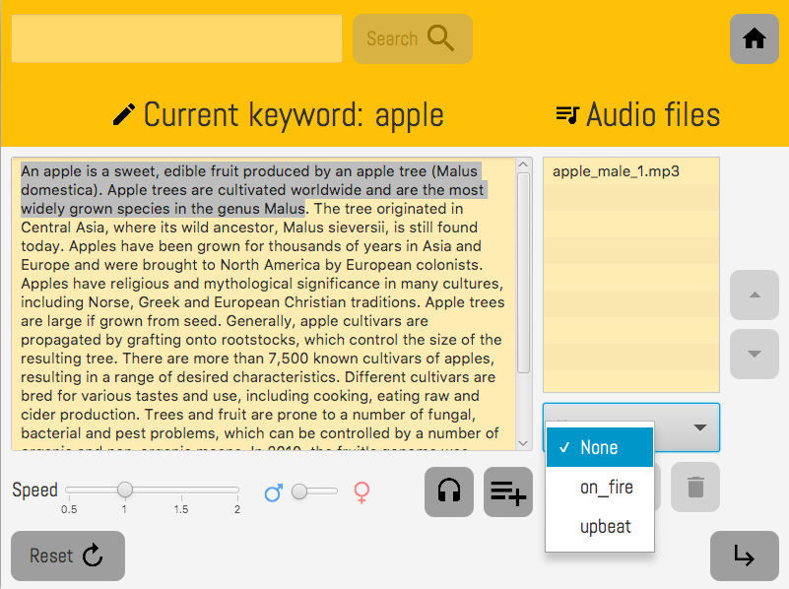

Figure 2.11: Adding background music

## Selecting Images for Creation

In this scene, twelve images are generated, and the user has the option to choose up to 10 images.

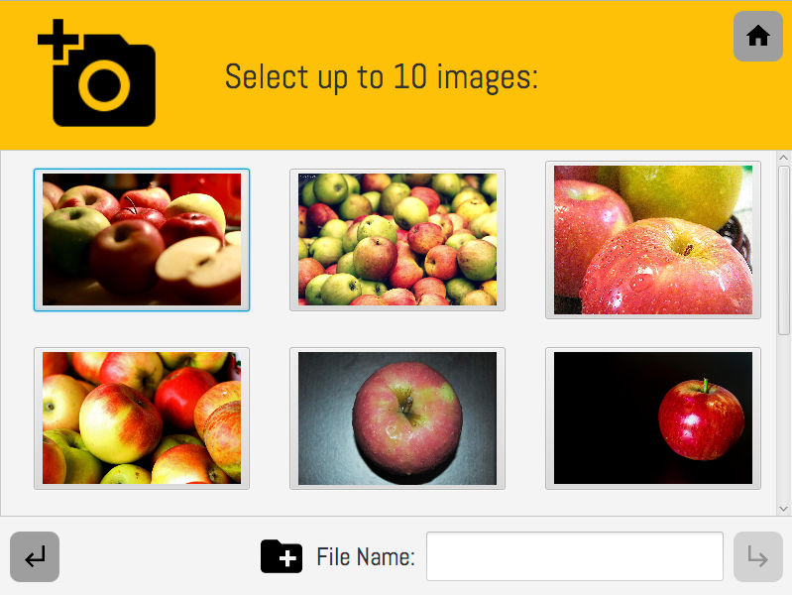

Figure 2.12: Image selection scene

Once the user is satisfied with the images, they enter a name for the creation which they can refer back to in the future. Then press the next arrow which will create the creation.

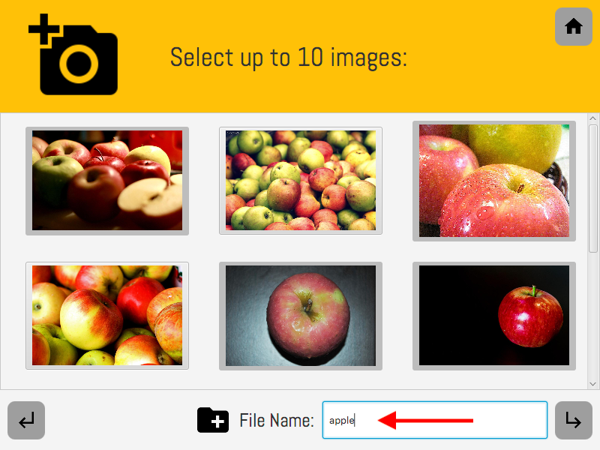

Figure 2.13: Final image selection

After creating the creation, the user can choose to play the creation straight away or go back to the Main Menu.

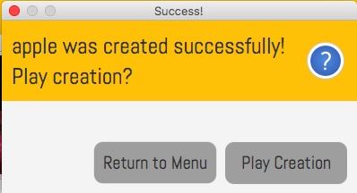

Figure 2.14: Play creation or return to menu

# Viewing a Creation

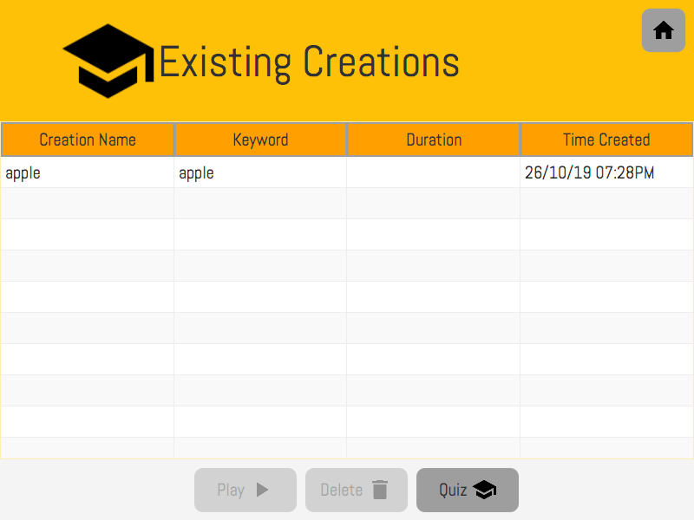

Figure 3.1: View creation scene

In the creation scene, the user can select an existing creation and either:

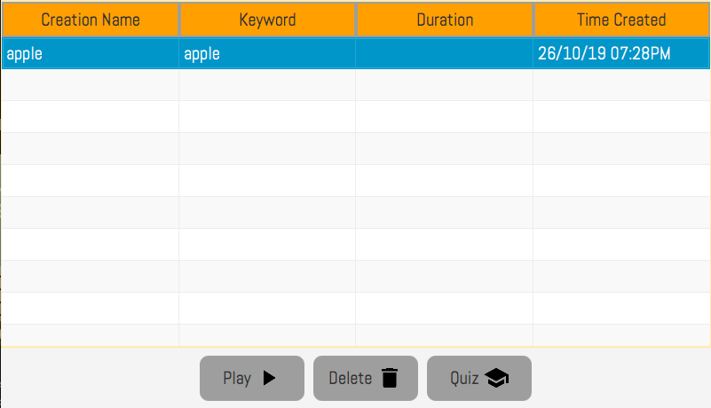

Figure 3.2: Selected creation

|  |  |
| --- | --- |
| Figure 3.3: Play creation button | Figure 3.4: Delete creation button |

# Playing Creations

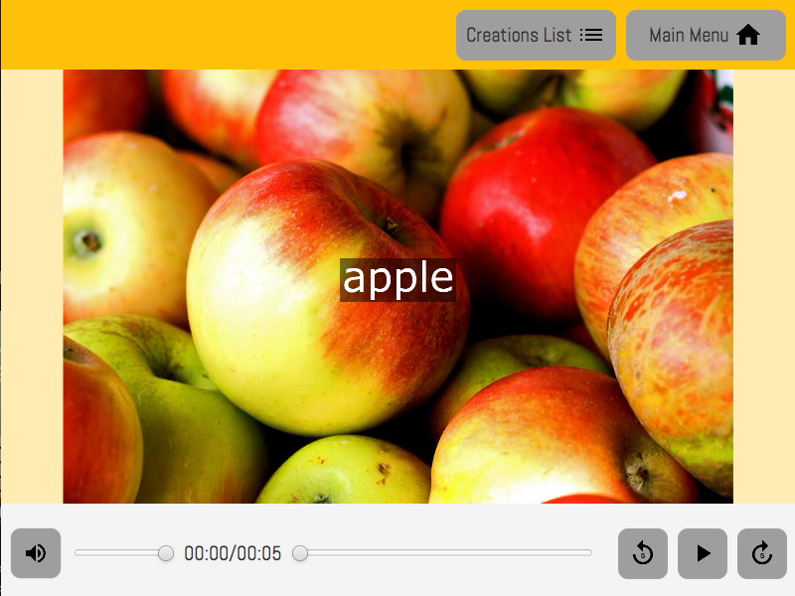

Figure 4.1: Playing the creation

Once the user has navigated to the media player to play the creation, the user can mute, rewind, fast forward and play/pause.

|  |  |  |  |
| --- | --- | --- | --- |
| Figure 4.2: Mute button | Figure 4.3: Rewind button | Figure 4.4: Fast forward button | Figure 4.5: Play button |

When the user is finished viewing the creation, the user can either go back to view different creations or go back to the main menu.

# Quiz

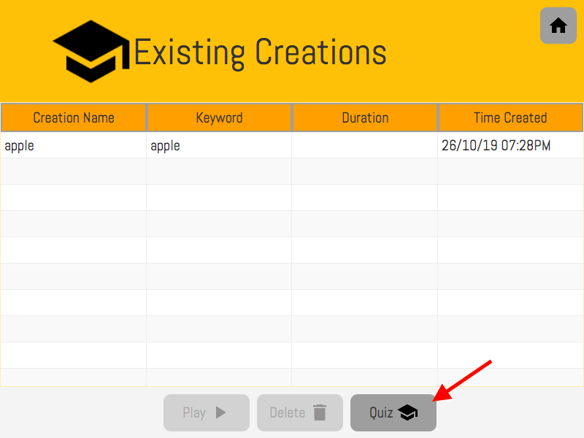

Figure 5.1: Quiz scene

To test the user, they can click on the quiz button and it will navigate them to the quiz scene. In the quiz, the user must type the answer to what they think the creation’s search term is in the text box and can check the answer, then move onto the next question.

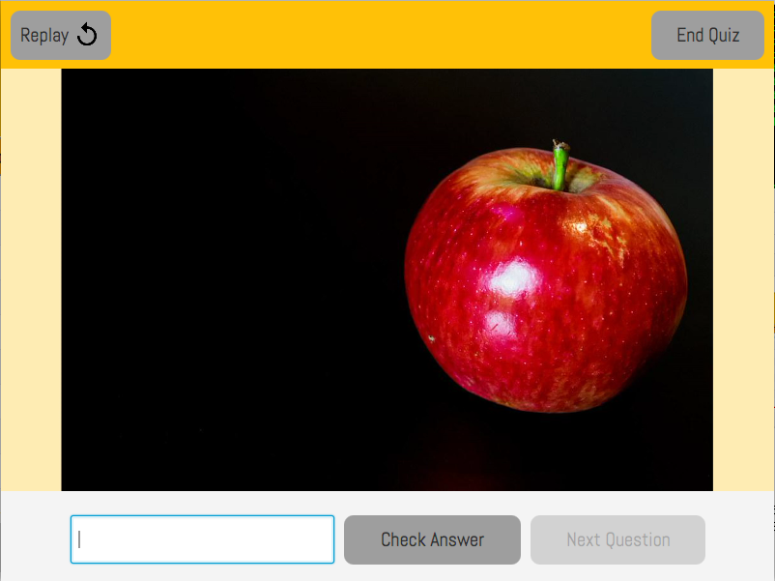

Figure 5.2: Quiz testing scene