1. 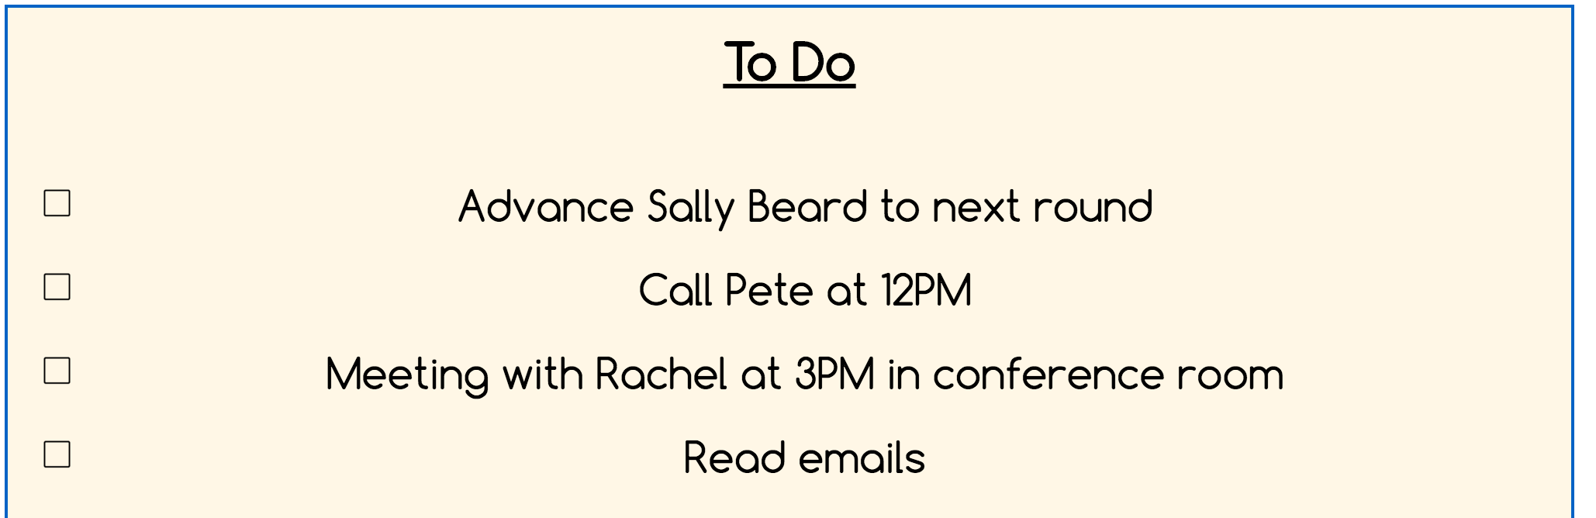

The problem I found here was that there was no way to add or delete/finish the tasks on the to do list. The checkboxes do not work and feel like those were a bit misleading. Also, it feels intuitive that you can press the tasks and it would lead to the part of the website where you could finish the task. **This problem would be a major problem in external consistency, learnability, and efficiency.**

2 and 3.



The problem I found here was that the links on some of the headers were not working on click. It maybe that the calendar is not implemented, but I noticed that in some parts of the website, you gave the error of stuff not implemented. It gave a misleading part that the calendar was supposed to work but was not. **This is a major problem in Learnability.**

The second problem here is that most websites give you the option of logging out when you either click or hover on the user id on the top right corner. It seems that there is no logging out function for the website? It would be a good safety measure to put one somewhere. **This problem would also be a major problem but in safety.**

4, 5, and 6.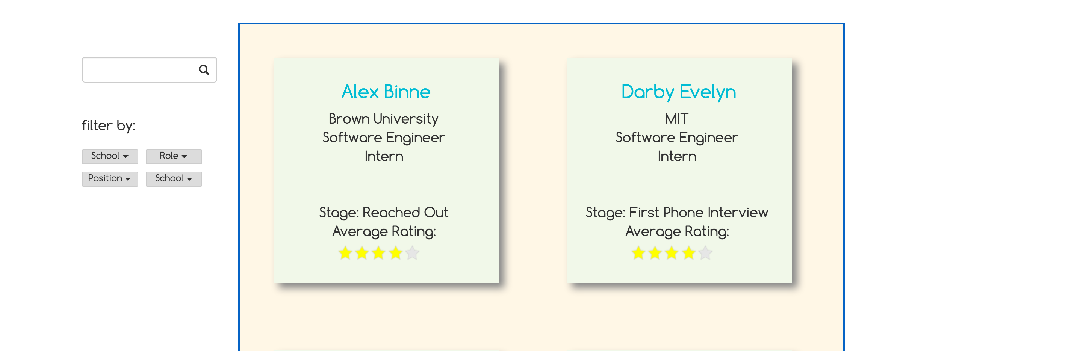

So, I found quite a bit of problems with this page. The first one I would like to discuss is the white space on the right. I like the balance of view with the centering, but if there were many candidates, there would be a whole lot of scrolling. Maybe you could somehow balance the widths to fit three on a line instead of two. **This problem is a minor problem in cosmetics, usability, and efficiency.**

Another problem I had here was the color contrast of the candidate “sticky notes”. Although I do like the coloring, there are a lot of similar color tastes that make things hard to see. For instance, the stars are a bit hard to see. Also the sticky note itself is a similar color scheme with the background. This problem gives the borders a little hard to see without the shadowing. **This problem is a major problem in cosmetics and usability.**

The third problem I found was that the font coloring was similar to the background and there are generally no contrast of font colors. Different color fonts are a powerful tool to have things stand out, but right now the candidate names actually do not stand out. They actually are blended in with the background so that the black font stands out more than the light blue. **This problem is a major problem in cosmetics and readability.**

7.

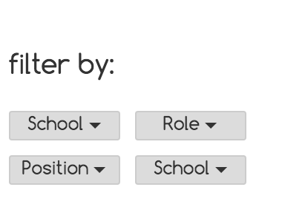

There are two filters for schools, which seems unnecessary. There is also a position filter and a role filter. I’m not sure what the difference is between the two, but both seem like the same thing to me. **This problem is a major problem in internal consistency.**

8.

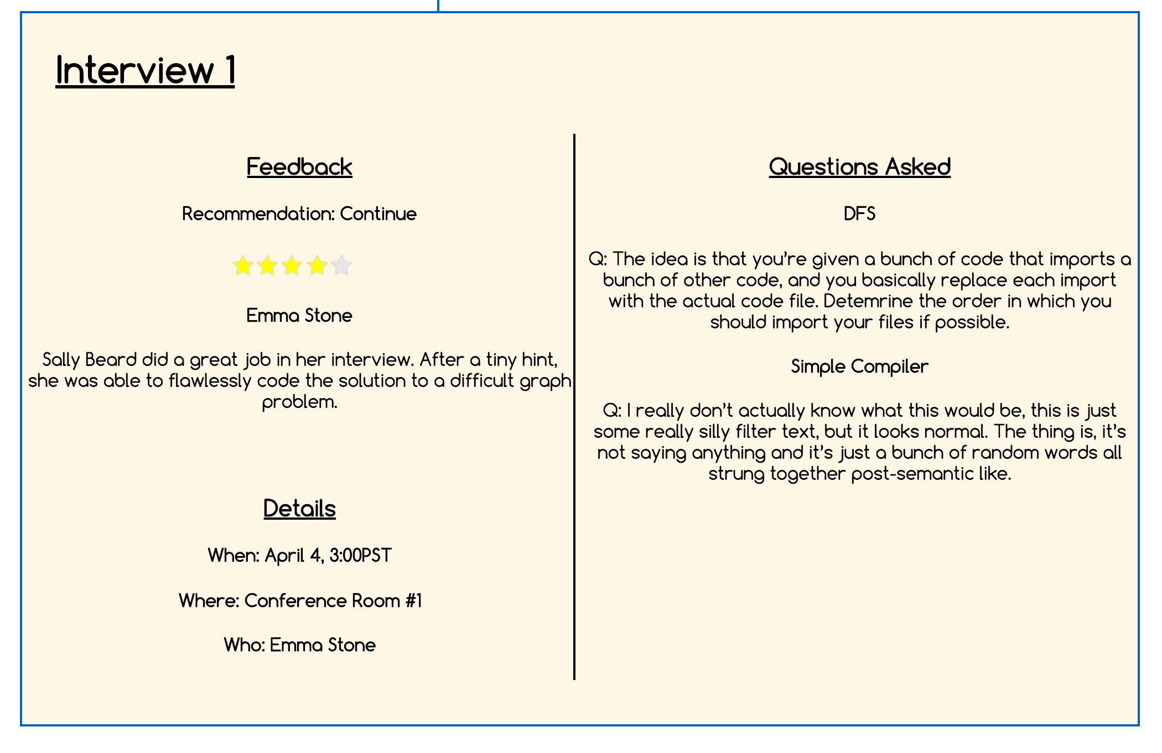

One problem I found with this UI is that nothing really stands out. You have the titles of each section pretty much just bolded and underlined, but even then because the colors are uniform, nothing catches the eye. Also the stars here are not visible easily. **This is a major problem in readability and cosmetics**.

9.

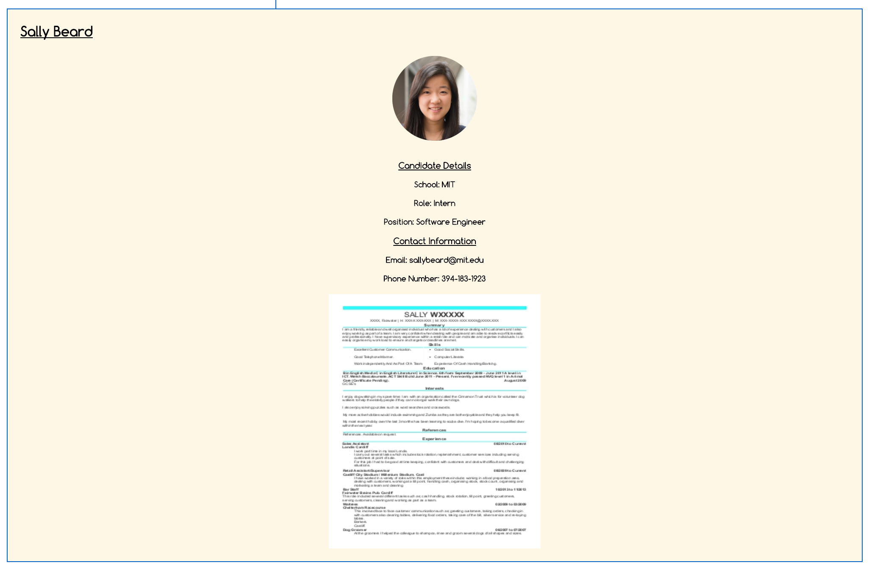

For this picture, I actually had to zoom out to see the whole thing. It seems like a efficiency and usability handicap if we have everything spaced out so much. Everything is centered, which isn’t a big problem, but each item has its own line that it fills too much space. There are definitely ways to view this UI without have to scroll. **This is a major problem in readability and efficiency.**

10.



There wasn’t a problem with this part, but I just wanted to comment on how I really liked this part. It was very intuitive that the blue + would create a new part to the timeline. The highlighted circle was also helpful in showing which part of the timeline you were at. **This was a great way internal consistency and learnability feature.**

11.

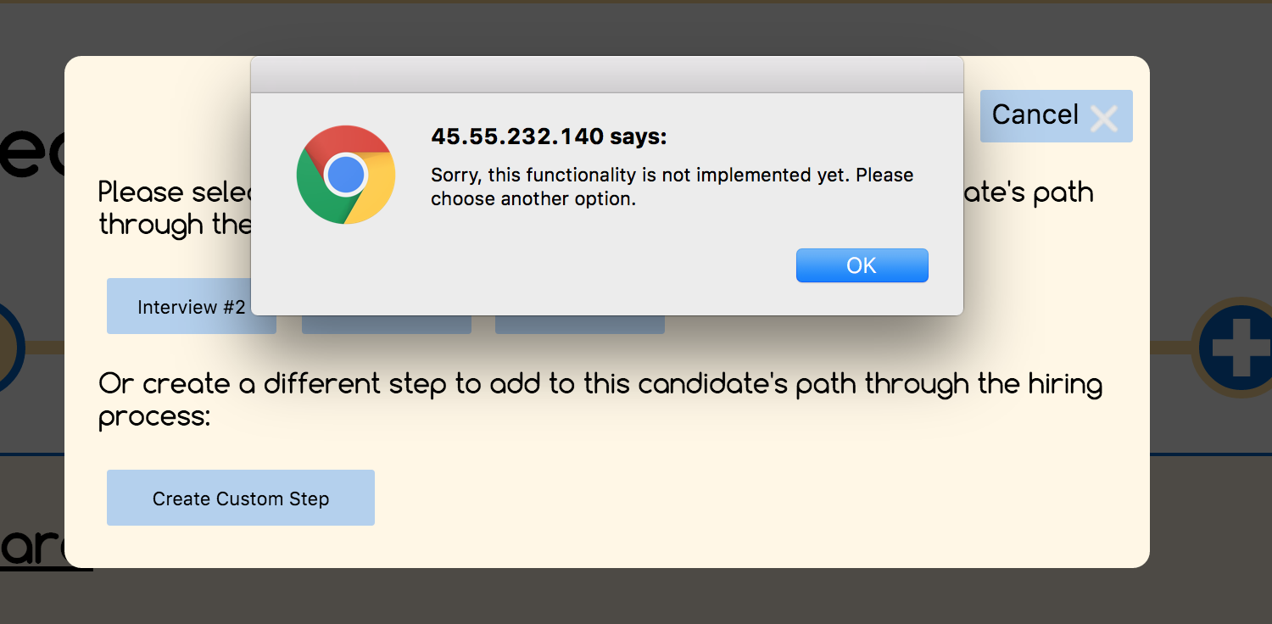

This was a good way error message display to show which functions were implemented and which were not. It gave me a sense to which ones I could use as of now. This is good if you’re planning on adding new features but have not implemented them as of now. **This was a great safety and error message feature.**

12.

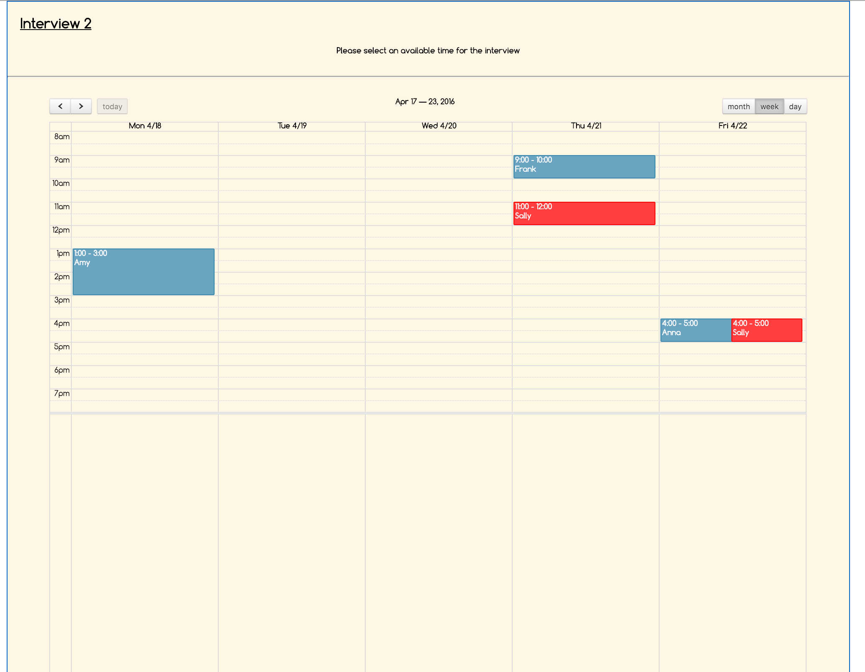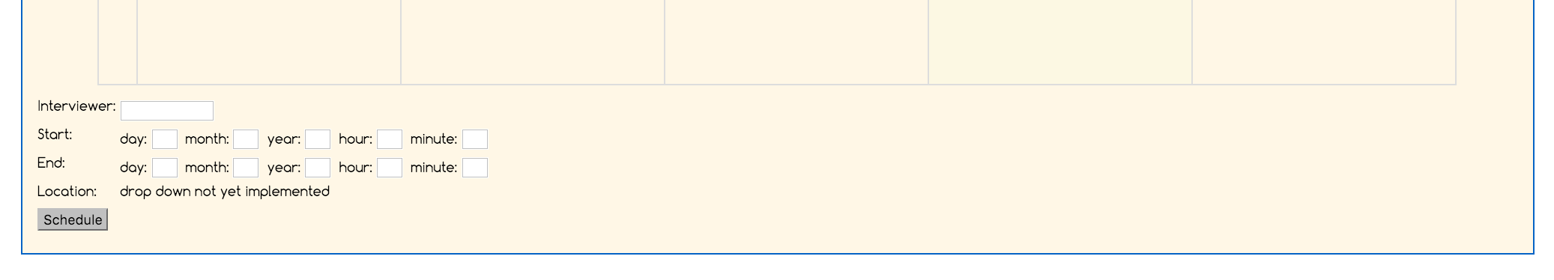

One this page, I had to get a whole page shot by zooming out to 50%. The problem here was that at 100% zoom, on first glance, I thought the way you select a time was to either click on the time slots with sally’s name on it or that I had to drag a time slot like Google calendar. None of these features worked, and I got confused. I didn’t actually find the bottom portion till way later. **This would be a problem in usability, learnability, and external consistency.**

13.

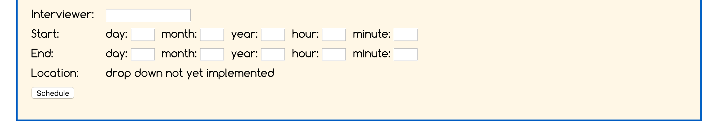

I think that the text forms for filling out the start and end date/time for the interview was unnecessary. Interviews typically only take a day, so having a start and end date doesn’t really make sense. Also for the time, it seems much more intuitive to just have a time slot instead of the hour and minutes text boxes. **This is a problem with internal consistency and external consistency.**

14.

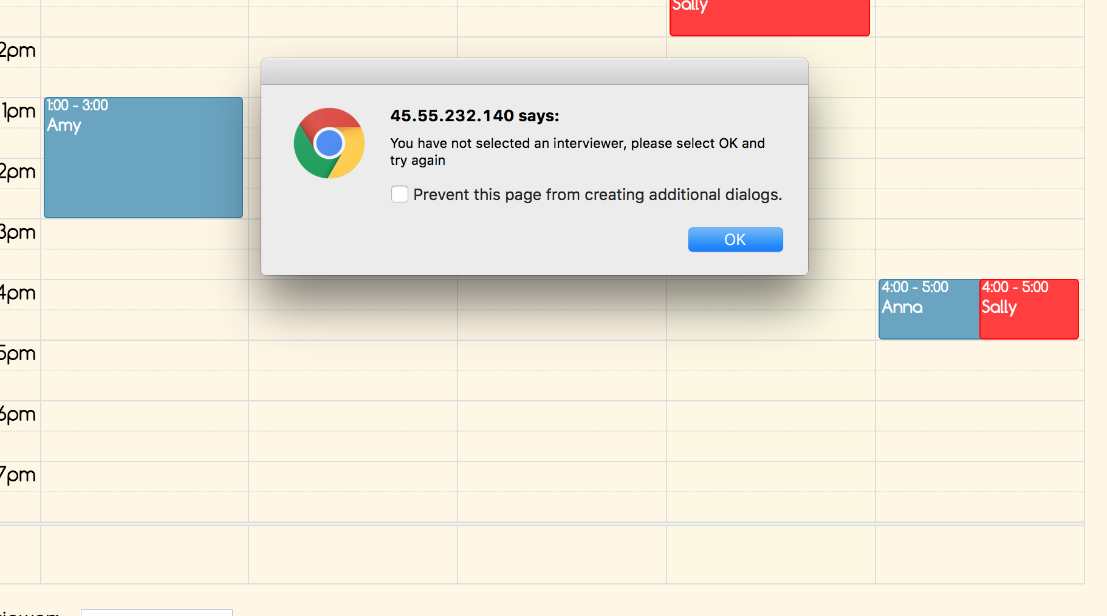

After creating an event, it seems like we should be lead to a different page where you could fill out a form of how the event/interview went. Maybe it might not be that form, but one feels the anticipation that they would be lead to a new page instead of staying at the old page. **This is a minor problem with internal consistency.**

15.

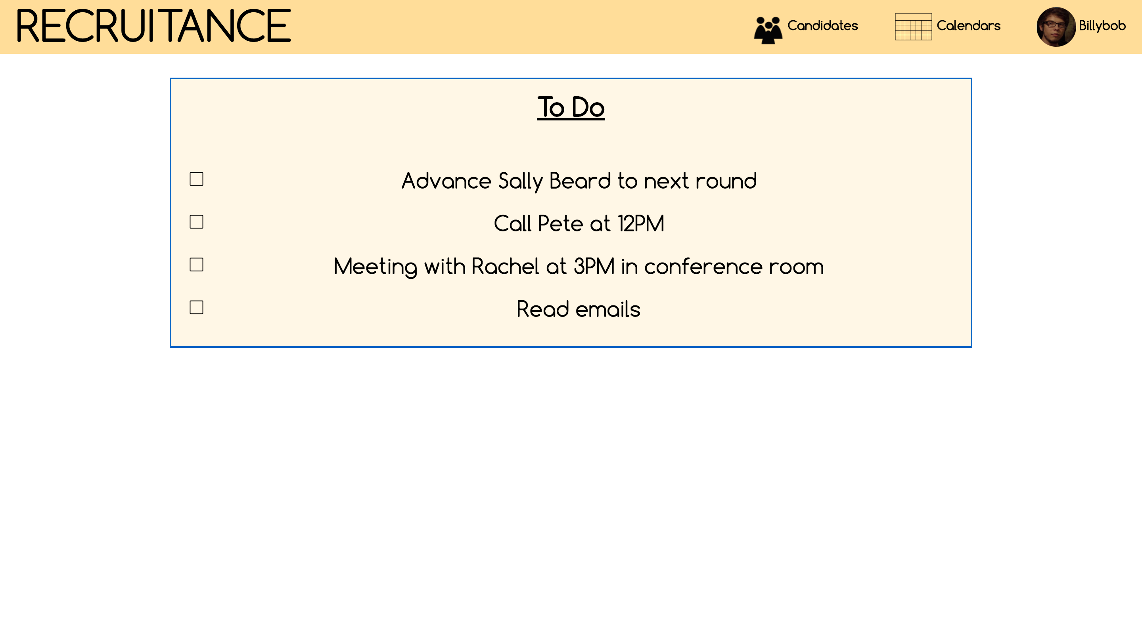

In general, I thought the website was very simple and easy to use as of the tasks that are implemented as of now. I’m not sure how it’ll turn out later on, but I like the balance in the feel and looks. Most things were intuitive what to do and where to go. **Overall, the website was simple and easy to learn.**