feat. Visualizing the history of hip hop collaborations in the United States

Sonja Khan  sonjak3@cs.washington.edu | Riley Porter  rileymp2@cs.washington.edu | Kevin Quinn  kchq@cs.washington.edu | Vinod Rathnam  rathnam@cs.washington.edu

ABSTRACT
In this paper we describe ‘feat.’, a novel interactive visualization that facilitates dynamic temporal exploration of inter- and intra-regional hip hop collaborations in the United States. We provide a brief history of the hip hop genre and culture, discuss our methods for collecting and cleaning data, and the process of designing and refining the interaction.

Author Keywords
Data visualization, hip hop, collaboration, temporal exploration instructions, author’s kit, conference publications.

INTRODUCTION
Hip hop is a genre and culture born in the United States with a rich history and powerful sound. Our visualization is motivated by hip hop’s emphasis on collaboration and regional distinction. Unfortunately, the availability of datasets centered around hip hop music are extremely limited, with most existing visualizations requiring hand compiled data focused on extremely specific aspects of the genre.

Brief History of Hip Hop
DJ kool herc, migration to west coast, emergence of gangsta rap, murders, evolution of sound, etc.

Motivation
Maybe talk about the regional interplay here (referring to the history section above) and the importance of collaborations.

Related work

Hip Hop Vocabulary Size
In addition to the visualization, discuss how data collection occurred.

Hip Hop Word Count
Talk about failure to find the database?

Music Timeline
https://music-timeline.appspot.com/#HIP_HOP_RAP
Kind of shows regional info (west coast, south) but doesn’t show geographic data or collaborations. Good indicator of the subgenres of hip hop within the broader

Methods
Our method for creating the visualization had two distinct phases – data collection, and interaction design and implementation.

Data Collection
Our data came from multiple different sources. Below we describe each step.

Selecting Artists
133 hip hop artists were hand selected based on their popularity and influence.

MusicBrainz

Spotify
Vinod

Data Cleaning

Visualization Implementation
Our data came from multiple different sources. Below we describe each step.

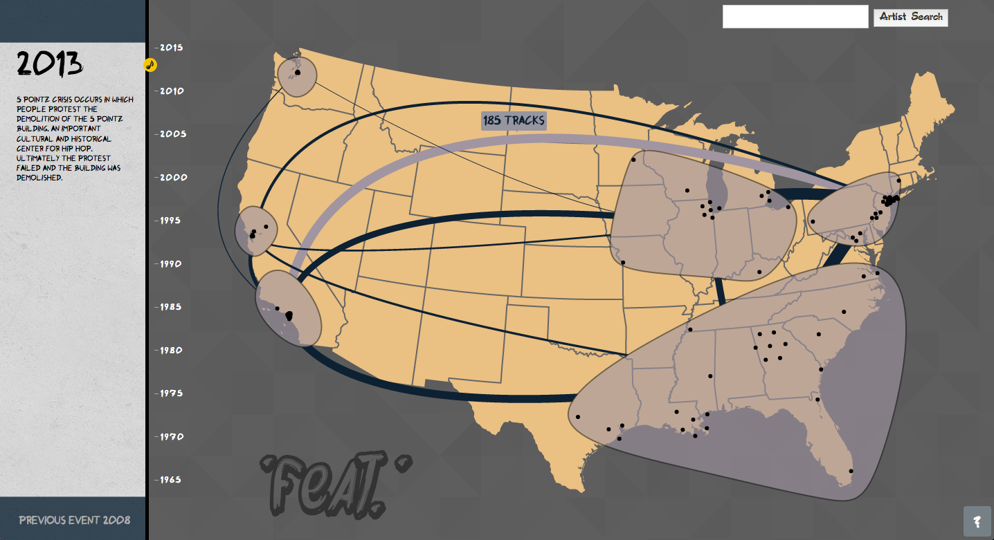
Figure 1. Table captions should be placed below the table.

results
Place figures and tables at the top or bottom of the appropriate column or columns, on the same page as the relevant text (see Figure 1). A figure or table may extend across both columns to a maximum width of 17.78 cm (7 in.).
Captions should be Times New Roman 9-point bold (Caption Style in this template file). They should be numbered (e.g., “Table 1” or “Figure 2”), centered and placed beneath the figure or table. Please note that the words “Figure” and “Table” should be spelled out (e.g., “Figure” rather than “Fig.”) wherever they occur.
Papers and notes may use color figures, which are included in the page limit; the figures must be usable when printed in black and white in the proceedings.

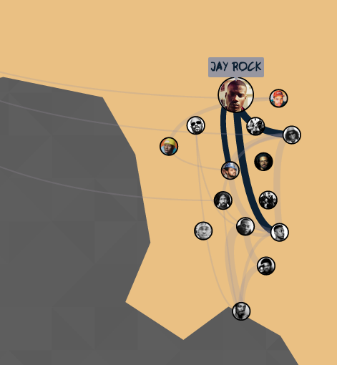
Figure 2. Table captions should be placed below the table.
The paper may be accompanied by a short video figure up to five minutes in length. However, the paper should stand on its own without the video figure, as the video may not be available to everyone who reads the paper.

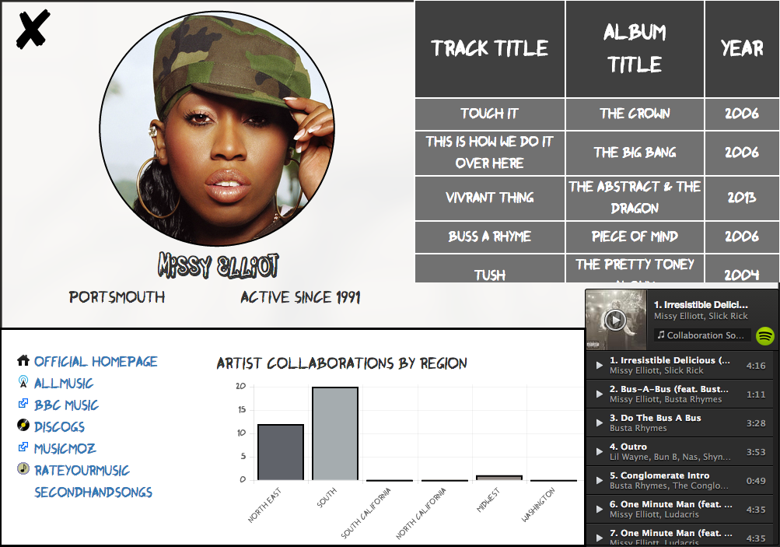
Figure 3. Table captions should be placed below the table.

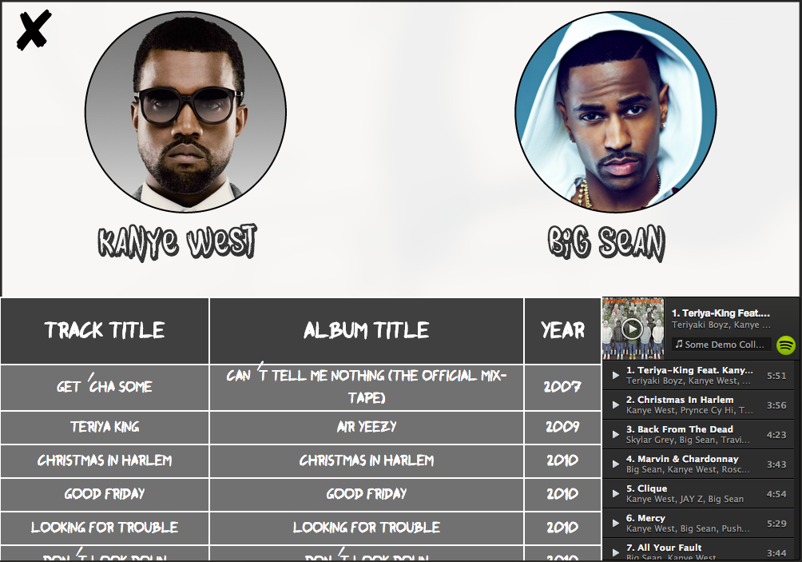
Figure 4. Table captions should be placed below the table

.

Discussion
The written and spoken language of SIGCHI is English. Spelling and punctuation may use any dialect of English (e.g., British, Canadian, US, etc.) provided this is done consistently. Hyphenation is optional. To ensure suitability for an international audience, please pay attention to the following:
- Write in a straightforward style.
- Try to avoid long or complex sentence structures.
- Briefly define or explain all technical terms that may be unfamiliar to readers.
- Explain all acronyms the first time they are used in your text – e.g., “Digital Signal Processing (DSP)”.
- Explain local references (e.g., not everyone knows all city names in a particular country).
- Explain “insider” comments. Ensure that your whole audience understands any reference whose meaning you do not describe (e.g., do not assume that everyone has used a Macintosh or a particular application).
- Explain colloquial language and puns. Understanding phrases like “red herring” may require a local knowledge of English. Humor and irony are difficult to translate.
- Use unambiguous forms for culturally localized concepts, such as times, dates, currencies and numbers (e.g., “1-5- 97” or “5/1/97” may mean 5 January or 1 May, and “seven o’clock” may mean 7:00 am or 19:00). For currencies, indicate equivalences – e.g., “Participants were paid 10,000 lire, or roughly $5.”
- Be careful with the use of gender-specific pronouns (he, she) and other gendered words (chairman, manpower, man-months). Use inclusive language that is gender-neutral (e.g., she or he, they, s/he, chair, staff, staff-hours, person-years). See [6] for further advice and examples regarding gender and other personal attributes.
- If possible, use the full (extended) alphabetic character set for names of persons, institutions, and places (e.g., Grønbæk, Lafreniére, Sánchez, Universität, Weißenbach, Züllighoven, Århus, etc.). These characters are already included in most versions of Times, Helvetica, and Arial fonts.

Future work

Additional Data
Headings of subsections should be in Helvetica 9-point bold with initial letters capitalized (Heading 2). (Note: For sub-sections and

Extensibility
Headings of subsections should be in Helvetica 9-point bold with initial letters capitalized (Heading 2). (Note: For sub-sections and

Numerical Analysis
Headings of subsections should be in Helvetica 9-point bold with initial letters capitalized (Heading 2). (Note: For sub-sections and

Conclusion
It is important that you write for the SIGCHI audience. Please read previous years’ Proceedings to understand the writing style and conventions that successful authors have used. It is particularly important that you state clearly what you have done, not merely what you plan to do, and explain how your work is different from previously published work, i.e., what is the unique contribution that your work makes to the field? Please consider what the reader will learn from your submission, and how they will find your work useful. If you write with these questions in mind, your work is more likely to be successful, both in being accepted into the Conference, and in influencing the work of our field.

ACKNOWLEDGMENTS
We would like to thank Professor Jeff Heer and the CSE512 staff, as well as Mike Bostock for the numerous d3 examples provided online. Thanks to the MusicBrainz community for taking the time to contribute data.

REFERENCES
- Adobe Acrobat Reader 7. http://www.adobe.com/products/acrobat/.
- Anderson, R.E. Social impacts of computing: Codes of professional ethics. Social Science Computing Review 10, 2 (1992), 453-469.
- How to Classify Works Using ACM’s Computing Classification System.
http://www.acm.org/class/how_to_use.html.
- Klemmer, R.S., Thomsen, M., Phelps-Goodman, E., Lee, R. and Landay, J.A. Where do web sites come from? Capturing and interacting with design history. In Proc. CHI 2002, ACM Press (2002), 1-8.
- Mather, B.D. Making up titles for conference papers. Ext. Abstracts CHI 2000, ACM Press (2000), 1-2.
- Schwartz, M. Guidelines for Bias-Free Writing. Indiana University Press, Bloomington, IN, USA, 1995.
- Zellweger, P.T., Bouvin, N.O., Jehøj, H., and Mackinlay, J.D. Fluid Annotations in an Open World. Proc. Hypertext 2001, ACM Press (2001), 9-18.

The columns on the last page should be of approximately equal length.

Note that the items in this bulleted list were formatted using the Bullet Style (in this template file).

