CoursesManagementApp
Sprint Report
Christos Karagiannidis 4375
Nefeli-Eleni Katsilerou 4385
Fotini Ifanti 4516

Versions History
Date | Version | Description | Author
26/2/2022 - 27/2/2022 | V0.0 | Reading and comprehending project requirements | CK , NK , FY
2/3/2022 - 6/3/2022 | V1.0 | Database creation | CK , NK , FY
8/3/2022 – 18/3/2022 | V2.0 | Creation of entities, controllers ,services and DAOs | CK , NK , FY
23/3/2022 – 1/4/2022 | V2.1 | Connection of Java with our DB | CK , NK , FY
6/4/2022 – 13/4/2022 | V2.2 | Implementation of user stories | CK , NK , FY
23/4/2022 – 2/5/2022 | V3.0 | HTML implementation | CK , NK , FY
3/5/2022 – 10/5/2022 | V4.0 | JUnit Testing | CK , NK , FY
12/5/2022 – 15/5/2022 | V4.1 | Sprint report creation and video recording | CK , NK , FY

Introduction

Purpose
The objective of this project is to develop a Web based application that allows an instructor to manage the grading of the courses that he teaches.

Document Structure
The rest of this document is structured as follows. Section 2 describes our Scrum team and specifies the this Sprint's backlog. In Section 3 we list the sprints that we performed and the user stories that have been realized in each Sprint. Section 4 includes the project design providing UML package and class diagrams.

Scrum team and Sprint Backlog

Scrum team
Product Owner | Christos Karagiannidis
Scrum Master | Nefeli-Eleni Katsilerou , Fotini Ifanti
Development Team | Christos Karagiannidis, Nefeli-Eleni Katsilerou , Fotini Ifanti

Sprints

Sprint No | Begin Date | End Date | Number of weeks | User stories
1 | 6/4/2022 | 9/4/2022 | 0 | US2,US3,US4,US5
2 | 9/4/2022 | 10/4/2022 | 0 | US6,US7,US8,US9
3 | 11/4/2022 | 11/4/2022 | 0 | US10,US11
4 | 12/4/2022 | 12/4/2022 | 0 | US12
5 | 13/4/2022 | 13/4/2022 | 0 | US1

Use Cases

Login
Use case ID | 1
Actors | Instructor
Pre conditions | Entered correct username and password in the corresponding fields
Main flow of events | - The user story begins when the instructor enters his login credentials  - Thymeleaf spring security verifies that the credentials given correspond to a USER with a role ADMIN in the DB.
Alternative flow 1 | If credentials do not match any user in DB then the login page is reloaded and a ‘wrong username or password’ message is reported.
Alternative flow 2
Post conditions | Instructor is redirected to the home page (course list).

List all courses
Use case ID | 2
Actors | Instructor
Pre conditions | A few courses exist in the DB
Main flow of events | - User story begins when the Instructor logs in.  - Java calls the course service function findAll() and saves the courses returned to a list of Courses.  - An attribute is added to the model containing the courses saved in the previous step
Alternative flow 1 | DB doesn’t contain any courses so a blank list is returned
Alternative flow 2 | .......
Post conditions | The corresponding HTML file is returned returning the results to the Instructor

Delete a course
Use case ID | 3
Actors | Instructor
Pre conditions | A course exists in order to be deleted.
Main flow of events | - User story begins when the Instructor presses the red delete button under the ‘Actions’ tab.  - Java creates a list with every student Registration associated to this course.  - Those student registrations are deleted.  - The course is deleted
Alternative flow 1
Alternative flow 2 | .......
Post conditions | Course list is reloaded with the new courses (without the deleted one).

Add a course
Use case ID | 4
Actors | Instructor
Pre conditions
Main flow of events | - User story begins when the Instructor presses the ‘Add course’ button.  - A new course item is created in Java.  - Course-form HTML file is returned  - Instructor fills the blank fields and presses ‘Save’ to submit  - Function/Method saveCourse is called
Alternative flow 1
Alternative flow 2 | .......
Post conditions | Course is saved in the DB and course list page is reloaded.

Update a course
Use case ID | 5
Actors | Instructor
Pre conditions | A course exists in the DB in order to be Updated
Main flow of events | - User story begins when the Instructor presses the ‘update’ button in the actions tab.  - Java calls the course service function findbyId() and saves the course returned.  - That course is added to the model.  - Course-form HTML file is returned  - Instructor fills the blank fields and presses ‘Save’ to submit.
Alternative flow 1 | Wrong input type given in fields (ex. String where float is expected) produces error.
Alternative flow 2 | .......
Post conditions | The updated course list is returned

Add a student registration
Use case ID | 6
Actors | Instructor
Pre conditions | A course exists in order to assign a proper value to the course id field.
Main flow of events | - User story begins when the Instructor presses the ‘Add student registration’ button  - Java creates a new StudentRegistration item and automatically sets its course id field to the id of the course next to which the instructor pressed the ‘Add student registration’ button in step 1.  - That item is added to the model  - The student registration form HTML file is returned  - The instructor fills in the rest blank fields (course id field is already assigned) and presses ‘Save’  - Function/Method saveStudentRegistration() is called
Alternative flow 1 | DB doesn’t contain any courses so a blank list is returned
Alternative flow 2 | .......
Post conditions | The student registration is saved in the DB and then the list of all the student registrations is reloaded.

Delete a course
Use case ID | 7
Actors | Instructor
Pre conditions | A student registration exists in order to be deleted.
Main flow of events | - User story begins when the Instructor presses the red delete button under the ‘Actions’ tab.  - The student registration is deleted
Alternative flow 1
Alternative flow 2 | .......
Post conditions | Instructor is redirected to the list that contains all student registrations (except the deleted one)

Update a student registration
Use case ID | 8
Actors | Instructor
Pre conditions | A student registration exists in the DB (associated with an already existing course) in order to be Updated
Main flow of events | - User story begins when the Instructor presses the ‘update’ button in the actions tab.  - Java calls the student registration service function findbyId() and saves the student registration returned.  - That student registration is added to the model.  - Student registration-form HTML file is returned  - Instructor fills the blank fields and presses ‘Save’ to submit.
Alternative flow 1 | Wrong input type given in fields (ex. String where float is expected) produces error.
Alternative flow 2 | .......
Post conditions | The updated student registration list is returned

Calculate overall/final grades
Use case ID | 9
Actors | Instructor
Pre conditions | There is at least one student to calculate overall grades for.
Main flow of events | - User story begins when the Instructor presses the ‘calculate grades’ button in the actions tab.  - Java calls the student registration service function findAllByCourseid() and saves the student registrations returned in a list.  - For every student registration in the list a final grade is calculated and added to its finalgrade field.  - All student registrations in the list are added to the model.
Alternative flow 1
Alternative flow 2 | .......
Post conditions | A list of all student registrations in this particular course is returned containing project ,exam and final grades for each student.

Calculate statistics
Use case ID | 10
Actors | Instructor
Pre conditions
Main flow of events | - User story begins when the Instructor presses the ‘calculate statistics’ button .  - Java calls the student registration service function findAll() and saves the student registrations returned.  - Min, Max, mean, stdDev, variance, percentiles, skewness, kurtosis and median are calculated for each grade type.  - Exam stats, Project stats and final stats are added to the model
Alternative flow 1 | Not enough student grades exist so some fields return 0 value or NaN
Alternative flow 2 | .......
Post conditions | Stats for the three grade types are shown on screen.

Design

Architecture

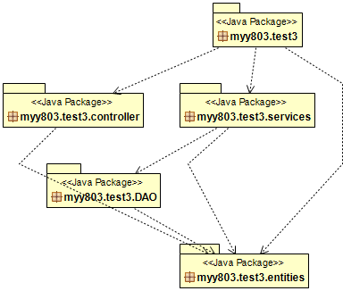

Design
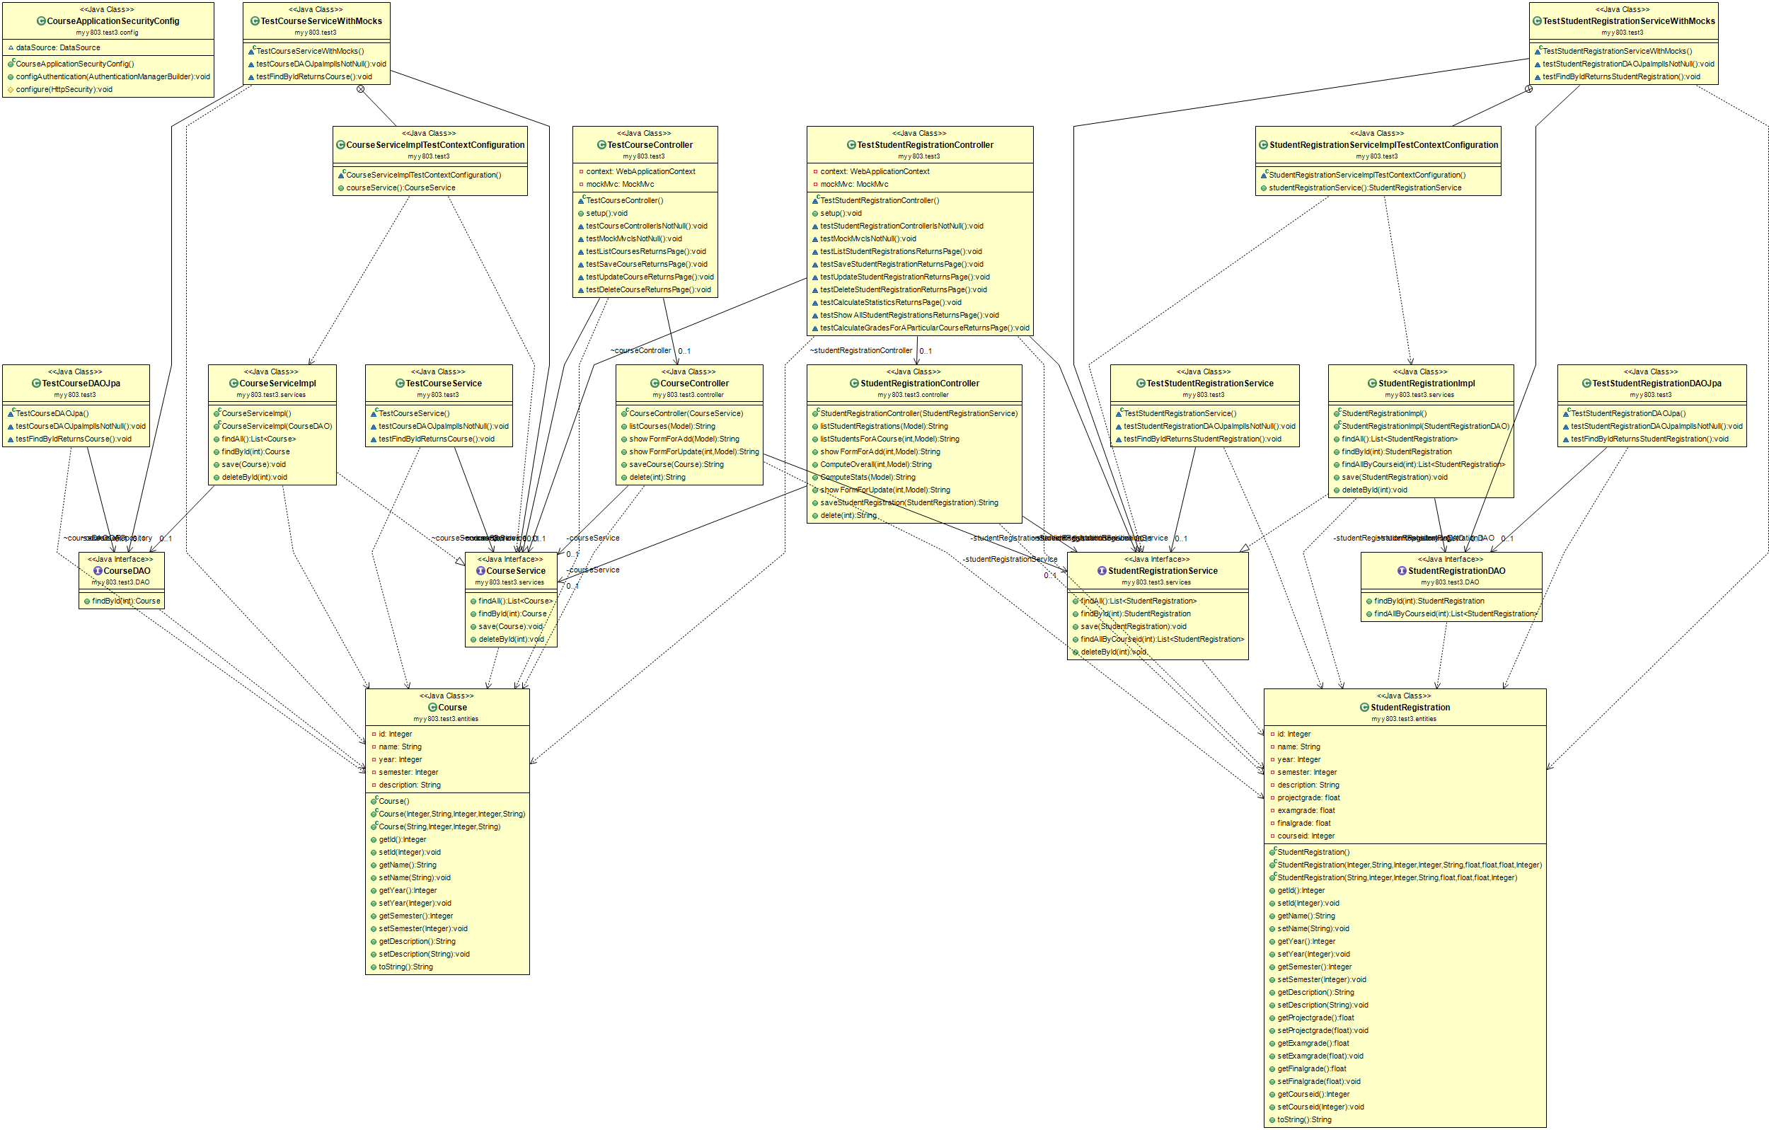
<Document the classes that are included in this release in terms of CRC cards according to the template that is given below.>
Class Name: Course
Responsibilities:  - Construct a course entity.  - Associate course’s java fields to mySQL columns.  - Create setters and getters. | Collaborations:

Class Name: StudentRegistration
Responsibilities:  - Construct a studentRegistration entity  - Associate studentRegistration’s fields to mySQL columns.  - Create setters and getters | Collaborations:

Class Name: CourseController
Responsibilities:  - Map URLs to functions/methods  - List all existing courses  - Add a new course  - Update an already existing course  - Delete an already existing course (first by deleting all existing studentRegistrations associated with that course)  - Save a course by calling course service function ‘save’.  - Delete a course by calling course service function ‘deletebyid’.  - Return HTML files for each function/method | Collaborations:  - Course service  - Student Registration service

Class Name: StudentRegistration Controller
Responsibilities:  - Map URLs to functions/methods  - List all student Registrations  - List all student registrations associated with a particular course  - Add a new student registration  - Update an already existing student registration  - Delete an already existing student registration  - Calculate Final grade with respect to a weighted average  - Show detailed statistics for a particular course’s exam grades, project grades and final grades.  - Save a student registration by calling studentRegistration service function ‘save’  - Delete a student registration by calling student registration service function ‘deletebyid’  - Return HTML files for each function/method | Collaborations:  - Course service  - Student Registration service

Class Name: StudentRegistration service impl
Responsibilities:  - Implement studentRegistration service’s methods  - Create a student registration repository  - Find all student registrations  - Find a particular student registration by id  - Find all student registrations associated with a particular course id  - Save a student registration to the student registration repository  - Delete a student registration from the student registration repository  - Delegates the appropriate calls to the studentRegistration DAO | Collaborations:  - studentRegistrationDAO  - studentRegistration service

Class Name: Course service impl
Responsibilities:  - Implement course service’s methods  - Create a course repository  - Find all courses  - Find a particular course by id  - Save a course to the course repository  - Delete a course from the course repository  - Delegates the appropriate calls to the course DAO | Collaborations:  - courseDAO  - course service

