SCALARS AND VECTORS

Apart from classifying physical quantities into fundamental and derived quantities, we can also classify them into scalar and vector quantities.

Scalar Quantities are those quantities which have only magnitude (but no direction). They can be described completely by their magnitude (without direction) Examples of scalar quantities include mass, length, time, temperature, electric current, luminous intensity, amount of substance (mole), distance, altitude, work done, energy, power, density, potential (any form of potential), capacitance, resistance, inductance and pressure etc.

Vector quantities are those quantities which have both magnitude and a specified direction. Examples of vectors include displacement, velocity acceleration, momentum, temperature gradient, impulse, moment (or torque), weight, all forces (tension, up thrust, friction etc.), all fields and field intensities (electric field, magnetic field and gravitational fields etc.) and flux.

IDEAS FOR REMEMBERING SCALARS AND VECTORS

3 p’s of scalars which are

Power, Pressure and Potential

3 M’s of vectors

Momentum, Moment and Magnetic field Intensity

Close Substitute

Scalars – Vectors

Distance – Displacement

Temperature – Temperature Gradient

Speed – Velocity

Mass – Weight

VECTORS

Vectors are parameters possessing magnitude and direction which add according to the parallelogram law.

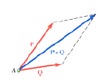

VECTOR CLASSIFICATION

Fixed (or bound) vectors: These have well defined points of application that cannot be changed without affecting an analysis

Free vectors: These vectors may be freely moved in space without changing their effect on an analysis

Sliding vectors: These vectors may be applied anywhere along their line of action without affecting an analysis

Equal vectors: Two vectors are said to be equal if they have the same magnitude and direction.

Negative vectors: The negative of a vector (A), usually written as (-A) is a vector that has the same magnitude as A but acts in an opposite direction

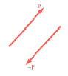

VECTOR REPRESENTATION

A vector (A) is represented as represented as A with arrows. In this topic, we’ll be treating vectors as forces. Force can be defined as the action of a body on another characterized by its point of application, magnitude, line of action and

UNIT VECTOR

A unit vector is a dimensionless vector with a magnitude of 1. It describes a direction in space and has no other physical significance. In the X-Y coordinate system, the vector I is defined as a vector whose direction is towards the X-axis and J is a unit vector in the direction of the Y-axis.

Generally, in the xyz plane, a vector A can be expressed as

$$A=A_{xi}+A_{yj}+A_{zk}$$

Unit vectors can be represented by i (in the direction (or parallel) to the x axis), j (in the direction of the y axis) and k.

$i∧j$ are defined as perpendicular unit vectors

$F_{x}∧F_{y}$ are defined as the scalar magnitudes or scalar components of the (unit) vector component

This $A=A_{xi}+A_{yj}+A_{zk}$ can easily be expressed as $A=A_{x}+A_{y}+A_{z}$ since the unit vectors have units of one each but the unit vectors are added to show direction since vectors have both magnitude and direction.

MAGNITUDE OF A VECTOR

The magnitude of a vector $A=A_{xi}+A_{yj}+A_{zk}$ is expressed as $\left|A\right|$ is defined mathematically as

$$\left|A\right|=\sqrt{{\left(A_{x}\right)}^{2}+{\left(A_{y}\right)}^{2}+{\left(A_{z}\right)}^{2}}$$

E.g. if

$$A=2_{i}−3_{j}−5_{k}$$

Find the magnitude of A

$$\left|A\right|=\sqrt{{\left(A_{x}\right)}^{2}+{\left(A_{y}\right)}^{2}+{\left(A_{z}\right)}^{2}}$$

$$\left|A\right|=\sqrt{{\left(2\right)}^{2}+{\left(−3\right)}^{2}+{\left(−5\right)}^{2}}$$

$$\left|A\right|=\sqrt{4+9+25}$$

$$\left|A\right|=\sqrt{38}units$$

ADDITION AND SUBTRACTION OF VECTORS

Vectors can be added and subtracted from one another based on their unit vectors (I, j and k).

For example, for a vector $A=A_{xi}+A_{yj}+A_{zk}$ and another $B=B_{xi}+B_{yj}+B_{zk}$

Their sum or difference is always a vector and is expressed as

$$A+B={\left(A_{x}+B_{x}\right)}_{i}+{\left(A_{y}+B_{y}\right)}_{j}+{\left(A_{z}+B_{z}\right)}_{k}$$

If $A=3i+4j+10k$ and $B=i−j+3k$, find A+B

$$A+B=3i+i+4j−j+10k+3k$$

$$A+B=4i+3j+13k$$

Find A-B

$$A−B=\left(3i−i\right)+\left(4j−−j\right)+\left(10k−3k\right)$$

$$A−B=2i+5j+7k$$

Find 3A-2B

$$3A−2B=3\left(3i+4j+10k\right)−2\left(i−j+3k\right)$$

$$3A−2B=9i+12j+30k−2i+2j−6k$$

$$3A−2B=7i+14j+24k$$

DOT PRODUCT

This is also known as scalar product. This is because the result of this product gives a scalar value. A value with magnitude but no direction

If $A=A_{xi}+A_{yj}+A_{zk}$

And $B=B_{xi}+B_{yj}+B_{zk}$

$$A∙B=\left(A_{x}B_{x}\right)+\left(A_{y}B_{y}\right)+\left(A_{z}B_{z}\right)$$

If the angle $\left(θ\right)$ between the two vectors A and B is given or the angle is to be found, the dot product can also be gotten as follows:

$$A∙B=\left|A\right|\left|B\right|cosθ$$

If the two vectors A and B are parallel,

$$A∙B=±\left|A\right|\left|B\right|$$

Given that $A=2i−j−k$ and $B=3i+4j−2k$

Find $A∙B$ and the angle between the two vectors

$$A=2i−j−k∧B=3i+4j−2k$$

$$A∙B=\left(A_{x}B_{x}\right)+\left(A_{y}B_{y}\right)+\left(A_{z}B_{z}\right)$$

$$A∙B=\left(2×3\right)+\left(−1×4\right)+\left(−1×−2\right)$$

$$A∙B=6−4+2$$

$$A∙B=4$$

$$A∙B=\left|A\right|\left|B\right|cosθ$$

$$4=\sqrt{{\left(2\right)}^{2}+{\left(−1\right)}^{2}+{\left(−1\right)}^{2}}×\sqrt{{\left(3\right)}^{2}+{\left(4\right)}^{2}+{\left(−2\right)}^{2}}×cosθ$$

$$4=\sqrt{4+1+1}×\sqrt{9+16+4}×cosθ$$

$$4=\sqrt{6}×\sqrt{29}×cosθ$$

$$4=\sqrt{6×29}×cosθ$$

$$4=\sqrt{174}×cosθ$$

$$cosθ=\frac{4}{\sqrt{174}}$$

$$cosθ=0.303239217$$

$$θ=\cos^{−1}0.303239217$$

$$θ=72.3477$$

CROSS PRODUCT

This is also known as Vector product because its result is a vector

If $A=A_{xi}+A_{yj}+A_{zk}$

And $B=B_{xi}+B_{yj}+B_{zk}$

$$\left|A×B\right|=\left|A\right|\left|B\right|sinθ$$

If the vectors are parallel, i.e. the angle between them is 0, $\left|A×B\right|=0$

If the vectors are perpendicular, the angle between them is 90, then $\left|A×B\right|=\left|A\right|\left|B\right|$

$$A×B=\left[\begin{matrix}i & j & k \\ A_{x} & A_{y} & A_{z} \\ B_{x} & B_{y} & B_{z}\end{matrix}\right]$$

$$A×B=i\left[\begin{matrix}A_{y} & A_{z} \\ B_{y} & B_{z}\end{matrix}\right]−j\left[\begin{matrix}A_{x} & A_{z} \\ B_{x} & B_{z}\end{matrix}\right]+k\left[\begin{matrix}A_{x} & A_{y} \\ B_{x} & B_{y}\end{matrix}\right]$$

$$A×B=i\left(A_{y}B_{z}−B_{y}A_{z}\right)−j\left(A_{x}B_{z}−A_{z}B_{x}\right)+k\left(A_{x}B_{y}−A_{y}B_{x}\right)$$

If $A=3i+4j−2k∧B=2i−6j+3k$ find $A×B$ and the angle between them.

$$A=3i+4j−2k∧B=2i−6j+3k$$

$$A×B=i\left(A_{y}B_{z}−B_{y}A_{z}\right)−j\left(A_{x}B_{z}−A_{z}B_{x}\right)+k\left(A_{x}B_{y}−A_{y}B_{x}\right)$$

$$A×B=i\left(\left(4×3\right)−\left(−6×−2\right)\right)−j\left(\left(3×3\right)−\left(−2×2\right)\right)+k\left(\left(3×−6\right)−\left(4×2\right)\right)$$

$$A×B=i\left(12−12\right)−j\left(9−−4\right)+k\left(−18−8\right)$$

$$A×B=i\left(0\right)−j\left(13\right)+k\left(−26\right)$$

$$A×B=−13j−26k$$

$$A×B=−13\left(j+2k\right)$$

Practice questions

$$IfA=3i−4j+6k,B=i−j−k∧C=2i+2j+2k$$

Find

$$\frac{\left(A×B\right)∙\left(B×C\right)}{C∙\left(A×C\right)}$$

Answer: Undefined

Find the angle between the vectors

$$A=2i+3j+4k∧B=i−2j+3k$$

Answer: 66.6

The resultant of 2 vectors A and B is a vector C and $C=2.2i+3.4j$ and $A=1.5i−2.0j$. Find B, its magnitude and the angle it makes with the positive x-axis.

The resultant of 2 vectors is the sum of the two vectors

$$C=A+B$$

$$B=C−A$$

$$B=\left(2.2i+3.4j\right)−\left(1.5i−2.0j\right)$$

$$B=2.2i−1.5j+3.4−−2.0j$$

$$B=0.7i+5.4j$$

The angle $\left(θ\right)$ that a vector $A=Axi+Ayj$ makes with the positive x-axis can be gotten from the formula

$$tanθ=\frac{Ay}{Ax}$$

$$B=0.7i+5.4j$$

$$tanθ=\frac{5.4}{0.7}$$

$$tanθ=7.714285$$

$$θ=\tan^{−1}\left(7.714285\right)$$

$$θ=82.61395684873$$

$$θ=82.614$$

More questions

An athlete (A) swims with a velocity of 4m/s perpendicularly across a gently flowing river (R) at 3m/s Find the resultant velocity of the athlete relative to the river. Answer: 5m/s $53°$ to the R direction

Vectors A and B are given as A = 3i+4j-2k and B = 2i-6j+3k. Evaluate A X B and find the angle between the two vectors

Two vectors A and B given as follows A =3.0i -4.5j and B = -2.5i +5.0j. Find the magnitude of their vector sum and the angle it makes with the positive x-axis

Answer: 0.71N 45 degrees

The resultant of two vectors A and B is vector C = 2.2i + 3.5j. If vector A = 1.5i-2.0j, find the magnitude of B and the angle it makes with the positive x-axis

A body moves in the x-y plane with velocity vm/s. The components of v are vx=5m/s and vy=7m/s along x and y axes respectively. What is the magnitude and direction of the velocity?

8.6m/s 54.5 degrees

RESULTANT FORCE/ VECTORS

Experimental evidence shows that the combined effect of two (or more) forces may be represented by a single resultant force.

Resultant vector can be defined as a single vector that can be used for replacing two or more vectors

The resultant of two vectors is simply the addition two vectors. The forces that make up the resultant are called the vector force components therefore, vector force components can be defined as two or more force vectors which together have the same effect as a single vector.

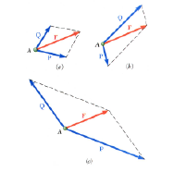

Vectors acting at zero degrees (0): These are vectors acting in the same direction. Their resultant can be obtained by simply adding their magnitude

Resultant Force $\left(F_{R}\right)$

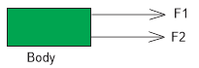

$$F_{R}=F_{1}+F_{2}$$

Vectors acting at 180: These are vectors that act in opposite direction. Their resultant can be obtained by finding the difference between the magnitude of the vectors

If F1 > F2,

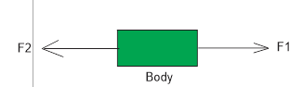

Towards $F_{1}$ (i.e. towards the east)

Vectors acting at right angle (90) or Rectangular vector components: The resultant of such vectors can be obtained using the Pythagoras theorem

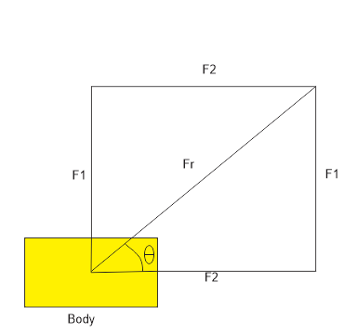

From Pythagoras’ theorem,

$${\left(Hypotenuse\right)}^{2}={\left(Opposite\right)}^{2}+{\left(Adjacent\right)}^{2}$$

$${\left(F_{R}\right)}^{2}={\left(F_{1}\right)}^{2}+{\left(F_{2}\right)}^{2}$$

$$F_{R}=\sqrt{{\left(F_{1}\right)}^{2}+{\left(F_{2}\right)}^{2}}$$

$$tanθ=\frac{opposite}{adjacent}$$

$$tanθ=\frac{F_{1}}{F_{2}}$$

The following Pythagorean triplets can be used for solving questions on vectors

(3, 4, 5), (5, 12, 13), (6, 8, 10), (7, 24, 25), (8, 15, 17), (9, 12, 15), (10, 24, 26)

For equal forces,

$$F_{1}=F_{2}=F$$

$$F_{R}=\sqrt{{\left(F\right)}^{2}+{\left(F\right)}^{2}}$$

$$F_{R}=\sqrt{2F^{2}}$$

$$F_{R}=F\sqrt{2}$$

$$tanθ=\frac{F_{1}}{F_{2}}$$

$$tanθ=\frac{F}{F}$$

$$tanθ=1$$

$$θ=\tan^{−1}1$$

$$θ=45$$

Therefore, for Equal forces

$$F_{R}=F\sqrt{2}$$

And

$$θ=45$$

The equation implies that for two equal forces, the angle between one of the forces and the resultant force is 45

Parallelogram law of forces (vectors): This is best used for angles other than 0, 90, and 180 degrees. This law states that when two forces are acting on a body, the lines of forces are used to represent the adjacent sides of a parallelogram.

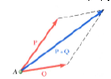

It can also be stated as if two vectors acting on a particle at the same time be represented in magnitude and direction by two adjacent sides of a parallelogram drawn from a point their resultant vector is represented in magnitude and direction by the diagonal of the parallelogram drawn from the same point

The diagonal of the parallelogram gives the resultant force (vector)

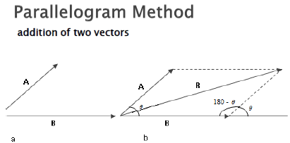

Applying cosine rule,

$${\left(F_{R}\right)}^{2}={\left(F | 1\right)}^{2}+{\left(F | 2\right)}^{2}−2F_{1}F_{2}cos\left(180−θ\right)$$

But

$$cos\left(180−θ\right)=−cosθ$$

$${\left(F_{R}\right)}^{2}={\left(F_{1}\right)}^{2}+{\left(F_{2}\right)}^{2}−\left[2F_{1}F_{2}\left(−cosθ\right)\right]$$

$${\left(F_{R}\right)}^{2}={\left(F | 1\right)}^{2}+{\left(F_{2}\right)}^{2}+2F_{1}F_{2}cosθ$$

Also,

$$\frac{sin⁡\left(180−θ\right)}{R}=\frac{sinα}{F_{1}}$$

Also, note that the difference of two vectors A and B (A – B) is defined as the vector sum of A and –B

$$A−B=A+\left(−B\right)$$

B and –B have the same magnitude but they act in opposite direction (at 180 degreed to each other)

NB: The maximum (resultant) vector is obtained when the angle between the two vectors is zero degree

The minimum resultant is obtained when the angle between the vectors is one hundred and eighty degrees (180)

The resultant force decreases as the value of theta increases and vice versa

Triangle rule of vector addition:

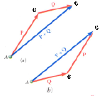

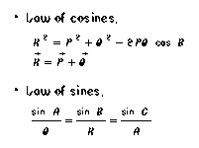

ADDITION OF MULTIPLE VECTORS

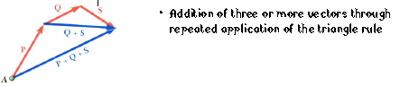

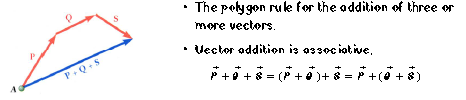

RESOLUTION OF VECTORS

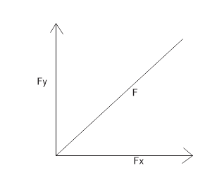

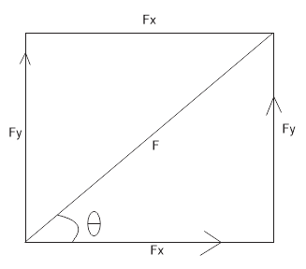

A vector can be resolved horizontally or vertically as shown below. These horizontal and vertical resolutions are called the components of the vector.

HORIZONTAL RESOLUTION

$$cosθ=\frac{adjacent}{hypotenuse}$$

$$cosθ=\frac{F_{x}}{F}$$

$$F_{x}=Fcosθ$$

$F_{x}$ Is called the horizontal component of the vector (force)

VERTICAL RESOLUTION

$$sinθ=\frac{opposite}{hypotenuse}$$

$$sinθ=\frac{F_{y}}{F}$$

$$F_{y}=Fsinθ$$

$F_{y}$ Is called the vertical component of the vector

RESOLVING MULTIPLE FORCES

The following steps are used to obtain the resultant of multiple forces

Resolve all the forces horizontally and find their sum $\sum{F_{x}}$

Resolve all the forces vertically and find their sum $\sum{F_{y}}$

Apply the formula,

$$R=\sqrt{{\left(\sum{F_{x}}\right)}^{2}+{\left(\sum{F_{x}}\right)}^{2}}$$

To obtain the direction (angle), the formula below is used.

$$θ=\tan^{−1}\left(\frac{\sum{F_{y}}}{\sum{F_{x}}}\right)$$

When resolving vectors, the angle $θ$ used is always the angle the vector makes with the horizontal (the x-axis).

In the resolution of vectors depending on the position it can either be negative or positive. For example, if resolving horizontally, if the force is towards the negative x-axis, then instead of adding the vector, it is written as $−Fcosθ$ and if it is on the positive x-axis we will have $+Fcosθ$. Similarly, when resolving vertically, if it is on the positive y-axis we have $+Fsinθ$ and if it is on the negative y-axis $−Fsinθ$