CENTROIDS, CENTER OF MASS AND CENTER OF GRAVITY

Applications of centroids, centre of gravity and centre of mass

1. In the designing and the structure for supporting an overhead water tank

2. In determining the stability of sport utility vehicles (SUV)

3. In designing the ground support structure for the goal post

4. The balancing of missiles in the air after they are fired.

5. The luggage compartment of tour buses located at the bottom of the bus in order to lower the centroid/center of mass of the bus in order to maintain stability

6. Racing cars are built to be low and broad for stability especially when navigating sharp turns at high speed without the risk of toppling

CONCEPT OF CENTER OF GRAVITY (CG) AND CENTER OF MASS (CM)

Hence, from the definition of a resultant force, the sum of moments due to individual particle weight about any point is the same as the moment due to the resultant weight located at G.

Also note that the sum of moments due to the individual particle’s weights about point G is zero

Similarly, the center of mass is a point which locates the resultant mass of a system of particles or body. Generally, its location is the same as that of G.

Centroid: The centroid is a point that defines the geometric center of an object. If the material composing a body is uniform or homogeneous, the density or specific weight will be constant throughout the body, then the centroid is the same as the center of gravity or center of mass

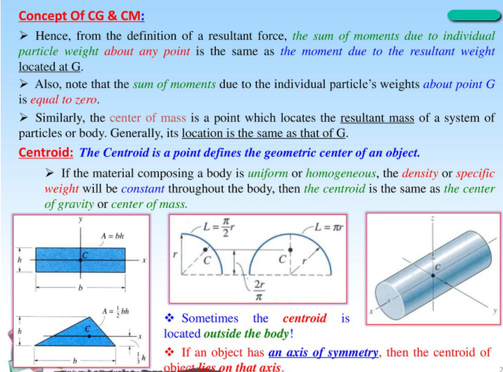

WAYS OF SOLVING CENTROIDS.

For a body on a 1d value, if you look at a metre rule on a fulcrum with some load on it, you will see is that the fulcrum will be placed at where the resultant of these weights act and that is the center of gravity.

The distance between the center of gravity and the beginning of the rule is expressed as

Where represents the weight of each element and represents the distance between the beginning of the rule and the center of gravity of that particle

CENTROIDS BY INTEGRATION

Bodies are made up of an infinite number of particles of weight i.e. the weight of each particle. These weights are parallel to each other and the total weight of all the bodies will be the total sum of all the weights of the individual particles concentrated on a single point called the center of gravity .

The location of the center of gravity can be located from each of the orthogonal (perpendicular) directions (or axes) by knowing that the moment caused by weight from a random point of reference (or datum) which will be the distance from the center of gravity times the weight

The moment about the x-axis for each particle is equal to

is the distance between the centroid of that particle and the y-axis

So the total moment of the object about the x-axis will be

The y-coordinate of the centroid will be given as

The same applies for all the coordinates

Remember that

are called the coordinates of the center of gravity

For a body in motion, we do not really care about the weight instead, we care about the centre of mass of the body

We can cancel the g out taking “g” as constant

Centroid of a volume:

Centroid of An Area:

The 3d can be simplified to 2d if z is taken as constant

**CENTROIDS OF AREAS BY INTEGRATION FROM SLIDES**

The following steps should be taken when solving centroid questions:

**USING A VERTICAL STRIP**:

First, take out a vertical strip of the shape.

The width of this strip will be

The height of the strip will be assumed to be y. My own reasoning concept being that each strip will have a height based on the equation of y.

Next mark out the assumed centre of the strip. Since that will be the centroid of the strip since it is a rectangle

Next, find the equation/equation of the graph as y as a function of x

If there are two equations, the upper one is the second equation and the lower one is the first equation.

We’ll call the y component of the centroid and it will be equal to 2 . If there is only one equation of the line,

Next, find the area of the strip

For single equations:

For two equations:

Next, we find the area of the shape using integration

Next find the area of the whole shape.

Next substitute the equation for the value of y.

The area of the whole shape is assumed as the sum of areas of all suspected strips taken out of the shape

Next we calculate the moment about x. In the moment about x, since its x position is going to be constant and its y position will vary, the moment about x is expressed as sum of all moments about the x axis

Similarly, the moment about y will be expressed as

Most times,

Most times,

To find the coordinate of the centroid G

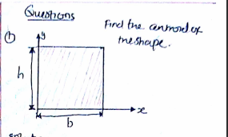

Solution:

First we take out a vertical strip,

The height of the strip will be y,

The width of the strip will be dx

The area of that strip will be dA, given as

Next, we find the equation of y since it wasn’t given to us

The y intercept “c” = h

The total area of the shape will be a sum of areas of all individual strips

From the diagram,

Next,

Next, we find the momentum about the x-axis

Next, we find the momentum about the y axis

The position of the centroid is given as

Answer:

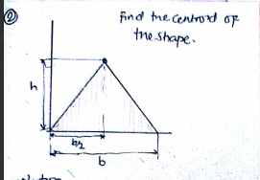

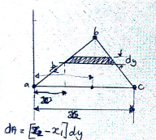

For this case, we are going to use the horizontal slip since that will be easier to solve with

If we take out a horizontal slip:

The height of the slip will be dy

The width of the slip will be x

And the area of the slip will be dA, given as

But taking a good look at that image, we would see that there are two possible equations i.e. one equation from point A to B and another from point B to A

For points to point

For points to point

And now, instead of area of the slip to be just

It is now going to be;

Next, we find the momenta

Answer:

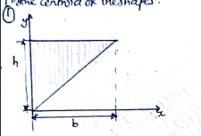

First, we take out a vertical strip:

But there are also two possible equations of y

Therefore,

Let the upper equation be

Let the lower equation be

m

Answer:

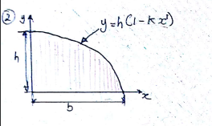

To get dA in this question,

We fisrt say, when y = 0 and x = b

That is used to get the value of k in the equation.

At point (b, 0)

But k =

A = 3bh/4

Answer:

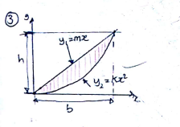

Therefore,

At point (b, h)

Therefore,

Here, dA = (y1 – y2)dx

Y1 = mx

M = h/b

Y1= hx/b

Answer: b/2 , 2h/5

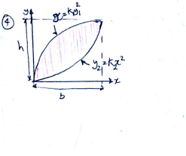

at point (h, b)

Answer: 9b/20, 9h/20

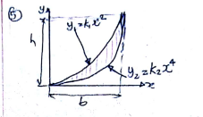

Answer: 5b/8, b/3

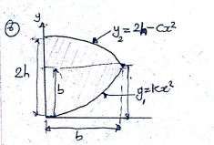

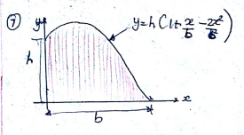

Answer: 2/5b, 12h/25

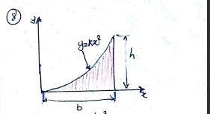

Answer: 3b/4 3h/10

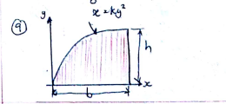

Answer: 3b/5, 3h/8

CENTROID BY GEOMETRY AND CENTROIDS OF SIMPLE SHAPES

If Gravity is assumed to be constant, the center of mass is the center of gravity and for bodies of uniform material and thickness, the center of gravity is located at the center of area which we call the centroid.

For bodies that are symmetrical about two axes like squares, circles and rectangles, the centroid is at the center of the shape of or at the point of intersection of the two lines of symmetry.

For bodies that have one line of symmetry, the centroid will lie of that line of symmetry. The centroid of a semicircle from its base (diameter) is given as where r is the radius

Right angled triangles (or triangles in general) have their centroid 1/3 of the height (from the base line) and 1/3 of the base from the (height line)

This method of solving centroids is quite easy but can be tricky a times.

Note the following:

1. The y value of a centroid is the distance between the centroid of the shape and the x-axis

2. Similarly, the x value of a centroid is the distance between the centroid of the shape and the y-axis

3. If a shape is symmetrical about a point and the axis passes through that point, the centroid will be 0.

For example, if a shape (circle) is symmetrical about a point and the x-axis passes through that point, the y value of the centroid will be 0.

|  |  |  |  |  |  |
| --- | --- | --- | --- | --- | --- |
| **Shape** |  |  |  |  | **Area** |
| Rectangle |  |  |  |  |  |
| Right-angled Triangle | Case 1: From the base –  Case 2: From the vertex – |  |  |  |  |
| Quarter circle |  |  |  |  |  |
| Circle |  |  |  |  |  |
| Parabola(symmetrical about the y axis) | Case 1: base at the x axis  Case 2: base at the y axis. | , |  |  |  |
| Semi Parabola |  |  |  |  |  |
| Parabolic Spandrel |  |  |  |  |  |
| Semi-Ellipse |  |  |  |  |  |
| Ellipse |  |  |  |  |  |
| Triangle (not right angled) |  | ` |  |  |  |
|  |  |  |  |  |  |

|  |  |  |  |
| --- | --- | --- | --- |
| Shape |  |  |  |
| Triangle |  |  |  |
| Quarter Circle or semi-circle |  |  |  |
| Quarter ellipse or semi-circle |  |  |  |
| Parabola |  |  |  |
| Parabolic Spandrel |  |  |  |
| Rectangle |  |  |  |
| Isosceles Triangle |  | from the base |  |
| Semi Circle | Half of the circle. If the line of the symmetry is at the center, then else |  |  |
| Circle |  |  |  |

For a parabola, the above formula is if the base of the parabola is the x-axis. However if the base of the parabola is the y-axis, then the formulae will be

Take note that the following formulae apply when the point of reference for the x-axis is the base and that of the y-axis

CENTROIDS OF COMPOUND OR COMPOSITE SHAPES

For 2d shapes, we can break the complex shapes into simpler shapes

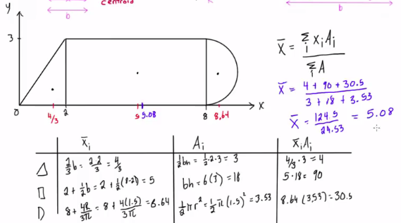

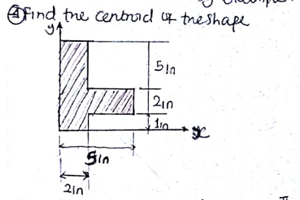

Answer: (1,68, 3.45)

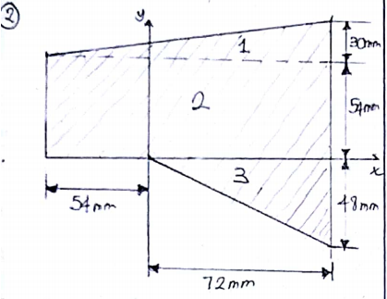

Answer: (19.27, 26.58)

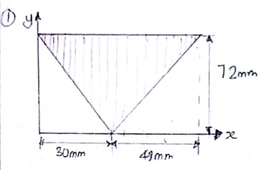



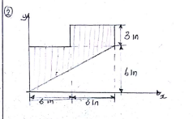



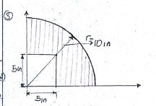

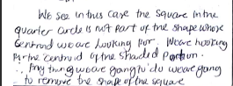

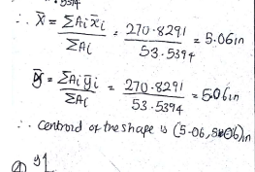

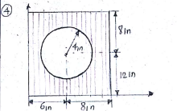

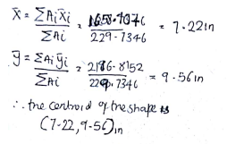

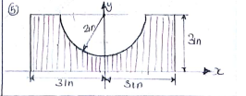

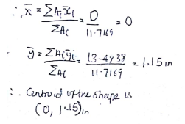

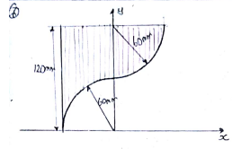



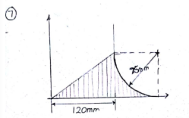

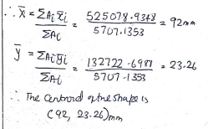

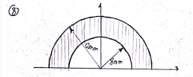



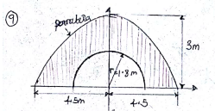

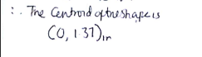

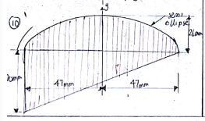



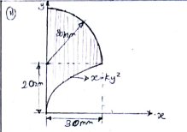



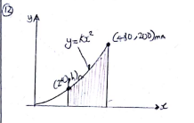

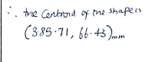

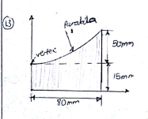

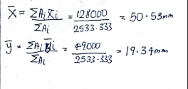

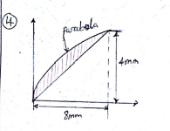

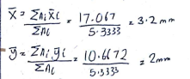

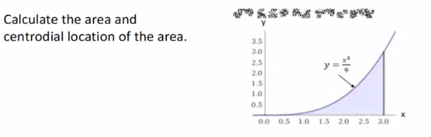

Next we take out a small section of the figure (in the form of a rectangular shape). The base of the shape will have a width dx and its height will be a certain value (y)

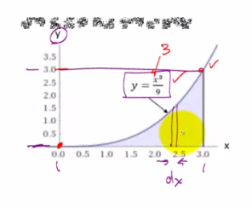

Now, the area of that chunk will be

Recall that the equation of the graph is

From the graph, we integrate from the lowest value of x in the function (0) to the highest value (3).

Remember that

When dealing with centroids, the value of will be half of the assumed rectangle that was created

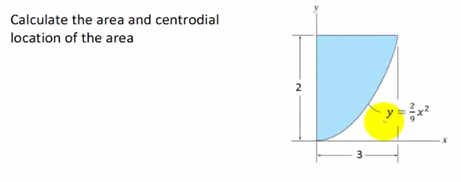

For this side, the height of the strip drawn will be

The reason we have that two is because if you look at the curve you will see that the curve is reducing in height and so as the value of x increases, the value of y reduces

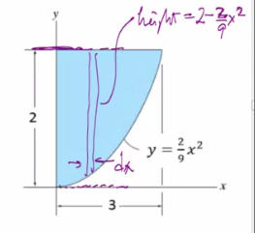

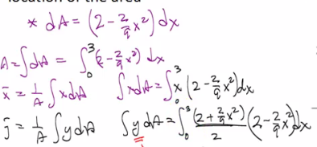

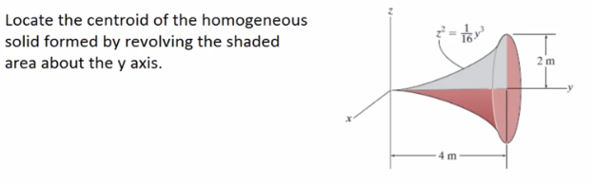

For example, cutting out a little part of the shape, we will have a small disk (cylinder) . This disk will have a radius of R and it will have a thickness of dy

Note that (when finding the center of area), if the object is symmetrical about the y axis and that y axis is your reference point, then the x coordinate will be zero. Likewise for the y and if the object is symmetrical about the x-axis the y coordinate will be zero if that line of symmetry is your reference point

The centroid of a triangle with a base b and a height h, the diagonal line (hypotenuse will be described by a straight line equation

The above tells us that the width of any rectangle given as (x) and has a distance y from the base,

The centroid from the bottom our point of reference is h/3

The centroid of a triangle will be 1/3 the height measured from the base of the triangle and also 1/3 of the width

Centroid is the geometric centre of a body (line, area or volume)

Integration for continuous system/body

Summation for discrete system

Center of gravity

The area of a semi elliptical shape is given as

And the centroid is

Where “a” is the radius and b is the height.

If we are to work on a plane, we are working with 2d objects and then

If the gravity of the place is constant (or assumed to be), we can substitute

Then that means the center of gravity of that object will also be the centerof mass of the object.

If the body has uniform density i.e. the density is constant, we can then say that the

Then we substitute that into the equation to get the center of volume of the object

Also, if we have an object of uniform thickness; we know that this object is composed of mini-particles that make up the object.

The center of gravity is gonna be based on the idea of a relationship between the thickness of the plate and the areas of each particles

So we divide the above formula of the volumes by the thickness

The center of area is called the centroid

Examples: Find the center of gravity of a rod that is 14inches in length. It has 10inches aluminium and 4 inches steel and has a thickness of 1inch

Al: , Steel:

QUESTIONS

The point through which the whole weight of the body acts is called ____________ Answer: Centre of gravity

The point at which the total area of a plane figure is assumend to be concentrated is called _________ Answer: Centroid

Where will the centre of gravity of a uniform rod lie? Answer: At its middle point

Where does the center of gravity of a circle lie? Answer: At its centre

Where will the centre of gravity of an I section will be if the dimension of upper web is , lower web and that of the flange is . If the y axis passes through the centre of the section?

A body is constituted of how many particles? Answer: Infinite

A body’s all small particles have their own weights which is being applied by them to the body, which adds up to the total weight of the body; true or false? Answer true

The small weights that are being applied by all the infinite particles of the body act ___________ to each other; Answer: parallel

The toal of all the weights of the small particles add up to give the total body weight. This weight is the force vector which is being passed by _________

The centre of gravity is the ratio of _________ to __________?Answer: Product of centroid and weight to the total weight

The x-axis coordinate and the y-axis coordinate of the centre of gravity are having different types of calculations to calculate them; true or false? Answer: False?

The centre of mass is the ratio of what to what?

The centre of volume is the ratio of what to what?

Volume is best given by the ratio of what to what? Mass to density