**SCALARS AND VECTORS**

Apart from classifying physical quantities into fundamental and derived quantities, we can also classify them into scalar and vector quantities.

Scalar Quantities are those quantities which have only magnitude (but no direction). They can be described completely by their magnitude (without direction) Examples of scalar quantities include mass, length, time, temperature, electric current, luminous intensity, amount of substance (mole), distance, altitude, work done, energy, power, density, potential (any form of potential), capacitance, resistance, inductance and pressure etc.

Vector quantities are those quantities which have both magnitude and a specified direction. Examples of vectors include displacement, velocity acceleration, momentum, temperature gradient, impulse, moment (or torque), weight, all forces (tension, up thrust, friction etc.), all fields and field intensities (electric field, magnetic field and gravitational fields etc.) and flux.

**IDEAS FOR REMEMBERING SCALARS AND VECTORS**

3 p’s of scalars which are

Power, Pressure and Potential

3 M’s of vectors

Momentum, Moment and Magnetic field Intensity

Close Substitute

**Scalars – Vectors**

Distance – Displacement

Temperature – Temperature Gradient

Speed – Velocity

Mass – Weight

**VECTORS**

Vectors are parameters possessing magnitude and direction which add according to the parallelogram law.

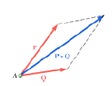

**VECTOR CLASSIFICATION**

Fixed (or bound) vectors: These have well defined points of application that cannot be changed without affecting an analysis calculation of the vector

Free vectors: These vectors may be freely moved in space without changing their effect on an analysis

Sliding vectors: These vectors may be applied anywhere along their line of action without affecting an analysis

Equal vectors: Two vectors are said to be equal if they have the same magnitude and direction.

Negative vectors: The negative of a vector (A), usually written as (-A) is a vector that has the same magnitude as A but acts in an opposite direction

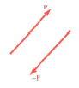

Force definition:

It is the action of one body on another characterized by its point of application, magnitude, line of action and sense (direction)

Experiment shows that the effect of two forces may be represented by a single resultant force

The resultant is equivalent to the diagonal of a parallelogram which contains the two forces in adjacent legs

Concurrent forces: These are forces that pass through the same point

**VECTOR REPRESENTATION**

Vectors are represented in boldface letters like **A** or with an arrow over the letter $\vec{A}$ or with an underscore $a_{}$. The magnitude (modulus or length) of the vector can be written as $\left|A\right|$. A straight line with an arrow can be used to represent a vectorIn this topic, we’ll be treating vectors as forces. Force can be defined as the action of a body on another; characterized by its point of application, magnitude, line of action and

**UNIT VECTOR**

A unit vector is a (dimensionless) vector with a magnitude of 1. It describes a direction in space and has no other physical significance. In the X-Y coordinate system, the vector I is defined as a vector whose direction is towards the X-axis and J is a unit vector in the direction of the Y-axis.

Generally, in the xyz plane, a vector A can be expressed as

$$A=A_{xi}+A_{yj}+A_{zk}$$

Unit vectors can be represented by i (in the direction (or parallel) to the x axis), j (in the direction of the y axis) and k (in the direction of the z axis).

$i∧j$ are defined as perpendicular unit vectors

$F_{x}∧F_{y}$ are defined as the scalar magnitudes or scalar components of the (unit) vector component

This $A=A_{xi}+A_{yj}+A_{zk}$ can easily be expressed as $A=A_{x}+A_{y}+A_{z}$ since the unit vectors have units of one each but the unit vectors are added to show direction since vectors have both magnitude and direction.

**MAGNITUDE OF A VECTOR**

Thus is also called the length or modulus of a vector

The magnitude of a vector $A=A_{xi}+A_{yj}+A_{zk}$ is expressed as $\left|A\right|$ is defined mathematically as

$$\left|A\right|=\sqrt{{\left(A_{x}\right)}^{2}+{\left(A_{y}\right)}^{2}+{\left(A_{z}\right)}^{2}}$$

E.g. if

$$A=2_{i}−3_{j}−5_{k}$$

Find the magnitude of A

$$\left|A\right|=\sqrt{{\left(A_{x}\right)}^{2}+{\left(A_{y}\right)}^{2}+{\left(A_{z}\right)}^{2}}$$

$$\left|A\right|=\sqrt{{\left(2\right)}^{2}+{\left(−3\right)}^{2}+{\left(−5\right)}^{2}}$$

$$\left|A\right|=\sqrt{4+9+25}$$

$$\left|A\right|=\sqrt{38}units$$

The unit vector of a vector A $\left(\hat{A}\right)$ is expressed as

$$\hat{A}=\frac{\vec{A}}{\left|A\right|}$$

That is the vector divided by its magnitude will produce a unit vector of the vector

**BRACKET NOTATION OF VECTORS**

A vector can also be represented using bracket notation

Example1: Given a vector $A=A_{x}i+A_{y}j+A_{z}k$, how is it represented in bracket notation?

The representation becomes $A=\left(A_{x},A_{y},A_{z}\right)$. $A_{x},A_{y}$ and $A_{z}$ are known as **terminal points** while the initial points are assumed to be at the origin

**ADDITION AND SUBTRACTION OF VECTORS**

Vectors can be added and subtracted from one another based on their unit vectors (I, j and k).

Special methods are employed in addition and subtraction of vectors e.g. graphical method (polygon and parallelogram method) and algebraic method

Note: When two vectors are added together, the resulting vector is called resultant vector as it has the same effect as two or more vectors taken together

Graphical method: This involves scale drawing e.g. polygon method. Let’s take vectors u and v to be drawn to scale as

**ADDITION OF VECTORS**

Trapezoidal rule for vector addition

In mathematics (numerical analysis), the trapezoidal rule AKA the trapezoid rule or trapezium rule; is a technique for approximating the definite integral

In Euclidean geometry, a convex quadrilateral with at least one pair of parallel sides is referred to as a trapezium in pure English but it is referred to as a trapezoid in north American English in places like the US and Canada. The parallel sides are called the bases while the other sides are called the legs or the lateral sides if they are not parallel. If they are parallel, then there are two pairs of bases in the trapezoid.

A scalene trapezoid is one with none of the sides of equal length

$\vec{u}+\vec{v}$ is a vector from the initial point of u to terminal of v

If the terminal point of the resultant is equal to the initial point of $u$, then the resultant will have a value of 0. Just like in displacement

Draw your Diagram OHHHH!!!!!

Where $\vec{u}+\vec{v}$ is said to be the resultant of both vectors

Subtraction of vectors

When a vector v is subtracted from a vector u as in u-v, it will be written as $u+\left(−v\right)$ where $−v$ is simply taken as the opposite vector of v

Example,

Given that v and u are vectors drawn to scale as

Diagram

Evaluate v-u using the polygon method

Polygon method

Parallelogram method

Triangle method

Trapezoidal method

TAKE NOTE OF THE FOLLOWING

If we have two points A (Ax, Ay, Az) and B (Bx, By, Bz) and a vector (r) joins the two points, r can be written as:

$$r=\overline{AB}$$

$$\overline{AB}=B−A$$

$$\overline{AB}=\left(B_{x},B_{y},B_{z}\right)−\left(A_{x},A_{y},A_{z}\right)$$

$$\overline{AB}+\overline{BA}=0$$

$$\overline{AB}=−\overline{BA}$$

$$\overline{AB}+\overline{BC}=\overline{AC}$$

Algebraic method

This is also known as component method. Unlike the geometric addition of vectors treated earlier, vectors in component form are added and subtracted algebraically

Example 1:

Given vector $A=−3i+j+4k$ and vector $B=2i−2j+5k$ Evaluate vector $A+B$

$$A+B=\left(−3+2\right)i+\left(1−2\right)j+\left(4+5\right)k$$

$$A+B=−i−j+9k$$

Subtraction of vectors

Given two points P and Q in space that have Cartesian coordinates (-3, 1, 4) and (2, -2, 5) respectively; determine the vector PQ

$$PQ=Q−P$$

$$Q−P=5i−3j+k$$

Magnitude of a vector in component form

Recall that I said a vector can be described by its components e.g. $A=Axi+Ayj+Azk$. How about when given a vector in its component form; how do we evaluate its magnitude?

We simply root the square of all its unit components

Example: Given the vectors $A=2i+3j+4k$ and $B=i−2j+3k$, what is their magnitude?

$$\left|A\right|=5.4$$

$$\left|B\right|=3.7$$

**STEPS TO SOLVING VECTOR PROBLEMS**

Representing the vectors as a parallelogram and measuring or by transforming it to a triangle and then using the sine and cosine rules

For example, for a vector $A=A_{xi}+A_{yj}+A_{zk}$ and another $B=B_{xi}+B_{yj}+B_{zk}$

Their sum or difference is always a vector and is expressed as

$$A+B={\left(A_{x}+B_{x}\right)}_{i}+{\left(A_{y}+B_{y}\right)}_{j}+{\left(A_{z}+B_{z}\right)}_{k}$$

If $A=3i+4j+10k$ and $B=i−j+3k$, find A+B

$$A+B=3i+i+4j−j+10k+3k$$

$$A+B=4i+3j+13k$$

Find A-B

$$A−B=\left(3i−i\right)+\left(4j−−j\right)+\left(10k−3k\right)$$

$$A−B=2i+5j+7k$$

Find 3A-2B

$$3A−2B=3\left(3i+4j+10k\right)−2\left(i−j+3k\right)$$

$$3A−2B=9i+12j+30k−2i+2j−6k$$

$$3A−2B=7i+14j+24k$$

What is the final answer of AB –CB+DA+2CD Answer: CD

What is the final answer of $3OA+6BZ+2AO+AB+5OB$ Answer: 6OZ

If $r=p_{i}+q_{j}$ and $s=3a_{i}+b_{j}$, find $2r+s$ and $s−r$

Find the values of $\overset{¨}{e}$ for which the points X and P are coincident given that

$$XB+3XP=\left(\overset{¨}{e}−5\right)PB$$

If A is a point and has a position “a” vector, and B is a point with position b, and P divides the line between A and B in the ratio m:n

$$\frac{AP}{PB}=\frac{m}{n}$$

$$n\left(AP\right)=m\left(PB\right)$$

$$OA+AP=OP$$

$$AP=OP−OA$$

$$AP=r−a$$

OP is the position vector of the point P

$$OP+PB=OB$$

$$PB=OB−OP$$

$$PB=b−r$$

$$n\left(AP\right)=m\left(PB\right)$$

$$n\left(r−a\right)=m\left(b−r\right)$$

If a point P with a position vector r divides two vectors a and b in the ratio (m: n). The position vector $\left(R\right)$ can be gotten as follows

$$r=\frac{na+mb}{m+n}$$

If the ratio (m:n) is positive, then the point P lies between the two vector points (A and B) (i.e. it divides the vectors internally) and if it is negative, it lies outside A and B

Also, if the value of m and n are equal, the position vector is given as

$$r=\frac{1}{2}\left(a+b\right)$$

$$n\left(r−a\right)=m\left(b−r\right)$$

Direction Ratios

Direction Ratios refer to the components of the vector

MAGNITUDE OF SUM OF VECTORS

The magnitude is given by the same formula as the one you gave, that is,

$$\left|x_{1}+x_{2}\right|=\sqrt{\left(X1+X2\right)⋅\left(X1+X2\right)}$$

We can play around with this formula in various ways. For example, we have

$$\left(x_{1}+x_{2}\right)⋅\left(x_{1}+x_{2}\right)=x_{1}⋅x_{1}+x_{2}⋅x_{2}+2x_{1}x_{2}$$

Note that {}*X**i*⋅*X**i*=∥*X**i*∥2

. Also, $X1⋅X2=∥X1∥∥X2∥cosθ$, where *θ* is the angle between the two vectors. So an alternate expression for the magnitude of the sum is

$$\left|x_{1}+x_{2}\right|=\sqrt{{\left|x_{1}\right|}^{2}+{\left|x_{2}\right|}^{2}+2\left(x_{1}⋅x_{2}cosθ\right)}$$

$$\left|x_{1}−x_{2}\right|=\sqrt{{\left|x_{1}\right|}^{2}+{\left|x_{2}\right|}^{2}−2\left(x_{1}⋅x_{2}cosθ\right)}$$

Note that that value of $2\left(x_{1}⋅x_{2}\right)$ is actually dot product and not just ordinary multiplication

$${\left|a+b+c\right|}^{2}={\left|a\right|}^{2}+{\left|b\right|}^{2}+{\left|c\right|}^{2}+2\left(a⋅b+b⋅c+c⋅a\right)$$

Questions:

Let a, b and c be vectors with magnitude 3, 4 and 5 respectively and a + b + c = 0, then the values of a.b + b.c + c.a is: Answer: -25

$${\left|a+b+c\right|}^{2}={\left|a\right|}^{2}+{\left|b\right|}^{2}+{\left|c\right|}^{2}+2\left(a⋅b+b⋅c+c⋅a\right)$$

**Direction Cosines**

This refers to the angle that a component of a vector makes with its corresponding axis i.e. the angle Ax makes with the x-axis

Direction angles $α,β,∧γ$ are the angles that a vector makes with the x, y and z components respectively. Direction cosines (of a vector A) are the direction angles of which are

$$cosα=\frac{A_{x}}{\left|A\right|}$$

$$cosβ=\frac{A_{y}}{\left|A\right|}$$

$$cosγ=\frac{A_{z}}{\left|A\right|}$$

$$\cos^{2}α+\cos^{2}β+\cos^{2}γ=1$$

Example, a vector shown below, calculate its direction cosines

$$\vec{O}=6i+2j−k$$

**LAWS OF VECTOR ALGEBRA**

Let a, b and c be vectors and n and m be scalars

$$a+b=b+a$$

$$a+\left(b+c\right)=\left(a+b\right)+c$$

$$m\left(na\right)=mn\left(a\right)=n\left(ma\right)$$

$$\left(m+n\right)a=ma+na$$

$$m\left(a+b\right)=ma+mb$$

Note: If we have a vector a and another vector b is represented as

$$b=ta$$

Where t is a scalar, it will be seen that b is parallel to a

**DOT PRODUCT**

This is also known as scalar product. This is because the result of this product gives a scalar value. A value with magnitude but no direction

If $A=A_{xi}+A_{yj}+A_{zk}$

And $B=B_{xi}+B_{yj}+B_{zk}$

$$A∙B=\left(A_{x}B_{x}\right)+\left(A_{y}B_{y}\right)+\left(A_{z}B_{z}\right)$$

If the angle $\left(θ\right)$ between the two vectors A and B is given or the angle is to be found, the dot product can also be gotten as follows:

$$A∙B=\left|A\right|\left|B\right|cosθ$$

Given that $A=2i−j−k$ and $B=3i+4j−2k$

Find $A∙B$ and the angle between the two vectors

$$A=2i−j−k∧B=3i+4j−2k$$

$$A∙B=\left(A_{x}B_{x}\right)+\left(A_{y}B_{y}\right)+\left(A_{z}B_{z}\right)$$

$$A∙B=\left(2×3\right)+\left(−1×4\right)+\left(−1×−2\right)$$

$$A∙B=6−4+2$$

$$A∙B=4$$

$$A∙B=\left|A\right|\left|B\right|cosθ$$

$$4=\sqrt{{\left(2\right)}^{2}+{\left(−1\right)}^{2}+{\left(−1\right)}^{2}}×\sqrt{{\left(3\right)}^{2}+{\left(4\right)}^{2}+{\left(−2\right)}^{2}}×cosθ$$

$$4=\sqrt{4+1+1}×\sqrt{9+16+4}×cosθ$$

$$4=\sqrt{6}×\sqrt{29}×cosθ$$

$$4=\sqrt{6×29}×cosθ$$

$$4=\sqrt{174}×cosθ$$

$$cosθ=\frac{4}{\sqrt{174}}$$

$$cosθ=0.303239217$$

$$θ=\cos^{−1}0.303239217$$

$$θ=72.3477$$

From $A∙B=\left|A\right|\left|B\right|cosθ$

$$A∙B=\left(\left|A\right|cosθ\right)\left|B\right|$$

$$A∙B=\left|A\right|\left(\left|B\right|cosθ\right)$$

$\left|A\right|cosθ$ is the projection of A in the direction of the vector B. Therefore dot product or scalar product is the product of the projection of the length of A in the direction B with the length of B or projection of B in the direction of A with the length of A

From the above, we will see that the product of two perpendicular vectors is zero

Note: If the cross product of two vectors is 0, the two vector are orthogonal (or perpendicular)

CHARACTERISTICS OF SCALAR PRODUCT

They are commutative PQ = QP

They are distributive $P\left(Q_{1}+Q_{2}\right)=PQ_{1}+PQ_{2}$

They are not associative (PQ)S = undefined

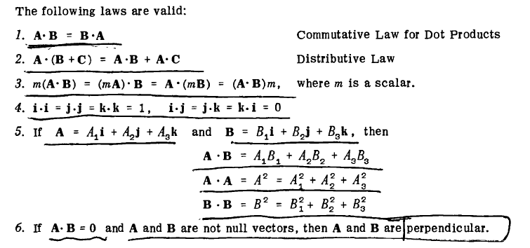

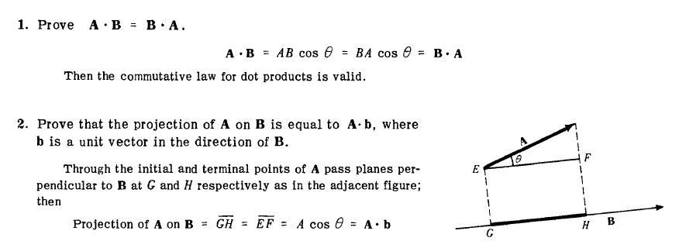

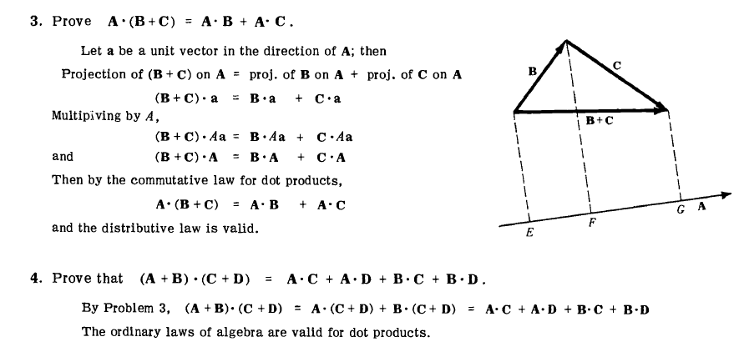

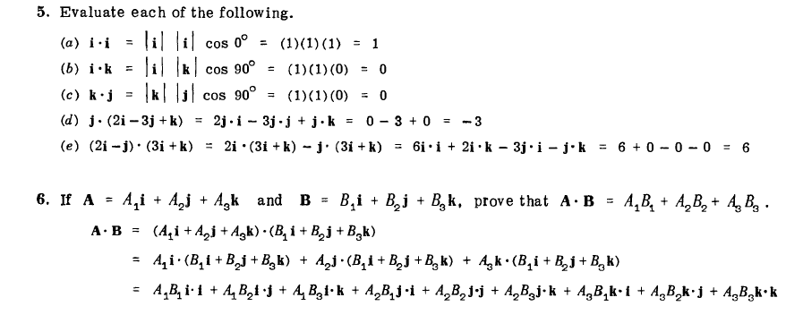

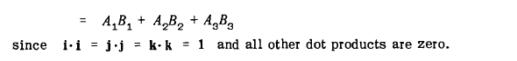

**CROSS PRODUCT**

This is also known as Vector product because its result is a vector. The concept of moment of a force about a point is more easily understood through applications of the vector product or cross product

If $A=A_{xi}+A_{yj}+A_{zk}$

And $B=B_{xi}+B_{yj}+B_{zk}$

$$A×B=\left[\begin{matrix}i & j & k \\ A_{x} & A_{y} & A_{z} \\ B_{x} & B_{y} & B_{z}\end{matrix}\right]$$

$$A×B=i\left[\begin{matrix}A_{y} & A_{z} \\ B_{y} & B_{z}\end{matrix}\right]−j\left[\begin{matrix}A_{x} & A_{z} \\ B_{x} & B_{z}\end{matrix}\right]+k\left[\begin{matrix}A_{x} & A_{y} \\ B_{x} & B_{y}\end{matrix}\right]$$

$$A×B=i\left(A_{y}B_{z}−B_{y}A_{z}\right)−j\left(A_{x}B_{z}−A_{z}B_{x}\right)+k\left(A_{x}B_{y}−A_{y}B_{x}\right)$$

If $A=3i+4j−2k∧B=2i−6j+3k$ find $A×B$ and the angle between them.

$$A=3i+4j−2k∧B=2i−6j+3k$$

$$A×B=i\left(A_{y}B_{z}−B_{y}A_{z}\right)−j\left(A_{x}B_{z}−A_{z}B_{x}\right)+k\left(A_{x}B_{y}−A_{y}B_{x}\right)$$

$$A×B=i\left(\left(4×3\right)−\left(−6×−2\right)\right)−j\left(\left(3×3\right)−\left(−2×2\right)\right)+k\left(\left(3×−6\right)−\left(4×2\right)\right)$$

$$A×B=i\left(12−12\right)−j\left(9−−4\right)+k\left(−18−8\right)$$

$$A×B=i\left(0\right)−j\left(13\right)+k\left(−26\right)$$

$$A×B=−13j−26k$$

$$A×B=−13\left(j+2k\right)$$

The vector product of two vectors P and Q is defined as the vector V which satisfies the following conditions:

Line of action of $V$ is perpendicular to plane containing P and Q

Magnitude of $V$ is $\left|P×Q\right|$

Direction of V is obtained from the right hand rule

Note: If C is the result of the cross product of two vectors A and B, C will be perpendicular to A and also perpendicular to B

**CHARACTERISTICS OF VECTOR PRODUCTS**

1.

1. Cross Products are not commutative

2. Cross products are distributive

3. The magnitude of a $A×B$ is the same as the area of a parallelogram with sides A and B

4. If , and A and B are not null vectors, then A and B are parallel vectors. i.e. the angle between the two of them is 0.

5. Are not associative

$$A×\left(B×C\right)≠\left(A×B\right)×C$$

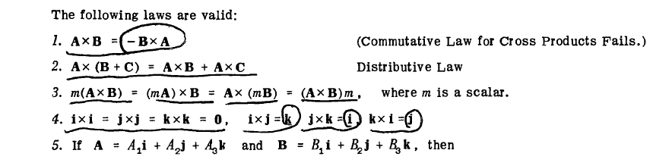

Practice questions

$$IfA=3i−4j+6k,B=i−j−k∧C=2i+2j+2k$$

Find

$$\frac{\left(A×B\right)∙\left(B×C\right)}{C∙\left(A×C\right)}$$

Answer: Undefined

Find the angle between the vectors

$$A=2i+3j+4k∧B=i−2j+3k$$

Answer: 66.6

The resultant of 2 vectors A and B is a vector C and $C=2.2i+3.4j$ and $A=1.5i−2.0j$. Find B, its magnitude and the angle it makes with the positive x-axis.

The resultant of 2 vectors is the sum of the two vectors

$$C=A+B$$

$$B=C−A$$

$$B=\left(2.2i+3.4j\right)−\left(1.5i−2.0j\right)$$

$$B=2.2i−1.5j+3.4−−2.0j$$

$$B=0.7i+5.4j$$

The angle $\left(θ\right)$ that a vector $A=Axi+Ayj$ makes with the positive x-axis can be gotten from the formula

$$tanθ=\frac{Ay}{Ax}$$

$$B=0.7i+5.4j$$

$$tanθ=\frac{5.4}{0.7}$$

$$tanθ=7.714285$$

$$θ=\tan^{−1}\left(7.714285\right)$$

$$θ=82.61395684873$$

$$θ=82.614$$

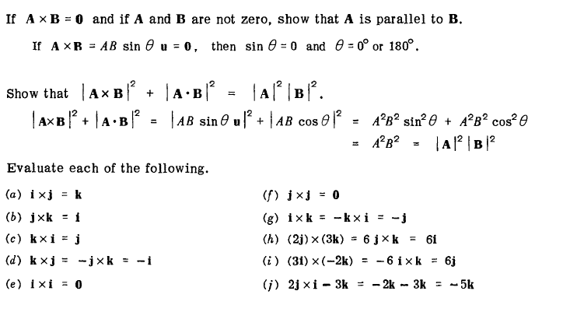

TRIPLE PRODUCTS

Dot and cross multiplication of three vectors A, B and C may produce a meaningful products of the form $\left(A⋅B\right)⋅C$, $A⋅\left(B×C\right)$ and $A×\left(B×C\right)$. The following laws are valid.

$\left(A⋅B\right)⋅C≠A⋅\left(B⋅C\right)$

The product $A⋅\left(B×C\right)$ is sometimes called the scalar triple product or box product and may be denoted by $\left[ABC\right]$. Also note that, **If three forces are coplanar, their triple scalar product is 0**.

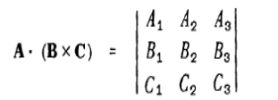

The $A×\left(B×C\right)$ is called the **vector triple product**

$A⋅\left(B×C\right)$ can sometimes be written as $A⋅B×C$ and so you’ll notice that the brackets are sometimes emitted. However, for vector triple product, you should never omit the brackets $A×\left(B×C\right)$

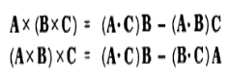

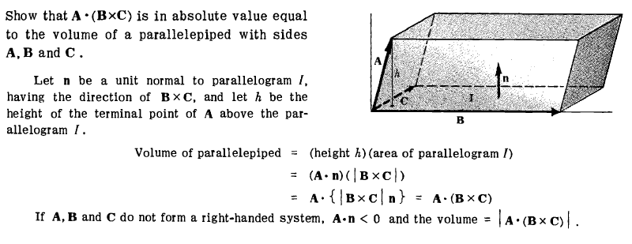

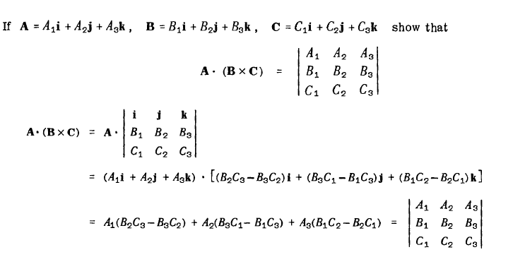

**RESULTANT FORCE/ VECTORS**

Experimental evidence shows that the combined effect of two (or more) forces may be represented by a single resultant force.

Resultant vector can be defined as a single vector that can be used for replacing two or more vectors

The resultant of two vectors is simply the addition two vectors.

That is if we have two vectors:

$$A=2i+5j−3k$$

And

$$B=4i+3j+2k$$

The resultant of these two vectors is just their sum.

The forces that make up the resultant are called the vector force components therefore, vector force components can be defined as two or more force vectors which together have the same effect as a single vector.

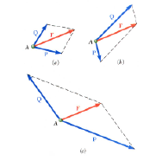

Finding the resultant of vectors using their magnitude

**Vectors acting at zero degrees (0)**: These are vectors acting in the same direction. Their resultant can be obtained by simply adding their magnitude

Resultant Force $\left(F_{R}\right)$

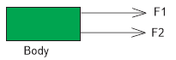

$$F_{R}=F_{1}+F_{2}$$

**Vectors acting at 180**: These are vectors that act in opposite direction. Their resultant can be obtained by finding the difference between the magnitude of the vectors

If F1 > F2,

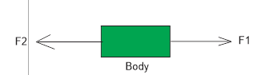

Towards $F_{1}$ (i.e. towards the east)

**Vectors acting at right angle (90) or Rectangular vector components**: The resultant of such vectors can be obtained using the Pythagoras theorem

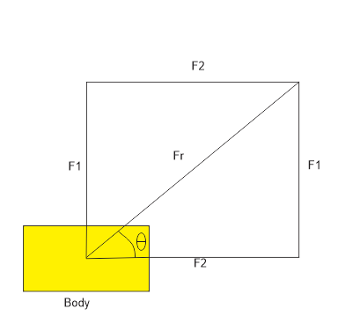

From Pythagoras’ theorem,

$${\left(Hypotenuse\right)}^{2}={\left(Opposite\right)}^{2}+{\left(Adjacent\right)}^{2}$$

$${\left(F_{R}\right)}^{2}={\left(F_{1}\right)}^{2}+{\left(F_{2}\right)}^{2}$$

$$F_{R}=\sqrt{{\left(F_{1}\right)}^{2}+{\left(F_{2}\right)}^{2}}$$

$$tanθ=\frac{opposite}{adjacent}$$

$$tanθ=\frac{F_{1}}{F_{2}}$$

The following Pythagorean triplets can be used for solving questions on vectors

(3, 4, 5), (5, 12, 13), (6, 8, 10), (7, 24, 25), (8, 15, 17), (9, 12, 15), (10, 24, 26)

For equal forces,

$$F_{1}=F_{2}=F$$

$$F_{R}=\sqrt{{\left(F\right)}^{2}+{\left(F\right)}^{2}}$$

$$F_{R}=\sqrt{2F^{2}}$$

$$F_{R}=F\sqrt{2}$$

$$tanθ=\frac{F_{1}}{F_{2}}$$

$$tanθ=\frac{F}{F}$$

$$tanθ=1$$

$$θ=\tan^{−1}1$$

$$θ=45$$

Therefore, for Equal forces

$$F_{R}=F\sqrt{2}$$

And

$$θ=45$$

The equation implies that for two equal forces, the angle between one of the forces and the resultant force is 45

**Parallelogram law of forces (vectors)**: This is best used for angles other than 0, 90, and 180 degrees. This law states that when two forces are acting on a body, the lines of forces are used to represent the adjacent sides of a parallelogram.

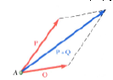

It can also be stated as if two vectors acting on a particle at the same time be represented in magnitude and direction by two adjacent sides of a parallelogram drawn from a point their resultant vector is represented in magnitude and direction by the diagonal of the parallelogram drawn from the same point

The diagonal of the parallelogram gives the resultant force (vector)

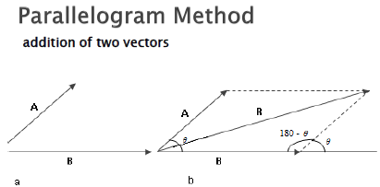

Applying cosine rule,

$${\left(F_{R}\right)}^{2}={\left(F | 1\right)}^{2}+{\left(F | 2\right)}^{2}−2F_{1}F_{2}cos\left(180−θ\right)$$

But

$$cos\left(180−θ\right)=−cosθ$$

$${\left(F_{R}\right)}^{2}={\left(F_{1}\right)}^{2}+{\left(F_{2}\right)}^{2}−\left[2F_{1}F_{2}\left(−cosθ\right)\right]$$

$${\left(F_{R}\right)}^{2}={\left(F | 1\right)}^{2}+{\left(F_{2}\right)}^{2}+2F_{1}F_{2}cosθ$$

Also,

$$\frac{sin⁡\left(180−θ\right)}{R}=\frac{sinα}{F_{1}}$$

Also, note that the difference of two vectors A and B (A – B) is defined as the vector sum of A and –B

$$A−B=A+\left(−B\right)$$

B and –B have the same magnitude but they act in opposite direction (at 180 degrees to each other)

**NB**: The maximum (resultant) vector is obtained when the angle between the two vectors is zero degree

The minimum resultant is obtained when the angle between the vectors is one hundred and eighty degrees (180)

The resultant force decreases as the value of theta increases and vice versa

**Triangle rule of vector addition:**

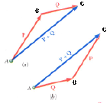

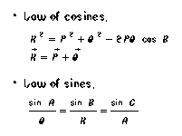

**ADDITION OF MULTIPLE VECTORS**

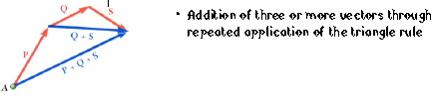

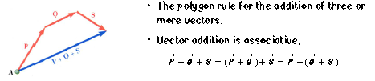

**RESOLUTION OF VECTORS**

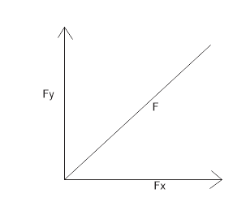

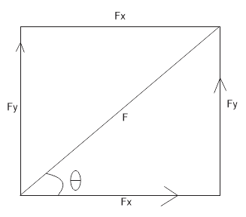

A vector can be resolved horizontally or vertically as shown below. These horizontal and vertical resolutions are called the components of the vector.

**HORIZONTAL RESOLUTION**

$$cosθ=\frac{adjacent}{hypotenuse}$$

$$cosθ=\frac{F_{x}}{F}$$

$$F_{x}=Fcosθ$$

$F_{x}$ Is called the horizontal component of the vector (force)

**VERTICAL RESOLUTION**

$$sinθ=\frac{opposite}{hypotenuse}$$

$$sinθ=\frac{F_{y}}{F}$$

$$F_{y}=Fsinθ$$

$F_{y}$ Is called the vertical component of the vector

**RESOLVING MULTIPLE FORCES**

The following steps are used to obtain the resultant of multiple forces

Resolve all the forces horizontally and find their sum $\sum{F_{x}}$

Resolve all the forces vertically and find their sum $\sum{F_{y}}$

Apply the formula,

$$R=\sqrt{{\left(\sum{F_{x}}\right)}^{2}+{\left(\sum{F_{x}}\right)}^{2}}$$

To obtain the direction (angle), the formula below is used.

$$θ=\tan^{−1}\left(\frac{\sum{F_{y}}}{\sum{F_{x}}}\right)$$

When resolving vectors, the angle $θ$ used is always the angle the vector makes with the horizontal (the x-axis).

In the resolution of vectors depending on the position it can either be negative or positive. For example, if resolving horizontally, if the force is towards the negative x-axis, then instead of adding the vector, it is written as $−Fcosθ$ and if it is on the positive x-axis we will have $+Fcosθ$. Similarly, when resolving vertically, if it is on the positive y-axis we have $+Fsinθ$ and if it is on the negative y-axis $−Fsinθ$

EG

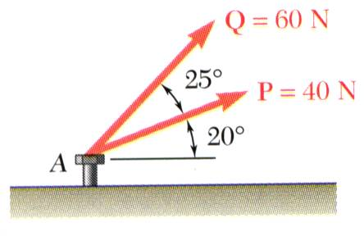

The two forces act on a bolt at *A*. Determine their resultant (and direction of their resultant)

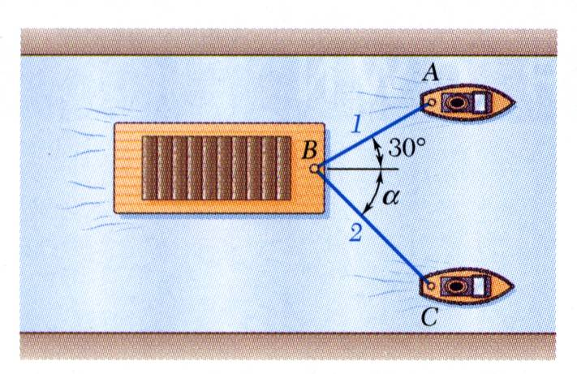

A barge is pulled by two tugboats. If the resultant of the forces exerted by the tugboats is 5000 lbf directed along the axis of the barge, determine

1. the tension in each of the ropes for a = 45o,
2. the value of a for which the tension in rope 2 is a minimum.

SOLUTION:

* Find a graphical solution by applying the Parallelogram Rule for vector addition. The parallelogram has sides in the directions of the two ropes and a diagonal in the direction of the barge axis and length proportional to 5000 lbf.
* Find a trigonometric solution by applying the Triangle Rule for vector addition. With the magnitude and direction of the resultant known and the directions of the other two sides parallel to the ropes given, apply the Law of Sines to find the rope tensions.
* The angle for minimum tension in rope 2 is determined by applying the Triangle Rule and observing the effect of variations in a.

MORE QUESTIONS

* An airplane travels on a bearing of 100° at an airspeed of 190 km/h while a wind is blowing 48 km/h from 220°. Find the ground speed of the airplane and the direction of its track, or course, over the ground.

EXTERNAL AND INTERNAL FORCES

Forces acting on a body can be divided into external and internal forces

External forces like a push or pull or friction all act on a body

The weight of a body is an example of an internal force.

If the external force is unopposed by the internal forces or by other external forces or if the force is greater than the opposing forces then the force can impart a motion of translation or rotation or both

PRINCIPLE OF TRANSMISSIBILITY:

The equilibrium or motion state of a body are not affected by transmitting (sliding or moving) a force along its line of action. For example if a pull force makes a car to move. If the force is applied to the back of the car (i.e. a push force), then the car will still move at the same velocity. So you can see that by transmitting the force along its line of action to the back of the car, it doesn’t affect the motion or equilibrium of the car and it also doesn’t affect other forces acting on the body

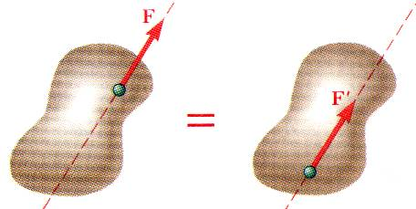

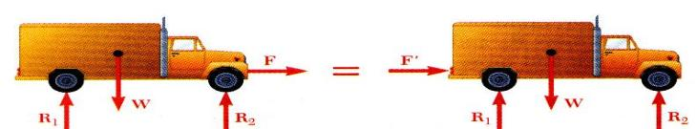

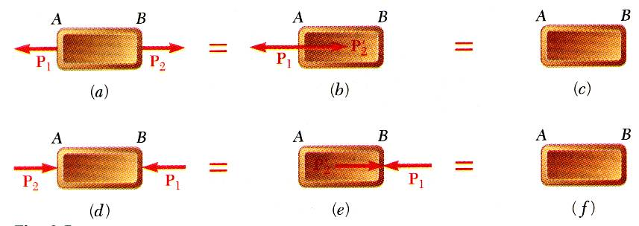

MORE QUESTIONS

1. Determine the *x and y components of each of the* forces shown. Also find the resultants of the forces.

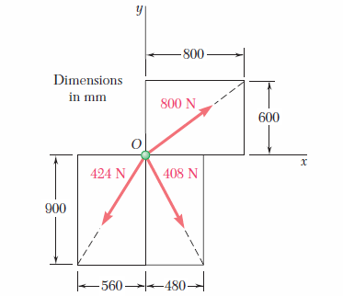

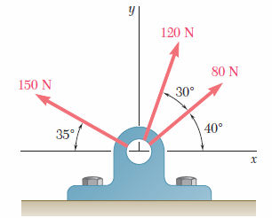

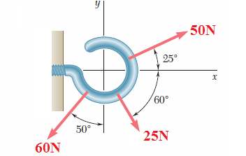

1. Two forces P and Q are applied as shown at point A of a hook support. Knowing that P = 75N and Q=125N, determine graphically the magnitude and direction of their resultant using
2. The parallelogram law
3. The triangle law

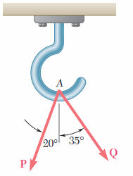

1. Two forces P and Q are applied as shown at point A of a hook support. Knowing that P = 75N and Q=125N, determine graphically the magnitude and direction of their resultant using
2. The parallelogram law
3. The triangle law



1. Two forces are applied at point B of beam AB. Determine graphically the magnitude and direction of their resultant using
2. The parallelogram law
3. The triangle rule

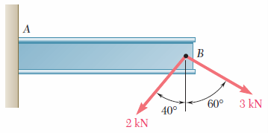

EQUILIBRIUM

When the resultant of all forces acting on a particle is zero, the particle is in equilibrium

According to Newton’s first law, if the resultant force on a particle is zero, the particle will remain at a rest or will continue at constant speed in a straight line

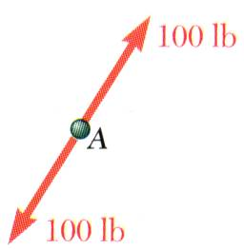

Particle acted upon by two forces:

equal magnitude

same line of action

opposite sense

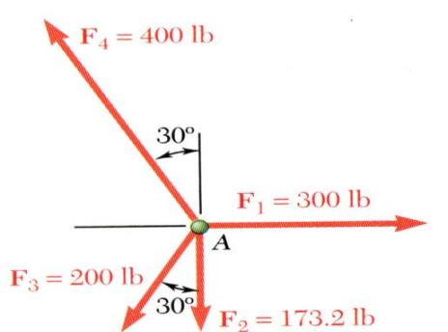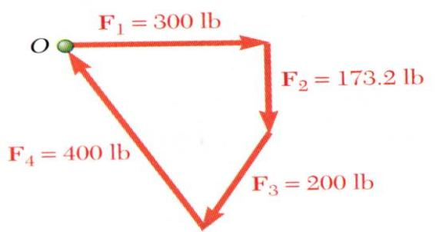

Particle acted upon by three or more forces:

graphical solution yields a closed polygon

algebraic solution



*Space Diagram*: A sketch showing the physical conditions of the problem

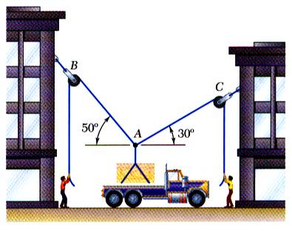

*Free-Body Diagram*: A sketch showing only the forces on the selected particle.

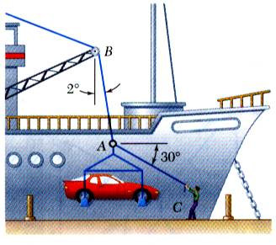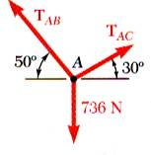

In a ship-unloading operation, a 3500-lb automobile is supported by a cable. A rope is tied to the cable and pulled to center the automobile over its intended position. What is the tension in the rope?

SOLUTION:

* Construct a free-body diagram for the particle at the junction of the rope and cable.
* Apply the conditions for equilibrium by creating a closed polygon from the forces applied to the particle.
* Apply trigonometric relations to determine the unknown force magnitudes.

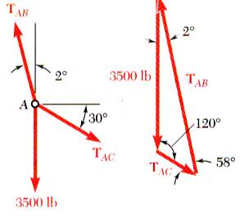

SOLUTION:

* Construct a free-body diagram for the particle at *A*.
* Apply the conditions for equilibrium.
* Solve for the unknown force magnitudes.







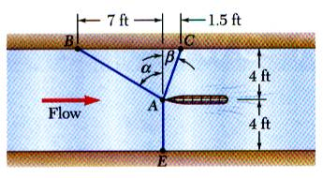

It is desired to determine the drag force at a given speed on a prototype sailboat hull. A model is placed in a test channel and three cables are used to align its bow on the channel centerline. For a given speed, the tension is 40 lb in cable *AB* and 60 lb in cable *AE*.

Determine the drag force exerted on the hull and the tension in cable *AC*.

SOLUTION:

* Choosing the hull as the free body, draw a free-body diagram.
* Express the condition for equilibrium for the hull by writing that the sum of all forces must be zero.
* Resolve the vector equilibrium equation into two component equations. Solve for the two unknown cable tensions.

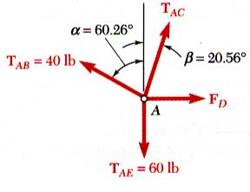

SOLUTION:

* Choosing the hull as the free body, draw a free-body diagram.





* Express the condition for equilibrium for the hull by writing that the sum of all forces must be zero.



.(a) Find the shortest distance between the two lines A and B. where

A = (2, 0, 7) + t(1, 1, 1), B = (1, 2, 4) + s(0, 1, 2).

Also find the angle between A and B.

(b) Find the equation of a plane through the point (4, 3, 1) and with normal (i -2j +3k).

2. (i) An engineering student of the University of Lagos is jugging at a speed of 50m/s from the senate building to the gate i.e. from a point A to B which is 300m directly opposite the senate building. A wind blows against the student at 20m/s. If the student always jugs in the direction parallel to AB, find how he gets to point B. In what direction must the student jug in order to cross directly from A to B.

Find the distance from the point (0, 1, 0) to the plane that passes through the point (4, 3, 1) and has a normal (i -2j + 3k).

Obtain the equation of the line through the point A(1,-3,2) and parallel to the vector (-12,4,3)

i.) verify that the point (-23,5,8) lies on this line.

ii.) find the co-ordinates of the point on the line with x-co-ordinates 3.

iii.) find the co-ordinates of two points on the line each distant 5 units from A.

4. Show that

5. Solve for the vector **u**, if

6. Obtain the vector equation of the line through the point A(-1,0,3) and parallel to the vector u=(5,3,-4). Find the point where this line intersects the xy-plane.

7. Obtain the equation of the plane through the point (1,-1,2) and normal to 2i-3j+4k.

8. Write vector V as a linear combination of thee unit vectors I and j given that the vector V has a magnitude of 16 and an angle of 30 with the positive x-axis

Solution: v has a magnitude of 16 and is inclined at 30 degrees to the horizontal

x-component $v_{x}=vcosθ=vcos30=v×\frac{\sqrt{3}}{2}=\frac{16\sqrt{3}}{2}=8\sqrt{3}$

$$v_{y}=vsinθ=vsin30=\frac{v}{2}=\frac{16}{2}=8$$

Find the magnitude of the vector shown below and determine the angle that it makes with the positive x axis

$$\left|v\right|=\sqrt{3^{2}+{\left(−8\right)}^{2}}$$

$$\sqrt{75}$$

$$θ=\tan^{−1}\left(−\frac{8}{3}\right)=−69.44°$$

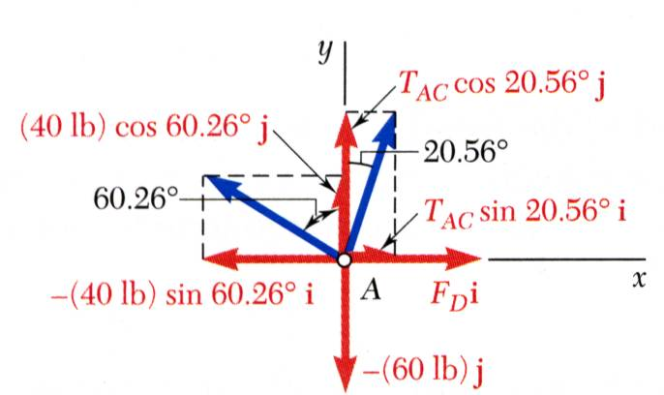

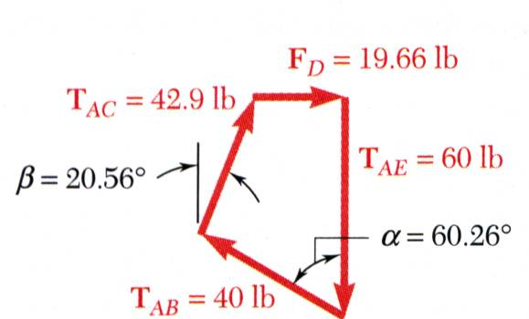

* Resolve the vector equilibrium equation into two component equations. Solve for the two unknown cable tensions.







This equation is satisfied only if each component of the resultant is equal to zero



PROJECTIONS

The figure shows representations $\overline{\left|PQ\right|}$ and $\overline{\left|PR\right|}$ of two vectors a and b with the same initial point P

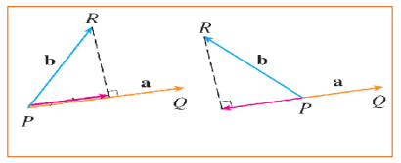

The vector representation PS os called the vector projection of b onto a and is denoted by ${proj}_{a}b$. You can think of it as a shadow of b on a

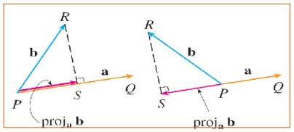

SCALAR PROJECTION

The scalar projection of b onto a (also called the component of b along a) is defined to be the signed magnitude of the vector projection. This is the number $\left|b\right|cosθ$. Here, theta is the angle between a and b

This is denoted as ${comp}_{a}b$ and the value will be negative if $90<θ<180$

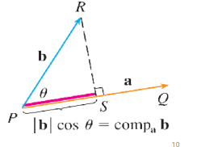

From the equation

$$a∙b=\left|a\right|\left|b\right|cosθ$$

$$a∙b=\left|a\right|\left(\left|b\right|cosθ\right)$$

We can see that the dot product of a and b can be interpreted as the length (or magnitude) of a times the scalar projection of b onto a

$$\left|b\right|cosθ=\frac{a∙b}{\left|a\right|}=\frac{a}{\left|a\right|}∙b$$

The component of b along a can be computed by taking the dot product of b with unit vector in the direction of a

Scalar projection of b onto a:

$${comp}_{a}b=\frac{a∙b}{\left|a\right|}$$

Vector projection of b onto a:

$${proj}_{a}b={comp}_{a}b∙\hat{a}$$

$${proj}_{a}b=\frac{a∙b}{\left|a\right|}∙\frac{a}{\left|a\right|}$$

Or

$${proj}_{a}b={\left(\frac{a}{\left|a\right|}\right)}^{2}∙b$$

$${proj}_{a}b={\left(\hat{a}\right)}^{2}∙b$$

$${proj}_{a}b=\frac{a∙b}{\left|a\right|}∙a$$

Take note:

The projection of a vector (B + C) on a vector a

projection of B on a + project of C on a

The shortest distance between two lines A and B of parametric equations

$$A=r1+t$$

$$B=\left(0,1,2\right)+s\left(1,2,4\right)$$

Is given as

$$d=\left|\frac{\left(r2−r1\right)∙\left(a1×a2\right)}{\left|a1×a2\right|}\right|$$

The equation of a plane through a point r1and a normal n is given as

R = r1 + tn

E.g. the equation of the plane through a point (4, 3, 1) and with nomal (i-2j+3k)

R = (4, 3, 1) + t(1 , -2, 3)

DIFFERENTIATION OF VECTOR EQUATIONS

We want to consider vectors that are functions of parameter (t) assuming that “t” is time. Differentiating the components with respect to time

$$\frac{d}{dt}\left(x\left(t\right)i+y\left(t\right)j+z\left(t\right)k\right)=x^{'}i+y^{'}j+z^{'}k$$

$$\frac{d}{dt}\left(a\left(t\right)∙b\left(t\right)\right)=a^{'}\left(t\right)∙b\left(t\right)$$

$$+a\left(t\right)∙b^{'}\left(t\right)$$

$$\frac{d}{dt}\left(a\left(t\right)×b\left(t\right)\right)=a^{'}\left(t\right)×b\left(t\right)+a\left(t\right)×b^{'}\left(t\right)$$

Recall the definition of a derivative,

$$\frac{d}{dt}f\left(t\right)=\lim_{h→0}{\frac{f\left(t+h\right)−f\left(t\right)}{h}}$$

$$\frac{d}{dt}\left(x\left(t\right)i+y\left(t\right)j\right)=\lim_{h→0}{\frac{1}{h}}$$

$$\lim_{h→0}{\frac{1}{h}\left(\left[x\left(t+h\right)−x\left(t\right)\right]i+\left[y\left(t+h\right)−y\left(t\right)\right]j\right)}$$

$$\lim_{h→0}{\frac{\left[x\left(t+h\right)−x\left(t\right)\right]i}{h}}$$

$$\lim_{h→0}{\frac{\left[y\left(t+h\right)−y\left(t\right)\right]j}{h}}$$

$$\frac{d}{dt}\left(x\left(t\right)i+y\left(t\right)j\right)=\frac{d}{dt}x\left(t\right)i+\frac{d}{dt}y\left(t\right)j$$

A vector valued function

Vectors can be differentiated

A the vector function correspondends to a curve

The first derivative

If we have a vector,

$$\vec{r}\left(t\right)=x\left(t\right),y\left(t\right)>$$

If we take the derivative,

$${\vec{r}}^{'}\left(t\right)$$

One thing we know is that the derivative corresponds to a tangent in the direction the of the tangent

The unit vector of the tangent vector $\vec{T}=\frac{{\vec{r}}^{'}\left(t\right)}{\left|{\vec{r}}^{'}\left(t\right)\right|}$

Dot product

I . I = 1

J . J = 1

K . K = 1

i.j = 0

i.k= 0

k.j = 0

Vector operator $⊳$

$$⊳=i\frac{δ}{δx}+j\frac{δ}{δy}+k\frac{δ}{δz}$$

Gradient $ϕ$

FROM THE SLIDES

We can differentiate vectors from the basic rule below

$$\frac{d}{dt}f\left(t\right)=\lim_{h→0}{\frac{f\left(t+h\right)−f\left(t\right)}{h}}$$

If the point P has a position vector r(t), r’(t) = tangent at that point P

If we also have another point Q with a position vector $r\left(t+h\right)$, the vector connecting PQ will be $r\left(t+h\right)–r\left(t\right)$ and this vector passes through the points P and Q therefore called a secant vector

Recall that a secant line is one that passes through two given points on a graph

If $h>0$, $\frac{PQ}{h}$ (tangent line) will have the same direction as PQ (secant line); PQ is the vector between p and Q while $\frac{PQ}{h}$ is the vector after Q that is in the same direction as PQ

As h approaches 0, it appears that $\frac{PQ}{h}$ is the tangent vector

The unit tangent vector $T\left(t\right)=\frac{\left[r’\left(t\right)\right]}{\left|r’\left(t\right)\right|}$

If you look at this carefully you will see the mean value theorem in it

The mean value theorem says, there’s a point c where

$$f^{'}\left(c\right)=\frac{f\left(b\right)−f\left(a\right)}{b−a}$$

Let a = the point P

Let b = the point Q

$$f\left(a\right)=f\left(P\right)=r\left(t\right)$$

$$f\left(b\right)=f\left(Q\right)=r\left(t+h\right)$$

$$b−a=\left(t+h\right)−t=h$$

$$f^{'}\left(c\right)=\frac{f\left(b\right)−f\left(a\right)}{b−a}=r^{'}\left(t\right)=\frac{r\left(t+h\right)−r\left(t\right)}{h}$$

Recall that the derivative of a function is the slope of the function. Therefore,

$$r^{'}\left(t\right)=slopeatpointt$$

From mean value theorem,

Slope of tangent line = slope of secant line

$$tangentline=\lim_{\left(b−a\right)→0}{secantline}$$

$$f^{'}\left(c\right)=\lim_{\left(b−a\right)→0}{\frac{f\left(b\right)−f\left(a\right)}{b−a}}$$

$$r^{'}\left(t\right)=\lim_{h→0}{\frac{r\left(t+h\right)−r\left(t\right)}{h}}$$

Find the derivative of

$$r\left(t\right)=\left(1+t^{3}\right)i+te^{−t}j+sin2tk$$

Find the unit tangent vector at the point where t = 0.

Solution

$$\frac{d}{dt}\left(x\left(t\right)i+y\left(t\right)j\right)=\frac{d}{dt}x\left(t\right)i+\frac{d}{dt}y\left(t\right)j$$

$$r^{'}\left(t\right)=3t^{2}i+e^{−t}−te^{−t}j+2cos2tk$$

$$r^{'}\left(t\right)=3t^{2}i+e^{−t}\left(1−t\right)j+2cos2tk$$

At t=0,

$$r^{'}\left(t\right)=3{\left(0\right)}^{2}i+e^{−\left(0\right)}\left(1−0\right)j+2cos2\left(0\right)k$$

$$0i+1j+2k$$

$$j+2k$$

The unit tangent $T\left(0\right)=\frac{r^{'}\left(0\right)}{\left|r^{'}\left(0\right)\right|}=\frac{j+2k}{\sqrt{1+4}}=\frac{j+2k}{\sqrt{5}}=\frac{1}{\sqrt{5}}j+\frac{2}{\sqrt{5}}k$

For the curve $r\left(t\right)=\sqrt{t}i+\left(2−t\right)j$, find $r^{'}$ and sketch the position vector $r\left(1\right)$ and the tangent vector $r^{'}\left(1\right)$

$$r^{'}\left(t\right)=\frac{1}{2\sqrt{t}}i−j$$

$$r^{'}\left(1\right)=\frac{1}{2}i−j$$

Position