INTEGRATION TOPICS

1. Indefinite and Definite integrals (anti derivatives)

2. Trigonometric integration

3. Exponential Integration

AGENDA

1. Integral Calculus

2. Definite Integral

3. Mean Value Theorems

d/dx (x rsup n) = n{x rsup {n-1}} => int {x^ndx} = {x ^ {n+1}} over {n+1} + c

d/dx lnx = 1/x => int {1/x dx} = ln x + c

d/dx e^x =e^x => int {e^x dx} = e^x + c

d/dx e^kx = ke^kx => int {e^kx} = e^kx/k + c

d/dx a^x = a^xln a => int {a^x dx} = a^x/lna + c

Integration. This can be seen as the anti derivatives of something.

Take a look at the power rule of differentiation:

You’ll see that the power rule for integration will be

If we find the derivative of , it will be

Now, if we find the integral of , we will have

1: Find the anti derivative of

1. Answer:

2. Answer:

3. Answer:

2. Find the integral of 4

3. Find Answer:

DEFINITE INTEGRALS

The process by which we evaluate the anti derivatives comes from thew fundamental theorem of calculus.

A function represented with f(x) – small f – while the anti-derivative F(x) – capital F –

One of the theorems says, the integral from a to b of a function f(x) where this function is continuous on a closed interval [a, b] is given below.

You should note that

Example 7:

# The c will cancel out

METHODS OF SOLVING INTEGRATION

1. Direct method

2. Substitution method

3. Integration by Parts

4. Integration by Partial Fractions

5. Integration by trigonometry

METHOD OF SUBSTITUTION

Given this

We can say, let

Making dx the subject of the formula,

Looking at another example,

Let

Solve

Answer:

Using the u substitution

Typically you want to make “u” the stuff that is more complicated.

When using the substitution method, you want to make eliminate every value of x when you are substituting the u

Answer:

Answer:

Answer:

Answer:

Let u = sin (x). Answer:

Answer:

Let u = 3x + 2

If you do it the normal way, you’ll see that you’ll get a value like

And the value 3 won’t be able to cancel out the outstanding x.

So in this situation where it both expressions, they have the same power. That is in x and {3x + 2}, you’ll have to solve for x

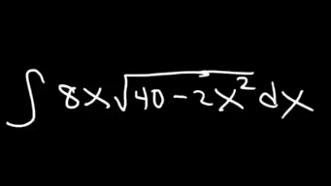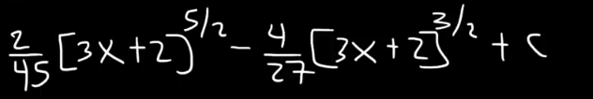

EXPONENTIAL INTEGRATION

Recall that, given a function

For the anti-derivatives,

.

This applies if and only if the function f(x) is a linear function like ax+b or something.

For example

INTEGRATION TO THE FORM

Proving it by the method of substitution

Let

But

TIPS TO SOLVING INTEGRAL QUESTIONS

1. Learn a lot of trigonometric identities.

2.

If n = odd and m = even,

We can say that n = 2k+1

From this point on, we can then decide to do the u-substitution with

u = sin x

3. A similar method can be applied if m is odd and n is even

For that, we are going to end up with something like:

4.

When m and n are even (m=n=even)

We will use the half-angle formula

5. If both are odd

QUESTIONS

1.

Let u = cos x

Find the integral of cot (x)

Let

Find the integral:

Typically, you will want to bring out a tan^2. This is because of the identity

Next we use the substitution method.

For the first 2, let u = tan (x)

Recall that

After solving sha, you should have an answer:

MORE ON TRIGONOMETRIC

int {sin x} = - cos x + c

int {cos x} = sin x + c

int {sec^2xdx} = tan x + c

Hyperbolic functions

int {sinh x dx} = cosh x + c

int {cosh x dx} = sinh x + c

d/dx sin ^ -1 x