Course Code: **CEG211** Course:

**The Effect of Stress on the Strength of Structures**

Submitted by: **Kingsley Ihemelandu Chukwudi**

Matriculation Number: **210407040**.

Department: **Systems Engineering**.

Level: **200lvl**

Group No: **2**

Submitted On: **Friday, 12th January, 2024**.

**OBJECTIVE**

1. To determine the Young’s Modulus of elasticity of steel, brass and aluminum rods from tensile test on these rods.

2. To determine the tensile strength (i.e. the ultimate tensile stress) of the steel rod.

**THEORY**

Internal forces are created when an external load is applied to a beam. When a body is operated upon by a load or external force, it experiences progressive deformation (i.e., a change in shape or dimensions). During deformation, the body's material opposes the load's tendency to distort it, and when the load's effect is replaced by the internal resistance of the body's material, it becomes stable. **Stress** is the internal resistance that the body provides to meet the load. Stress can be considered either as total stress or unit stress. Overall stress is measured in N, KN, or MN and indicates the total resistance to an external effect. Unit stress is measured in kN/m2, MN/m2, or N/mm2 and reflects the resistance created by a unit area of cross-section. The unit "Pascal" (1 Pa = 1 N/m2) is named after the mathematician and physicist Blaise Pascal (1623– 1662), whereas Augustin Louis Cauchy (1789–1857) coined the term "stress." An imaginary cut of the bar can be used to visualize the internal forces.

To calculate the stresses, we first select an imaginary cut c-c perpendicular to the bar's axis. The stresses are represented in the free-body diagram by the symbol σ. We assume that they act perpendicular to the cross section's exposed surface A and that they are evenly distributed. Normal stresses are defined as stresses that are normal to the cross section. The normal force N, as illustrated in Fig. 1.1c, is the outcome of their interaction. As a result, we obtain N = σA, and we can compute the stresses using the normal force N:

$$σ=\frac{N}{A}$$

In the case of a positive normal force N (tension) the stress σ is then positive (tensile stress). Reversely, if the normal force is negative (compression) the stress is also negative (compressive stress).

The various types of stresses may be classified as :

1 Simple or direct stress

(i) Tension

(ii) Compression

(iii) Shear

Images...

2. Indirect stress

(i) Bending

(ii) Torsion.

3. Combined stress. Any possible combination of types 1 and 2.

**SIMPLE STRESS**

Simple stress is often called direct stress because it develops under direct loading conditions. Simple tension and compression occur when the applied force, termed load, is parallel to the member's axis (axial loading), while simple shear occurs when equal, parallel, and opposing forces tend to cause a surface to move relative to the neighboring surface. The stresses that emerge in particular loading scenarios are not simple stresses.

When any type of simple stress σ (sigma) develops, we can calculate the magnitude of the stress by,

Equations…

$$σ=\frac{P}{A}$$

σ = Stress ${kN}/{m^{2}}$ or $N/{{mm}^{2}}$

P = Load [external force causing stress to develop]

A = Area over which stress develops, $m^{2}$ or $mm2$

It should be observed that the regions that resist the load in either simple tension or simple compression are perpendicular to the direction of forces. The resistant region of a member exposed to simple shear is parallel to the force direction.

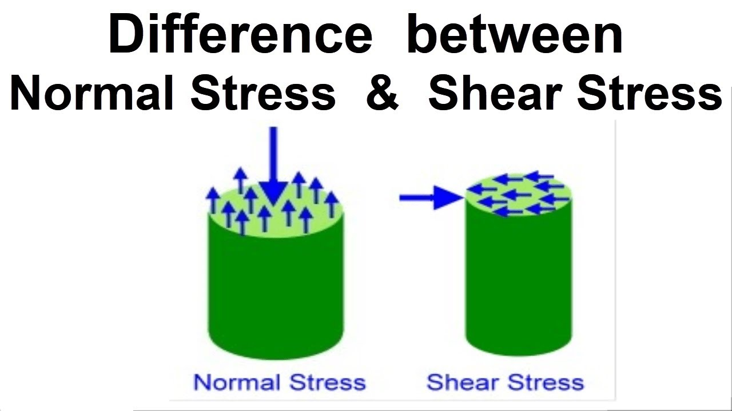

**STRAIN**

A strained element in a material is one that has been exposed to stress. The deformation caused by stress is known as strain (e). The various types of strains are explained below

**Tensile Strain**

When a piece of uniform cross-section material is exposed to a uniform axial tensile stress, it will lengthen from l to (l + {%delta}I), with the length increment $δl$ representing the material's actual deformation. The tensile strain or fractional deformation is given by

$$e_{t}=\frac{δl}{l}$$

**Compressive Strain**

Under compressive forces, a similar piece of material would be reduced in length from $δltill\left(l−δl\right)$. The strain ec is determined by the fractional deformation where,

**Shear Strain**

When a shearing load is applied, a shear strain is created, which is quantified by the angle at which the body distorts. A rectangular block LMNP, fastened on one face and subjected to force F, is depicted above. It distorts via an angle ɸ after the force is applied and takes up the new position LM'N'P. The shear strain (e) is calculated as follows:

$$e_{s}=\frac{NN’}{NP}=tanϕ=ϕ\left(radians\right)$$

$tanϕ=ϕ$ because $ϕ$ is very small

The above result has been obtained by assuming N' equal to an arc (as N' is small) drawn with centre P and radius PN.

**Volumetric Strain**

It is indicated by ev and is defined as the ratio between change in volume and original volume of the body.

$$e_{v}=\frac{{Change}_{}}{OriginalVolume}=\frac{δV}{V}$$

Elastic strains are strains that dissipate when a load is removed, and an elastic body is a body that returns to its original position when a force is removed. If the stresses persist even after the external force has been removed, the body is considered to be plastic. The stress corresponding to this load is known as the elastic limit. There is always a limiting value of load up to which the strain completely dissipates when the load is removed.

**DUCTILE AND BRITTLE MATERIALS**

Ductile and brittle materials are the two most prevalent classifications for metallic engineering materials. A ductile material (for example, structural steel or aluminum) has a very significant tensile strain up to the point of rupture, whereas a brittle material has a comparatively small strain up to the same point. The dividing line between these two types of materials is typically assumed to be 0.05 mm/mm arbitrary strain. Brittle materials include cast iron and concrete.

**HOOKE’S LAW**

It is obvious that the relationship between stress and strain is linear for comparably small strain values for any material with a stress-strain curve of the default kind. Hooke's law is a linear relationship between elongation and the axial force that causes it. Robert Hooke observed that, within the elastic limit, stress varies directly as strain.

i.e. $Stress∝Strain$

or

$$\frac{Stress}{Strain}=aconstant$$

where E represents the slope of the straight-line part OP of of the default stress agains strain curve. The constant E is the modulus of elasticity of the material under tension, or Young's modulus, which is the ratio of the unit stress to the unit strain. Because the unit strain is a pure number (being a ratio of two lengths), it follows that Young’s modulus E and the stress have the same unit, N/m2. The modulus of elasticity in compression is almost identical to that in tension for many typical engineering materials.

Modulus of Elasticity for some Common materials

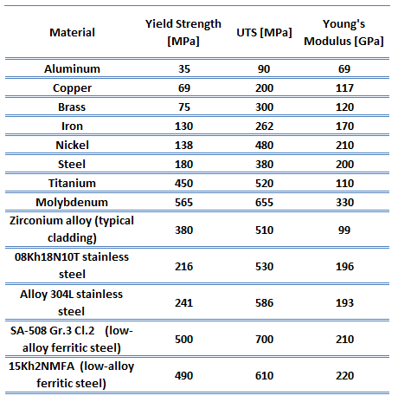

Some specific module of elasticity to note are

(i) **Young's modulus**: This is the ratio between tensile stress to tensile strain or compressive stress to compressive strain. It's represented by the letter E and is the same as the modulus of elasticity.

(ii) **Modulus of rigidity**: It is indicated by C, N, or G and is defined as the ratio of shear stress � (tau) to shear strain. It's also known as the Shear Modulus of Elasticity

(iii) **Bulk or volume modulus of elasticity**: It is denoted by the letter K and is defined as the ratio of normal stress (on each face of a solid cube) to volumetric strain.

Deformation of a Body Due to Force Acting on it Consider a body subjected to a tensile stress.

**STRESS-STRAIN CURVE**

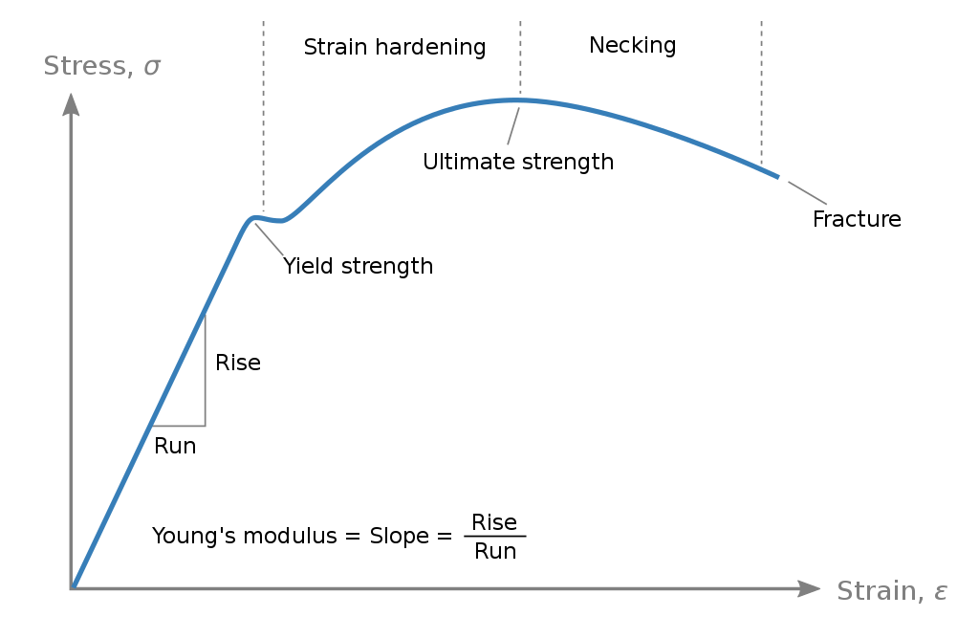

The total elongation across the bar length is measured at each increment of load as the axial stress on the body is gradually raised, and this is repeated until the specimen fractures. Experimental data can be displayed using these parameters as the ordinate and abscissa, respectively, once several pairs of values of normal stress σ and normal strain � have been acquired. This is the stress-strain curve or diagram of the material for this type of loading.

Stress-strain diagrams assume widely differing forms for various materials.

**MECHANICAL PROPERTIES OF MATERIALS**

The stress-strain curve may be used to describe a variety of material strength properties. They are as follows:

1. **Proportional Limit**: The ordinate of the point P is known as the proportional limit, i.e., the maximum stress that may be developed during a simple tension test such that the stress is a linear function of strain. For a material having the stress-strain curve like in nonferrous alloys, there is no proportional limit.

2. **Elastic Limit**: The ordinate of a point almost coincident with the proportional limit is known as the elastic limit, i.e., the maximum stress that may be developed during a simple tension test such that there is no permanent or residual deformation when the load is entirely removed. For many materials the numerical values of the elastic limit and the proportional limit are almost identical and the terms are sometimes used synonymously. In those cases where the distinction between the two values is evident, the elastic limit is almost always greater than the proportional limit.

3. **Elastic and Plastic Ranges**: The region of the stress-strain curve extending from the origin to the proportional limit is called the elastic range. The region of the stress-strain curve extending from the proportional limit to the point of rupture is called the plastic range.

4. **Yield Point**: The ordinate of the point at which there is an increase in strain with no increase in stress, is known as the yield point of the material. After loading has progressed to the point Y, yielding is said to take place. Some materials exhibit two points on the stress-strain curve at which there is an increase of strain without an increase of stress. These are called upper and lower yield points.

5. **Ultimate Strength or Tensile Strength**: The ordinate of the point U in Figure (a), the maximum ordinate to the curve, is known either as the ultimate strength or the tensile strength of the material. Young’s Modulus is the factor that measures the tensile or compressive stiffness of a material when the force is applied length-wise. Tensile strength of a material is the characteristic tensile strength of a material which is the value/ strength of that material after which it cannot accommodate any further stress. Simply put, it is the **STRENGTH OF FAILURE**.

6. **Breaking Strength**: This is the point of rupture

7. **Modulus of Resilience**: The work done on a unit volume of material, as a simple tensile force is gradually increased from zero to such a value that the proportional limit of the material is reached, is defined as the modulus of resilience. This may be calculated as the area under the stress-strain curve from the origin up to the proportional limit. The unit of this quantity is N · m/m3 in the SI system. Thus, resilience of a material is its ability to absorb energy in the elastic range.

8. **Modulus of Toughness**: The work done on a unit volume of material as a simple tensile force is gradually increased from zero to the value causing rupture is defined as the modulus of toughness. This may be calculated as the entire area under the stress-strain curve from the origin to rupture. Toughness of a material is its ability to absorb energy in the plastic range of the material.

9. **Percentage Reduction in Area**: The decrease in cross-sectional area from the original area upon fracture divided by the original area and multiplied by 100 is termed percentage reduction in area. It is to be noted that when tensile forces act upon a bar, the cross-sectional area decreases, but calculations for the normal stress are usually made upon the basis of the original area. As the strains become increasingly larger it is more important to consider the instantaneous values of the cross-sectional area (which are decreasing), and if this is done the true stress-strain curve is obtained.

**Percentage Elongation**

The increase in length of a bar after fracture divided by the initial length and multiplied by 100 is the percentage elongation. Both the percentage reduction in area and the percentage elongation are considered to be measures of the ductility of a material.

10. **Working Stress**: The above-mentioned strength characteristics may be used to select a working stress. Frequently such a stress is determined merely by dividing either the stress at yield or the ultimate stress by a number termed the safety factor. Selection of the safety factor is based upon the designer’s judgment and experience. Specific safety factors are sometimes specified in design codes.

11. **Strain Hardening**: If a ductile material can be stressed considerably beyond the yield point without failure, it is said to strain- harden. This is true of many structural metals. The nonlinear stress-strain curve of a brittle material, characterises several other strength measures that cannot be introduced if the stress-strain curve has a linear region. They are:

a. **Yield Strength**: The ordinate to the stress-strain curve such that the material has a predetermined permanent deformation or ‘‘set’’ when the load is removed is called the yield strength of the material. The permanent set is often taken to be either 0.002 or 0.0035 mm per mm. These values are of course arbitrary. The ordinate of Y represents the yield strength of the material, sometimes called the proof stress.

b. **Tangent Modulus**: The rate of change of stress with respect to strain is known as the tangent modulus of the material.

**COEFFICIENT OF LINEAR EXPANSION**

This is defined as the change of length per unit length of a straight bar subject to a temperature change of one degree and is usually denoted by a. The value of this coefficient is independent of the unit of length but does depend upon the temperature scale used. Temperature changes in a structure give rise to internal stresses, just as do applied loads. The thermal strain due to a temperature change ΔT is

**POISSON’S RATIO**

When a bar is subjected to a simple tensile loading there is an increase in length of the bar in the direction of the load, but a decrease in the lateral dimensions perpendicular to the load. The ratio of the strain in the lateral direction to that in the axial direction is defined as Poisson’s ratio. It is denoted by the Greek letter ν. For most metals it lies in the range 0.25 to 0.35. For cork, ν is very nearly zero.

**GENERAL FORM OF HOOKE’S LAW**

The simple form of Hooke’s law has been given for axial tension when the loading is entirely along one straight line, i.e., uniaxial. By superposing the strain components arising from lateral contraction due to Poisson’s effect upon the direct strains we obtain the general statement of Hooke’s law:

**ELASTIC VERSUS PLASTIC BEHAVIOUR OF A MATERIAL**

The behavior of a material under stress is determined by its physical properties, such as its elasticity, ductility, and brittleness. Elasticity refers to the ability of a material to deform under an applied force and then return to its original shape when the force is removed [1]. When a force is applied to a material within its elastic limit, the material returns to its original shape, and no deformation effect is noticed [1]. However, it has been shown that deformation does not totally cease beyond this point. Perfectly elastic materials return to their original shape and size when the applied force is removed [1].

Plastic deformation, on the other hand, is a permanent deformation or change in shape of a solid body without fracture under the action of a sustained force. When a material is stressed beyond its elastic limit, it might behave in one of four ways: brittle, inelastic, or ductile. Brittle materials do not deform much before breaking, while inelastic materials do not return to their original shape and size after the applied force is removed. Ductile materials deform significantly before breaking.

The elastic-plastic behavior of a material is described by its stress-strain curve, which plots the material’s stress against its strain as it is loaded. The curve typically exhibits a linear region at low stresses, corresponding to elastic deformation, followed by a nonlinear region at higher stresses, corresponding to plastic deformation. The extent of stretching or compressing (as a response to the stress) is called strain. Every material responds differently to stress. The response is highly dependent on the chemical bond type of the substance.

Understanding the difference between elastic and plastic deformation is crucial in fields such as engineering, construction, and manufacturing, where materials are subjected to various types of stress. By studying the properties of materials, engineers can design structures and machines that are safe, efficient, and long-lasting. The ability to predict the behavior of materials under stress is also important in fields such as geology and seismology, where the deformation of rocks and other materials is studied to understand the behavior of the Earth’s crust [2]. The study of elastic and plastic deformation is a fundamental concept in materials science and engineering, and it has numerous applications in various fields of science and technology [1].

**APPARATUS**

1. Controls universal testing machine: This is a machine that is used for exerting tensile force on a rod inserted in it. When the machine is switched on with the rod set inside it, the machine begins to stretch the rod until it snaps. The machine has an analogue meter where readings can be obtained.

2. Steel rod: The metal specimen being experimented on for tensile test

3. Vernier callipers: This is used to measure the length, depth, internal and external diameters of objects. In this experiment, the vernier caliper was used to measure the diameter of the steel rod used.

4. Metric rule: geometrical device that is used to measure distances between two points

**PROCEDURE**

1. Connect the machine

2. Swtich on the mains and the machine itself

3. Put the rod level to either compression or tension depending on the one you’re carrying out

4. Check if the mould is the right one for the specimen

5. Open both upper and lower jaw of the mould and insert your specimen (a 500mm long steel bar) named at every 100mm in case it’s steel/flat bar and clamp 100mm to upper and lower jaw respectively to leave 300mm as guage length and then lock it. Support the piston to accommodate the speciment, incase you are testing for comparison

6. On the display unit, click on test run, click on either compression or tension, to move the piston up or apart.

7. Follow the displayed command, input the area of the specimen and click test.

8. Then, load the piston by moving up the short lever with the black knob and follow the reading on the display unit.

9. For tensile strength, record both force and stress as shown at the yield and ultimate points

10. Release the clamp, remove the specimen, hold it together, and measure the elongation and record it.

11. Repeat the same procedure for the number of speciment in one set i.e. at least 2 pieces.

**RESULT**

|  |  |  |  |  |  |  |  |  |
| --- | --- | --- | --- | --- | --- | --- | --- | --- |
| Bar Diameter Size (mm) | k | Yield | | Ultimate | | | Elongation (%) | |
| Load (KN) | Stress (N/{mm^2}) | | Load(KN) | Stress | |  |
| 120 | 2.72 | 60 | 534 | | 71.43 | 631.58 | | 11 |

The stiffnes of the material, $k=\frac{AE}{l}=\frac{F}{δl}$

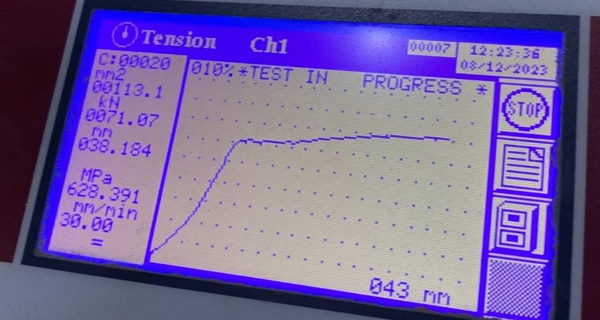

**CALCULATIONS**

Using a meter rule, the initial length, $l_{o}=200mm$ (only 2/5 of the rod was measured)

After the experiment, the length of the rod was then measured to be $l=220mm$

Hence, extension $δl=\left|l_{o}−l\right|$

$$δ=\left|200−220\right|$$

$$δ=20mm$$

The $elongation\left(\text{\%}\right)=\frac{l−l_{o}}{l_{o}}×100$

$$\text{\%}=\frac{220−200}{20}×100$$

$$elongation=\frac{22}{200}×100$$

$$elongation=11\text{\%}$$

Area of steel =, $A=\frac{πd^{4}}{4}$

$$A=\frac{π×{120}^{2}}{4}$$

$$A=\frac{14400π}{4}$$

$$A=11309.7{mm}^{2}$$

The stiffness, $k=\frac{AE}{l}$

$$k=\frac{A×\frac{stress}{strain}}{l}$$

$$k=\frac{A×\frac{Fl}{Ae}}{l}$$

$$k=\frac{F}{e}$$

$$k=\frac{60N}{22mm}$$

$$k=2.72N{mm}^{−1}$$

**REPORT**

From the experiment performed, the Young’s modulus of the steel rod was determined from the tensile test performed on the rod. The steel rod was also tested for tensile strength (ultimate stress), and the value was obtained. Since direct readings for extension were not recorded in every case, the graph of extension against load for the steel rod was constructed using the lower yield point and the origin.

**PRECAUTIONS**

1. When using the vernier callipers, error due to parallax was avoided 2. When putting the material into the testing machine, parallax errors were also prevented.

3. Error due to parallax (zero error) of the metre rule was avoided.

**DISCUSSION AND CONCLUSION**

It is well-known that when an external force is applied to a body, the body deforms. [**Hooke’s law states that if a force operates on a material within its elastic limit, the material returns to its original shape, and no deformation effect is noticed**1](https://www.britannica.com/science/Hookes-law). However, it has been shown that deformation does not totally cease beyond this point. [**When a material is stressed, it might behave in one of four ways: perfectly elastic, brittle, inelastic, or ductile**1](https://www.britannica.com/science/Hookes-law).

Perfectly elastic materials return to their original shape and size when the applied force is removed. Brittle materials, on the other hand, do not deform much before breaking. Inelastic materials do not return to their original shape and size after the applied force is removed. [**Ductile materials deform significantly before breaking**](https://www.britannica.com/science/Hookes-law).

The behavior of a material under stress is determined by its physical properties, such as its elasticity, ductility, and brittleness. [These properties are influenced by factors such as temperature, pressure, and the presence of impurities 1](https://www.britannica.com/science/Hookes-law). Understanding the behavior of materials under stress is crucial in fields such as engineering, construction, and manufacturing, where materials are subjected to various types of stress. [**By studying the properties of materials, engineers can design structures and machines that are safe, efficient, and long-lasting**1](https://www.britannica.com/science/Hookes-law).

**REFERENCES**

1. Mechanics of Materials by Ferdinand P. Beer, E. Russell Johnston 2. Jr., John T. DeWolf, David F. Mazurek

3. Strength of Materials by R.K. Rajput

4. Strength of Materials by R.S. Khurmi

5. Schaum’s Outlines of Strength of Materials

6. Mechanics of Materials by Dietmar Gross, Werner Hauger, Jörg

7. Schröder, Wolfgang A. Wall, Javier Bonet