Course Code: **CEG211**

**Deflection of Simply Supported Beams**

Submitted by: **Kingsley Ihemelandu Chukwudi**

Matriculation Number: **210407040**.

Department: **Systems Engineering**.

Level: **200lvl**

Group No: **2**

Submitted On: **Friday, 12th January, 2024**.

**OBJECTIVE**

1. The objective of this experiment is to verify the use of the basic differential equation for calculating beam slopes and deflections.

$$EI\frac{d^{2}y}{dx^{2}}$$

**THEORY**

As the experiment is an exploration of the differential equation for bending of a beam, the theoretical values have been given in the instruction sheet. This avoids the tedium of integrating and evaluating constants, which is particularly clumsy for the unsymmetrical point load. Hence at the end of Part 4 the student is directed to an area moment solution for the end slopes of the beam. This is an application of the second theorem of area moments, namely

The deflection of end 8 from the tangent at end A is given by the moment of the MEI diagram from A to B about point B

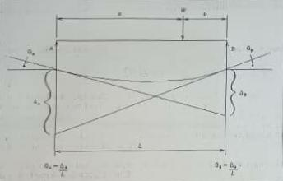

The bending moment diagram is divided into triangles and gives

$$B=\frac{1}{EI}\left(\frac{Wab}{L}.\frac{a}{b}\left(b+\frac{a}{3}\right)+\frac{Wab}{L}·\frac{b}{2}·\frac{2b}{3}\right)=\frac{Wab}{6EI}\left(a+2b\right)$$

**What is a beam?**

A *beam* is a structural member designed to support loads applied at various points along the member.

In most cases, when external forces (loads) are applied to a beam, the loads are perpendicular to the axis of the beam and will cause only shear (Fig. 1) and bending (Fig. 2) in the beam.

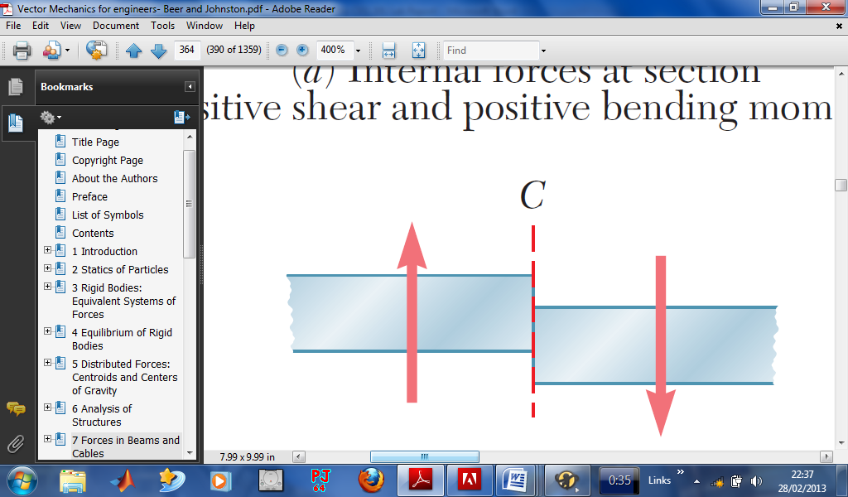

*Fig. 1: External force causing shear in a beam*

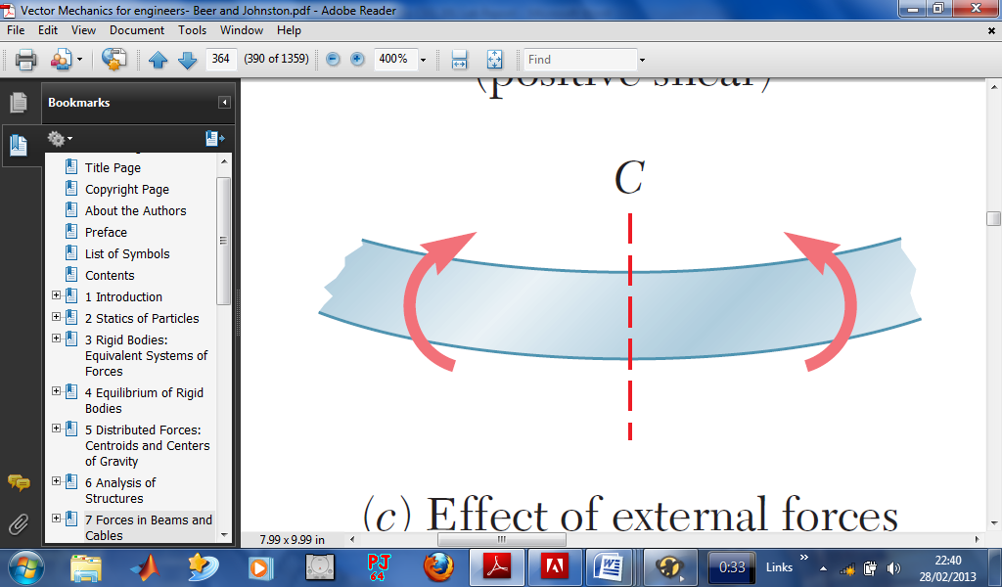

*Fig. 2: External force making a beam to bend*

Looking at the second diagram, we can observe that the external force applied to the beam has caused a bending moment in the beam, thereby causing a deflection. The value of this deflection can be calculated using the following formula

$$Deflection=\frac{WL^{3}}{48EI}$$

Various beams have different deflected shapes due to the kind of support they have.

Various types of beams and their deflected shapes are outlined below

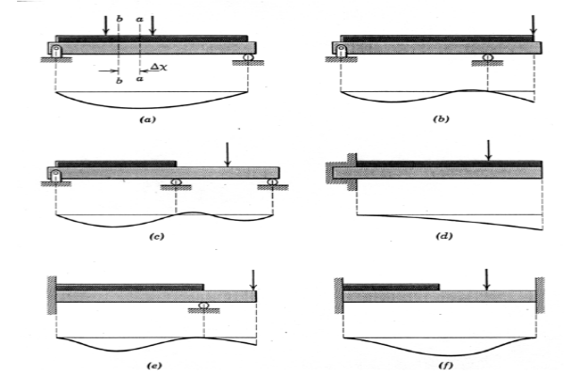

a. Simply supported beam

b. Overhanging beam

c. Cantilever beam

d. Continuous beam

e. Beam fixed at one end and simply supported at the other en

f. Fixed beam

As was shown in the first case above (case a), let us consider a beam AB simply supported at both ends, having an external force F acting between the two supports.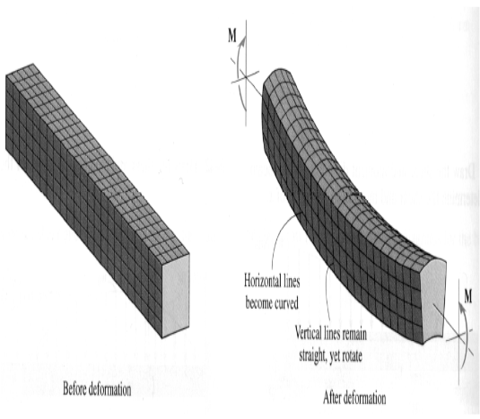

After deformation, it will bend due to deformation it has undergone and will then have the shape shown below

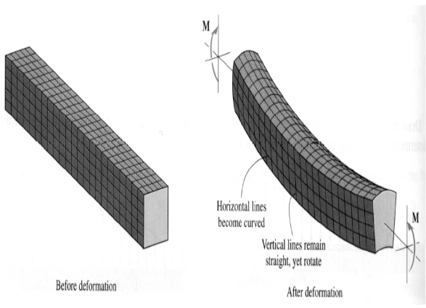  
  
The amount by which a beam deflects, depends upon its cross-section and the bending moment.

In modern design offices, there are two design criteria for the deflection of a cantilever or beam

1. Strength –

As per the strength criterion of the beam design, it should be strong enough to resist bending moment and shear force. Or in other words, the beam should be strong enough to resist the bending stresses and shear stresses.

1. Stiffness -

And as per the stiffness criterion of the beam design, which is equally important, it should be stiff enough to resist the deflection of the beam. Or in other words, the beam should be stiff enough not to deflect more than the permissible limit

Methods for Slope and Deflection at a Section

Though there are many methods to find out the slope and deflection at a section beam, yet two methods are listed below, just to mention a few:

* Macaulay’s method.

This method is suitable for several loads

* Double integration method.

This is suitable for a single load

Since we made use of a single load, the double integration method will be suitable for determining the deflection

$$M=El\frac{d^{2}y}{dx^{2}}$$

$$El\frac{dy}{dx}=\int{M}$$

$$El.y=∬M$$

After performing the necessary operations, we observe that

yc=Wl348EI

$$y_{c}=\frac{WL^{3}}{48EI}$$

Where yc = deflection

W = weights applied

*l* = length between the two supports

E = Young Modulus of the beam

I = Moment of Inertia

Hence, we arrived at

$$Deflectionδ=\frac{WL^{3}}{48EI}$$

**APPARATUS**

* 3 Dial Gauges:

A Dial gauge consists of a circular graduated dial and a pointer actuated by a member that contacts with the part being calibrated. They are used to measure the flatness and inclination of objects. It is used to check round bar roundness. It checks the flatness of an object as compared to the flatness of the standard object. In the mechanical field, dial gauges are used to check the flatness and alignment of various jobs and workpieces.

* Load hanger:

The purpose of the spring hanger is to support dead weight. In other words, this support is only to support downward direction movement.

* 2N Weights
* 25mm X 5mm bar
* 25mm X 3mm bar

**PROCEDURE**

Part 1: Mid Span Deflection and End Slopes of a Bear with a UDL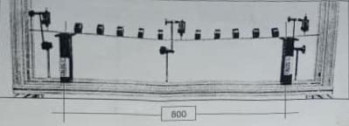

The apparatus should be mounted to make a simply supported beam using the 25mm x 5mm thick beam. Keep the left-hand movable bracket where it is as displayed in the image above.

Fix the right-hand movable bracket to the HST 1 frame. Attach the knife-edges to each support bracket Adjust the right-hand support bracket so that the span between the knife-edges is 800mm

Set up a dial gauge either side of the supports to measure the end rotations (slope) of the overhanging beam ends Set up the third dial gauge at mid span of the 800mm beam span

Record the 'No Load' dial gauge initial readings in table 1. Simulate a distributed load by placing 10 x 2N weights at approximately 80mm centre (40 mm at each end) and record the new gauge readings (see image above). The weights should be positioned with their slots sitting on the top face of the beam. Double the load by interposing a further 10 x 2N weights, reducing the spacing to 40 mm centre (20 mm at each end). See image below.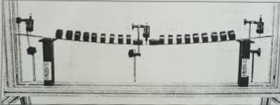

You will have to position the central two weights as shown above. They should be sat flat on the bear, with their slots facing the dial gauge spindle. This is to ensure the weights do not interfere with the middle dial gauge.

Record the dial gauge readings in table 1a.

Repeat same procedure for 25mm x 3mm thick beam and record the dial gauge readings in table 1b.

Part 2: Non-Symmetrical Point Load on a Beam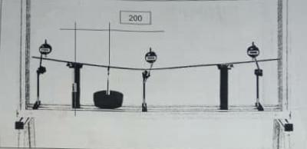

Keep the apparatus set up the same as in part 1 above, i.e., 25 x 5mm beam, 800mm span, knife-edges attached and 3 dial gauges assemblies.

Add a hanger clamp, load hanger and chain at 200 mm from the left-hand knife edge. Zero the dial gauges. Record the initial 'No Load" dial gauge readings in table 2a.

Apply a 50N load on the hanger and record the new dial gauge readings of all three dial gauges in table 2a.

Repeat same procedure for 25 x 3mm beam and record readings in table 2b.

Move the right-hand dial gauge to read the deflection of the hanger clamp, with the 50N load still applied (the load point) as shown below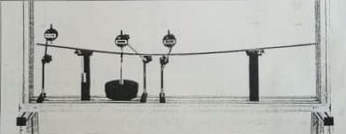

With the 50N load still applied record the hanger clamp dial gauge reading in table 2. Remove the 50N load and record the hanger clamp dial gauge reading in table 2c.

As an additional test (if required) re-apply the 50N load to the load hanger. Loosen the anchor plate that fastens the mid span dial gauge to the test frame, but hold the bracket firmly in place by hand. Now move the whole assembly so that the dial gauge runs along the beam between the hanger clamp position and the right-hand support bracket

By watching the dial gauge try to decide where the maximum deflection of the beam occurs. When confident the maximum position has been reached clamp the bracket and measure the beam deflection due to the 50 N load. Also note the position of this measurement along the beam by using the tape measure supplied.

**RESULTS**

**DEFLECTION & SLOPE AT LOADED END OF A CANTILEVER FOR UDL**

|  |  |  |  |  |  |  |
| --- | --- | --- | --- | --- | --- | --- |
| Load – W (N) | Deflection Guage | | | Slope Guage | | |
| Reading (mm) | Deflection (mm) | Theoretical deflection  y(mm) | Reading (mm) | Deflection (mm) | Slope Ɵ (0.01 rad) |
| 0 | 0.00 | 0.00 | 0.00 | 0.00 | 0.00 | 0.000 |
| 10 x 1N | 2.52 | 2.52 | 1.50 | 3.57 | 3.57 | 1.055 |
| 10 x 2N | 4.97 | 4.97 | 3.00 | 6.96 | 6.96 | 1.990 |

**MID SPAN DEFLECTIONS & SLOPES (END SLOPES) OF A UDL BEAM**

|  |  |  |  |  |  |  |
| --- | --- | --- | --- | --- | --- | --- |
| Load (N) | LHE Slope Guage | | Mid Span Guage | | RHE Slope Guage | |
| Reading (mm) | Slope (rad) | Reading (mm) | Deflection (mm) | Reading (mm) | Slope (rad) |
| 0 | 0.00 | 0.00 | 0.00 | 0.00 | 0.00 | 0.00 |
| 10 x 2N | 1.05 | 0.0161 | 2.66 | 2.66 | 1.07 | 0.0159 |
| 10 x 2N | 2.21 | 0.0337 | 5.58 | 5.58 | 2.24 | 0.0334 |

**NON-SYMMETRICAL POINT LOAD ON A BEAM AT MID SPAN**

|  |  |  |  |  |  |  |
| --- | --- | --- | --- | --- | --- | --- |
| Load – W (N) | LHE Slope Guage | | Mid Span Guage | | RHE Slope Guage | |
| Reading (mm) | Slope (rad) | Reading (mm) | Deflection (mm) | Reading (mm) | Slope (rad) |
| 0 | 0.00 | 0.00 | 0.00 | 0.00 | 0.00 | 0.00 |
| 50 | 3.41 | 0.0341 | 7.15 | 7.15 | 2.43 | 0.0243 |

**AT LOAD HANGER**

|  |  |  |  |  |  |  |
| --- | --- | --- | --- | --- | --- | --- |
| Load – W (N) | LHE Slope Guage | | Mid Span Guage | | RHE Slope Guage | |
| Reading (mm) | Slope (rad) | Reading (mm) | Deflection (mm) | Reading (mm) | Slope (rad) |
| 0 | 0.00 | 0.00 | 0.00 | 0.00 | 0.00 | 0.00 |
| 50 | 2.78 | 0.0278 | 5.88 | 5.88 | 1.81 | 0.0181 |

**CALCULATIONS**:

* DEFLECTION & SLOPE AT LOADED END OF A CANTILEVER FOR UDL:
  + Deflection at 10 × 1N:

Deflection of beam(y) = wL48EI

L = 400mm

I = Bd312 = 260.42mm4

E = 205000N/mm2

w = 10400

= 10 × 40038 × 205000 × 260.42 = 1.5mm

* Deflection at 10 × 2N:

=20 × 4003 8 × 205000 × 260.42 = 2.997mm ≈ 3.00mm

* MID SPAN DEFLECTIONS & SLOPES (END SLOPES) OF A UDL BEAM:
  + The mid span guage, deflection = y - yo
  + 10 × 2N, deflection = 2.66-0.00 = 2.66mm
  + 20 × 2N deflection = 5.58 - 0.00 = 5.58mm
  + Reading on the LHE slope guage = (B - Bo)-(A - Ao)100
  + 10 ×2N =2.66 - 1.05100 = 0.0161
  + 20 × 2N = 5.58 - 2.21100 = 0.0337
  + 10 ×2N =2.66 - 1.07100 = 0.0159
  + 20 × 2N = 5.58 - 2.24100 = 0.0334
* NON-SYMMETRICAL POINT LOAD ON A BEAM AT MID SPAN:
  + Deflection in mid span guage = 7.15 - 0.00 = 7.15mm
  + Slope reading in the LHE slope guage = 3.41100 = 0.0341
  + Slope reading in the RHE slope guage = 2.43100 = 0.0243

**REPORT/ OBSERVATION**

The experiment was carried out to determine the deflection of simply supported beams were done using:

* A 25mm by 5mm flat bar of 800mm span; and
* A 25mm by 3mm flat bar of 800mm span.

From the experiment performed, the deflection for each beam have been calculated.

Generally, the experimental results verified the theory as it was observed that as the load increased, the deflection of the beam also increased. It was also observed that the thicker the beam, the lesser the deflection recorded.

**PRECAUTIONS**

* I ensured that the dial gauge was set to zero before starting the experiment
* I ensured that the tip of the dial gauge was in contact with the beam first touching at its centre.
* I ensured that the instrumental parts were not touched so as to avoid false deflections.

**DISCUSSION AND CONCLUSION**

From the theory, it is already stated that the deflection depends on the applied load, the length of the beam (span), the cross- sectional area, the moment of inertia and the results obtained from the experiments carried out, it will be thus proven.

The 25mm by 5mm flat beam has a lesser deflection for a load than the 25mm by 3mm flat beam.

This experiment is very useful for an engineer e.g., testing the strength of materials used by electrical engineers in setting high tension wires on poles is very important.

**REFERENCES**

1. Strength of Materials by R.S. Khurmi
2. Strength of Materials by R. K. Rajput
3. Vector Mechanics for engineers by Beer & Johnson