**TRUSSES**

**4.1 INTRODUCTION**

A truss is a system of connecting members arranged in a series of triangles. These triangles work together to distribute load efficiently. Trusses were made for two major purposes

1. Withstanding or supporting loads

2. Share and transfer load

**4.2 COMMON TYPES OF TRUSSES**

Certainly! Let’s explore different types of trusses commonly used in structural engineering. Trusses are essential components in roof and bridge structures, providing stability and load-bearing capacity. Here are some notable truss types:

1. Warren Truss:

- Often used for steel railway bridges.

- Features a triangular arrangement of members.

- The top and bottom chords may be manufactured as one piece.

- Connection type (hinges or fixed) affects design.

- [Static system: 1 pin and 1 roller support](https://www.structuralbasics.com/types-of-trusses/).

2. Fink Truss:

- Commonly used in residential and commercial roofs.

- Consists of diagonal web members forming triangles.

- Lightweight and efficient design.

- [Static system: 1 pin and 1 roller support](https://www.structuralbasics.com/types-of-trusses/).

3. Howe Truss:

- Suitable for long-span roofs and bridges.

- Diagonal members intersect vertical web members.

- [Static system: 1 pin and 1 roller support](https://www.structuralbasics.com/types-of-trusses/).

4. Pratt Truss:

- Widely used in steel bridges and buildings.

- Vertical web members with diagonal tension members.

- [Static system: 1 pin and 1 roller support](https://www.structuralbasics.com/types-of-trusses/).

5. King Post Truss:

- Simple design with a central vertical post.

- Often seen in smaller roof structures.

- [Static system: 1 pin and 1 roller support](https://www.structuralbasics.com/types-of-trusses/).

6. Queen Post Truss:

- Similar to the king post truss but with two vertical posts.

- Provides better load distribution

- Used in larger roof spans.

- [Static system: 1 pin and 1 roller support](https://www.structuralbasics.com/types-of-trusses/).

7. Flat Truss:

- Horizontal top and bottom chords.

- Suitable for flat roofs and ceilings.

- [Static system: 1 pin and 1 roller support](https://www.structuralbasics.com/types-of-trusses/).

8. Scissors Truss:

- Features angled web members resembling scissors.

- Creates a vaulted ceiling effect.

- Used in residential and commercial buildings.

- [Static system: 1 pin and 1 roller support](https://www.structuralbasics.com/types-of-trusses/).

9. Fan Truss:

- Radial arrangement of web members.

- Used in dome structures and circular roofs.

- [Static system: 1 pin and 1 roller support](https://www.structuralbasics.com/types-of-trusses/).

10. Double Fink Truss:

- Variation of the Fink truss with additional diagonals.

- Provides extra strength for larger spans.

- [Static system: 1 pin and 1 roller support](https://www.structuralbasics.com/types-of-trusses/).

11. Double Howe Truss:

- Similar to the Howe truss but with additional diagonals.

- Used for long-span roofs and bridges.

- [Static system: 1 pin and 1 roller support](https://www.structuralbasics.com/types-of-trusses/).

**4.3 RIGID, OVER-RIGID AND UNDER-RIGID TRUSSES**

**4.3.1 RIGID TRUSS**

- For a rigid truss or a perfect truss,

- A perfect truss is non-collapsible.

**4.3.2 OVER-RIGID TRUSS**

- For an over rigid truss,

- An over rigid truss is also non-collapsible

- These are statically indeterminate

- These are solved with the force method or displacement method (not needed rn)

**4.3.3 UNDER-RIGID TRUSS**

- For an under rigid truss,

- An under rigid truss is collapsible

$m$– Number of members

$n$– Number of joints

**4.4 ASSUMPTIONS OF A TRUSS**

For we to take a structure as a truss, some assumptions must be possible

1. Joints are assumed to be pin connections

2. Loads or forces are only applied at the joints and not the members

3. The weight of the members are negligibly small

4. Trusses are statically determinant. Therefore, they can be found with the major equations of statics

5. When calculating, we take into consideration the reactions, axial forces and external forces

6. If the whole body or truss is in equilibrium, we assume that each member is also in equilibrium

NB:

It is always good to start your solving where we have at least 1 known and a maximum of two unknowns.

**4.5 METHODS OF SOLVING TRUSSES**

There are two major methods that are used when solving trusses and these are

1. Method of Joints

2. Method of Sections

**4.5.1 METHOD OF JOINTS**

Steps to follow:

1. Find the reactions at the supports

When calculating the reactions, we only need to care about the external forces and reactions at that moment. We don’t need the forces along each member

2. However, remember to start at a place where there is a maximum of two unknowns and a minimum of one known.

3. We’ll be assuming the members are either in tension.

4. Draw the free body diagrams for each joint

5. Forces that have angles should be resolved into vertical and horizontal components

6. We calculate the axial forces and also the forces along the members.

Also take note of the following:

1. When resolving the forces at the joints. The forces pointing upward are positive and the forces pointing downward are negative.

2. Also since we assume the forces are in tension, the force is on the left of the joint, it is negative.

METHOD OF SECTIONS

1. Draw the free body diagrams

2. Use this the equilibrium equations to solve for the reactions

4.6 ZERO FORCE MEMBERS

1. When you have two of the members aligned in one direction and the third member will have a vertical component which will be zero

2. Two members connected at a joint with two of the members not aligned.

The above two conditions are true only if no external load is applied at those joints.

**4.6 QUESTIONS**

1. A truss is loaded and supported as shown in the figure below. Find by the method of joints the axial forces in each member of the truss

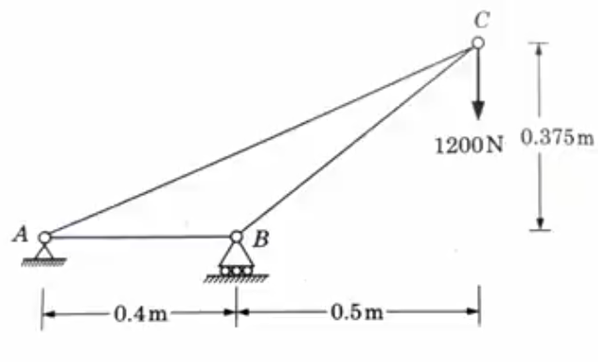

2. Find the force in the member RQ of the frame shown below

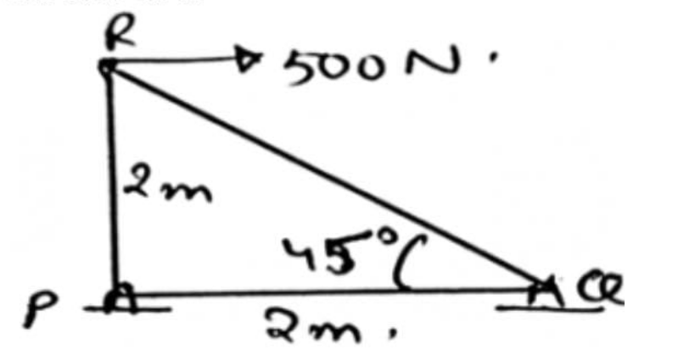

3. Find the axial forces (in terms of P) in the members 1,2 and 3 by the method of joints

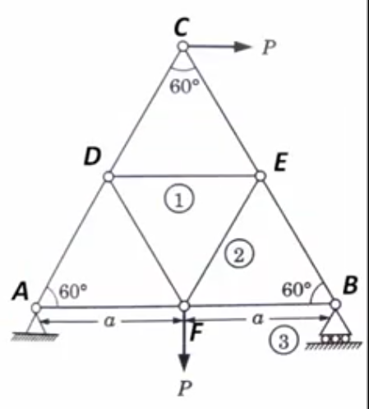

4. Find the force in each member and whether they are in tension or compression

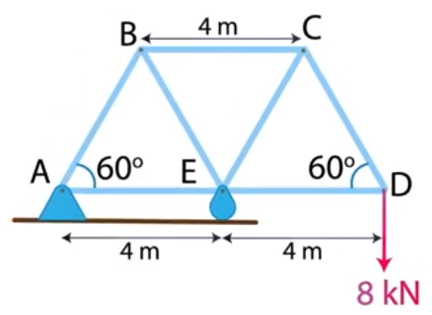

5. Find the force in each member and determine whether they are in tension or compression

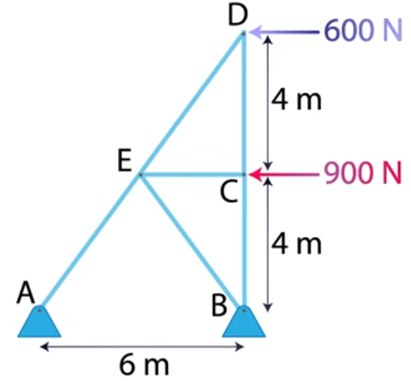

6. Find the force in the member RQ of the frame shown below

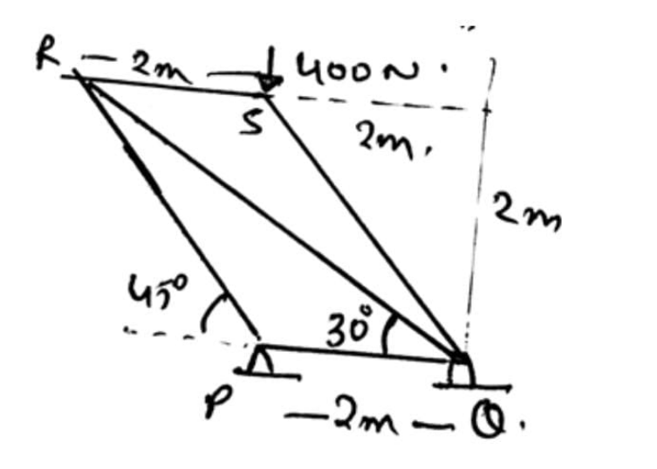

SOLUTION

Step 1, find the reactions

$$\sum{F_{y}}=0$$

$$V_{A}+V_{B}–1200=0$$

$V_{A}+V_{B}=1200$--- Equation 1

$$\sum{M_{A}}=0$$

$$V_{B}×0.4–1200×0.9=0$$

$$V_{B}=\frac{1200×0.9}{0.4}$$

$$V_{B}=2700$$

But, $V_{A}+V_{B}=1200$

$$V_{A}+2700=1200$$

$$V_{A}=−1500$$

$F_{AC}$ will have a vertical and a horizontal component]

$$F_{{AC}_{y}}=F_{AC}sin\left(22.62\right)$$

$$F_{{AC}_{x}}=F_{AC}cos\left(22.62\right)$$

There are three forces acting at point A: which are: , and

2. Find the force in the member RQ of the frame shown below



For this,

We find the reactions

$$\sum{F_{x}}=0$$

$$H_{P}+H_{Q}−500=0$$

$$H_{P}+H_{Q}=500$$

Well I’m stuck here. However, according to someone (Aliya to be precise), the way to solve is

3. Find the axial forces (in terms of P) in the members 1,2 and 3 by the method of joints



4. Find the force in each member and whether they are in tension or compression



So we start at the place where there is at least one known and a maximum of two unknowns

So we start at point D

We draw the joint separately

Any force not lying on the vertical or horizontal will be resolved into components

5. Find the force in each member and determine whether they are in tension or compression



So as you can see, it is not compulsory you start by finding the reactions of the supports

6. Find the force in the member RQ of the frame shown below



Finding the reactions:

$$\sum{F_{y}}=0$$

$$V_{P}+V_{Q}−400=0$$

$$V_{P}+V_{Q}=400$$

Taking moment about P

$$400×0–V_{Q}⋅2=0$$

$$0=V_{Q}⋅2$$

$$V_{Q}=0$$

$$V_{P}+V_{Q}=400$$

$$V_{P}+0=400$$

$$V_{P}=400$$

At point S, (Here we have one known and a maximum of 3 unknowns)

The forces acting at that point are:

400N

$F_{SQ}$ and

$$F_{SR}$$

On solving,

$$\sum{F_{y}}=0$$

$$400+F_{SQ}sin\left(45\right)=0$$

$$F_{SQ}sin\left(45\right)=−400$$

$$F_{SQ}=\frac{−400}{sin\left(45\right)}$$

$$F_{SQ}=−565.69$$

$$F_{SQ}=565.69\left(C\right)$$

Also, similarly, sum of horizontal forces is equal to 0

$$F_{SR}+F_{SQ}cos\left(45\right)=0$$

$$F_{SR}−400=0$$

$$F_{SR}=400$$

At point Q,

Sum of vertical forces = 0

$$−F_{SQ}sin\left(45\right)+F_{QR}sin30+V_{Q}=0$$