NORTON-THEVENIN TRANSFORMATION

$$R_{th}=R_{N}=\frac{V_{th}}{I_{N}}$$

**THEVENIN’S THEOREM**

Thevenin’s theorem states that it is possible to simplify any linear circuit, irrespective of how complex it is, to an equivalent circuit with a single voltage source and a series resistance.

A thevenin circuit typically has one that has a voltage source, and two resistors in series. One of the resistors is the load resistance (Usually represented with R_L)

To solve thevenins theorem

1. Convert the independent voltage sources to short circuits

2. Convert the independent current sources to open circuits

3. Redraw the circuit with only the resistors excluding the load resistance

4. Solve for the equivalent resistance (this becomes the thevenin resistance)

5. Next we find the Thevenin voltage

To do this we redraw the whole circuit and we just exclude the load resistance

Next we can apply nodal analysis

Next, draw the simplified circuit [the voltage source, the calculated resistance, the load resistance]

Next calculate the current

**NORTON’S THEOREM**

Norton’s theorem states that a linear two-terminal circuit can be replaced by an equivalent circuit consisting of a current source I_N in parallel with a resistor R_N, where I_N is the short circuit current through the terminals and R_N is the input or equivalent resistance at the terminals when the independent sources are turned off

Typically at the end of applying norton’s theorem, we will have a current source, two resistors connected in parallel.

Steps:

1. Convert the voltage sources to short circuits

2. Convert the current sources to open circuits

3. Redraw the circuit with only the resistors excluding the load resistance ($R_{L}$)

Solve for the equivalent resistance (this becomes the thevenin resistance or norton’s resistance)

Next, we calculate the Norton current

- We disconnect the load resistance

- We apply KCL

- Norton’s current is given as $I_{N}=\frac{V_{th}}{R_{N}}$

The current through the load resistor $R_{L}$, is given as $I_{L}=I_{N}\left(\frac{R_{N}}{R_{N}+R_{L}}\right)$

**MAXIMUM POWER TRANSFER THEOREM**

This states that the maximum power delivered from source to load resistance occurs when the resistance of the load is equal to the thevenin resistance

$$R_{l}=R_{th}$$

The formula for the maximum power transfer is given as

$$P_{max}=\frac{{V_{th}}^{2}}{4R_{th}}$$

In a ciruit, for maximum power transfer, the load impedance should be equal to the source impedance of the circuit.

When a source is delivering maximum power to a load, the efficiency of the circuit is always 50%.

QUESTIONS TO SOLVE

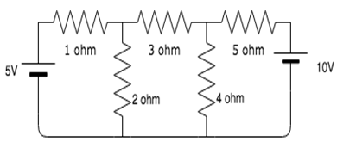1. Find the value of the currents $i_{1}$, $i_{2}$ and $i_{3}$ flowing clockwise in the first, second and third mesh respectively.

For mesh 1:

$$5–i_{1}–2\left(i_{1}–i_{2}\right)=0$$

$$5–i_{1}–2i_{1}+2i_{2}=0$$

$$5–3i_{1}+2i_{2}=0$$

$$3i_{1}–2i_{2}=5$$

For mesh 2:

$$2\left(i_{1}–i_{2}\right)–3i_{2}–4\left(i_{2}–i_{3}\right)=0$$

$$2i_{1}–2i_{2}–3i_{2}–4i_{2}+4i_{3}=0$$

$$2i_{i}–9i_{2}+4i_{3}=0$$

For mesh 3:

$$4\left(i_{2}–i_{3}\right)–5i_{3}–10=0$$

$$4i_{2}–4i_{3}–5i_{3}=10$$

$$4i_{2}–9i_{3}=0$$

On comparing eqn 1 and 2

$$3i_{1}–2i_{2}=5...×2$$

$$2i_{1}–9i_{}2+4i_{3}=0...×3$$

$$6i_{1}–4i_{2}=10$$

- $6i_{1}–27i_{2}+12i_{3}=0$

$$23i_{2}−12i_{3}=10$$

Recall that...

2. If , find q between and

3. In Superposition theorem, while considering a source, all other voltage sources are?  
a) open circuited  
b) short circuited  
c) change its position  
d) removed from the circuit

4. In Superposition theorem, while considering a source, all other current sources are?  
a) short circuited  
b) change its position  
c) open circuited  
d) removed from the circuit

5. In the circuit shown, find the current through 4Ω resistor using Superposition theorem.

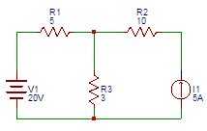

a) 4  
b) 5  
c) 6  
d) 7

6. Consider the circuit shown below. Find the voltage across 2Ω resistor due to the 10V voltage source using Superposition theorem.  
[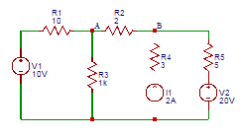](https://www.sanfoundry.com/wp-content/uploads/2017/06/network-theory-questions-answers-superposition-theorem-q4.png)

a) 0  
b) 1  
c) 2  
d) 3

7. Find the voltage across 2Ω resistor due to 20V source in the following figure.  
[](https://www.sanfoundry.com/wp-content/uploads/2017/06/network-theory-questions-answers-superposition-theorem-q4.png)  
a) -2.92  
b) 2.92  
c) 1.92  
d) -1.92

8. Calculate the Thevenin resistance across the terminal AB for the following circuit.  
[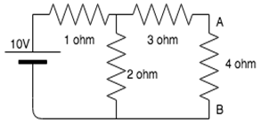](https://www.sanfoundry.com/wp-content/uploads/2018/02/basic-electrical-engineering-questions-answers-thevenins-theorem-q1.png)  
a) 4.34 ohm  
b) 3.67 ohm  
c) 3.43 ohm  
d) 2.32 ohm

9.  Calculate Vth for the given circuit.  
[](https://www.sanfoundry.com/wp-content/uploads/2018/02/basic-electrical-engineering-questions-answers-thevenins-theorem-q1.png)  
a) 5.54V  
b) 3.33V  
c) 6.67V  
d) 3.67V

10. Calculate the current across the 4 ohm resistor.  
[](https://www.sanfoundry.com/wp-content/uploads/2018/02/basic-electrical-engineering-questions-answers-thevenins-theorem-q1.png)  
a) 0.86A  
b) 1.23A  
c) 2.22A  
d) 0.67A

11. Thevenin’s theorem is true for __________  
a) Linear networks  
b) Non-Linear networks  
c) Both linear networks and nonlinear networks  
d) Neither linear networks nor non-linear networks

Answer: A

12. . Consider the figure shown below. Find the voltage (V) at node 1.  
  
a) 13  
b) 14  
c) 15  
d)

16. Consider the figure shown below. Find the voltage (V) at node 1.  
[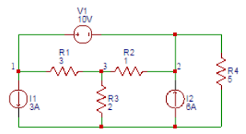](https://www.sanfoundry.com/wp-content/uploads/2017/06/network-theory-questions-answers-supernode-analysis-q1.png)  
a) 13  
b) 14  
c) 15  
d) 16

Answer: B