TRUTH TABLE

It is a means of describing how a large circuit output depnds on the logic circuit input.

Truth tables are used to help show the functions of logic gates

For two inputs

|  |  |  |  |
| --- | --- | --- | --- |
| Inputs | | Outputs | |
| A | B | | X |
| 0 | 0 | | 1 |
| 0 | 1 | | 0 |
| 1 | 0 | | 0 |
| 1 | 1 | | 1 |

For three inputs, ABC.

The output depends on the logic gates applied.

LOGIC GATES AND LOGIC CIRCUITS

Signals can be represented as ON or OFF, 1 or 0 as well. Therefore,

1 means ON or TRUE (T)

0 means OFF or FALSE (F)

A large number of electronic circuits (in computers, control units, and so on) are made up of logic gates. These process signals which represent true or false

Digital systems are said to be constructed by using logic gates. These gates are the BUFFER, AND, OR, NOT, NAND, NOR, EXOR, EXNOR gates. The basic operations are described below with the aid of a truth table. Boolean operations are represented by logic gates or simply gates.

There are three basic boolean operations which are “AND”, “OR”, “NOT”.

Logic circuit is a circuit to perform complex functions defined in terms of elementary functions of mathematical logic. An electronic circuit used in computers to perform a logical operation on its two or more input signals. There are seven basic gates which are the AND, OR, NOT, NAND, NOR, XOR and XNOR circuits which can be combined into more complex circuits.

BOOLEAN OPERATIONS

AND GATE





The AND gate is an electronic circuit that gives a high output (1) only if all its inputs are high. A dot (.) is used to show the AND operation i.e. $\left(A⋅B\right)$. Bear in mind that this dot is sometimes omitted i.e. AB

It is represented as

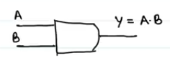

OR GATE

The OR gate is an electronic circuit that gives a high output (1) if one or more of its inputs are high. A plus (+) is used to show the OR operation.

It is one of the three basic boolean operations. In operation, if at least on of the inputs is one (1) the output wil be one (1)

It is represented as





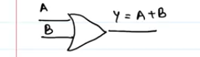

NOT

NOT Gate





The NOT gate is an electronic circuit that produces an inverted version of the input at its output. It is also known as an inverter. If the input variable is “A”, the inverted output is known as NOT A.

This is also shown as:

A', or

A with a bar over the top $\overline{A}$.

UNIVERSAL GATES

These are the NAND and NOR gates.

These are called universal gates because they can be used to construct any other gate as will be seen below

NAND GATE

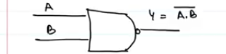

NOR GATE

NAND GATE





This is a NOT-AND gate which is equal to an AND gate followed by a NOT gate. The outputs of all NAND gates are high if any of the inputs are low. The symbol is an AND gate with a small circle on the output. The small circle represents inversion

NOR gate:



This is a NOT-OR gate which is equal to an OR gate followed by a NOT gate. The outputs of all NOR gates are low if any of the inputs are high.

The symbol is an OR gate with a small circle on the output. The small circle represents inversion



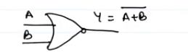

The diagrams below show two ways that the NAND logic gate can be configured to produce a NOT gate. It can also be done using NOR logic gates in the same way.



To use a nand gate as a nor gate, divide the input A into two then you get two inputs A and A. Then on the NAND operation, you get (A.A)’ which will equal A’ which is not A.

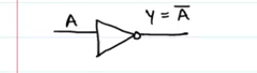

OTHER GATES

Asides the basic operations in boolean algebra, there are other operations which can be done on inputs

EXOR / XOR → Exclusive Or

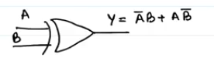

$$A⊕B=\bar{A}B+A\bar{B}$$

You’ll notice that when you make the truth table of an exor gate, you’ll notice that

If inputs are same, output = 0

If inputs are different, output = 1

EXNOR, XNOR. This is the opposite of the exor gate

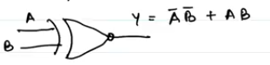

$$\overline{A⊕B}=\overline{\bar{A}B+A\bar{B}}$$

On solving with De Morgan’s theorem, you’ll get

$$\overline{A⊕B}=\bar{A}\bar{B}+AB$$

For the truth that if both inputs are the same, the output will be 1

If the inputs are not the same, output is 0.

EXOR or XOR





The 'Exclusive-OR' gate is a circuit which will give a high output if either, but not both, of its two inputs are high. An encircled plus sign () is used to show the EOR operation

EXNOR Gate





The 'Exclusive-NOR' gate circuit does the opposite to the EOR gate. It will give a low output if either, but not both, of its two inputs are high. The symbol is an EXOR gate with a small circle on the output. The small circle represents inversion

Note:

The NAND and NOR gates are called universal functions since with either one, the “AND” “OR” and “NOT” functions can be generated.

In general, the gate symbols are:



The above table is a summary truth table of the input/output combinations for the NOT gate together with all possible input/output combinations for the other gate functions. Also note that a truth tables with 'n' inputs has $2^{n}$ rows. You can compare the outputs of different gates.

Take note of the following diagrams





In logic gates, we have to learn to interpret circuits and draw given truth tables e.g.

This logic circuit gives the following truth table and output expression.

TRUTH TABLES

Truth tables are used to show logic gate functions

The not gate has only one input, but all others have two inputs

When constructing a truth table, the binary values 1 and 0 are used. Every possible combination, depending on the number of inputs is produced. Basically, the number of possible combinations of ones an zeros is $2^{n}$ where n = number of inputs. For example, 2 inputs will have 4 combinations, 3 inputs will have 8 combinations



Try the following examples

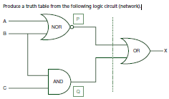

A system used 3 switches A, B and C; a combination of switches determines whether an alarm, X, sounds: If switch A or switch B are in the ON position and if switch C is in the OFF position then a signal to sound an alarm, X is produced.

A manufacturing process is controlled by a built in logic circuit which is made up of AND, OR and NOT gates only. The process receives a STOP signal (i.e. X = 1) depending on certain conditions, shown in the following table:

‘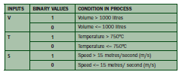

A stop signal (X = 1) occurs when:

Volume, V > 1000 litres and Speed, S <= 15 m/s or

Temperature, T <= 750ºC and Speed, S > 15 m/s

Draw the logic circuit and truth table to show all the possible situations when the stop signal could be received.

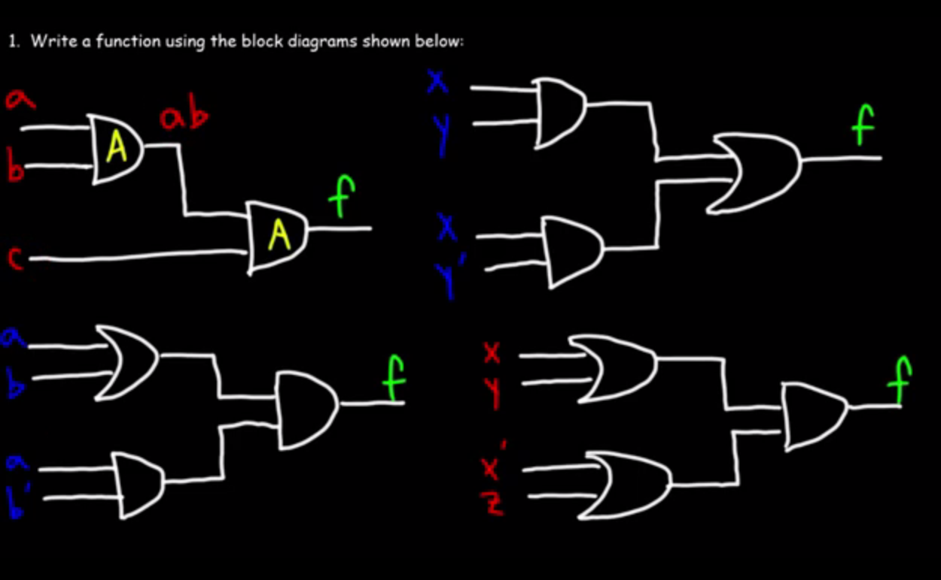

For the first one, the answer is f = abc

The second one is f = (xy)+(xy’)

For the second one, the answer is f = (a + b)(ab’)

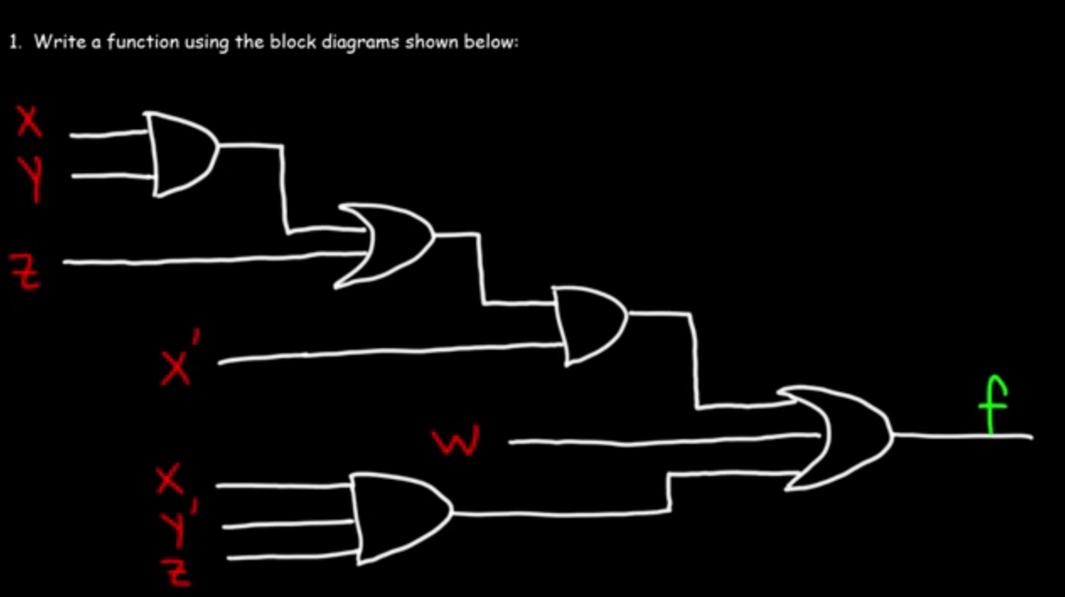

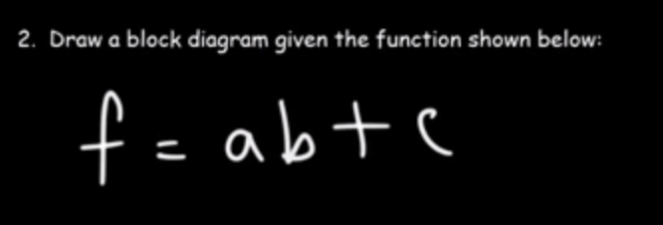

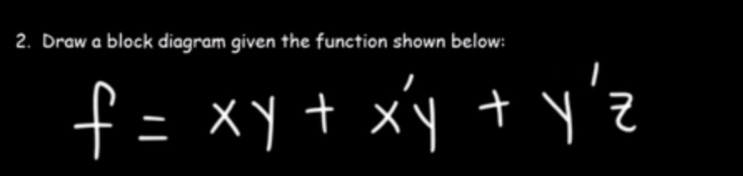

The above is said to be a sum of products (SOP)

Literals -> inputs

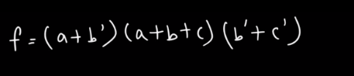

This is a product of sums (POS)

CONSTRUCTION OF GATES USING NAND GATE

AND NOR GATE

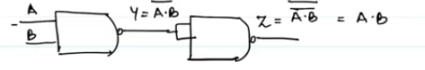

OR GATE BY NAND GATE

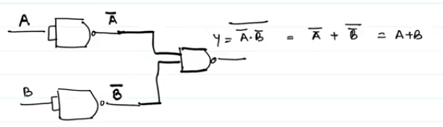

NOT GATE BY NAND GATE

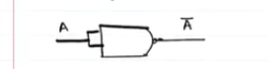

CONSTRUCTING THE GATES USING THE NOR GATE

AND GATE BY NOR GATE

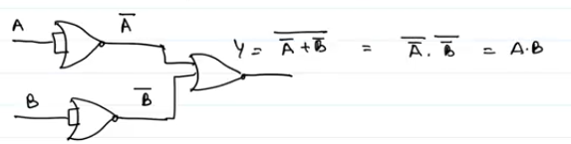

OR GATE WITH NOR GATE

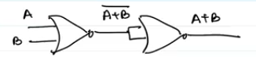

NOT GATE WITH NOR GATE



So those are the gates and solvings