# PROJECT: ONLINE COURSE FEEDBACK

BY

V.KRISHNA CHAITANYA

09010159(CSE)

The main objective of this project is to take feedback of the courses from the student that he has taken and for a faculty to view the feedback from students and the faculty should not know which student gave a particular feedback. This has to be implemented in a very simple way.

PLATFROMS USED:

* Apache
* Html
* Php
* Mysql

In this project first user visits the online feedback portal then he will have two options to login as a student or to login as a faculty. If it is a student after logging in he will see the list of the courses he has registered then he selects one of the courses and gives the feedback and submits, this feedback will be recorded in the database. If it is a faculty after logging in he will see the courses he is teaching and then he will select a course and sees the feedback given till then (he will not be able to see the student details though).

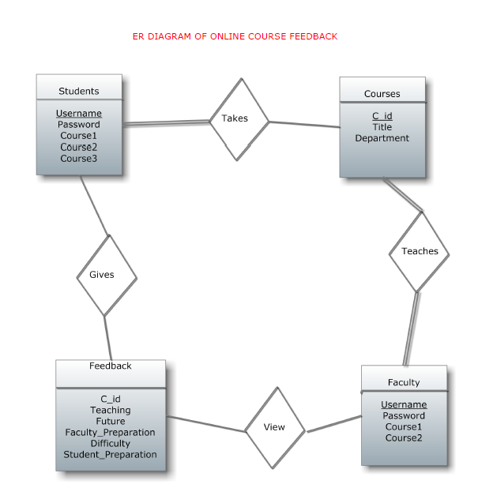

Usefulness of this Project

Taking feedback from students after completion of the course is very important, it gives the faculty an idea how the course went and how he can improve next time when he takes the same course for another batch. But taking it on a paper is a very complex process, to evaluate the feedback it will take a lot of time and it is a resource waste (paper) but using a portal for that simplifies the process very much, the data can be organized very efficiently, for a faculty to see a feedback it will be very easy and here we don’t waste any resources and it is just a one-time effort just to build the portal and we just need to update the database once in a semester which is quite simple.