Satisfaction with the State of Democracy: A Potential Omitted Variable When Studying Economic Satisfaction in the Russian Federation

Kathleen Cimino

18 December 2021

**Abstract**

The interaction between opinions on democracy and those on the free market in Russia is still a point of interest for economists studying the region. How strongly related are these opinions? Using data from the 2016 European Social Survey, this paper indicates that satisfaction with the state of the economy is related to satisfaction with the state of democracy among Russian citizens.

**1 Introduction**

When studying economic policy in the Russian Federation, and former Soviet Countries more generally, it is vital to consider the recent history of these countries. The changes required post Cold War for Russia to join the international community predominantly focused on the democratization of Russia and the transition to a market economy from a planned economy (Stivachtis 2015, 130). Many former Soviet Countries, including the Russian Federation, underwent a series of policies dictated by the IMF labeled shock therapy, which relied heavily on pure economic theory without any input from experts in the region. While the aim of the IMF is supporting democratic institutions, it undermined the democratic process by imposing shock therapy in the nations it assisted (Stiglitz 2000). The (attempted) simultaneous implementation of a free market economy and democracy in Russia has caused the two to become intertwined when discussing the effects of either. Even outside of the Russian Federation, political and economic systems are interlinked and both are jointly affected by various factors (Daron et al 2008).

By most measures, particularly GDP and household consumption rates, the transition from a planned economy to a free market economy has been a success. However, many people in transition economies report lower life satisfaction and many report strong dissatisfaction with transition, and believe the economic situation in their country is no better than it was in 1989 (Guriev and Zhuravskaya 2009, 143-146). In some cases once outside factors are controlled for, any relationship between income and democracy becomes insignificant (Daron et al 2008). Common knowledge might indicate that dissatisfaction with the transition from a planned economy to one based on the free market is merely due to a fundamental difference in the values of people in transition economies. However, Russians tend to have similar opinions on both democracy and the free market as those of Americans, indicating that something other than a preference for a planned economy is causing this dissatisfaction (Boycko and Shiller, 2016).

Given the contradiction between the improvement in household consumption and the dissatisfaction with transition (Guriev and Zhuravskaya 2009), it is important to look at people’s satisfaction with the economy and not just more objective measures like household consumption. This paper contributes to the literature by looking at satisfaction with the state of democracy as a potential explanation for satisfaction with the state of the economy considering the close connection between democracy and the free market in Russia.

To preview, this analysis reveals a significant relationship between satisfaction with the state of democracy and satisfaction with the state of the economy. Compared to those who rated their satisfaction with the state of democracy zero, those who rated their satisfaction with the state of democracy three were 10% more likely to be satisfied with the state of the economy. Those who rated their satisfaction with the state of the economy as ten were 62% more likely to be satisfied with the state of the economy. These results are consistent with the idea that satisfaction with the state of democracy is related to satisfaction with the state of the economy

**2 Data**

To evaluate the relationship between satisfaction with the state of the economy and satisfaction with the state of democracy in the Russian Federation, this paper utilizes individual-level data from the European Social Survey round 8. The European Social Survey is an in person survey which occurs every two years with a new cross-sectional sample in an effort to track changes in the opinions and behaviors of people in the countries included. Round Eight, the data used for this paper, occurred in 2016. The subset used, which includes only citizens from the Russian Federation who answered the questions about their level of satisfaction with democracy and the economy, includes 1632 observations.

Table 1: Means of Participant Responses

|  | Satisfied with Economy | Unsatisfied with Economy | Total Population |
| --- | --- | --- | --- |
| Satisfaction with Current State of Democracy (0-3) | .0787 | .493 | .3892 |
| Satisfaction with Current State of Democracy (4-6) | .4952 | .4324 | .4481 |
| Satisfaction with Current State of Democracy (7-10) | .4261 | .0746 | .019 |
| Household Income Percentile (0-3) | .2764 | .3118 | .3029 |
| Household Income Percentile (4-6) | .2206 | .2978 | .3029 |
| Household Income Percentile (7-10) | .503 | .3905 | .4187 |
| Satisfaction with Household Income (Comfortable) | .0627 | .0549 | .0569 |
| Satisfaction with Household Income (Coping) | .4715 | .3434 | .3755 |
| Satisfaction with Household Income (Difficult) | .3878 | .3596 | .3666 |
| Satisfaction with Household Income (Very Difficult) | .078 | .2422 | .2011 |

The survey data of interest includes how the participant rated their satisfaction with the state of democracy in their country (stfdem), their household income percentile, their satisfaction with the state of the economy in their country (stfeco), and how they feel about their household income. Participants rated their satisfaction with the state of the economy and democracy on a ten point scale, with zero being the lowest and ten being the highest. They rated how they feel about their household income on a scale of one to four, with one being that they were able to live comfortably and with four being it was very difficult to get by. Figure 1 displays the distribution of satisfaction with the state of the economy, and Figure 2 displays the distribution of satisfaction with the state of democracy. Figure 3 shows those who are less satisfied with the state of democracy tend to not be satisfied with the state of the economy. Those who are not satisfied with the state of the economy are also less satisfied with their household income, and are more evenly distributed across household income percentiles.

**3 Model**

It is important to look at the effect satisfaction with the state of democracy has on satisfaction with the state of the economy in the Russian Federation for two reasons. The first is that there has been a gap between measures of objective economic well being (e.g. household consumption rates) and subjective satisfaction (e.g. life satisfaction) in transition economies (Guriev and Zhuravskaya 2009) which indicates that there are factors which likely affect the efficacy of economic policies which are currently unaccounted for in studies on economic policies. Second is that any study on the effect of economic policies which does not account for political policies might be heavily affected by omitted variable bias.. If this is correct, we would expect to see that satisfaction with the state of democracy is related to satisfaction with the state of the economy. This paper utilizes an ordinary least squares (OLS) regression of :

[](https://www.codecogs.com/eqnedit.php?latex=satecon_i%20%3D%20%5Cbeta_0%20%2B%20%5Cbeta_1%20stfdem_i%20%2B%20%5Cbeta_2%20householdincome_i%20%2B%20%5Cbeta_3%20householdincomefeel_i%20%2B%20%5Cepsilon_i#0)

where satecon is the outcome variable for whether or not a participant was satisfied with the state of the economy. Satisfaction with the state of the economy (stfeco) has been coerced into a binary (0-4 unsatisfied with the economy, 6-10 satisfied) for the purposes of the analysis.

Stfdem is how satisfied the participant is with the state of democracy in the Russian Federation on a scale of 0-10, with 0 being unsatisfied and 10 being satisfied. Householdincome is the percentile in which a participant’s household income fell as an objective measure of how the participant is doing economically. Householdincomefeel is a participant’s perception of their income measured on a scale of 1-4 where 1 is that they find it very difficult to get by on their income and 4 is that they are able to live comfortably, included to attempt to account for differences in cost of living and accessibility of public goods in different regions. Finally, [](https://www.codecogs.com/eqnedit.php?latex=%5Cepsilon#0) is the normally-distributed error term. The coefficient of interest is [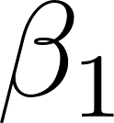](https://www.codecogs.com/eqnedit.php?latex=%5Cbeta_1#0) which captures the relationship between satisfaction with the state of democracy and satisfaction with the state of the economy. Sampling weights provided by the ESS were used to bring the sample closer to the population of interest using the code provided by the ESS.

It will not be possible to determine a causal relationship between satisfaction with the state of democracy and satisfaction with the state of the economy. This regression suffers from potential reverse causality; it is possible that a person’s satisfaction with the state of democracy is caused by their satisfaction with the state of the economy. In addition, there is likely some omitted variable bias, of particular note is the potential effect of age given that many older adults are more strongly affected by underprovision of public goods in former Soviet countries (Guriev and Zhuravskaya 2009).

**4 Results**

Table 2 presents the estimates from ordinary least squares regression. The relationship between satisfaction with the state of the economy and satisfaction with the state of democracy is statistically significant at the five percent error rate for all values of stfdem except zero, one, and two. The estimated effect also differs between levels, typically the more satisfied someone is with the state of democracy the more likely they are satisfied with the state of the economy, with the largest effect at stfdem9 of .758. The smallest statistically significant effect was at stfdem4, where those who rated their satisfaction with the state of democracy as 4 were 8% more likely to be satisfied with the state of the economy than those who had rated their satisfaction with the state of the economy as 0. This indicates that there is cause to believe that satisfaction with the state of democracy affects how likely a person is to be satisfied with the state of the economy, and that they are positively correlated.

There is no statistically significant relationship between feelings about one’s household income and satisfaction with the state of the economy. The relationship between household income percentile and satisfaction with the state of the economy is only statistically significant at the fifth and sixth decile, with a slight negative coefficient compared to the first decile. This indicates that more objective measures like household income are not strongly linked to a participant’s opinion on the state of the economy, and even a person’s subjective opinion of their personal economic state is not a strong predictor of their satisfaction with the economy. This is a departure from previous literature which indicated that the state of public goods, one’s own economic situation, and one’s income affected satisfaction in former Soviet countries (). This model accounts for 31% of the variation in satisfaction with the state of the economy. While this is far from explaining most of the variation, it does indicate that this model provides useful insight into one factor affecting people’s satisfaction with the state of the economy. These results are associations, and do not prove a causal link between satisfaction with the state of democracy and satisfaction with the state of the economy.

**5 Conclusions**

The relationship between democracy and the free market economy is one well studied by economists. Some research has indicated that measures like GDP and household consumption rates increasing during economic transitions do not correspond to an increase in life satisfaction in former Soviet countries. As such, it is important to consider alternative ways of measuring the

Table 2 : Ordinary Least Square Estimates of the Effect of Satisfaction With the State of Democracy on Satisfaction With the State of the Economy

|  | Estimate | Std. Error | p-value |
| --- | --- | --- | --- |
| (Intercept) | 0.075 | 0.070 | 0.2821 |
| satisfaction with current state of democracy (1) | 0.014 | 0.022 | 0.5313 |
| satisfaction with current state of democracy (2) | 0.012 | 0.023 | 0.6204 |
| satisfaction with current state of democracy (3) | 0.105 | 0.038 | 0.0065** |
| satisfaction with current state of democracy (4) | 0.081 | 0.0394 | 0.0417* |
| satisfaction with current state of democracy (5) | 0.249 | 0.049 | 0.00000105*** |
| satisfaction with current state of democracy (6) | 0.437 | 0.059 | 1.17E-11*** |
| satisfaction with current state of democracy (7) | 0.615 | 0.079 | 1.4E-12*** |
| satisfaction with current state of democracy (8) | 0.584 | 0.083 | 8.75E-11*** |
| satisfaction with current state of democracy (9) | 0.758 | 0.091 | 4.36E-14*** |
| satisfaction with current state of democracy (10) | 0.620 | 0.137 | 0.0000122*** |
| Household Income Percentile (2) | -0.062 | 0.064 | 0.3325 |
| Household Income Percentile (3) | -0.048 | 0.071 | 0.5007 |
| Household Income Percentile (4) | 0.008 | 0.076 | 0.9124 |
| Household Income Percentile (5) | -0.162 | 0.065 | 0.0138* |
| Household Income Percentile (6) | -0.121 | 0.054 | 0.0262* |
| Household Income Percentile (7) | -0.025 | 0.059 | 0.674 |
| Household Income Percentile (8) | -0.124 | 0.067 | 0.0667 |
| Household Income Percentile (9) | 0.007 | 0.085 | 0.9335 |
| Household Income Percentile (10) | 0.015 | 0.101 | 0.8851 |
| Satisfaction with Household Income (Difficult) | 0.032 | 0.046 | 0.4834 |
| Satisfaction with Household Income (Coping) | 0.044 | 0.053 | 0.4028 |
| Satisfaction with Household Income (Comfortable) | -0.094 | 0.059 | 0.1122 |
| Observations = 1632 | R-squared =.321 | Adjusted R-squared = .312 |  |

Notes: * p < 0.05, ** p < 0.01, *** p < 0.001 Satisfied with the economy is defined as 1 if the participant rated their satisfaction with the state of the economy as 6-10, 0 if they rated it 0-4. Sample is limited to those who answered their level of satisfaction with the state of the economy and democracy and were Russian citizens.

rates increasing during economic transitions do not correspond to an increase in life satisfaction in former Soviet countries. As such, it is important to consider alternative ways of measuring the success of economic policies, with satisfaction with the state of the economy as one possible measure. When using this measure it is important to consider the possibility that opinions on democracy will affect opinions on the economy due to the strong connection between the democratization of Russia and the move from a planned economy to a free market economy in Russia (Stivachtis 2015; Boycko and Shiller, 2016).

This paper finds that there is a statistically significant relationship between satisfaction with the state of democracy and satisfaction with the state of the economy. The significance of this relationship varies according to the level of satisfaction with the state of democracy. Compared to those who rated their satisfaction with the state of democracy a zero, those who rated it a four were 8% more likely to be satisfied with the state of the economy, while those who rated it a nine were 76% more likely to be satisfied with the state of the economy. These results are significant as they are likely to contribute to omitted variable bias in any attempt to determine the effect of economic policies without taking into consideration the effect of opinions on the political situation in which they occur.

This paper does not prove a causal link between satisfaction with the state of democracy and satisfaction with the state of the economy. It fails to account for several likely sources of omitted variable bias (e.g. age), and has not undergone robustness checks. These findings, while not causal, do provide some indication of areas for future research. In particular, research on the relationship between satisfaction with the state of democracy and satisfaction with the state of the economy in the Russian Federation which accounts for age and opinions on what the correct state is (e.g. where a person considers themself on the Left-Right scale, if they are pro-democracy) to better understand this relationship and move closer to a potential causal relationship could prove fruitful. In addition, if the same data is used for this research, an ordinal logistic regression would likely be better able to determine the relationship between satisfaction with the state of democracy and satisfaction with the state of the economy. This paper also indicates that future research on the effect of economic policies on citizens in the area could potentially benefit from constructing models which control for satisfaction with the political situation. The implication for policy is that economic policies should take into consideration more than just GDP or household consumption as measures of success, further research will be required to provide prescriptive implications. In addition, economic policies should take into consideration how the political system might affect the outcome of particular policies. To use an example from shock therapy, making stocks publicly available in a country without a preexisting stock market (or general cultural understanding of the use of stocks) is likely to concentrate power in the hands of the already wealthy instead of empowering workers. Satisfaction with the state of the economy can be a useful measure for the success of economic policies given the disconnect between many other measures of economic success and the experiences of people, however this paper indicates that it is important to consider satisfaction with the political system in any research using this measure.

**Figures**

Figure 1

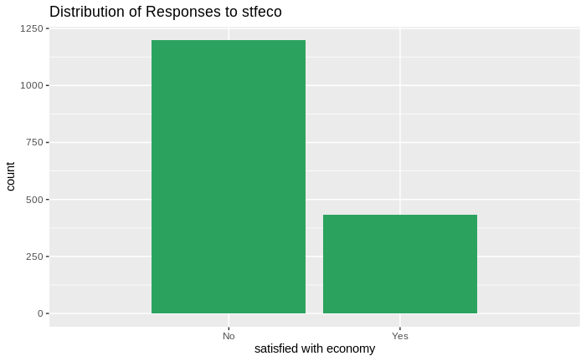

Figure 2

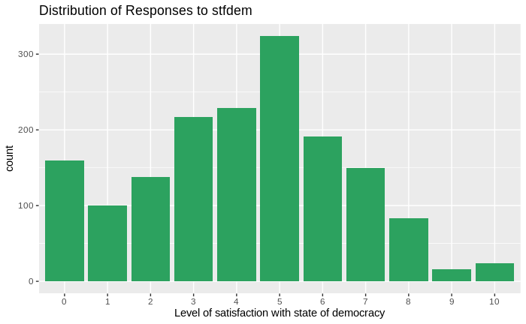

Figure 3

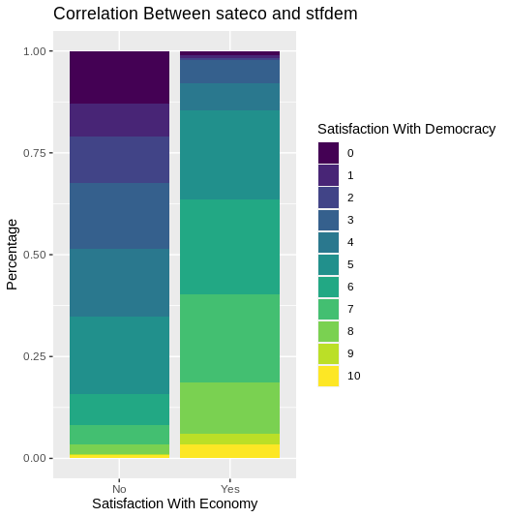

**References**

Acemoglu, Daron, Simon Johnson, James A. Robinson, and Pierre Yared. 2008. "Income and Democracy." American Economic Review, 98 (3): 808-42.

ESS Round 8: European Social Survey Round 8 Data (2016). Data file edition 2.2. NSD - Norwegian Centre for Research Data, Norway – Data Archive and distributor of ESS data for ESS ERIC. doi:10.21338/NSD-ESS8-2016.

Boycko, Maxim, and Robert J. Shiller. 2016. "Popular Attitudes toward Markets and Democracy: Russia and United States Compared 25 Years Later." American Economic Review, 106 (5): 224-29.

Guriev, Sergei, and Ekaterina Zhuravskaya. 2009. "(Un)happiness in Transition." Journal of Economic Perspectives, 23 (2): 143-68.

Stiglitz, Joseph E. “The Insider - What I Learned at the World Economic Crisis.” The New Republic, 2000, 56.

Stivachtis. (2015). Liberal democracy, market economy, and international conduct as standards of “civilization” in contemporary international society: The case of Russia’s entry into the “community of civilized states.” Journal of Eurasian Studies, 6(2), 130–142. https://doi.org/10.1016/j.euras.2015.04.001

**Appendix**

library(tidyverse)

library(desc)

library(survey)

library(ggplot2)

library(foreign)

library(viridis)

# load data

init <- read.csv("ESS1-9e01_1.csv")

# create binary satdem, recode NAs, select only columns of interest, create satdem which is a binary

mydata <- init %>%

mutate(

satecon = ifelse(stfeco > 5 & stfeco <11, 1, ifelse(stfeco == 5 | stfeco > 10, NA, 0)),

stfdem = factor(ifelse(stfdem>10, NA, stfdem)),

stfeco = factor(ifelse(stfeco>10, NA, stfeco)),

hinctnta = factor(ifelse(hinctnta >10, NA, hinctnta)),

hincfel = factor(ifelse(hincfel > 4, NA, hincfel))

) %>%

filter(ctzcntr==1 & !is.na(stfdem) & !is.na(satecon)) %>%

select(anweight, idno, stfeco, stfdem, hinctnta, hincfel, satecon)

# create design and weight appropriately (as guided by ESS documentation)

weights <- read.dta("ESS8SDDFe01_1.dta")

weights <- weights %>% filter(cntry == "RU")

weights.all <- left_join(mydata, weights, by = "idno")

rm("init")

design <- svydesign(ids = ~psu, strata = ~stratum, weights = ~anweight, data = weights.all)

rm("weights.all")

# create model and get information from it

model.weighted <- svyglm(satecon~stfdem+hinctnta+hincfel, design=design)

summary(model.weighted)

# get r^2 because it's not available in survey package

svyvar(~satecon, design)

r.squared <- 1 - 0.1288195 / 0.18963

adj.r.squared <- 1 - (1 - r.squared) * ((2430 - 1)/(2430-3-1))

# plotting important ones

mydata %>%

ggplot(aes(x=factor(satecon), fill=factor(stfdem)))+

geom_bar(position="fill") +

scale_fill_viridis(discrete=TRUE)+

labs(

title= "Correlation Between sateco and stfdem",

x = "Satisfaction With Economy",

y = "Percentage",

fill = "Satisfaction With Democracy"

)+

scale_x_discrete(

limits = c(factor(0) , factor(1)),

labels = c("No", "Yes"))

mydata %>%

ggplot(aes(x=stfdem))+

geom_bar(fill = "#2ca25f")+

labs(

title = "Distribution of Responses to stfdem",

x = "Level of satisfaction with state of democracy"

)

mydata %>%

ggplot(aes(x=satecon))+

geom_bar(fill = "#2ca25f")+

labs(

title = "Distribution of Responses to stfeco",

x="satisfied with economy")+

scale_x_discrete(

limits = c(0 , 1),

labels = c("No", "Yes"))