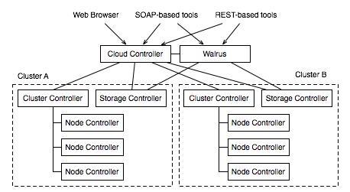

- Test System
the Cloud/Cluster/Storage/Walrus Front End Server
> Atom PC (192.168.2.146)
the Node Controller(s)
> DL320G5 (192.168.2.119)

- Install the Cloud/Cluster/Storage/Walrus Front End Server
Ubuntu 9.10 Server CD
> Install ubuntu Enterprise Cloud
> Cluster
> IP range

- Install the Node Controllers(s)
> Install ubuntu Enterprise Cloud
> Node

- Register the Node(s)
On NC
> sudo passwd eucalyptus

On CLC
> sudo -u eucalyptus ssh-copy-id -i ~eucalyptus/.ssh/id_rsa.pub eucalyptus@192.168.2.119
> sudo euca_conf -addnode 192.168.2.119

- Obtain Credentials
From a Command Line
On CLC
> mkdir -p ~/.euca
> chmod 700 ~/.euca
> cd ~/.euca
> sudo euca_conf –get-credentials mycreds.zip
> unzip mycreds.zip
> cd -

- Extracting and Using Your Credentials
> . ~/.euca/eucarc
> echo “[ -r ~/.euca/eucarc ] && . ~/.euca/eucarc” >> ~/.bashrc
> sudo apt-get install euca2ools
> . ~/.euca/eucarc
> euca-describe-avaiability-zones verbose
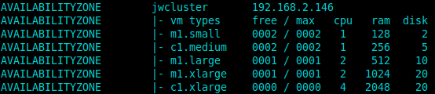
- Install an image from the store
> https://192.168.2.146:8443 ( id/pwd : admin/admin)
> Store Tab > Install ( download image)

- Run an Image
> Use the command line
> if [ ! -e ~/.euca/mykey.priv ]; then
touch ~/.euca/mykey.priv
chmod 0600 ~/.euca/mykey.priv
euca-add-keypair mykey > ~/.euca/mykey.priv
fi
> euca-describe-groups
> euca-authorize default -P tcp -p 22 -s 0.0.0.0/0
> euca-run-instances $EMI -k mykey -t c1.medium
($EMI : https://192.168.2.146:8443 다운받은 이미지 How to run? 클릭으로 확인)
> 확인
> watch -n5 euca-describe-instances
(state : pending → running)
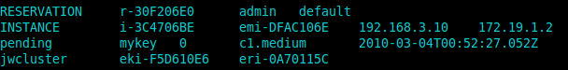
> IPADDR=$(euca-describe-instances | grep $EMI | grep running | tail -n1 |
awk ‘{print $4}’) ex) 192.168.3.10
>접속 : ssh -i ~/.euca/mykey.priv ubuntu@$IPADDR

> INSTANCEID=$(euca-describe-instances | grep $EMI | grep running | tail -n1 |
awk ‘{print $2}’) ex) i-3C4706BE
> terminate instance
on CLC
euca-terminate-instance $INSTANCEID
> reboot instance
on CLC
euca-reboot-intance $INSTANCEID

- Using Block Storage
> Creating a volume
euca-create-volume –size 1 -z myzone ( myzone에 1G 추가)
(euca-describe-availability-zones verbose에서 zone확인)

> Attaching a volume to an instance
euca-attach-volume -i i-467307E6 -d /dev/sdb vol-332804B7
=> instance i- 467307E6에 device명 /dev/sdb으로 volume vol-332804B7 attach

> Detaching a volume
euca-detach-volume vol-332804B7

> Delete a volume ( detach → delete )
euca-delete-volume vol-332804B7

> Creating a snapshot
euca-create-snapshot vol-332804B7

snapshot으로 volume 생성하기
> euca-create-volume –snapshot <snapshot-id> --zone <zone>
> euca-describe-volumes로 volume ID확인
> euca-attach-volume -i i-467307E6 -d /dev/sdb vol-332804B7

