* Search
  + I implemented searching with this query
    - select \* from movies where name like concat('%', :term, '%') limit 10
    - it enables you to search with any letter that is included in the movie title
* top 5 movies by categories
  + I used this query
  + select \* from movies m inner join rating r on m.id= r.movieId where m.categoryId =:categoryId order by r.rating desc limit 5
* random movie
  + This allows you to get a random movie
  + select \* from movies ORDER BY RAND() LIMIT 1
* Some screenshots
  + 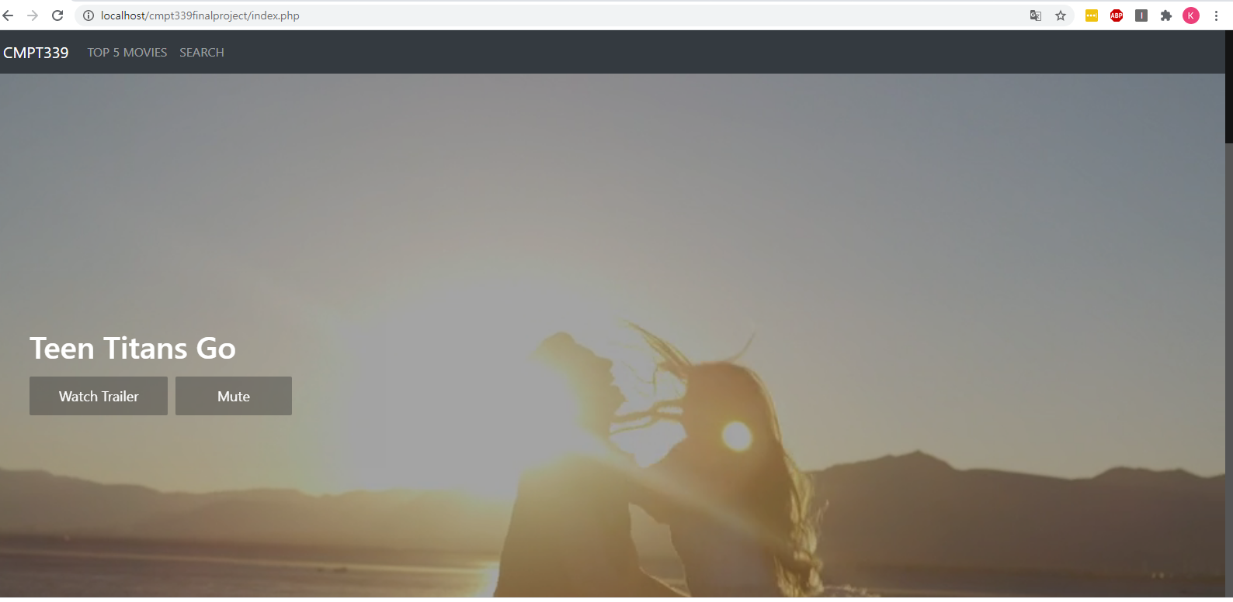
    - Main page
  + 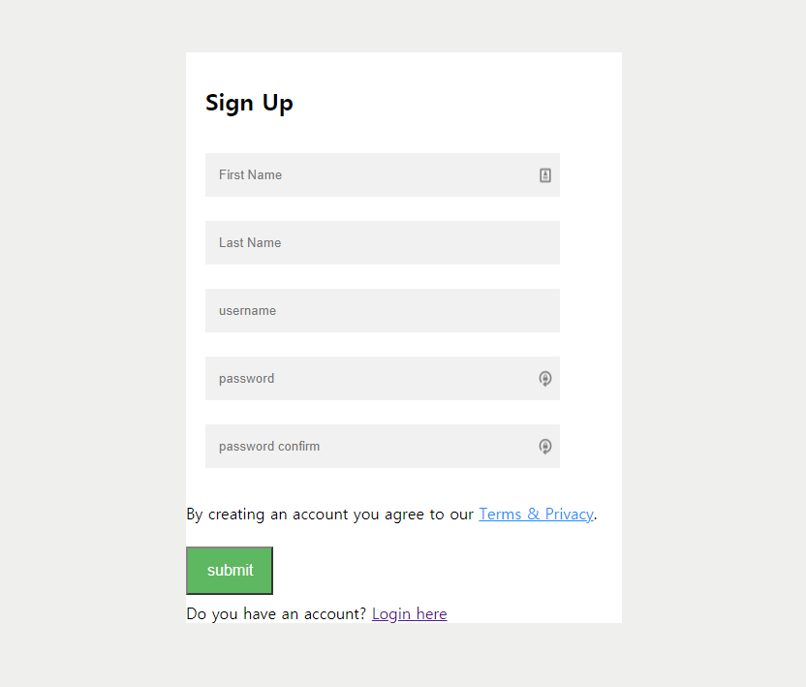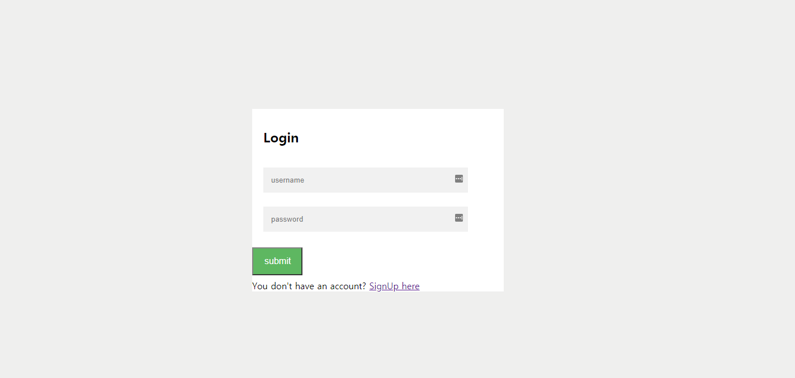
  + 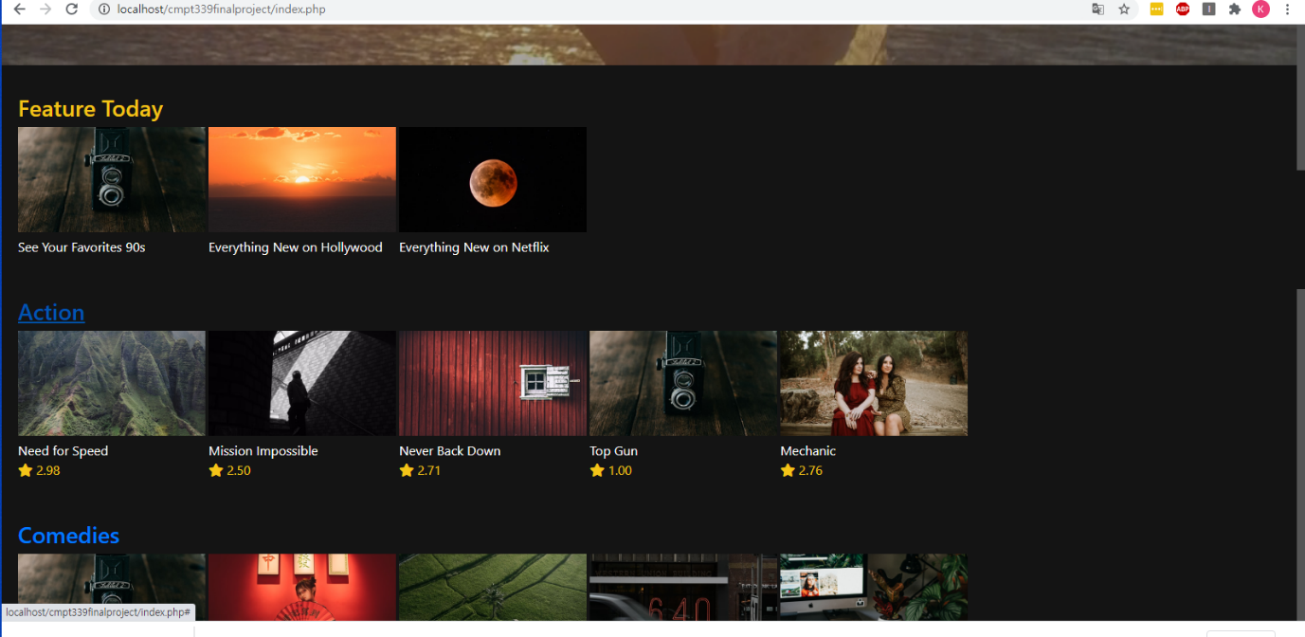
    - Shows feature today and other categories with rating
  + 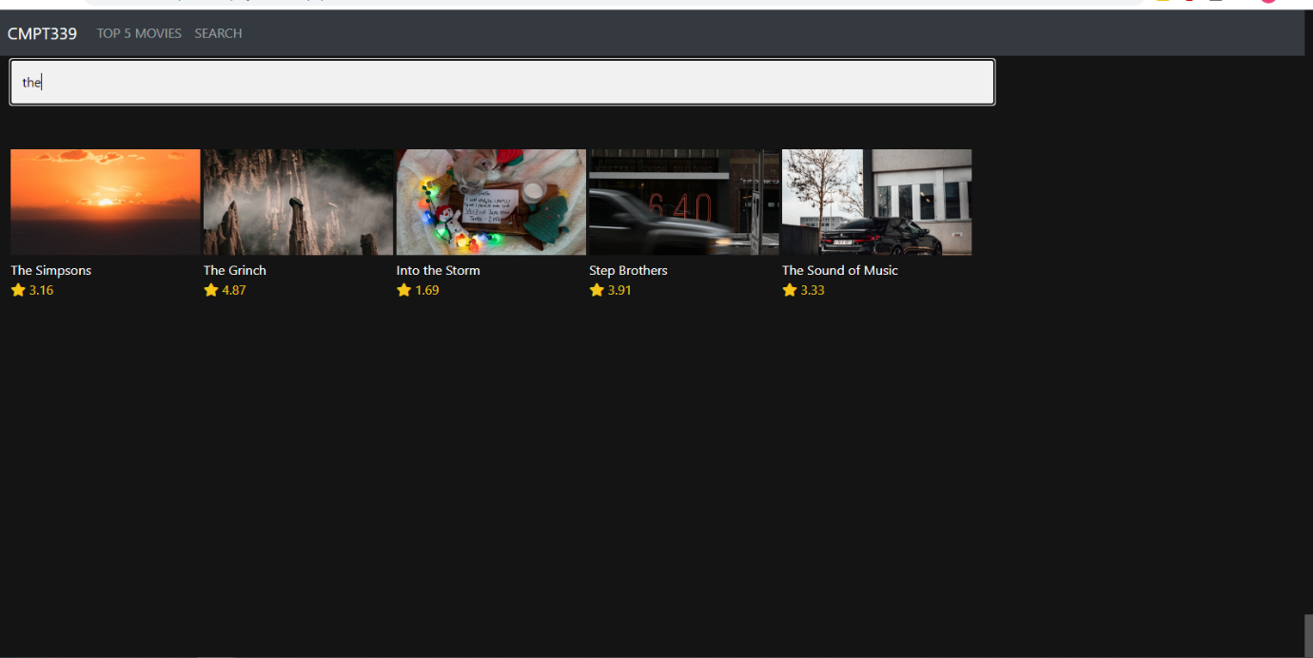
    - Searching screen shot
  + 
    - Full screen shot of the video playing