* Motivation
  + I got the motivation from IMDB, where they have trailers, reviews, rating, login, and sign-in functionalities.
  + This is the screen shot of IMDB
  + 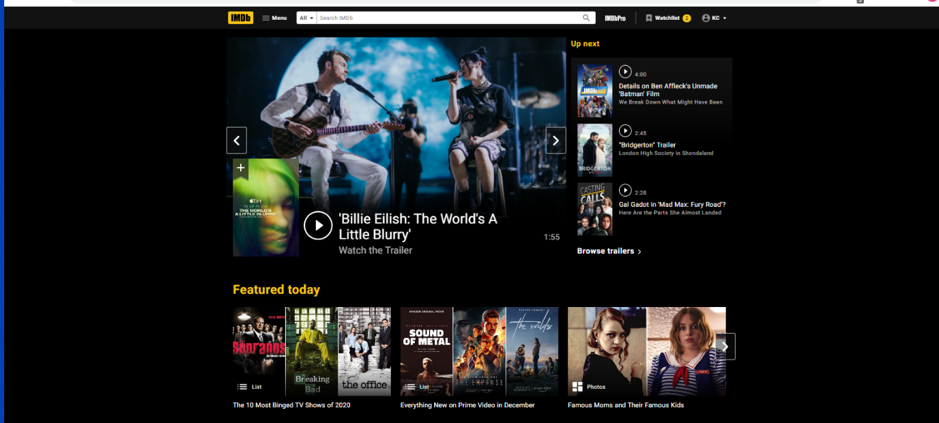
  + I tried to use a black background to mimic the IMDB site.
  + One feature I tried to imitate was featured today.
  + I also incorporated rating like IMDB
  + One thing that I did not implement was the watchlist. This functionality would have improved the user’ experience
  + I also tried to incorporate the trailer video aspect so that clients can watch trailers that interest them.