Kyung Cheol Koh

Dr. McBride

CMPT 334

31st October 2021

Triage Scheduler

1. Step 1: Creating a data set
   1. Set 1

|  |  |  |  |
| --- | --- | --- | --- |
| Process | Burst Time | Category | Priorities |
| 1 | 5 | Knee Surgery | 2 |
| 2 | 9 | Back Surgery | 5 |
| 3 | 4 | Leg surgery | 3 |
| 4 | 3 | Eye surgery | 2 |
| 5 | 4 | Ankle surgery | 1 |
| 6 | 12 | Brain surgery | 5 |
| 7 | 2 | Eye surgery | 3 |
| 8 | 8 | Back surgery | 4 |

* 1. Set 2

|  |  |  |  |
| --- | --- | --- | --- |
| Process | Burst Time | Category | Priorities |
| 1 | 8 | Brain Surgery | 5 |
| 2 | 7 | Brain Surgery | 5 |
| 3 | 1 | leg surgery | 1 |
| 4 | 2 | leg surgery | 2 |
| 5 | 2 | back surgery | 2 |
| 6 | 4 | back surgery | 3 |
| 7 | 2 | eye surgery | 1 |
| 8 | 7 | leg surgery | 4 |

* 1. Set 3

|  |  |  |  |
| --- | --- | --- | --- |
| Process | Burst Time | Category | Priorities |
| 1 | 1 | eye Surgery | 1 |
| 2 | 2 | ankle Surgery | 1 |
| 3 | 3 | leg surgery | 3 |
| 4 | 2 | ankle surgery | 1 |
| 5 | 3 | knee surgery | 2 |
| 6 | 2 | knee surgery | 2 |
| 7 | 10 | brain surgery | 5 |
| 8 | 3 | leg surgery | 1 |

1. Step 2: Implement a simple scheduling algorithm – first come first serve Algorithm(FCFS)

**Results**

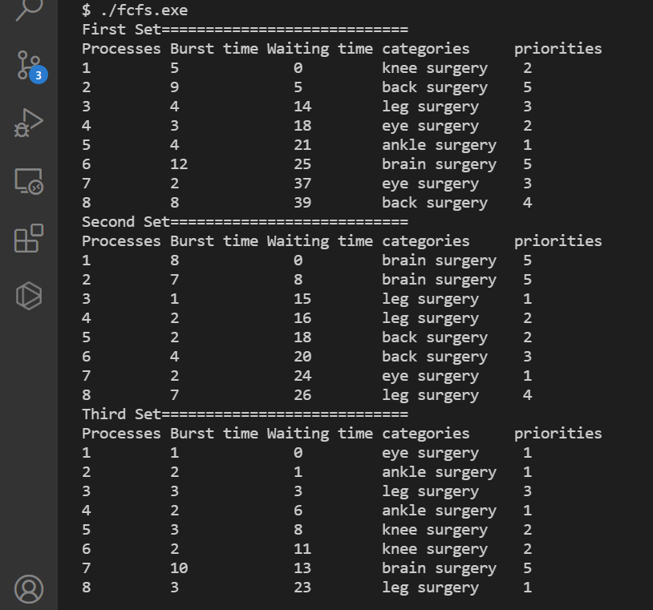

**Discussion of the result**

The scheduling algorithm I implemented was first come first serve algorithm. This algorithm that executes processes in order of their arrival time. As the results show, the execution of surgery is done by their arrival time. It is important to note that first come first serve algorithm does not take consideration of priorities and burst time. The waiting time indicates the performance. FCFS is not performant in terms of waiting time because some surgeries are important and need to be done quickly; whereas, some surgeries can be done quickly because it has low burst time. Thus, next algorithm should consider burst time which is the time that takes to finish a surgery.

1. Step 3: Implement a more advanced scheduling algorithm – Shortest Job first Algorithm (SJF)

**Results**

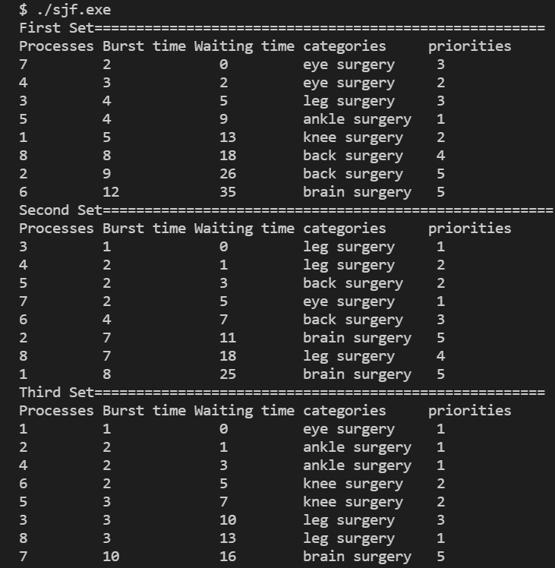

**Discussion of the result**

With the shortest job first algorithm, many surgeries can be operated; thus, it is efficient. However, people who have higher authorities like brain surgery are operated at the end. If the priorities indicate the emergency of the patients’ status, they may die before they get operations. Thus, the next algorithm tries to consider priorities instead of the shortest job.

1. Step 4: implement a new improvement – Priority algorithm

**Results**

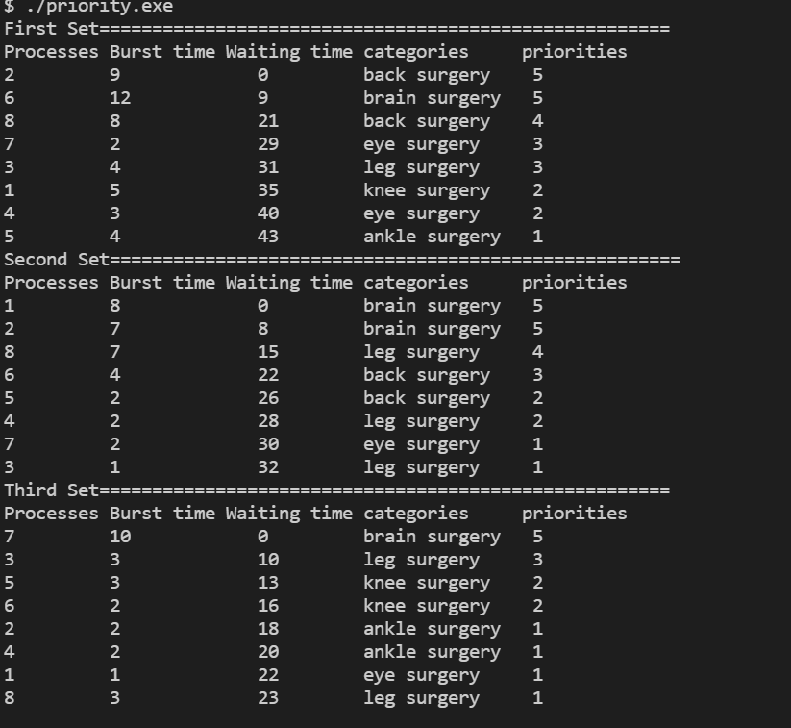

**Discussion of the result**

With the priority algorithm, it takes consideration of priority values. The priority represents the emergency of people’s life, in which higher priority means that they get the operation as soon as possible. This algorithm makes sense because surgeries like brain surgery and back surgery have low waiting time in the beginning to be operated. With this approach, the doctor’s time can be used in the most efficient way possible.